**MODULAR SOAPUI FRAMEWORK**

**Modular Assertions**

|  |  |
| --- | --- |
| Author | Umamahesh Senagavarapu |
| Author Details | Test Automation Solutions Architect, L&G SSP Smart Quote Project |
| Document version | Draft |
| Issued Date | 25/03/2018 |

**Declaimer:**

The users should be well-versed with Basic concepts of Computer, Operating System, SOAPUI, MS EXCEL, Software testing and Web services before attempting to consume the modular framework. Above basics are not covered in this document. This document is the property of SSP and as of now in draft state. It shall be communicated to authorised personnel only. It is not to be disclosed outside the authorised group without prior written consent.

**OVERVIEW OF Modular Assertions :**

1. Before going thru the document please make sure you are well-versed with basic concepts of Computer, Operating System, SOAPUI, MS EXCEL, Software testing and Web services .
2. There are various types of Assertions I SOAPUI. We assume you are already familiar with SOAPUI Assrtions before using this guide.
3. This Modular Assertions framework is developed to add numerous ‘XPath’ assertions dynamically to a ‘Web Service Request Template’ addition to existing asssertions already you have given. (To know more about WS request please go thru relevant documentation provided on that topic).
4. Artefacts related to this modular assetions frmaework found under the folder “<PROJECT_HOME>\ModularSOAPUIFramework\TestDataAndRunConfig\AssertionsData” .
5. These artefacts are “AssertionsData.xls “, “LGNameSpaces.properties”.

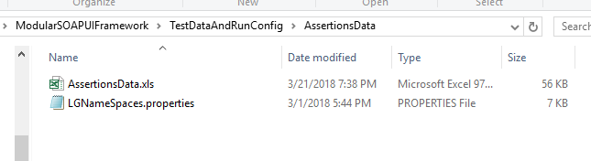

1. LGNameSpaces.properties has the XML Name space entries of each web service to be tested. We need to add new web services in this file. This is one time activity unless there is change in Web Service request Schema.

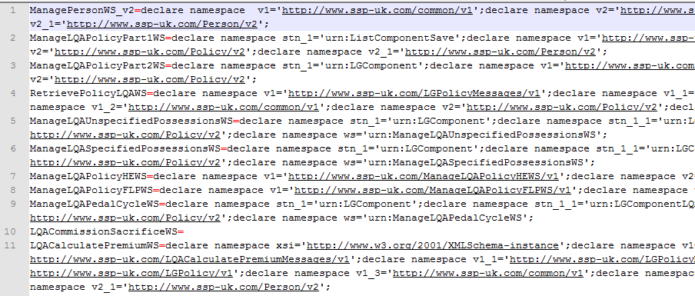

1. 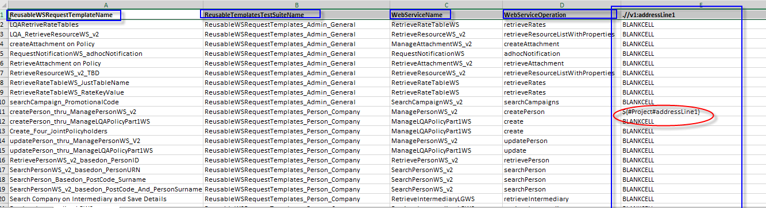AssertionsData.xls has assertions mapping against Reusable templates of specific Web Service Operation of a WebService.
2. The XML node need to be asserted should be maintained as a column. The column name is the Xpath of the XML Node.
3. The value under the specific column will become the value need to be asserted in the response of partcular WS REQUEST template.
4. Make sure you enter dynamic values (project proeprty variable names rather than hard coded values) as much as possible for assertions.
5. In each WS request template, “Add Assertions” and “Log Assertion Results” steps consume this framework.

