1. Import project from SVN. And expand the Test Suite “LGNQA_RateTables_TestPack”
2. Navigate to specific test case you wanted add assertion. In this example, I navigated to “LQARetriveRateTables_S_G_TestCase”.

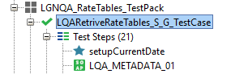

1. Navigate to a specific test step. Example I navigated to “Create new ‘script Assertion’.

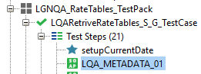

1. Open the test step request, and go to Assertion tab, add “assertion”, by clicking on + icon.

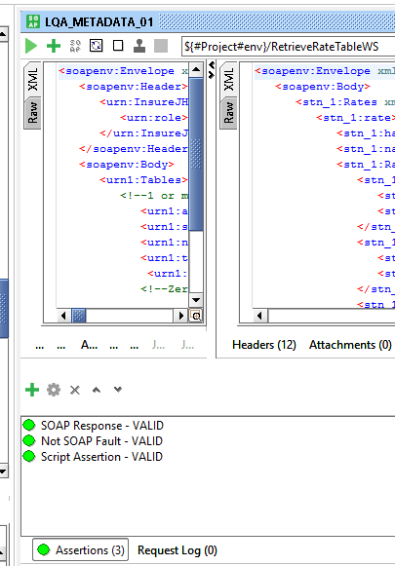

1. Add assertion of the type “Script Assertion”.

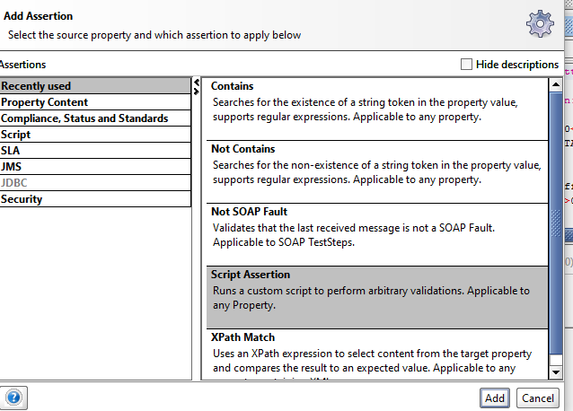

1. Name the assertion as <**SCHEMENAME>_SUBSCHEMENAME>_Check** based on the specific test step of a specific test case.

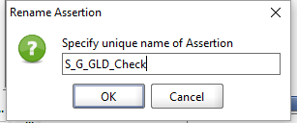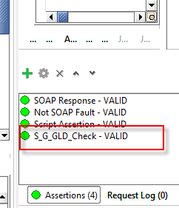

Go to LQA_UPP_DEFAULT step, and select any <**SCHEMENAME>_SUBSCHEMENAME>_Check**

Styled assertion, and copy the script, and paste in to the script assertion you created above.

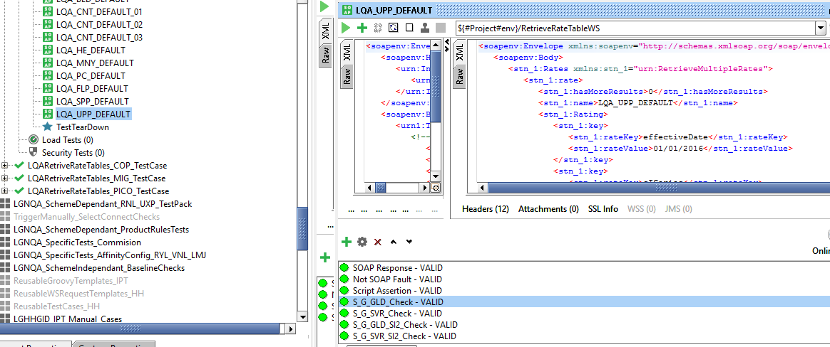

Replace the XML piece in the “Contains” part with the expacted one in the response, applicable to that step.

