Wordoku

An  Alphabetic Sudoku

Project Overview

Wordoku is a variation of the most famous number game- ‘Sudoku.’ Instead of using numbers, the player has to use alphabets to complete the puzzle. Wordoku follows the same rules as a Sudoku puzzle i.e. the same single alphabet may not appear twice in the same row, column, or any of the nine 3×3 subgrids of the 9×9 main grid. The project will consist of a two variation:

1. Classic Wordoku- The player has to complete the partially filled classic 9x9 main grid with the allotted alphabets.
2. Mini Wordoku- The Mini wordoku will consist of a smaller 6x6 grid (consisting six 2x3 subgrids) which is easy to solve. This variation of wordoku is specially designed for children and beginners.

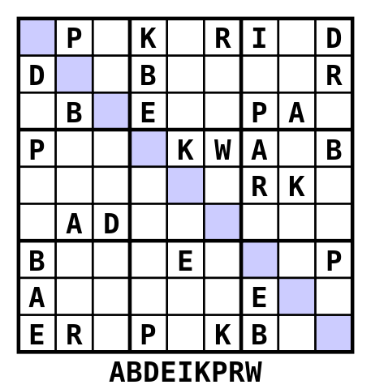 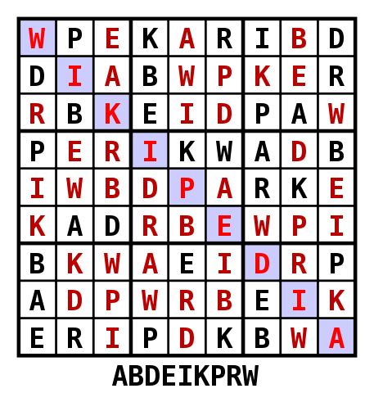

Problem and Solution Statement

Logic building and problem solving are some the key skills that everyone should possess. But there aren't enough proper development programs by which a person can improve these fundamental skills. Wordoku is a fun puzzle solving activity by which a person can develop logic and problem solving skills. It increases the word forming ability of a child, helps adults to do things quickly and increases sense of time. Also, it reduces chances of developing Alzheimer by keeping your brain active. Wordoku helps people of all ages.

Benchmark

Wordoku is fun to play and easy to understand puzzle application. Using alphabets instead of numbers that are used in conventional Sudoku provides uniqueness to application. Also, wordoku being a digital puzzle  there is no need to carry anything with you. You can play it wherever you want, whenever you want. While the classic 9x9 grid puzzle can be tough for beginners and children, this application provides a mini version (Mini Wordoku) consisting of a 6x6 grid which is easy to solve and ideal to begin with.

Implementation strategy

The basic idea currently for developing this project is  by the use of object oriented programming languages like C++, Java and Python. The project will mainly use multidimensional arrays and strings for storing the elements of the puzzle. Usage of various fundamental concepts like dynamic arrays will be an important part of the project. Use of pointer will be  key towards problem solving as it will help to change the values of any box while solving the puzzle. Values of the elements of the puzzle that are being provided by the programmer will be stored by static arrays so that a user may not be able to  change the puzzle. Online reference and help will be taken from various websites and other developers. Also, Guidance in the project will be provided by the faculty members.

Contributors

|  |  |  |  |
| --- | --- | --- | --- |
| Name | Roll No | Contact No | Email |
| Shah Axat D. | 19IT126 | 9428039723 | 19it126@charusat.edu.in |
| Patva Viraj K. | 19IT117 | 9429637250 | 19it117@charusat.edu.in |