**AIM:**

Design a hybrid network using star and ring topology.

Use class A and class C ip address

**PROCEDURE**

**Step 1:**

Make a Star Topology

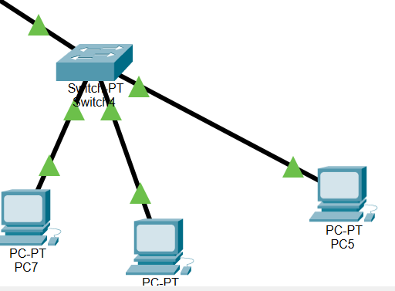

**Step 2:**

Assign Ip address to every PC

**Step 3:**

Make Ring topology

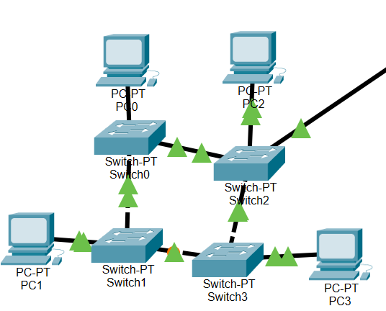

**Step 4:**

Assign IP address to every PC

**Step 5:**

Connect the both networks with the help of router

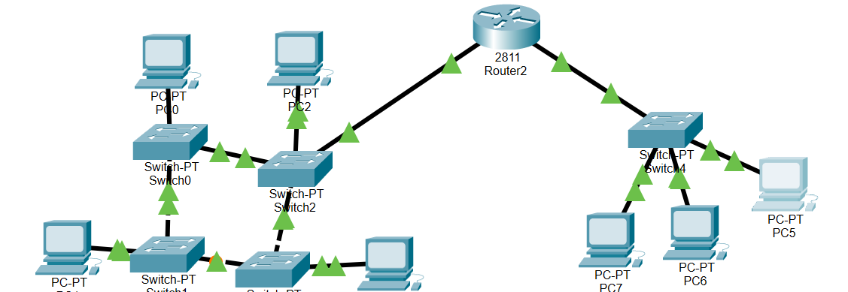

**Step 6:**

Configure the router

**Step 7:**

Run ping test

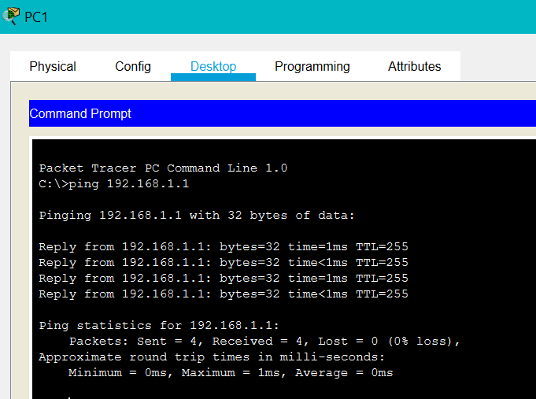

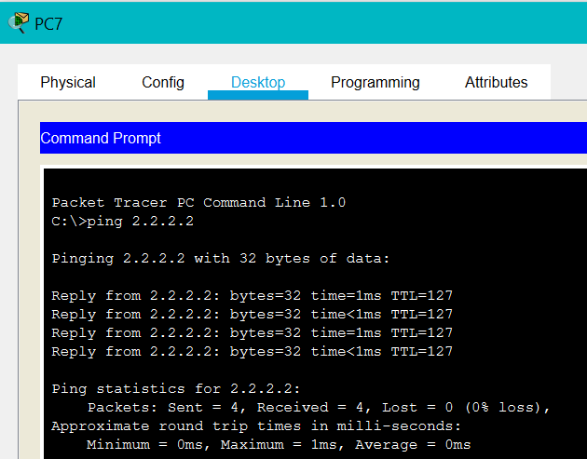

**CONCLUSION:**

Thus we have constructed a hybrid topology using class A and class C IP address