**PRACTICAL-2**

**AIM:** Illustration of various networking commands:

• Ping (types of responses)

• tracert/traceroute

• netstat

• arp

• ipconfig/ifconfig

• nslookup

**Theory/Practical**:

## PING:

* PING stands for “Packet Internet Grouper”.
* The ping command sends packets of data to a specific [IP address](https://www.howtogeek.com/341307/how-do-ip-addresses-work/) on a network, and then lets you know how long it took to transmit that data and get a response
* It can be used to check if whether your connection is alive or not

To use ping: ping hostname/IP address (To stop ping press Ctrl+C)

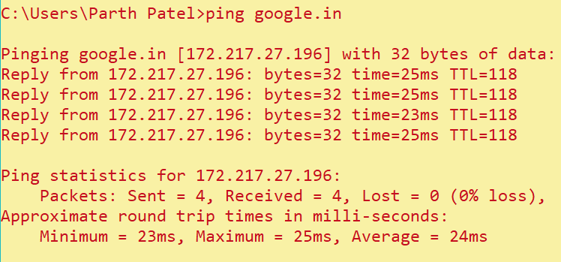 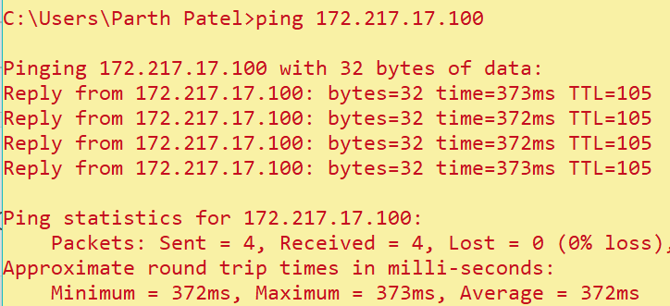

## Netstat:

* Netstat is derived from “Network” and “Statistics”
* It delivers basic statistics on all network activities and informs users on which ports and addresses the corresponding connections (TCP, UDP) are running and which ports are open for tasks.
* There are various options for Netstat. Some are displayed below:

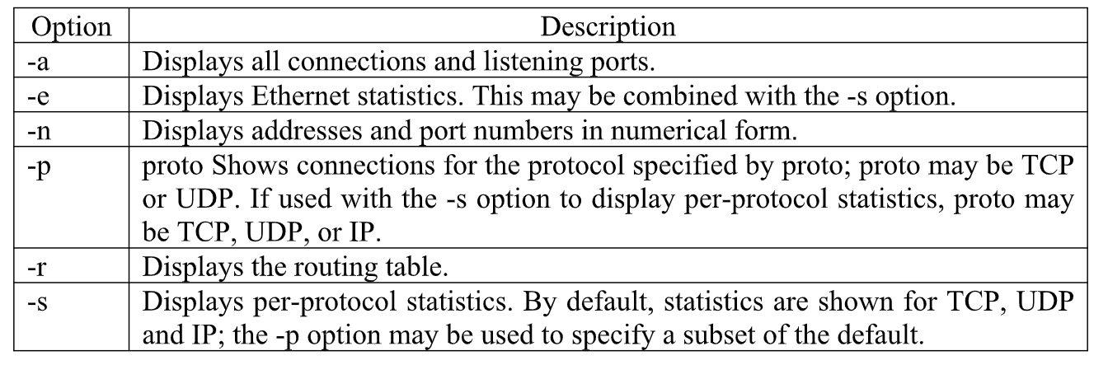

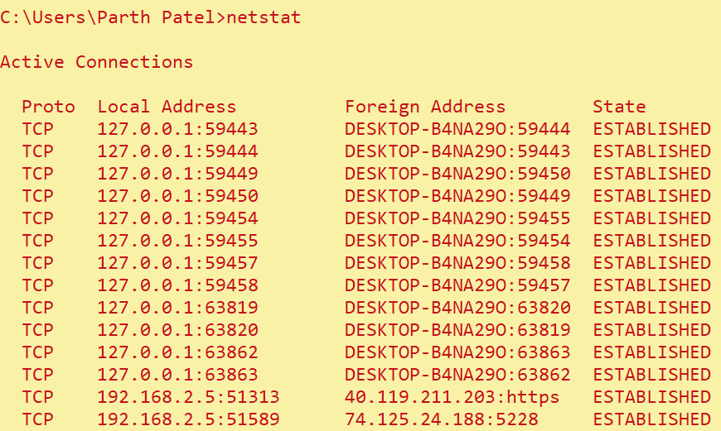

## Ipconfig/ifconfig:

* Ipconfig stands for “Internet Protocol Configuration”.
* This command is used to view all the current TCP/IP network configurations values of the computer.
* ifconfig stands for “Interface Configuration.”
* This command is the same as ipconfig, and is used to view all the current TCP/IP network configurations values of the computer.
* ipconfig/all: It gives the full configuration of the system.
* ipconfig/registerdns: This command refreshes all DHCP leases and reregisters the DNS names.
* ipconfig/displaydns: It displays the information that is stored in the DNS Resolver cache. It has all the DNS information that has been used earlier.
* ipconfig/showclassid adapter: It displays all the class id’s that are allowed for the adapter.
* ipconfig/setclassid adapter [classid]: This command is used to modify the DHCP class id.

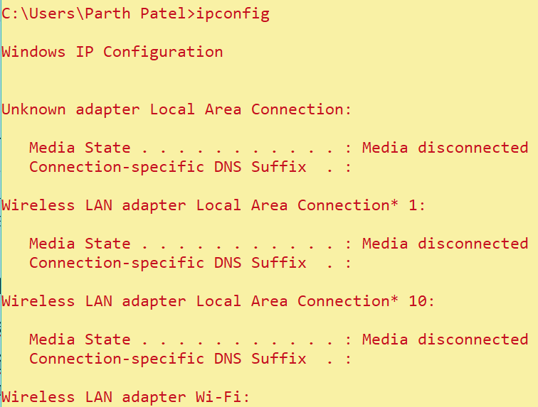

## Tracert:

* tracert stands for “Trace Route”
* Traceroute is a network diagnostic tool used to track in real-time the pathway taken by a packet on an IP network from source to destination, reporting the IP addresses of all the routers it pinged in between.
* Traceroute also records the time taken for each hop the packet makes during its route to the destination.

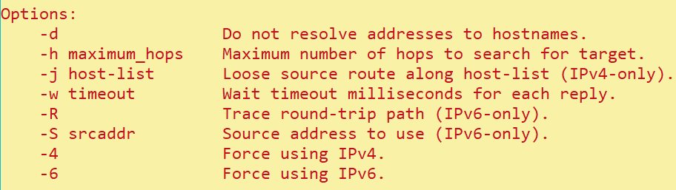

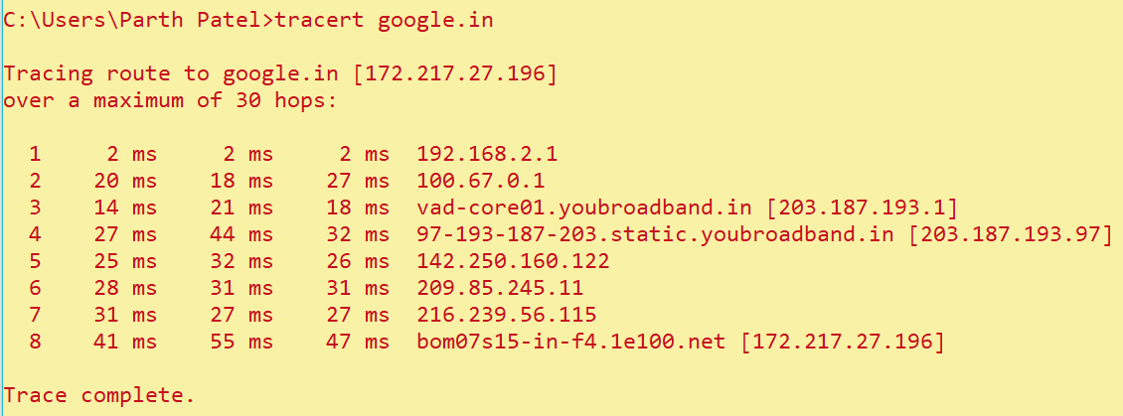

## ARP:

* Arp stands for “Address Resolution Protocol”.
* This protocol is used by network nodes to match IP addresses to MAC addresses.

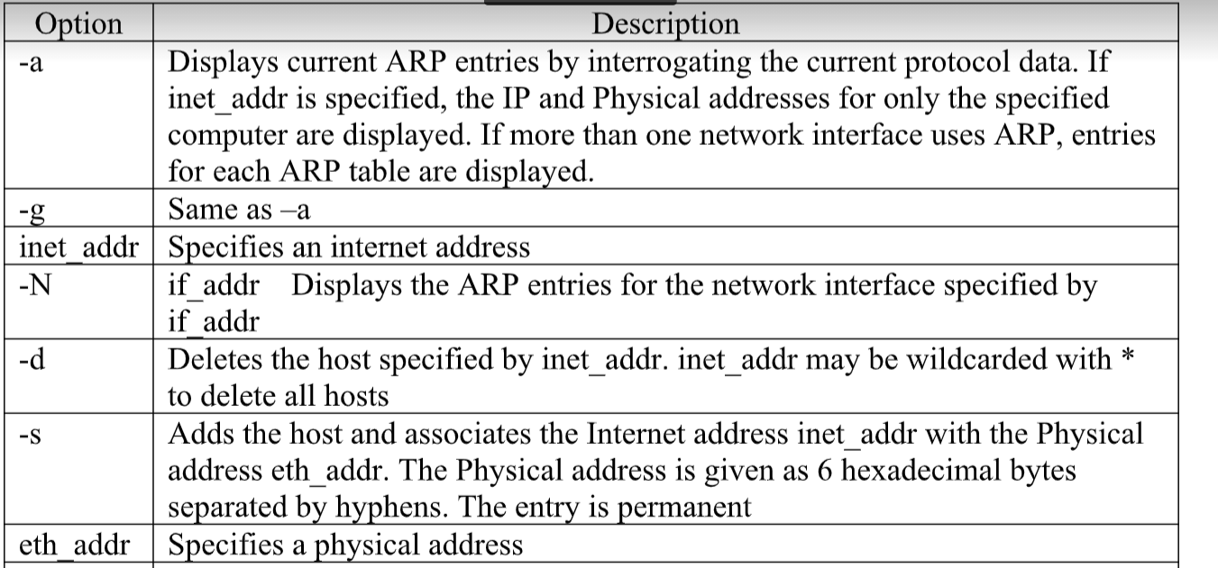

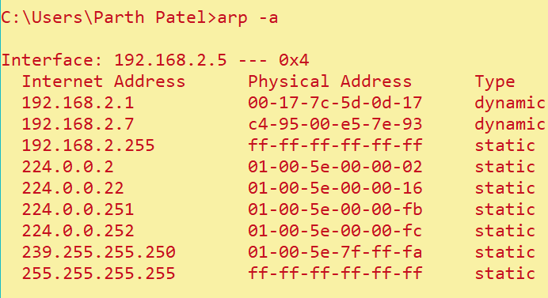

## Nslookup:

* Nslookup stands for “Network Server lookup”.
* nslookup is a network administration command-line tool available in many computer operating systems for querying the Domain Name System (DNS) to obtain domain name or IP address mapping, or other DNS records.

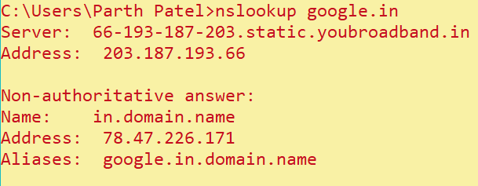

**Conclusion:**

By performing the above practical, we got to know about various networking commands that will be useful in networking.