**PRACTICAL-4**

**AIM:** Work on Classful Addressing in IPv4, Network Address, Broadcast Address in each Class.

**PRACTICAL/THEORY:**

* IP address is an address having information about how to reach a specific host, especially outside the LAN.
* An IP address is a 32 bit unique address having an address space of 232.

IP Addressing is two types:

* Classless addressing
* Classful addressing

## **Classful Addressing:**

* The 32-bit IP Address is divided into five sub-classes.
* They are as follows:
  + Class A
  + Class B
  + Class C
  + Class D
  + Class E

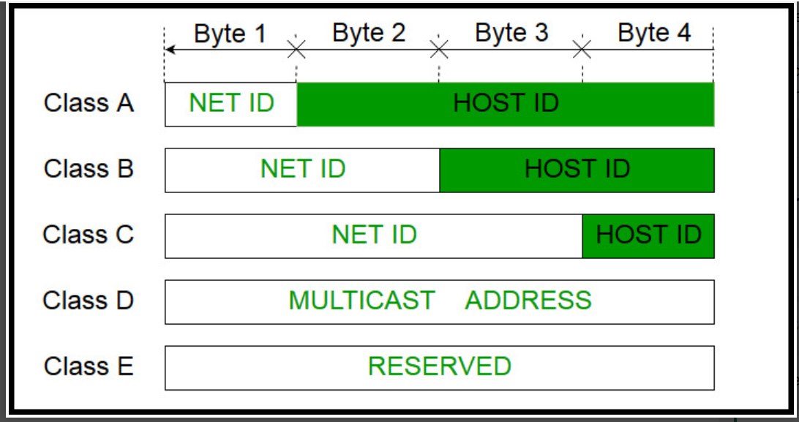

## **CLASS A:**

* IP address belonging to class A are assigned to the networks that contain a large number of hosts
* The network ID: 8 bits
* The host ID: 24 bits
* class A has a total of:
* 2^7-2= 126 network ID
* 2^24 – 2 = 16,777,214 host ID
* IP addresses belonging to class A ranges from 1.x.x.x – 126.x.x.x

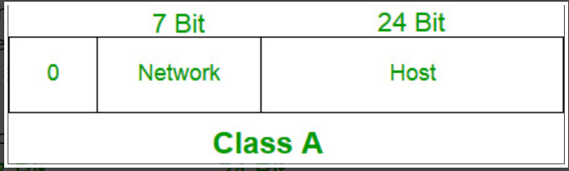

## **Class B:**

* IP address belonging to class B are assigned to the networks that ranges from medium-sized to large-sized networks
* The network ID: 16 bits
* The host ID: 16 bits
* Class B has a total of:
* 2^14 = 16384 network address
* 2^16 – 2 = 65534 host address
* IP addresses belonging to class B ranges from 128.0.x.x – 191.255.x.x.

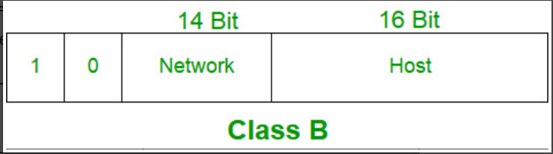

## **Class C:**

* IP address belonging to class C are assigned to small-sized networks
* The network ID: 24 bits
* The host ID: 8 bits
* 2^21 = 2097152 network address
* 2^8 – 2 = 254 host address
* IP addresses belonging to class C ranges from 192.0.0.x – 223.255.255.x

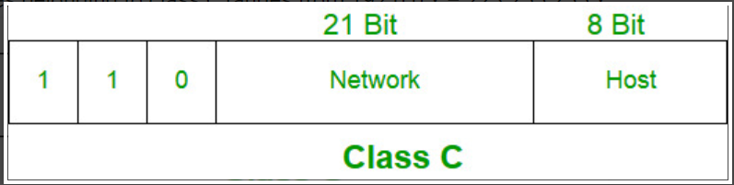

## **Class D:**

* IP address belonging to class D are reserved for multi-casting.
* Class D does not possess any sub-net mask
* IP addresses belonging to class D ranges from 224.0.0.0 – 239.255.255.255.

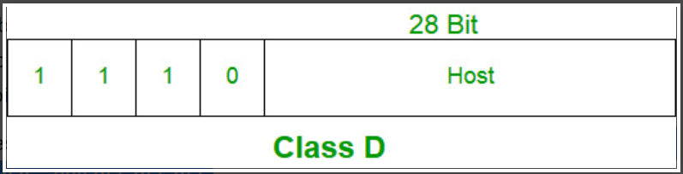

**Class E**:

* IP addresses belonging to class E are reserved for experimental and research purposes
* IP addresses of class E ranges from 240.0.0.0 – 255.255.255.254

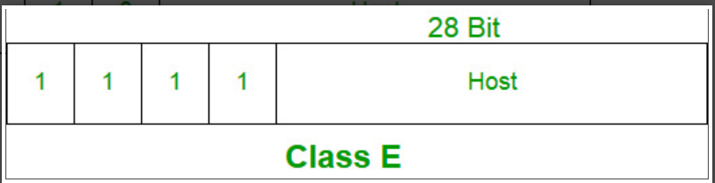

**CONCLUSION:**

By performing the above practical, we got to learn about classful addressing for IP address.