PRACTICAL-6

AIM: Capture HTTP & ICMP Traffic using Wireshark. 2. Understand DNS packet format through captured Traffic. 3. Follow TCP/UDP Stream to look inside packet

ICMP:





HTTP:



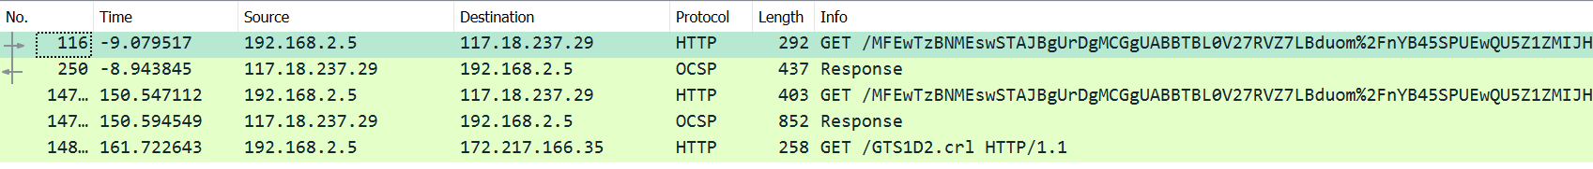

DNS:



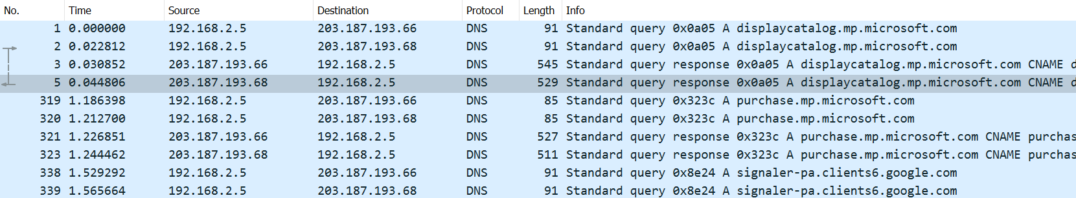

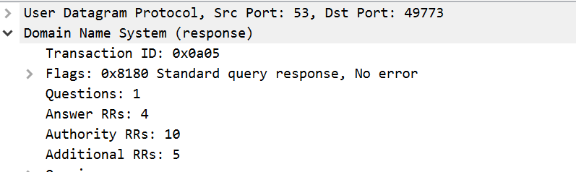

UDP/TCP:

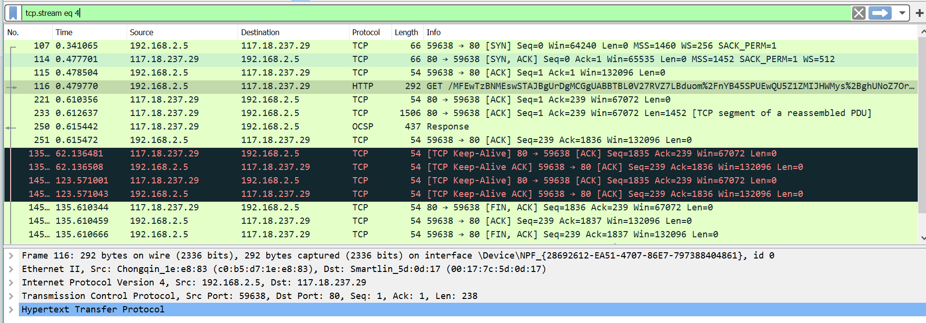

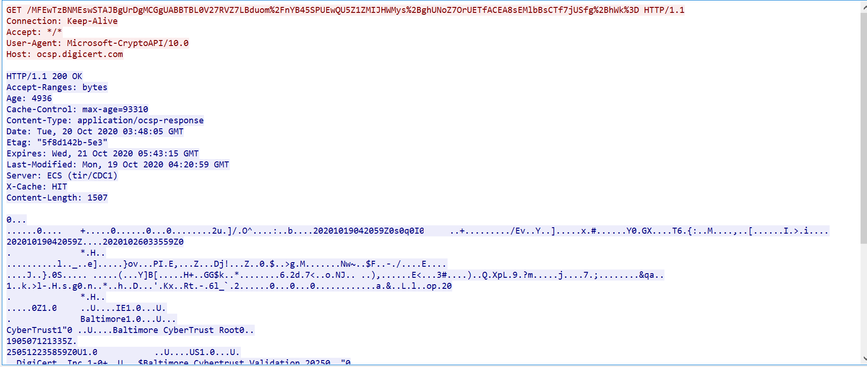

PRACTICAL-7

AIM: Understand basic configuration (Password/Switch name/time) of Switch using Packet Tracer CLI & Actual Device. Create Star topology

