**PRACTICAL-8**

**Create topology having 2 switch, 1 Router and 5 Host where router port is configured though Cisco Packet Tracer’s Wizard.**

**AIM:**

Static routing configuration using Cisco Packet Tracer

**PRACTICAL/STEPS:**

* Take 5 Host and configure their respective IP address.
* Then take two switches.
* To one switch connect 3 hosts and to other connect the remaining with the wires.
* Configure the Switch name and wait for 10-15 seconds so that switch and hosts establish connections.
* Then run ping tests to check if the switch and hosts are properly working.
* Then take one router.
* Connect the router with the two switches with the wires.
* Then do the necessary IP configuration in the router so it acts as a gateway for the switches.
* Then set the default gateway in all the hosts and check if the topology is working or not.

**OUTPUT:**

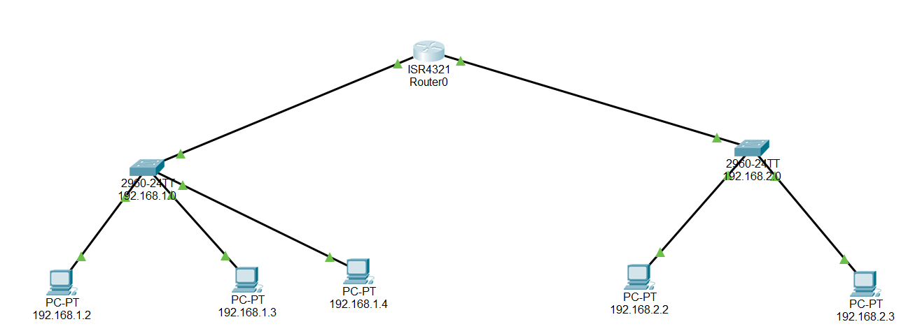

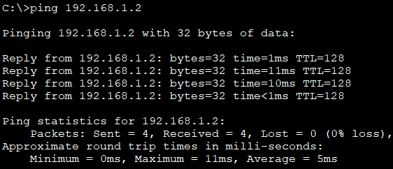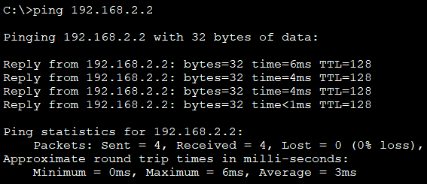

PING test for switch-1(192.168.1.0) PING test for switch-2(192.168.2.0)

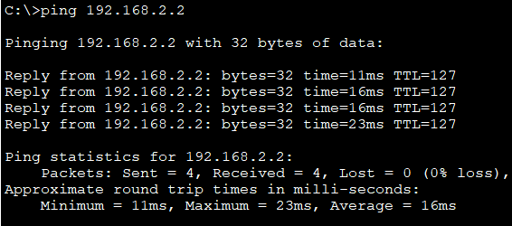

PING test to check if router works as a gateway

**CONCLUSION:**

Thus, above shown is the procedure to connect devices to switch and to the routers using CISCO packet tracer.