PRACTICAL-9

AIM: Configuration of Wireless Router using CLI and create traffic in Three LAN Architecture using Cisco Packet Tracer.

PRACTICAL/THEORY:

* Firstly, take two PCs and two router and then, connect them.
* Switch-off both the routers and add WIC-1T card to both and again switch on the routers
* Then configure both the routers using CLI so that they can get connected wirelessly
* 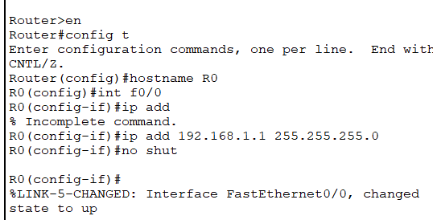 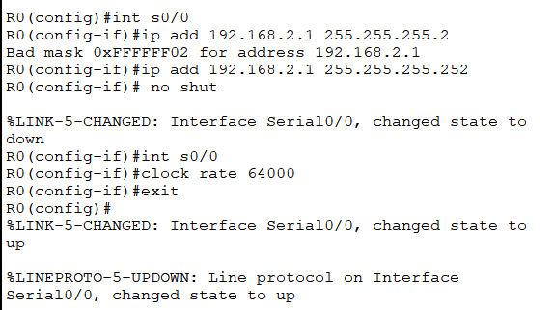
* Then assign IP address and Default gateway to both PCs
* Run ping test

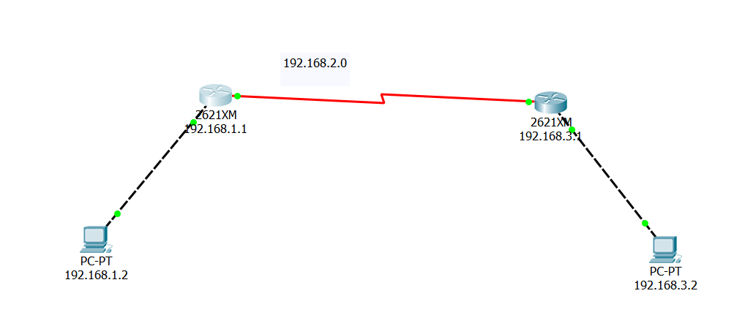

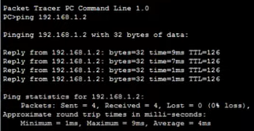

CONCLUSION:

By performing the above practical, we got to know how we can configure wireless connection between two networks