**PRACTICAL-1**

**import** java.util.*;

**public** **class** ArrayEqual

{

**boolean** checkArray(**int**[] a1,**int**[] a2)

{

**return** Arrays.*equals*(a1, a2);

}

**public** **static** **void** main(String arg[])

{

**int**[] array1=**new** **int**[5];

**int**[] array2=**new** **int**[5];

ArrayEqual ae=**new** ArrayEqual();

Scanner input=**new** Scanner(System.***in***);

System.***out***.println("Enter the array1: ");

**for**(**int** i=0;i<5;i++)

{

array1[i]=input.nextInt();

}

System.***out***.println("Enter the array2: ");

**for**(**int** i=0;i<5;i++)

{

array2[i]=input.nextInt();

}

**if**(ae.checkArray(array1,array2)==**true**)

System.***out***.println("Both the arrays are identical");

**else**

System.***out***.println("Both the arrays are not identical");

}

}

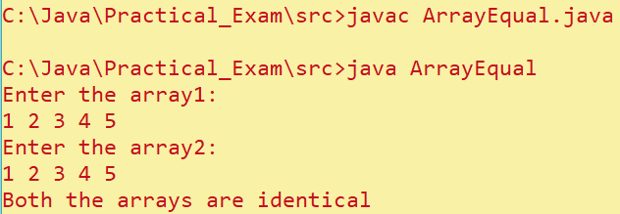

**PRACTICAL-2**

**import** java.util.*;

**class** Vehicle{

String manufacturer;

String purchaseDate;

**float** kilometers;

**int** price;

Vehicle()

{

manufacturer = **new** String();

purchaseDate = **new** String();

kilometers = 0;

price = 0;

}

**void** scan()

{

Scanner input = **new** Scanner(System.***in***);

System.***out***.print("Enter manufacturer: ");

manufacturer = input.nextLine();

System.***out***.print("Enter purchase date: ");

purchaseDate = input.nextLine();

System.***out***.print("Enter kilometers: ");

kilometers = input.nextFloat();

kilometers = input.nextFloat();

System.***out***.print("Enter price: ");

price = input.nextInt();

}

**void** print()

{

System.***out***.println("Manufacturer is "+manufacturer+"\nPurchase date is "+purchaseDate+"\nKilometers travelled are: "+kilometers+"\nPrice of the vehicle is "+price);

System.***out***.println("");

}

}

**public** **class** prac2 {

**public** **static** **void** main(String[] args) {

Scanner input = **new** Scanner(System.***in***);

System.***out***.print("Enter number of vehicles to be added: ");

**int** n = input.nextInt();

Vehicle[] vehicles = **new** Vehicle[n];

**for**(**int** i=0;i<n;i++)

{

vehicles[i] = **new** Vehicle();

vehicles[i].scan();

}

**for**(Vehicle vehicle : vehicles)

{

vehicle.print();

}

}

}

