**QUESTION-1**

import java.util.Scanner;

public class Clock {

Scanner input=new Scanner(System.*in*);

int hours,min,sec;

void inputData()

{

System.*out*.print("Enter the hours,minutes,seconds : ");

hours=input.nextInt();

min=input.nextInt();

sec=input.nextInt();

}

int validate()

{

if(hours>=0 && hours<=24)

{

if(min>=0 && min<=60)

{

if(sec>=0 && sec<=60)

return 1;

else

return 0;

}

else

return 0;

}

else

return 0;

}

void setTime()

{

if(hours>12)

{hours=24-hours;

System.*out*.println("Time : "+hours+":"+min+":"+sec+" PM");

}

else

System.*out*.println("Time : "+hours+":"+min+":"+sec+" AM");

}

public static void main(String[] args)

{

Clock c=new Clock();

c.inputData();

if(c.validate()==1)

{

System.*out*.println("Time is valid");

c.setTime();

}

else

System.*out*.println("Time is invalid");

System.*out*.println("Parth Patel\n19DCS098");

}

}

**OUTPUT:**

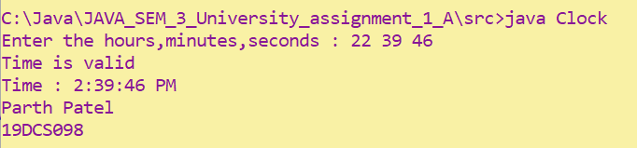

**QUESTION-2**

**public** **class** Fibonacci

{

**public** **static** **void** main(String[] args)

{

**int** sum=0,a=0,b=1;

System.***out***.print("Fibonacci series of "+args[0]+" is : "+a+" "+b);

**for**(**int** i=0;i<=Integer.*parseInt*(args[0]);i++)

{

sum=a+b;

a=b;

b=sum;

System.***out***.print(" "+sum);

}

System.***out***.println("\nParth Patel\n19DCS098");

}

}

**OUTPUT:**

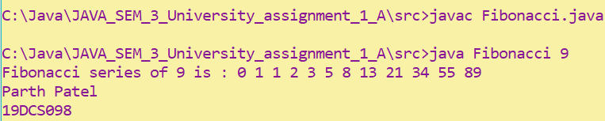

**QUESTION-3**

**public** **class** Ball

{

**float** x,y,xDelta,yDelta;

**int** radius;

Ball(**float** x,**float** y,**int** speed,**int** direction)

{

setX(x);

setY(y);

setxDelta(xDelta);

}

**float** getX() {

**return** x;

}

**void** setX(**float** x) {

**this**.x = x;

}

**float** getY() {

**return** y;

}

**void** setY(**float** y) {

**this**.y = y;

}

**float** getxDelta() {

**return** xDelta;

}

**void** setxDelta(**float** xDelta) {

**this**.xDelta = xDelta;

}

**float** getyDelta() {

**return** yDelta;

}

**void** setyDelta(**float** yDelta) {

**this**.yDelta = yDelta;

}

**int** getRadius() {

**return** radius;

}

**void** setRadius(**int** radius) {

**this**.radius = radius;

}

**void** move()

{

x+=xDelta;

y+=yDelta;

}

**void** reflectHorizontal()

{

xDelta=-xDelta;

}

**void** reflectertical()

{

yDelta=-yDelta;

}

**public** String toString()

{

**return** "Ball[( "+x+","+y+" ),speed=( "+xDelta+","+yDelta+" )]";

}

}

**class** Test

{

**public** **static** **void** main(String[] args)

{

Ball b=**new** Ball(10.1f,20.2f,2,10);

b.setRadius(15);

b.setxDelta(0.1f);

b.setyDelta(0.2f);

System.***out***.println("INFO:\n---------------------------------------");

System.***out***.println("x= "+b.getX());

System.***out***.println("y= "+b.getY());

System.***out***.println("delta x= "+b.getxDelta());

System.***out***.println("delta y= "+b.getyDelta());

b.move();

System.***out***.println(b.toString());

b.reflectHorizontal();

b.reflectertical();

b.move();

b.move();

System.***out***.println(b.toString());

System.***out***.println("Parth Patel\n19DCS098");

}

}

**OUTPUT:**

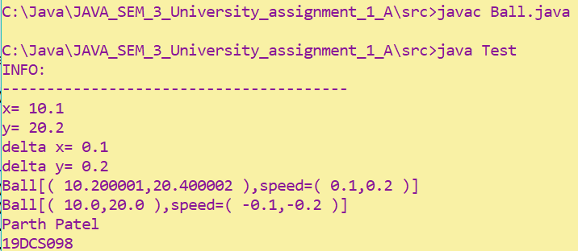

**QUESTION-4**

**class** Arithmetic

{

**public** **static** **void** main(String[] args)

{

**int** x=Integer.*parseInt*(args[0]);

**int** y=Integer.*parseInt*(args[1]);

String c=args[2];

**int** result=0;

**switch**(c)

{

**case** "+":

result=x+y;

**break**;

**case** "-":

result=x-y;

**break**;

**case** "*":

result=x*y;

**break**;

**case** "/":

result=x/y;

**break**;

}

System.***out***.println("Result of "+x+" "+c+" "+y+" = "+result);

System.***out***.println("PARTH PATEL\n19DCS098");

}

}

**OUTPUT:**

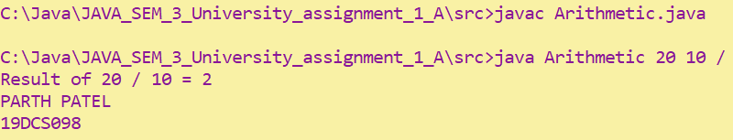

**QUESTION-5**

**class** Circle

{

**double** radius=1.0;

String color="red";

Circle()

{System.***out***.println("This is circle");}

Circle(**double** radius)

{

**this**.radius=radius;

}

Circle(**double** radius,String color)

{

**this**.radius=radius;

**this**.color=color;

}

**double** getRadius() {

**return** radius;

}

**void** setRadius(**double** radius) {

**this**.radius = radius;

}

String getColor() {

**return** color;

}

**void** setColor(String color) {

**this**.color = color;

}

**double** getArea()

{

**return** 2*3.14*radius*radius;

}

**public** String toString()

{

**return** "Circle[radius= "+radius+", color= "+color+"]";

}

}

**class** Cylinder **extends** Circle

{

**double** height=1.0;

Cylinder()

{

System.***out***.println("This is cylinder");

}

Cylinder(**double** radius)

{

**this**.radius=radius;

}

Cylinder(**double** radius,**double** height)

{

**this**.radius=radius;

**this**.height=height;

}

Cylinder(**double** radius,**double** height,String color)

{

**this**.radius=radius;

**this**.height=height;

**this**.color=color;

}

**double** getHeight() {

**return** height;

}

**void** setHeight(**double** height) {

**this**.height = height;

}

**double** getVolume()

{

**return** 3.14*radius*radius*height;

}

}

**class** testCircleCylinder

{

**public** **static** **void** main(String[] args)

{

System.***out***.println("Circle-1 :\n");

Circle c1=**new** Circle();

System.***out***.println(c1.toString());

System.***out***.println("Circle-2 :\n");

Circle c2=**new** Circle(10.0);

System.***out***.println(c2.toString());

System.***out***.println("Circle-3 :\n");

Circle c3=**new** Circle(12.0,"Blue");

System.***out***.println(c3.toString());

System.***out***.println("--------------------------------------------------------------------------");

System.***out***.println("For Cylinder-1 :\n");

Cylinder cy1=**new** Cylinder();

System.***out***.println("Volume : "+cy1.getVolume());

System.***out***.println("For Cylinder-2 :\n");

Cylinder cy2=**new** Cylinder(10.0);

System.***out***.println("Volume : "+cy2.getVolume());

System.***out***.println("For Cylinder-3 :\n");

Cylinder cy3=**new** Cylinder(11.0,12.0);

System.***out***.println("Volume : "+cy3.getVolume());

System.***out***.println("For Cylinder-4 :\n");

Cylinder cy4=**new** Cylinder(10.0,13.0,"Yellow");

System.***out***.println("Volume : "+cy4.getVolume());

System.***out***.println("\nPARTH PATEL\n19DCS098");

}

}

**OUTPUT:**

