**PRACTICAL-1**

**Program Code:**

import java.util.*;

class Vowels_practice

{

public static void main(String[] args)

{

String str="1111111212ABCDEIOUFGFDGEabcdeiuoeioe1212121";

int count=0;

for(int i=0;i<str.length();i++)

{

char c=str.charAt(i);

if(c=='A'||c=='E'||c=='I'||c=='O'||c=='U'||c=='a'||c=='e'||c=='i'||c=='o'||c=='u')

count++;

else

continue;

}

System.out.println("Number of vowels : "+count);

}

}

**Output:**

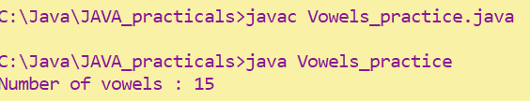

**PRACTICAL-2**

**Program Code:**

import java.util.*;

class Find_practice

{

public static void main(String[] args)

{

int count_char=0,count_digit=0,count_symbol=0;

String str="Depstar @2020";

for(int i=0;i<str.length();i++)

{

char c=str.charAt(i);

if (c>='A' && c<='z')

count_char++;

else if(c>='0' && c<='9')

count_digit++;

else if(c!=' ')

count_symbol++;

else

continue;

}

System.out.println("Total Characters : "+count_char);

System.out.println("Total Digit : "+count_digit);

System.out.println("Total Symbols :"+count_symbol);

}

}

**Output:**

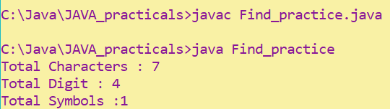

**PRACTICAL-3**

**Program Code:**

import java.util.*;

class Check_Password

{

public static void main(String[] args)

{

int count_upper=0,count_digit=0,count_symbol=0,count_lower=0;

Scanner input=new Scanner(System.in);

System.out.print("Enter your password : ");

String str=input.nextLine();

if(str.length()<8)

System.out.println("Your password is invalid, Please select a strong password");

else{

for(int i=0;i<str.length();i++)

{

char c=str.charAt(i);

if (c>='A' && c<='Z')

count_upper++;

else if(c>='a'&&c<='z')

count_lower++;

else if(c>='0' && c<='9')

count_digit++;

else if(c!=' ')

count_symbol++;

else

continue;

}

if(count_upper>=1 && count_digit>=1 && count_symbol>=1&&count_lower>=0)

System.out.println("Your password satisfied all the conditions\nPassword accepted");

else

System.out.println("Your password is invalid, Please select a strong password");

}

}

}

**Output:**

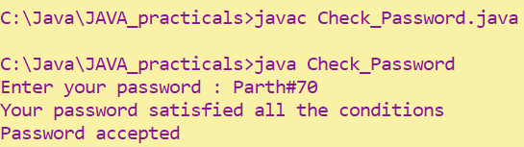

**PRACTICAL-4**

**Program Code:**

import java.util.*;

class String_anagram

{

public static void main(String[] args)

{

Scanner input=new Scanner(System.in);

System.out.print("Enter the string 1 : ");

String str1=input.nextLine();

System.out.print("Enter the string 2 : " );

String str2=input.nextLine();

char str1_array[]=str1.toCharArray();

Arrays.sort(str1_array);

char str2_array[]=str2.toCharArray();

Arrays.sort(str2_array);

if(Arrays.equals(str1_array,str2_array))

System.out.println(str1+" and "+str2+" are anagrams");

else

System.out.println(str1+" and "+str2+" are not anagrams");

}

}

**Output:**

