**Name: Parth N Patel**

**ID: 19DCS098**

**PRACTICAL 1:**

import java.util.*;

class SwapString

{

public static void main(String[] args)

{

String str1=new String();

String str2=new String();

Scanner input=new Scanner(System.in);

System.out.print("Enter the String 1 : ");

str1=input.next();

System.out.print("Enter the String 2 : ");

str2=input.next();

System.out.println("Before Swapping\n---------------------------------------------");

System.out.println (str1+"\t"+str2);

str1=str1+str2;

str2=str1.substring(0,str1.length()-str2.length());

str1=str1.substring(str2.length());

System.out.println("------------------------------------------\nAfter Swapping”);

System.out.println(str1+"\t"+str2);

}

}

**Output:**

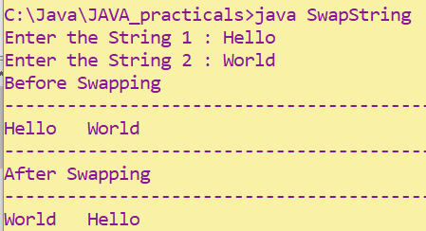

**Practical-2:**

import java.util.*;

class Alphabet

{

public static void main(String[] args)

{

String x;

Scanner input=new Scanner(System.in);

System.out.print("Enter the Character : ");

x=input.next();

int y=x.charAt(0);

if(x.charAt(0)>='A' && x.charAt(0)<'Z')

y++;

else if(x.charAt(0)>='a' && x.charAt(0)<'z')

y++;

else if(x.charAt(0)=='Z')

System.out.println("Next Alphabet is : Z");

else if(x.charAt(0)=='z')

System.out.println("Next Alphabet is : Z");

else

System.out.println("it is not an alphabet");

System.out.println("Next Alphabet is : "+(char)y);

}

}

**Output:**

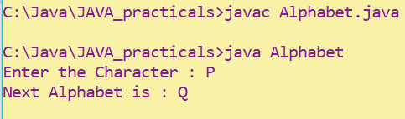

**Practical-3:**

import java.util.*;

class CountVowel

{

public static void main(String[] args)

{

int a_count=0,e_count=0,i_count=0,o_count=0,u_count=0;

Scanner input=new Scanner(System.in);

String str=new String();

System.out.print("Enter the String : ");

str=input.next();

for(int i=0;i<str.length();i++)

{

if(str.charAt(i)=='A')

a_count++;

else if(str.charAt(i)=='E')

e_count++;

else if(str.charAt(i)=='I')

i_count++;

else if(str.charAt(i)=='O')

o_count++;

else if(str.charAt(i)=='U')

u_count++;

else

continue;

}

System.out.println("Frequency of vowels:");

System.out.println("a : "+a_count);

System.out.println("e : "+e_count);

System.out.println("i : "+i_count);

System.out.println("o : "+o_count);

System.out.println("u : "+u_count);

}

}

**Output:**

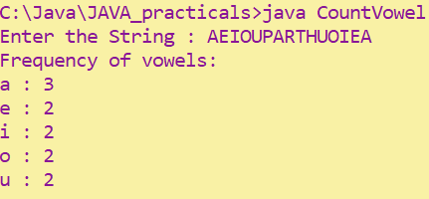

**Practical-4:**

import java.util.*;

class Asterisk

{

public static void main(String[] args)

{

String str=new String();

Scanner input=new Scanner(System.in);

System.out.print("Enter the String : ");

str=input.next();

for(int i=0;i<str.length();i++)

{

if(str.charAt(i)=='A' ||str.charAt(i)=='E'||str.charAt(i)=='I'||str.charAt(i)=='O'||str.charAt(i)=='U'||str.charAt(i)=='a'||str.charAt(i)=='e'||str.charAt(i)=='i'||str.charAt(i)=='o'||str.charAt(i)=='u')

str=str.substring(0,i)+'*'+str.substring(i+1);

}

System.out.println(str);

}

}

**Output:**

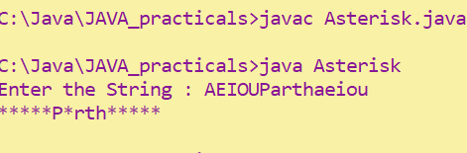

**Practical-5:**

class Calculator

{

private int num,f,rev;

Calculator(int n)

{

num=n;

f=0;

rev=0;

}

int prime()

{

int count=0;

f=num;

for(int i=2;i<f/2;i++)

{

if(f%i==0)

{count++;

break;

}

}

if(count==0)

return 1;

else

return 0;

}

int reverse()

{

int f=num;

while(f>0)

{rev=(rev*10)+f%10;

f=f/10;}

return rev;

}

void display()

{

if(prime()==1)

{

if(num == rev)

System.out.println("The number "+num+" is prime palindrome");

else

System.out.println("The number "+num+" is not prime palindrome");

}

else

System.out.println("The number "+num+" is not prime palindrome");

}

}

class CalculatorExecution

{

public static void main(String[] args)

{

Calculator cal=new Calculator(23);

System.out.println(cal.reverse());

cal.display();

}

}

**Output:**

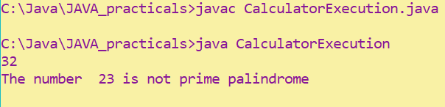

**Practical-6:**

import java.util.*;

class StringNOVowel

{

public static void main(String[] args)

{

String str=new String();

Scanner input=new Scanner(System.in);

System.out.print("Enter the String : ");

str=input.next();

for(int i=0;i<str.length();i++)

{

if(str.charAt(i)=='A' ||str.charAt(i)=='E'||str.charAt(i)=='I'||str.charAt(i)=='O'||str.charAt(i)=='U'||str.charAt(i)=='a'||str.charAt(i)=='e'||str.charAt(i)=='i'||str.charAt(i)=='o'||str.charAt(i)=='u')

str=str.substring(0,i)+str.substring(i+1);

}

System.out.println(str);

}

}

**Output:**

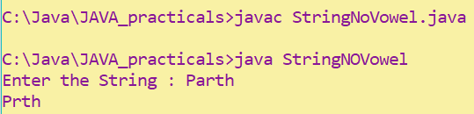

**Practical-7:**

class hcflcm

{

private int a;

private int b;

hcflcm(int x,int y)

{

a=x;

b=y;

}

void calculate()

{

int hcf=1;

for(int i=2;i<=a && i<=b;i++)

{

if (a%i==0 && b%i==0)

{

hcf=i;

}

}

int lcm=(a*b)/hcf;

System.out.println("HCF of "+a+" and "+b+" is : "+hcf);

System.out.println("LCM of "+a+" and "+b+" is : "+lcm);

}

}

class HL

{

public static void main(String[] args)

{

hcflcm obj=new hcflcm(2,200);

obj.calculate();

}

}

**Output:**

