**PRACTICAL-1**

**Write a program that declares one integer variable called var1. Give value 10 to this variable and then, using one println() statement, display the value on the screen like this:**

**“10 is the value of var1.”**

**PROGRAM CODE:**

class SP_1

{

public static void main(String[] args)

{

int var1=10;

System.out.println(var1+" is the value of var1");

System.out.println("PARTH PATEL");

System.out.println("19DCS098");

}

}

**OUTPUT:**

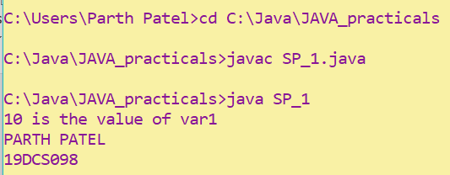

**PRACTICAL-2**

**Write a console program to declare and initialize a double variable with some value such as 1234.5678. Then retrieve the integral part of the value and store it in a variable of type long, and the first four digits of the fractional part and store them in an integer of type short.**

**Display the value of the double variable by outputting the two values stored as integers**

**PROGRAM CODE:**

class SP_2

{

public static void main(String[] args)

{

double x=1234.5678;

long x1;

short x2;

x1=(long)x;

x=x%1234;

x*=10000;

x2=(short)x;

System.out.println(x2+"."+x1);

System.out.println("PARTH PATEL");

System.out.println("19DCS098");

}

}

**OUTPUT:**

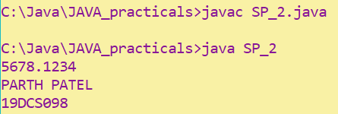

**PRACTICAL-3**

**Write an application that creates a two-dimension array with int values. The first, second and third elements should be arrays with one, two and three numbers respectively. Display the length of each dimension.**

**PROGRAM CODE:**

class SP_3

{

public static void main(String[] args)

{

int x[][]={{1},{1,2},{1,2,3}};

System.out.println(x.length+" is the length of row");

System.out.println(x[0].length+" is the length of column 1");

System.out.println(x[1].length+" is the length of column 2");

System.out.println(x[2].length+" is the length of column 3");

System.out.println("PARTH PATEL");

System.out.println("19DCS098");

}

}

**OUTPUT:**

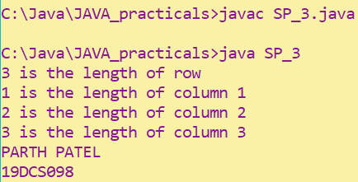

**PRACTICAL-4**

**An electric appliance shop assigns code 1 to motor,2 to fan,3 to tube and 4 for wires. All other items have code 5 or more. While selling the goods, a sales tax of 8% to motor,12% to fan,5% to tube light,7.5% to wires and 3% for all other items is charged. A list containing the product code and price in two different arrays. Write a java program using switch statement to prepare the bill.**

**PROGRAM CODE:**

import java.util.*;

class SP_4

{

public static void main(String args[])

{

int code[]={1,2,3,4,5};

int price[]={200,100,50,50,500};

double bill=0;

Scanner input= new Scanner(System.in);

System.out.print("Enter the code : ");

int code2=input.nextInt();

switch(code2)

{

case 1:

bill+=price[0]+(price[0]*8)/100;

System.out.println("Product Code : "+code[0]);

System.out.println("Price : "+price[0]);

System.out.println("TOTAL : "+bill);

break;

case 2:

bill+=price[1]+(price[1]*12)/100;

System.out.println("Product Code : "+code[1]);

System.out.println("Price : "+price[1]);

System.out.println("TOTAL : "+bill);

break;

case 3:

bill+=price[2]+(price[2]*5)/100;

System.out.println("Product Code : "+code[2]);

System.out.println("Price : "+price[2]);

System.out.println("TOTAL : "+bill);

break;

case 4:

bill+=price[3]+(price[3]*7.5)/100;

System.out.println("Product Code : "+code[3]);

System.out.println("Price : "+price[3]);

System.out.println("TOTAL : "+bill);

break;

case 5:

bill+=price[4]+(price[4]*3)/100;

System.out.println("Product Code : "+code[4]);

System.out.println("Price : "+price[4]);

System.out.println("TOTAL : "+bill);

break;

}

input.close();

System.out.println();

System.out.println("PARTH PATEL");

System.out.println("19DCS098");

}

}

**OUTPUT:**

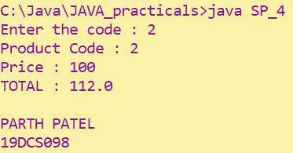

**PRACTICAL-5**

**Write a program to show output like:**

**\* * * * \***

**\* * * \***

**\* * \***

**\* \***

**\***

**PROGRAM CODE:**

class SP_5

{

public static void main(String[] args)

{

for(int i=5;i>=1;i--)

{

for(int j=1;j<=i;j++)

System.out.print("*");

System.out.println();

}

System.out.println("PARTH PATEL");

System.out.println("19DCS098");

}

}

**OUTPUT:**

