**PRACTICAL-1**

**Write a java program for converting Pound into Rupees. (Accept Pounds from command line argument and using scanner class also and take 1 Pound = 100 Rupees.)**

**Program Code**:

import java.util.Scanner;

class SP_11

{

public static void main(String[] args)

{

double pound=0,rupee=0;

Scanner input=new Scanner(System.in);

System.out.print("Enter the Value in Pound : ");

pound=input.nextDouble();

rupee=pound*100;

System.out.println("The value of "+pound+" pound is "+rupee+" rupees");

}

}

**Output:**

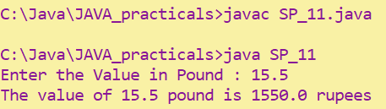

**PRACTICAL-2**

**Write a program that defines TriangleArea class with three constructor. The first form accept no arguments. The second accept one double value for radius. The third form accept any two arguments.**

**Program Code:**

class TriangleArea

{

double radius;

String str=new String();

public TriangleArea()

{

radius=0;

str=null;

System.out.println("Constructor has no argument");

}

public TriangleArea(double r)

{

radius=r;

System.out.println("Constructor has one argument");

}

public TriangleArea(String s,double r)

{

radius=r;

str=s;

System.out.println("Constructor has two arguments");

System.out.println("STR: "+str);

}

}

class SP_12

{

public static void main(String[] args)

{

TriangleArea obj=new TriangleArea();

TriangleArea obj1=new TriangleArea(10.22);

TriangleArea obj2=new TriangleArea("TRIANGLE",10.22);

}

}

**Output:**

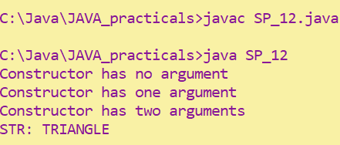

**PRACTICAL-3**

**Create a class called Employee that includes three pieces of information as instance variables—a first name (type String), a last name (type String) and a monthly salary( double). Your class should have a constructor that initializes the three instance variables. Provide a set and a get method for each instance variable. If the monthly salary is not positive, set it to 0.0. Write a test application named Employee Test that demonstrates class Employee’s capabilities. Create two Employee objects and display each object’s yearly salary. Then give each Employee a 10% raise and display each Employee’s yearly salary again.**

**Program Code:**

class Employee

{

private String firstName;

private String lastName;

private double monthlySalary;

Employee(String fname,String lname,double ms)

{

firstName=fname;

lastName=lname;

if(ms<0)

monthlySalary=0.0;

else

monthlySalary=ms;

}

void set_firstName(String fname)

{

firstName=fname;

}

void set_lastName(String lname)

{

lastName=lname;

}

void set_monthlySalary(double ms)

{

if(ms<0)

monthlySalary=0.0;

else

monthlySalary=ms;

}

String get_firstName()

{

return firstName;

}

String get_lastName()

{

return lastName;

}

double get_monthlySalary()

{

return monthlySalary;

}

double yearlySalary()

{

return 12*monthlySalary;

}

void raise(double raisePercent)

{

monthlySalary=(monthlySalary*raisePercent)/100+monthlySalary;

}

}

class SP_13

{

public static void main(String[] args)

{

Employee emp1=new Employee("Parth","Patel",550000);

Employee emp2=new Employee("Jason","Taylor",120000);

System.out.println("Monthly Salary of "+ emp1.get_firstName() +" is "+ emp1.yearlySalary());

System.out.println("Monthly Salary of "+ emp2.get_firstName() +" is "+ emp2.yearlySalary());

emp1.raise(10.0);

emp2.raise(10.0);

System.out.println("Monthly Salary of "+emp1.get_firstName()+" is "+emp1.yearlySalary());

System.out.println("Monthly Salary of "+emp2.get_firstName()+" is "+emp2.yearlySalary());

}

}

**Output:**

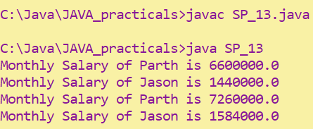

**PRACTICAL-4**

**Create a class called Date that includes three pieces of information as instance variables—a month (type int), a day (type int) and a year (type int). Your class should have a constructor that initializes the three instance variables and assumes that the values provided are correct. Provide a set and a get method for each instance variable. Provide a method displayDate that displays the month, day and year separated by forward slashes (/). Write a test application named DateTest that demonstrates class Date’s capabilities.**

class Date

{

private int day;

private int month;

private int year;

Date(int d,int m,int y)

{

day=d;

month=m;

year=y;

}

void set_day(int d)

{

day=d;

}

void set_month(int m)

{

month=m;

}

void set_year(int y)

{

year=y;

}

int get_day()

{

return day;

}

int get_month()

{

return month;

}

int get_year()

{

return year;

}

void displayDate()

{

System.out.println(month+"/"+day+"/"+year);

}

}

class SP_14

{

public static void main(String[] args)

{

Date d1=new Date(06,04,2001);

d1.displayDate();

}

}

**Output:**

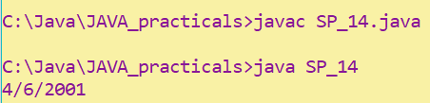

**PRACTICAL-5**

**Complete the code and write main () method to execute program.**

**Program Code:**

public class MethodOverloading

{

/*private void methodOverloaded()

{

System.out.println("Private method-1");

}*/

private int methodOverloaded(int i)

{

System.out.println("private int method\n"+"Entered value="+i);

return i;

}

protected int methodOverloaded(double d)

{

System.out.println("protected int method\n"+"Entered value= "+d);

return 1;

}

public void methodOverloaded(int i,double d)

{

System.out.println("Public int method\n"+"Entered value="+i+" "+d);

}

}

class SP_15

{

public static void main(String[] args)

{

MethodOverloading m1=new MethodOverloading();

//m1.methodOverloaded();

System.out.println(m1.methodOverloaded(10));

System.out.println(m1.methodOverloaded(20.99));

m1.methodOverloaded(15,21.2);

}

}

**Output:**

**Before Commenting :**

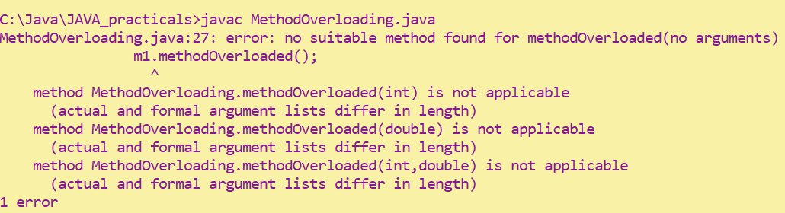

**After Commenting:**

