

**CERTIFICATE**

This is to certify that the report entitled “**Agriguide**” is a bonafied work carried out by **Parth Patel(19DCS098), Savan Pedhadiya (19DCS107), Saumya Shah (19DCS133) and Irfan Ukani (19DCS151)** under the guidance and supervision of **Prof. Rima Patel and Prof. Priyal Vaghela** for the subject CE244-**Software Group Project-I** CSE of 3rd Semester of Bachelor of Technology in **DEPSTAR** at Faculty of Technology & Engineering – CHARUSAT, Gujarat.

To the best of my knowledge and belief, this work embodies the work of candidate himself, has duly been completed, and fulfills the requirement of the ordinance relating to the B.Tech. Degree of the University and is up to the standard in respect of content, presentation and language for being referred to the examiner.

|  |  |
| --- | --- |
| Prof. Rima Patel  Prof. Priyal Vaghela  Branch Name: CSE  DEPSTAR, Changa, Gujarat. |  |
| Dr. Amit Ganatra  Principal, DEPSTAR  Dean, FTE  CHARUSAT, Changa, Gujarat. | |

**Devang Patel Institute of Advance Technology And Research At: Changa, Ta. Petlad, Dist. Anand, PIN: 388 421. Gujarat**

**A**

**Project Report**

**On**

**"AGRIGUIDE"**

**Prepared by**

Parth Patel (19DCS098)

Savan Pedhadiya (19DCS107)

Saumya Shah (19DCS133)

Irfan Ukani (19DCS151)

**Under the guidance of**

Prof. Rima Patel

Prof. Priyal Vaghela

A Report Submitted to

Charotar University of Science and Technology

for Partial Fulfillment of the Requirements for the

3rd Semester Software Group Project-I CE244

**Submitted at**



**CSE**

**DEPSTAR**

**At: Changa, Dist: Anand – 388421**

**November 2020**

**ACKNOWLEDGEMENT**

* We, the developers of “AGRIGUIDE”, with immense pleasure and commitment would like to present the project assignment. The development of this project has given me wide opportunity to think, implement and interact with various aspects of management skills as well as the new emerging technologies.
* We hereby avail this opportunity to express our gratitude to number of people who extended their valuable time, full support and cooperation in developing the project.
* We express deep sense of gratitude towards our Head of the CSE Department, Dr. Parth Goel and project guides Prof. Rima Patel and Prof. Priyal Vaghela for the support during the whole session of study and development. It is because of them, that we were prompted to do hard work, adopting new technologies.
* Thanks,

Parth Patel

Savan Pedhadiya

Saumya Shah

Irfan Ukani

**ABSTRACT**

Agriculture plays a critical role in the global economy. Pressure on the agricultural system will increase with the continuing expansion of the human population. Agri-technology and precision farming, now also termed digital agriculture, have arisen as new scientific fields that use data intense approaches to drive agricultural productivity while minimizing its environmental impact. The data generated in modern agricultural operations is provided by a variety of different sensors that enable a better understanding of the operational environment (an interaction of dynamic crop, soil, and weather conditions) and the operation itself (machinery data), leading to more accurate and faster decision making.

Machine learning (ML) has emerged to create new opportunities to unravel, quantify, and understand data intensive processes in agricultural operational environments.

Blending of Machine Learning (ML) and agriculture and farming sector can create a new corridor for economic growth for not only farmers and farm workers but for also Government.

**Table of Contents**

Certificate………………………………………………………………..1

Cover Page………………………………………………………………2

Acknowledgement……………………………………………………….3

Abstract…………………………………………………………………..4

Project Definition………………………………………………………..6

Description………………………………………………………………7

Tools and Technologies used……………………………………………8

System Requirements……………………………………………………9

Major Functionality……………………………………………………..10

Flow Chart………………………………………………………………11

Screen Shots…………………………………………………………….12

Limitations………………………………………………………………13

Outcomes………………………………………………………………..14

Future Enhancements…………………………………………………...15

References………………………………………………………………16

**LIST OF FIGURES**

Figure 1…………………………………………………………………11

Figure 2…………………………………………………………………12

Figure 3…………………………………………………………………12

Figure 4…………………………………………………………………12

Figure 5…………………………………………………………………12

Figure 6 ,7 ...……………………………………………………………12

**PROJECT DEFINITION**

AGRIGUIDE- One Stop Solution To All Your Farming Needs is an Application designed specifically for farmers.

* Our main Aim is to help farmers of India in increasing the production of crops.
* Agriguide will also help farmers to decrease their expense for crop production.
* Through Agriguide, the new Technologies will be introduced to the agriculture sector.
* Agriguide will connect Farmers of India and also will connect the Farmers globally with the world.
* Agriguide will provide farmers information about crops
* Agriguide will assist farmers in recognizing Crop Diseases.

**DESCRIPTION**

AGRIGUIDE as the name suggest is made up of two words:

1. AGRI- Related to Agriculture
2. Guide- Go along the route to show the way

* Agriguide as the name suggest is a multi-purpose app which will help the farmers in decision making and to get the latest information about the trends in the Global Agriculture Market
* Agriguide uses the concept of Machine Learning to predict the crop disease
* Agriguide also gives information about which crops can be grown in particular location
* Agriguide also gives latest information about new trends and policies of Farming and Agriculture Sector to the Farmers.
* So, in short saying Agriguide is a one stop solution to farming needs of farmers.

**TOOLS AND TECHNOLOGIES USED:**

* Android Studio
* Google Colab
* Jupyter Notebook
* Adobe xD
* Tensorflow
* Flat UI Colors
* FireBase
* Adobe Illustrator
* VS Code
* Android Studio is used for the purpose of app development.
* Google Colab and Jupyter Notebook is used for Data analysis and filtering the data and also for Machine Learning.
* Adobe xD and Flat UI colors are used for the purpose of designing
* VS Code used for debugging

**Software and Hardware Requirements:**

* As majority of farmers reside in rural areas and still there are network issues prevailing in the rural areas so we have tried to keep the System requirements as minimum as possible and also in a way that farmers can afford
* To access Agriguide one must have a smartphone

**Hardware Requirements:**

* 1 GB RAM
* Camera with 12.0 Megapixel Resolution

**Software Requirement:**

* Internet Connectivity (2G Minimum)
* Android version 4.0 or above

**Major Functionality**

* The main Functionalities of Agriguide are:
  + District Wise Crop Information
  + Disease Recognition
  + To convey news and blogs regarding agriculture
* The Farmer has to login to get access to the functionalities
* For Crop information, the user has to enter the District Name and then all the crops that can be grown in the district are displayed
* For Disease Recognition, the user has to input the image of plant or a part of plant that has been infected by the disease and then the result will be displayed
* Farmer can read the news regarding the agriculture sector
* Also, the user can read the blogs posted by other users
* The user can write their own blogs

**FLOW CHART**

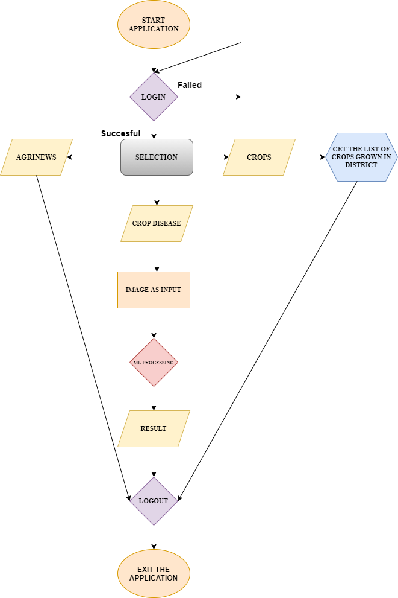

FIGURE 1

**Screen Shots**

  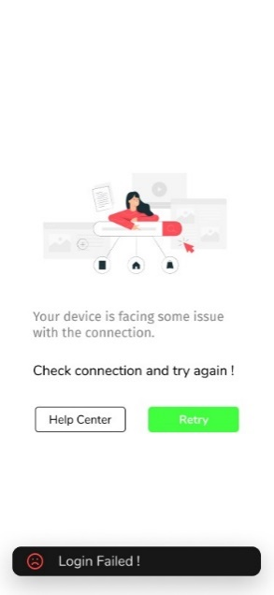

Intro page Sign-in Page Sign-in Failed

Figure 2 Figure 3 Figure 4

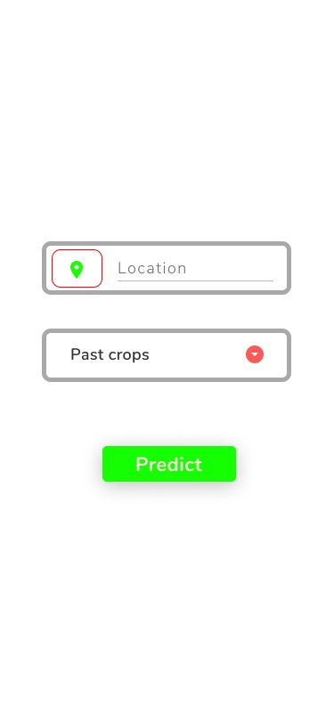 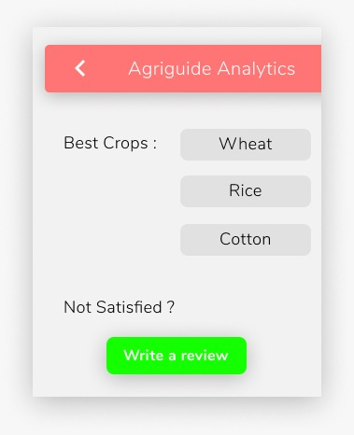 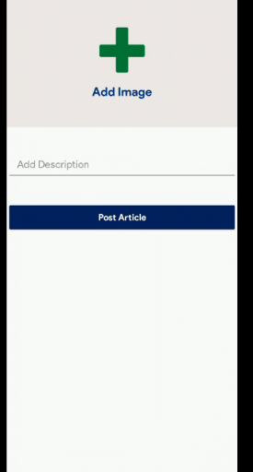

Crop details Section Result Section Blog Section

Figure 5 Figure 6 Figure 7

**Limitations of Project**

* The first and prime most limitation of the Agriguide is that it predicts disease using Machine Learning so, sometimes results might not be right or accurate
* For the time being, the District wise Crop information is only limited to the state of Gujarat
* Also, there is no such condition or filter check for the blog so anyone can kind any kind of data in blog that may hurt sentiments or ethic values of someone else.
* Another con of Agriguide is that it requires continuous internet connectivity which sometimes becomes difficult in remote rural areas.
* To access the application the user must have smartphone with internet connection that almost more than half of farmers don’t have
* Currently, the Application can only run on Android Operating System so users using other Operating Systems like Windows, Mac OS, Linux will not be able to use the application
* Application might get stop abruptly because of loss of connectivity

**Project Outcomes**

* By introducing this application, we want to introduce new technologies to farmers
* Agriguide will make the farmers of India to get all the information about the crops in single application so they don’t have to go to Farmer Information desk frequently
* Agriguide will connect the farmers of different parts of India with eachother and also it will connect the our farmers with the Global world
* Agriguide will provide the farmers a platform to express their views
* Agriguide will help the farmers in recognizing diseases to which their crops are infected

**Future Enhancements**

* These are the following new features that we are planning to add to Agriguide so that it can really become one step solution to every Farming needs
* District wise crop prediction using Machine Learning
* Introduction of Rain and weather prediction using Machine Learning
* Introduction of Solution Feature which will be an add on to disease prediction feature where along with the disease name all the remedies to cure the disease will be given to the user
* Introduction of Policy Feature, which will provide the user all the policies of Central Government and State Government for Agriculture
* The overall layout of the application will be made more user friendly.
* The application will be made more interactive
* Voice assistant will be added
* Chatbot will also be added

**References**

* [**https://www.tensorflow.org/resources/learn-ml**](https://www.tensorflow.org/resources/learn-ml)
* [**https://www.coursera.org/learn/introduction-tensorflow/home/welcome**](https://www.coursera.org/learn/introduction-tensorflow/home/welcome)
* [**https://www.instagram.com/p/CEs578jgXGy/?igshid=1g8lhr3f1766e**](https://www.instagram.com/p/CEs578jgXGy/?igshid=1g8lhr3f1766e)
* [**https://colab.research.google.com/**](https://colab.research.google.com/)
* [**https://stackoverflow.com/**](https://stackoverflow.com/)
* [**https://www.geeksforgeeks.org/introduction-machine-learning/**](https://www.geeksforgeeks.org/introduction-machine-learning/)
* [**https://developers.google.com/**](https://developers.google.com/)