**CHAROTAR UNIVERSITY OF SCIENCE AND TECHNOLOGY**

**DEVANG PATEL INSTITUTE OF ADVANCE TECHNOLOGY AND RESEARCH**

**DEPARTMENT OF COMPUTER SCIENCE AND ENGINEERING**

|  |  |  |  |  |  |
| --- | --- | --- | --- | --- | --- |
| **STUDENT ID** | **:** | 19DCS098 | **STUDENT NAME** | **:** | Parth N Patel |
| **SUBJECTCODE** | **:** | CE 246 | **SUBJECT NAME** | **:** | DBMS |
| **EXAM DATE** | **:** | 27 April 2021 |  |  |  |

**DEFINITION:**

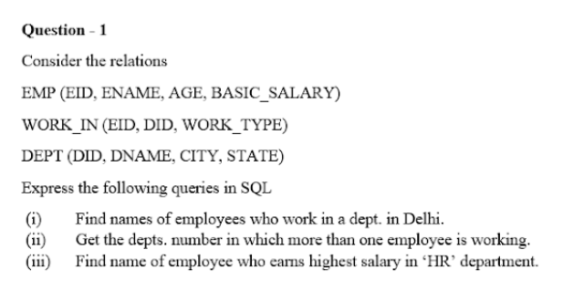

**SOLUTION :**

CREATE TABLE emp(eid VARCHAR2(4),ename VARCHAR2(10),age NUMBER(2),basic_salary NUMBER);

CREATE TABLE work_in(eid VARCHAR2(4),did VARCHAR2(4),work_type VARHCHAR2(10));

CREATE TABLE dept(did VARCHAR2(4),dname VARCHAR2(10),city VARCHAR2(20),state VARCHAR2(20));

/* FOR QUERY-1 */

SELECT emp.ename FROM emp

JOIN work_in ON emp.eid=work_in.eid

WHERE did= (SELECT did FROM dept WHERE city='delhi');

/* QUERY-2 */

SELECT did "department number"

FROM work_in GROUP BY did HAVING COUNT(eid) IN

(SELECT COUNT(eid) FROM work_in GROUP BY did)

/* FOR QUERY-3 */

SELECT ename FROM emp

WHERE basic_salary=(SELECT MAX(basic_salary) FROM emp

WHERE eid IN (SELECT eid FROM work_in WHERE did='d001'));

**SCREEN SHOTS:**

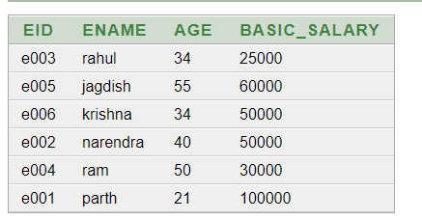

**Data of emp table**

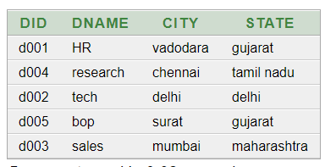

**Data of dept table**

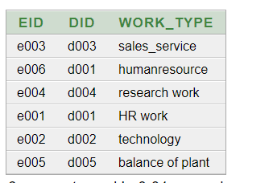

**Data of work_in table**

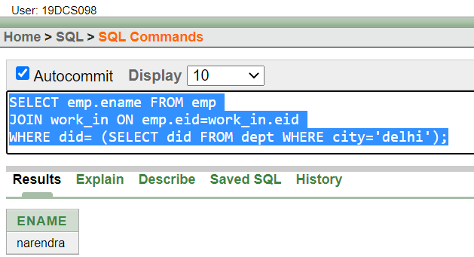

**OUTPUT OF QUERY 1**

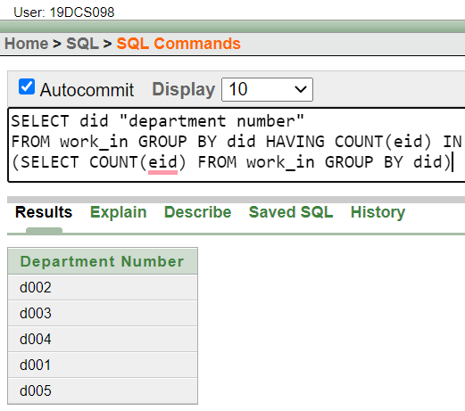

**FOR QUERY 2**

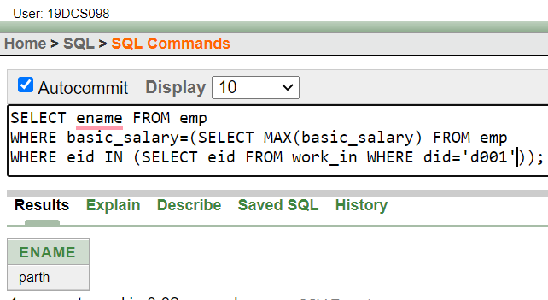

**OUTPUT OF QUERY 3**

**DEFINITION :**



**SOLUTION:**

DECLARE

str VARCHAR2(10) := 'parthpatel';

vowels NUMBER := 0;

tmp CHAR;

BEGIN

FOR i IN 1..LENGTH(str) LOOP

tmp:=Substr(str,i,1);

IF tmp IN ('A','E','I','O','U','a','e','i','o','u') THEN

vowels:=vowels+1;

END IF;

END LOOP;

DBMS_OUTPUT.PUT_LINE('STRING : '||str);

DBMS_OUTPUT.PUT_LINE(' TOTAL VOWELS IN STRING IS : '||vowels);

END

**OUTPUT SCREENSHOT:**

