|  |  |  |  |
| --- | --- | --- | --- |
| **STUDENT ID:** | 19DCS098 | **STUDENT NAME:** | Parth N Patel |
| **SUBJECT CODE:** | CE245 | **SUBJECT NAME:** | DSA |
| **DATE OF EXAM:** | April 26 2021 |  |  |

**DEFINITION:**

**Write a menu driven program to implement following operations using double ended queue.**

* **Insertion at Front**
* **Insertion at Rear**
* **Deletion from Rear**
* **Display**

**SOLUTION:**

#include<iostream>

using namespace std;

void line()

{

for(int i=0;i<50;i++)

cout<<"-";

cout<<endl;

}

class dequeue

{

private:

int size,front,rear;

int *arr;

public:

void initialize()

{

cout<<"Enter the size of double ended Queue : ";

cin>>size;

arr=new int[size];

front=rear=-1;

line();

cout<<"The double ended queue created"<<endl;

line();

}

void enqueueFront(int x)

{

if((front==0 && rear==size-1) || front==rear+1)

{

cout<<"Overflow happened!!!"<<endl;

line();

return;

}

else if(front==-1 && rear==-1)

{

front=0;

rear=0;

arr[front]=x;

}

else

{

front--;

arr[front]=x;

}

cout<<"Element "<<arr[front]<<" inserted in front "<<endl;

line();

}

void enqueueRear(int x)

{

if((front==0 && rear==size-1) || front==rear+1)

{

cout<<"Overflow happened!!!"<<endl;

line();

return;

}

else if(front==-1 && rear==-1)

{

front=0;

rear=0;

arr[rear]=x;

}

else if(rear==size-1)

{

rear=0;

arr[rear]=x;

}

else

{

rear++;

arr[rear]=x;

}

cout<<"Element "<<arr[rear]<<" inserted at rear"<<endl;

line();

}

void dequeueRear()

{

if(front==-1 && rear==-1)

{

cout<<"Underflow Happened!!"<<endl;

line();

return;

}

else if(front==rear)

{

cout<<"Element "<<arr[rear]<<" deleted from rear"<<endl;

front=-1;

rear=-1;

}

else if(rear==0)

{

cout<<"Element "<<arr[rear]<<" deleted from rear"<<endl;

rear=size-1;

}

else

{

cout<<"Element "<<arr[rear]<<" deleted from rear"<<endl;

rear--;

}

line();

}

void display()

{

int temp=front;

cout<<"Elements in the double ended queue : "<<endl;

while(temp!=rear)

{

cout<<arr[temp]<<" ";

temp=(temp+1)%size;

}

cout<<arr[rear]<<endl;

line();

}

};

int main()

{

int c,tmp;

dequeue dq;

dq.initialize();

do

{

cout<<"Select the appropriate option : "<<endl;

cout<<"1. Insertion at Front"<<endl;

cout<<"2. Insertion at Rear"<<endl;

cout<<"3. Deletion from Rear"<<endl;

cout<<"4. Display"<<endl;

line();

cout<<"Enter your choice : "<<endl;

cin>>c;

line();

if(c==1)

{

cout<<"Enter the value : ";

cin>>tmp;

line();

dq.enqueueFront(tmp);

}

else if(c==2)

{

cout<<"Enter the value : ";

cin>>tmp;

line();

dq.enqueueRear(tmp);

}

else if(c==3)

{

line();

dq.dequeueRear();

}

else if(c==4)

{

line();

dq.display();

}

} while(c!=0);

cout<<"PARTH PATEL\n19DCS098"<<endl;

return 0;

}

**INPUT and OUTPUT SCREENSHOTS:**

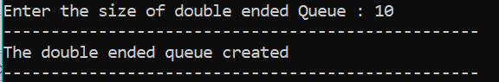

**DEQUEUE Created of Size 10**

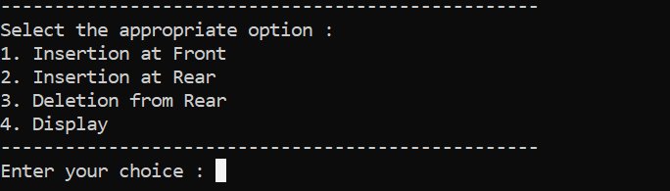

**Menu Driven Program Running**

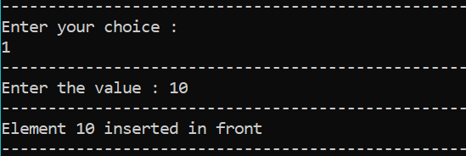

**Element added at front**

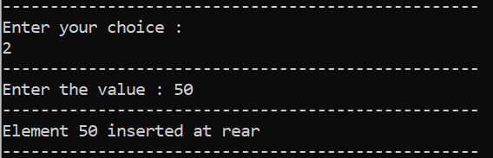

**Element Added at rear**

**After inserting various elements** **in the dequeue**

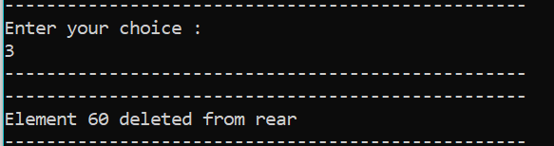

**Deletion from rear end**

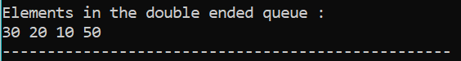

**Display Elements**

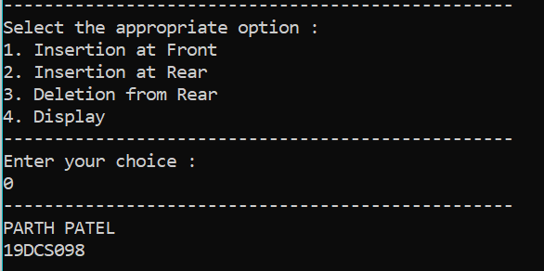

**Exiting from Menu**