**ASSIGNMENT-1**

**The chair is designed for the adults only.**

* Dimensions of the adults for whom the chair is designed:

|  |  |  |  |  |
| --- | --- | --- | --- | --- |
| Adult Number | Height(cm) | Hip (cm) | Knee to floor (cm) | Elbow to Palm (cm) |
| Adult-1 | 144 | 36 | 36 | 30 |
| Adult-2 | 152.4 | 42.5 | 45 | 35 |
| Adult-3 | 163 | 47 | 50 | 41 |
| Adult-4 | 166 | 51 | 55 | 43 |
| Adult-5 | 170 | 55 | 64.5 | 53 |

**Percentile values for height Percentile values for hip**

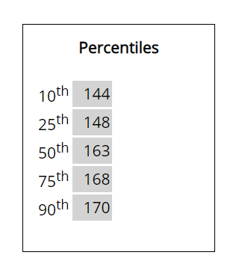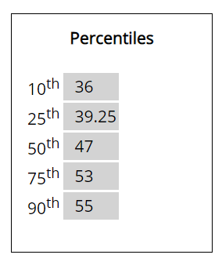

**Percentile Values for Knee to floor height. Percentile values for elbow to palm height.**

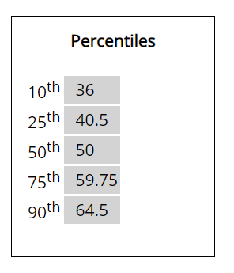 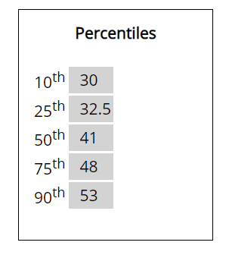

* Upon examining the percentiles of all the four dimensions, we can design a chair taking reference of 50th percentile from all the three dimensions and 75th percentile for one dimension.
* we can provide the basic adjustability so that each person can adjust the chair according to their comfort.
* We are taking the 50th percentile because most of the dimensions measured are almost or near to the 50th percentile value that we got.

According to that following will be the dimensions of the office chair:

|  |  |
| --- | --- |
| Seat Width | 53 cm |
| Seat Depth | 48 cm |
| Back Height | 53 cm |
| Seat Height (minimum) | 45 cm |
| Seat Height (maximum) | 60 cm |
| Chair Height (minimum) | 98 cm |
| Chair Height (maximum) | 113cm |
| Arm rest length | 41 cm |
| Wheels provided | Yes |

**Justification:**

* We took the measurement of height, chest, knee to floor, and elbow to palm as they are optimum for determining the dimensions of the chair.
* Most of the measurements are in close range of the 50th percentile value so will be using that for our designing.
* The seat width is taken as 38 cm as most of the adults will fit in comfortably, however few may have to make some adjustment to fit in comfortably.
* We have also provided the height adjustability so that each adult can adjust the position according to their own comfort.
* Wheels are also fitted at the end so that the chair is easy to move from one place to another and also wheel locks are provided for stability.