**ASSIGNMENT-2**

Working-Posture-1

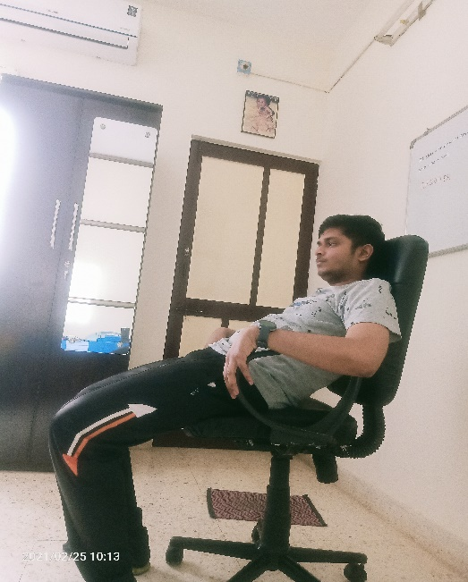

**Pros:**

* For short moment of time, one will be feeling quite comforting and relaxing.

**Cons:**

* the ergonomics of the chair are not properly utilised.
* It is very harmful for the back.
* It gives more strain on spinal cord.
* It also affects the neck.
* Prolong sitting in this posture may damage the knee caps.
* Current position of arms is incorrect.

**What to improve:**

* The person needs to sit in a way that his back rests on the backrest of the chair.
* He needs to adjust the height so that his legs lie on the floor flat.
* He needs to rest his hands properly on the arm rest.

Working-Posture-2

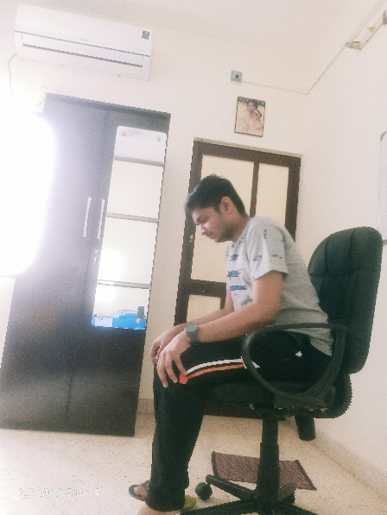

**Pros:**

* The seat-depth is properly utilised.
* The foot lies on the floor flat.

**Cons:**

* The sitting posture can damage the spinal cord as it is strained.
* The arms are also not rested on armrest instead the weight is given on thighs.
* The placement of the palm is also incorrect as it gives unnecessary weight to knees.

**What to improve:**

* The person needs to sit in a way that his back rests on the backrest of the chair.
* He needs to rest his hands properly on the arm rest.

Working-Posture-3

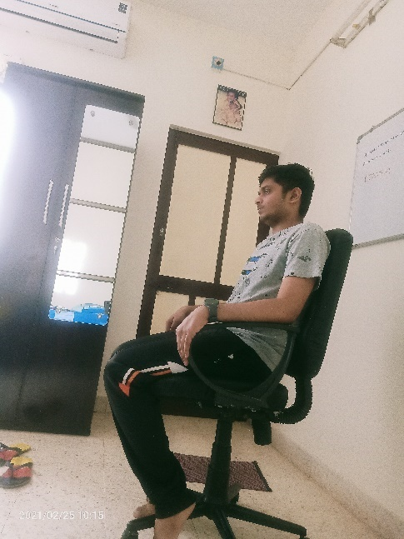

**Pros:**

* The back is properly rested on backrest.
* The arms are properly rested on armrest.
* The palms are almost placed properly.
* The seat depth is used properly.
* The hips are placed properly.

**Cons:**

* The backrest angle is slightly more.
* The feet are not lied flat on the ground.

**What to improve:**

* The backrest angle should be adjusted properly so that one can sit in upright position.
* The height of the chair should be adjusted so that the feet can lie flat on the ground making it perfect posture.