**CHAROTAR UNIVERSITY OF SCIENCE AND TECHNOLOGY**

**DEVANG PATEL INSTITUTE OF ADVANCE TECHNOLOGY AND RESEARCH**

**NAME: Parth N Patel**

**ID: 19DCS098**

**SUBJECT: MPCO**

**SEM:4**

**PRACTICAL-1**

**AIM:**

**a) Write an ALP to move block of data bytes from one location to another location.**

**b) Write an ALP to exchange block of data bytes.**

**PROGRAM CODE:**

1. **Moving Block of data**

org 100h

mov [5000h],1

mov [5001h],2

mov [5002h],3

mov [5003h],4

mov [5004h],5

mov [5005h],6

mov [5006h],7

mov [5007h],8

mov [5008h],9

mov [5009h],10

mov [500Ah],11

mov [500Bh],12

mov [500Ch],13

mov [500Dh],14

mov [500Eh],15

mov [500Fh],16

mov cl,16

mov si,5000h

mov di,7000h

l: mov al,[si]

mov [di],al

inc si

inc di

dec cl

jnz l

ret

**OUTPUT:**

**Data stored in the location 5000H-500FH**



**After Execution of Program:**



1. **Exchange Block of Data**

org 100h

mov [5000h],1

mov [5001h],2

mov [5002h],3

mov [5003h],4

mov [5004h],5

mov [5005h],6

mov [5006h],7

mov [5007h],8

mov [7000h],10H

mov [7001h],20H

mov [7002h],30H

mov [7003h],40H

mov [7004h],50H

mov [7005h],60H

mov [7006h],70H

mov [7007h],80H

mov cl,8H

mov si,5000H

mov di,7000H

l: mov al,[si]

mov bl,[di]

mov [si],bl

mov [di],al

inc si

inc di

dec cl

jnz l

ret

**OUTPUT:**

BEFORE:





AFTER:





**PRACTICAL-2**

**AIM:**

**a) Write an ALP to perform 16-bit and 32-bit addition and subtraction.**

**b) Write an ALP to perform 16-bit and 32-bit multiplication.**

**PROGRAM CODE:**

1. **16-bit and 32-bit Addition and Subtraction**

**16-bit Addition:**

org 100h

MOV AX , [5000H]

MOV BX , [5001H]

ADD AX, BX

MOV [5003H],AX

Ret

**OUTPUT:**

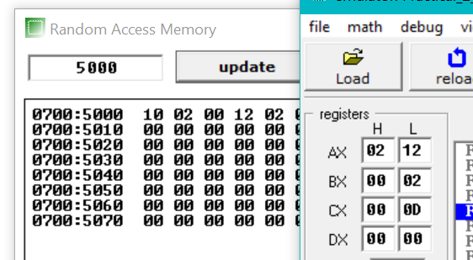

**32-Bit Addition:**

org 100h

MOV AX , [5000H]

MOV BX , [5001H]

MOV CX , [5010H]

MOV DX , [5011H]

ADD AX ,CX

ADD BX ,DX

MOV [5020H] , AX

MOV [5021H] , BX

Ret

**OUTPUT:**

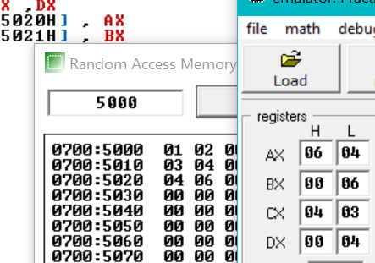

**16-Bit Subtraction:**

org 100h

MOV AX , [5000H]

MOV BX , [5001H]

SUB AX, BX

MOV [5003H],AX

ret

**OUTPUT:**

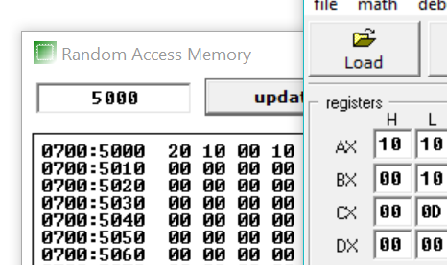

**32-Bit Subtraction:**

org 100h

MOV AX , [5000H]

MOV BX , [5001H]

MOV CX , [5010H]

MOV DX , [5011H]

SUB AX ,CX

SUB BX ,DX

MOV [5020H] , AX

MOV [5021H] , BX

ret

**OUTPUT:**

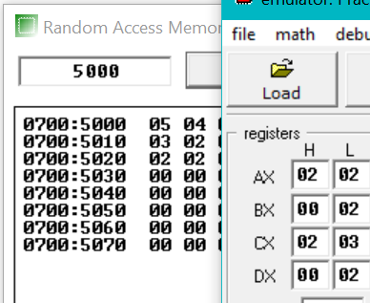

**16-Bit Multiplication:**

org 100h

MOV AX,[5000H]

MOV BX,[5001H]

MUL BX

MOV [5002H],AX

Ret

**OUTPUT:**

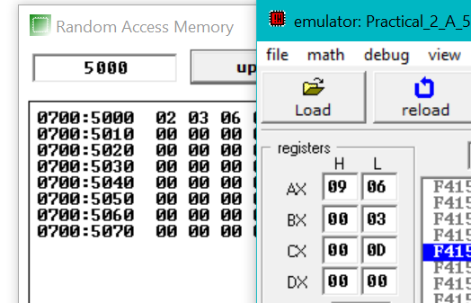

**32-Bit Multiplication:**

org 100h

MOV AX , [5000H]

MOV BX , [5001H]

MOV CX , [5010H]

MOV DX , [5011H]

MUL CX

MUL DX

MOV [5020H] , AX

MOV [5021H] , BX

ret

**OUTPUT:**

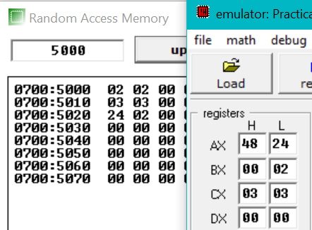

**PRACTICAL-3**

**AIM:**

**a) Write an ALP to perform sorting of array in ascending order.**

**b) Write an ALP to perform sorting of array in descending order.**

**PROGRAM CODE:**

1. **Sorting of array in ascending order**

org 100h

mov [500h],50H

mov [501h],40H

mov [502h],30H

mov [503h],20H

mov [504h],10H

mov dl,5

mov si,500h

mov di,500h

l2: mov al,[si]

mov cl,dl

l1: inc si

mov bl,[si]

cmp al,bl

jz next

jc next

xchg al,bl

mov [si],bl

next: loop l1

mov [di],al

inc di

mov si,di

dec dl

jnz l2

ret

**OUTPUT:**

**BEFORE:**



**AFTER:**



**b) Write an ALP to perform sorting of array in descending order.**

org 100h

mov [500h],10H

mov [501h],20H

mov [502h],30H

mov [503h],40H

mov [504h],50H

mov dl,5

mov si,500h

mov di,500h

l2: mov al,[si]

mov cl,dl

l1: inc si

mov bl,[si]

cmp al,bl

jz next

jnc next

xchg al,bl

mov [si],bl

next: loop l1

mov [di],al

inc di

mov si,di

dec dl

jnz l2

ret

**OUTPUT:**

**BEFORE:**



**AFTER:**



**PRACTICAL-4**

**AIM:**

**a) Write an ALP to perform factorial of a number**

**b) Write an ALP to check whether the given 16-bit number is palindrome or not**

**PROGRAM CODE:**

**a) Write an ALP to perform factorial of a number**

org 100h

mov [500h],5

mov ax,[500h]

mov bx,ax

dec bx

l1: mul bx

dec bx

jnz l1

mov [500h],ax

ret

**OUTPUT:**

**BEFORE:**



**AFTER:**



**78 is hexadecimal value of 120.**

**b) Write an ALP to check whether the given 16-bit number is palindrome or not**

org 100h

MOV SI,2000H

MOV DI,2004H

MOV CL,05H

next_char:

MOV AL,[DI]

MOV BL,[SI]

CMP AL,BL

JNE not_palindrome

INC SI

DEC DI

loop next_char

is_palindrome:

MOV AH,09H

MOV DX,OFFSET msg1

INT 21H

jmp stop

not_palindrome:

MOV AH,09H

MOV DX,OFFSET msg2

INT 21H

stop:

MOV AH,00H

INT 16H

ret

msg1 db "Palindrome!$"

msg2 db "Not Palindrome!$"

**OUTPUT:**



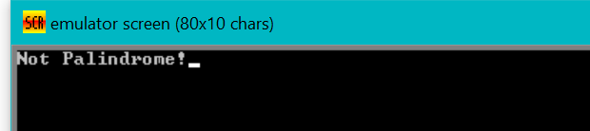

**Extra Practical :**

**AIM:**

**Write an ALP to perform Fibonacci series**

**PROGRAM CODE:**

org 100h

MOV AL, 00H

MOV SI, 2001H

MOV [SI], AL

ADD AL, 01H

MOV [SI], AL

MOV CX, [2010H]

SUB CX, 0002H

L1: MOV AL, [SI-1]

ADD AL, [SI]

ADD SI, 01H

MOV [SI], AL

LOOP L1

HLT

Ret

**OUTPUT:**

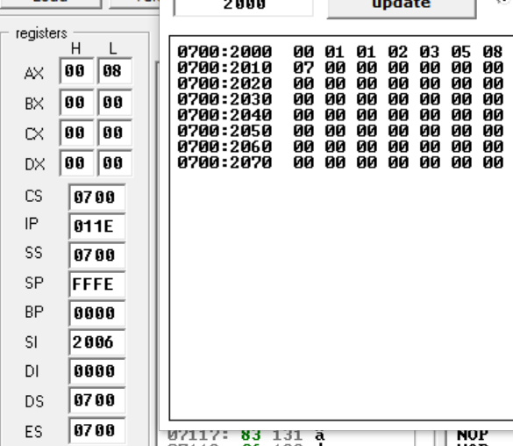

**PRACTICAL-5**

1. **Develop a program to interface Arduino with LED and blink led for 1second.**
2. **Develop a program to interface Input Switches and output LEDs with Arduino.**

**PROGRAM CODE:**

1. **Develop a program to interface Arduino with LED and blink led for 1second.**

**PROGRAM CODE:**

void setup()

{

pinMode(13, OUTPUT);

pinMode(12,OUTPUT);

pinMode(11,OUTPUT);

pinMode(10,OUTPUT);

}

void loop()

{

digitalWrite(12,LOW);

digitalWrite(10,LOW);

digitalWrite(13, HIGH);

digitalWrite(11,HIGH);

delay(2000);

digitalWrite(13,LOW);

digitalWrite(11,LOW);

digitalWrite(12,HIGH);

digitalWrite(10,HIGH);

delay(2000);

}

**OUTPUT:**

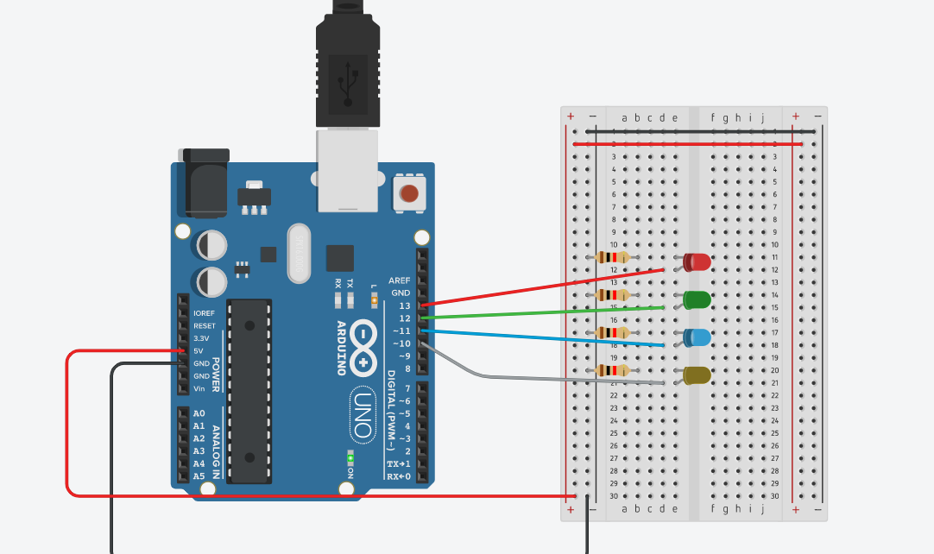

**Red and Blue light on**

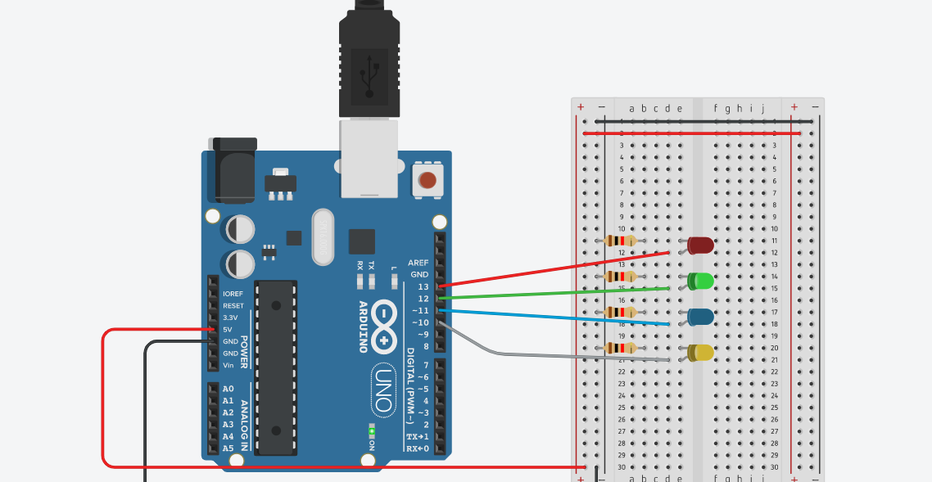

**GREEN and YELLOW light on**

1. **Develop a program to interface Input Switches and output LEDs with Arduino.**

**PROGRAM CODE:**

int btn=0;

void setup()

{

pinMode(3,INPUT);

pinMode(12,OUTPUT);

}

void loop()

{

btn=digitalRead(3);

if(btn==HIGH)

{digitalWrite(12,HIGH);

delay(5000);

}

else

{

digitalWrite(12,LOW);

}

}

**OUTPUT:**

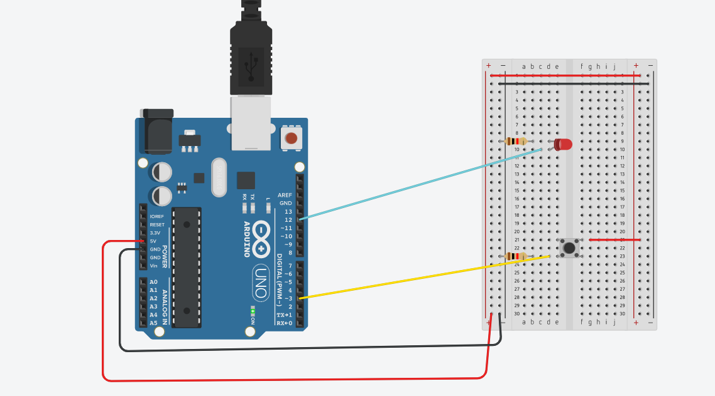

**PRACTICAL-6**

**AIM:**

**Interface 7 seg display with Arduino and Write a program to count and display 0 to 9 on it.**

**PROGRAM CODE:**

unsigned const int A = 13;

unsigned const int B = 12;

unsigned const int C = 11;

unsigned const int D = 10;

unsigned const int E = 9;

unsigned const int F = 8;

unsigned const int G = 7;

unsigned const int H = 6;

void setup(void)

{

pinMode(A, OUTPUT);

pinMode(B, OUTPUT);

pinMode(C, OUTPUT);

pinMode(D, OUTPUT);

pinMode(E, OUTPUT);

pinMode(F, OUTPUT);

pinMode(G, OUTPUT);

pinMode(H, OUTPUT);

}

void zero(void) {

digitalWrite(A, LOW);

digitalWrite(B, HIGH);

digitalWrite(C, HIGH);

digitalWrite(D, HIGH);

digitalWrite(E, HIGH);

digitalWrite(F, HIGH);

digitalWrite(G, HIGH);

digitalWrite(H, LOW);

}

void one(void) {

digitalWrite(A, LOW);

digitalWrite(B, LOW);

digitalWrite(C, LOW);

digitalWrite(D, HIGH);

digitalWrite(E, LOW);

digitalWrite(F, LOW);

digitalWrite(G, HIGH);

digitalWrite(H, LOW);

}

void two(void) {

digitalWrite(A, HIGH);

digitalWrite(B, LOW);

digitalWrite(C, HIGH);

digitalWrite(D, HIGH);

digitalWrite(E, HIGH);

digitalWrite(F, HIGH);

digitalWrite(G, LOW);

digitalWrite(H, LOW);

}

void three(void) {

digitalWrite(A, HIGH);

digitalWrite(B, LOW);

digitalWrite(C, HIGH);

digitalWrite(D, HIGH);

digitalWrite(E, LOW);

digitalWrite(F, HIGH);

digitalWrite(G, HIGH);

digitalWrite(H, LOW);

}

void four(void) {

digitalWrite(A, HIGH);

digitalWrite(B, HIGH);

digitalWrite(C, LOW);

digitalWrite(D, HIGH);

digitalWrite(E, LOW);

digitalWrite(F, LOW);

digitalWrite(G, HIGH);

digitalWrite(H, LOW);

}

void five(void) {

digitalWrite(A, HIGH);

digitalWrite(B, HIGH);

digitalWrite(C, HIGH);

digitalWrite(D, LOW);

digitalWrite(E, LOW);

digitalWrite(F, HIGH);

digitalWrite(G, HIGH);

digitalWrite(H, LOW);

}

void six(void) {

digitalWrite(A, HIGH);

digitalWrite(B, HIGH);

digitalWrite(C, HIGH);

digitalWrite(D, LOW);

digitalWrite(E, HIGH);

digitalWrite(F, HIGH);

digitalWrite(G, HIGH);

digitalWrite(H, LOW);

}

void seven(void) {

digitalWrite(A, LOW);

digitalWrite(B, LOW);

digitalWrite(C, HIGH);

digitalWrite(D, HIGH);

digitalWrite(E, LOW);

digitalWrite(F, LOW);

digitalWrite(G, HIGH);

digitalWrite(H, LOW);

}

void eight(void) {

digitalWrite(A, HIGH);

digitalWrite(B, HIGH);

digitalWrite(C, HIGH);

digitalWrite(D, HIGH);

digitalWrite(E, HIGH);

digitalWrite(F, HIGH);

digitalWrite(G, HIGH);

digitalWrite(H, LOW);

}

void nine(void) {

digitalWrite(A, HIGH);

digitalWrite(B, HIGH);

digitalWrite(C, HIGH);

digitalWrite(D, HIGH);

digitalWrite(E, LOW);

digitalWrite(F, HIGH);

digitalWrite(G, HIGH);

digitalWrite(H, LOW);

}

void loop(void)

{

zero();

delay(1000);

one();

delay(1000);

two();

delay(1000);

three();

delay(1000);

four();

delay(1000);

five();

delay(1000);

six();

delay(1000);

seven();

delay(1000);

eight();

delay(1000);

nine();

delay(1000);

}

**OUTPUT:**

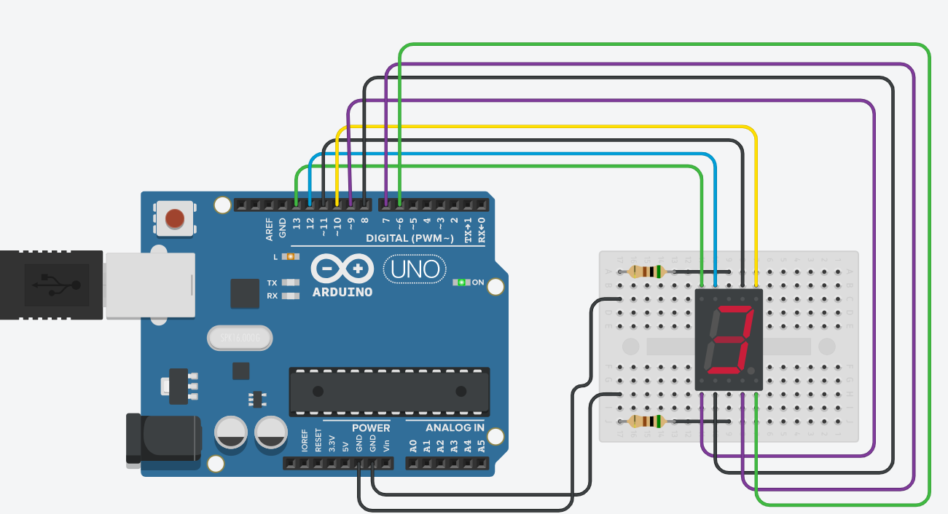

**PRACTICAL-7**

**AIM:**

**Interface 16x2 LCD with Arduino. Write a Program to Display “WELCOME DEPSTAR”.**

**PROGRAM CODE:**

#include<LiquidCrystal.h>

LiquidCrystal lcd(12,11,5,4,3,2);

void setup()

{

lcd.begin(16,2);

}

void loop()

{

lcd.setCursor(8,0);

lcd.print("WELCOME DEPSTAR");

lcd.scrollDisplayLeft();

delay(1000);

}

**OUTPTUT:**

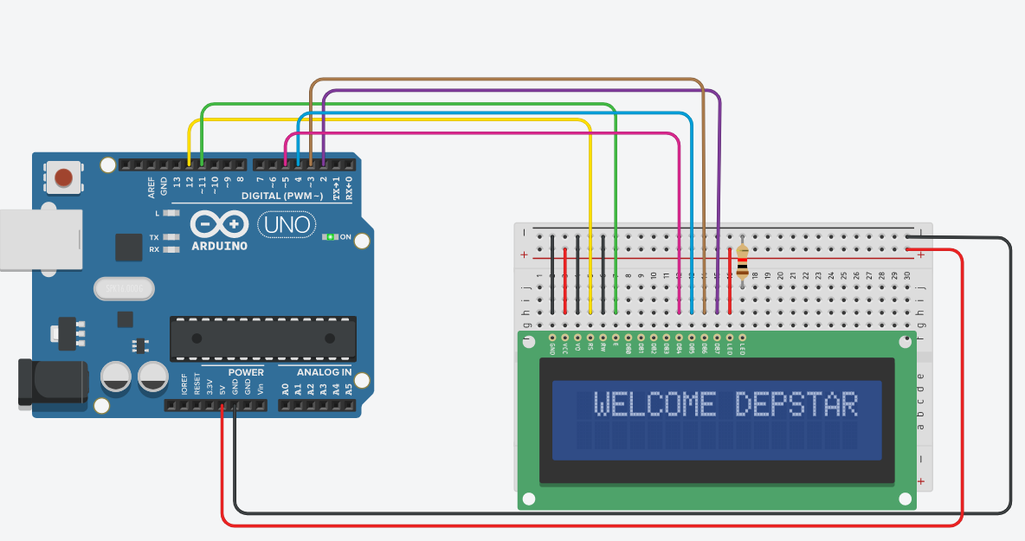

**PRACTICAL-8**

**AIM:**

**Interface Stepper motor and DC motor with Arduino and Write a Program to rotate motor into clockwise and anticlockwise.**

**PROGRAM CODE:**

void setup()

{

pinMode(13, OUTPUT);

pinMode(11,OUTPUT);

pinMode(9,OUTPUT);

digitalWrite(13,HIGH);

}

void loop()

{

digitalWrite(11,HIGH);

digitalWrite(9,LOW);

delay(3000);

digitalWrite(11,LOW);

digitalWrite(9,HIGH);

delay(3000);

}

**OUTPUT:**

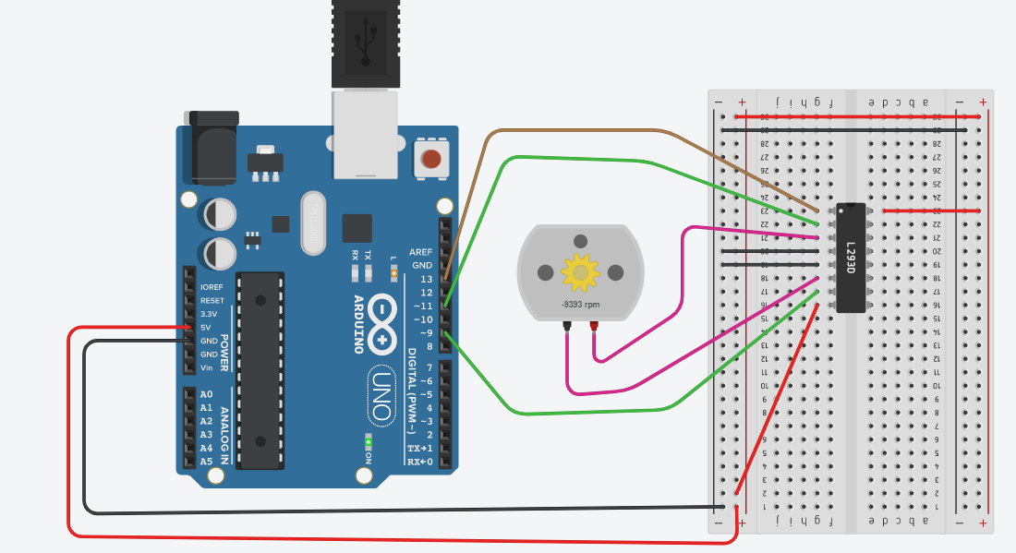

**PRACTICAL-9**

**AIM:**

**Interface Different Sensors (Ultrasonic, PIR, Temperature) with Arduino and also write a Program for one application of each sensors.**

**PROGRAM CODE:**

**ULTRASONIC SENSOR:**

#define echoPin 3

#define triggerPin 5

#define led 13

long duration;

int distance;

int val=0;

void setup()

{

pinMode(led,OUTPUT);

pinMode(echoPin,INPUT);

pinMode(triggerPin,OUTPUT);

Serial.begin(4800);

Serial.println("ULTRASONIC SENSOR TEST");

Serial.println("WITH ARDUINO UNO3");

}

void loop()

{

digitalWrite(triggerPin,LOW);

delayMicroseconds(2);

digitalWrite(triggerPin,HIGH);

delayMicroseconds(20);

digitalWrite(triggerPin,LOW);

val=digitalRead(3);

duration=pulseIn(echoPin,HIGH);

distance=(duration*0.034)/2;

Serial.print("Distance : ");

Serial.print(distance);

Serial.print(" cm");

if(distance<120)

{

digitalWrite(led,HIGH);

}

else

{

digitalWrite(led,LOW);

}

}

**OUTPUT:**

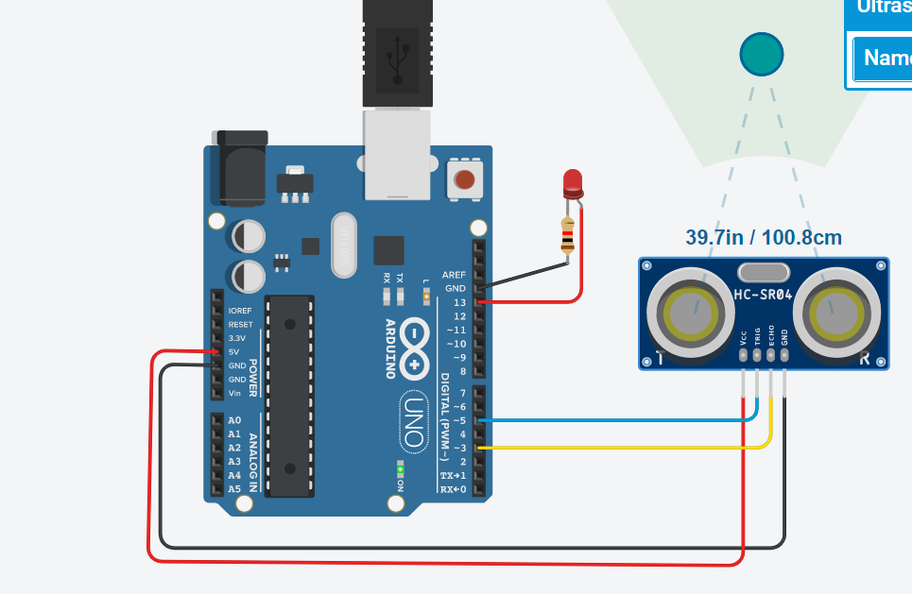

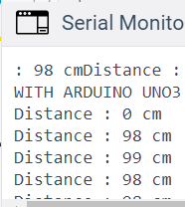

**PIR SENSOR:**

int val=0;

void setup()

{

pinMode(12, OUTPUT);

pinMode(3,INPUT);

Serial.begin(9600);

}

void loop()

{

val=digitalRead(3);

Serial.println(val);

if(val==HIGH)

{

digitalWrite(12,HIGH);

Serial.println("Sensor Activated");

}

else

{digitalWrite(12,LOW);

Serial.println("Sensor Deactivated");

}

}

**OUTPUT:**

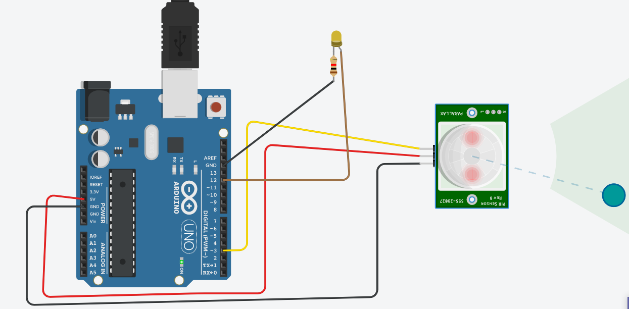

**TEMPERATURE SENSOR:**

float c,f;

void setup()

{

pinMode(A1,INPUT);

pinMode(13,OUTPUT);

Serial.begin(9600);

}

void loop()

{

c=analogRead(1);

c=c*0.0048828125;

c=(c-0.5)*100;

Serial.print(c);

Serial.println(" C");

f=(9*c)/5+32;

Serial.print(f);

Serial.println(" F");

if(c>=20)

{

digitalWrite(13,HIGH);

}

else

{

digitalWrite(13,LOW);

}

**OUTPUT:**

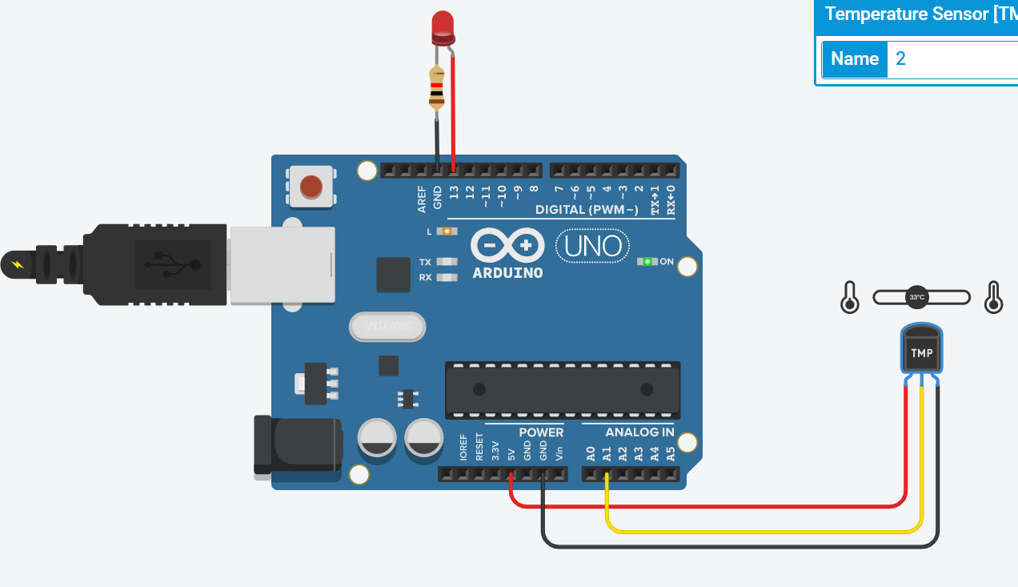

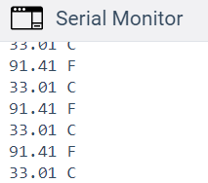

**PRACTICAL-10**

**AIM:**

**4 LEDs are Interfaced with Raspberry Pi. Develop a python script for Raspberry Pi to blink all LEDs with specific Time Interval.**

**PROGRAM CODE:**

from goto import * import time import var import pio import resource import RPi.GPIO as GPIO

# Peripheral Configuration Code (do not edit)

#---CONFIG_BEGIN--- import cpu import FileStore import VFP ledpin1 = 18 ledpin2 = 19 ledpin3 = 20 ledpin4 = 12

GPIO.setmode(GPIO.BCM)

GPIO.setup(ledpin1,GPIO.OUT)

GPIO.setup(ledpin2,GPIO.OUT)

GPIO.setup(ledpin3,GPIO.OUT)

GPIO.setup(ledpin4,GPIO.OUT)

while True: try:

GPIO.output(ledpin1,GPIO.HIGH) time.sleep(1)

#GPIO.output(ledpin1,GPIO.LOW)

# time.sleep(1)

GPIO.output(ledpin2,GPIO.HIGH) time.sleep(1)

#GPIO.output(ledpin2,GPIO.LOW)

#time.sleep(1)

GPIO.output(ledpin3,GPIO.HIGH) time.sleep(1)

# GPIO.output(ledpin3,GPIO.LOW)

# time.sleep(1)

GPIO.output(ledpin4,GPIO.HIGH) time.sleep(1)

except:

print("Some Error!")

finally:

GPIO.cleanup()

**PRACTICAL-11**

**AIM:**

**A 16 * 2 LCD is interfaced with Raspberry Pi. Develop a python script for**

**Raspberry Pi to display the string on LCD. E.g., “Welcome to Charusat”.**

**PROGRAM CODE:**

import RPi.GPIO as GPIO import time

LCD_RS = 7

LCD_E = 8

LCD_D4 = 25

LCD_D5 = 24

LCD_D6 = 23

LCD_D7 = 18

# Define some device constants

LCD_WIDTH = 16 # Maximum characters per line

LCD_CHR = True

LCD_CMD = False

LCD_LINE_1 = 0x80 # LCD RAM address for the 1st line

LCD_LINE_2 = 0xC0 # LCD RAM address for the 2nd line

# Timing constants

E_PULSE = 0.0005

E_DELAY = 0.0005

def main():

# Main program block

GPIO.setwarnings(False)

GPIO.setmode(GPIO.BCM) # Use BCM GPIO numbers

GPIO.setup(LCD_E, GPIO.OUT) # E

GPIO.setup(LCD_RS, GPIO.OUT) # RS

GPIO.setup(LCD_D4, GPIO.OUT) # DB4

GPIO.setup(LCD_D5, GPIO.OUT) # DB5

GPIO.setup(LCD_D6, GPIO.OUT) # DB6

GPIO.setup(LCD_D7, GPIO.OUT) # DB7

# Initialise display lcd_init()

while True:

# Send some test lcd_string("Welcome to",LCD_LINE_1) lcd_string("Charusat",LCD_LINE_2)

time.sleep(2)

def lcd_init(): # Initialise display

lcd_byte(0x33,LCD_CMD) # 110011 Initialise lcd_byte(0x32,LCD_CMD) # 110010 Initialise lcd_byte(0x06,LCD_CMD) # 000110 Cursor move direction lcd_byte(0x0C,LCD_CMD) # 001100 Display On,Cursor Off, Blink Off

lcd_byte(0x28,LCD_CMD) # 101000 Data length, number of lines, font size lcd_byte(0x01,LCD_CMD) # 000001 Clear display time.sleep(E_DELAY)

def lcd_byte(bits, mode):

# Send byte to data pins

# bits = data

# mode = True for character

# False for command

GPIO.output(LCD_RS, mode) # RS

# High bits

GPIO.output(LCD_D4, False)

GPIO.output(LCD_D5, False)

GPIO.output(LCD_D6, False)

GPIO.output(LCD_D7, False)

if bits&0x10==0x10:

GPIO.output(LCD_D4, True)

if bits&0x20==0x20:

GPIO.output(LCD_D5, True)

if bits&0x40==0x40:

GPIO.output(LCD_D6, True)

if bits&0x80==0x80:

GPIO.output(LCD_D7, True)

# Toggle 'Enable' pin lcd_toggle_enable()

# Low bits

GPIO.output(LCD_D4, False)

GPIO.output(LCD_D5, False)

GPIO.output(LCD_D6, False)

GPIO.output(LCD_D7, False)

if bits&0x01==0x01:

GPIO.output(LCD_D4, True)

if bits&0x02==0x02:

GPIO.output(LCD_D5, True)

if bits&0x04==0x04:

GPIO.output(LCD_D6, True)

if bits&0x08==0x08:

GPIO.output(LCD_D7, True)

# Toggle 'Enable' pin lcd_toggle_enable()

def lcd_toggle_enable(): # Toggle enable

time.sleep(E_DELAY)

GPIO.output(LCD_E, True)

time.sleep(E_PULSE)

GPIO.output(LCD_E, False)

time.sleep(E_DELAY)

def lcd_string(message,line):

# Send string to display

message = message.ljust(LCD_WIDTH," ")

lcd_byte(line, LCD_CMD)

for i in range(LCD_WIDTH):

lcd_byte(ord(message[i]),LCD_CHR)

if name == ' main ':

try:

main()

except KeyboardInterrupt:

pass

finally:

lcd_byte(0x01, LCD_CMD)

lcd_string("Goodbye!",LCD_LINE_1)

GPIO.cleanup()