|  |  |  |  |
| --- | --- | --- | --- |
| **STUDENT ID** | 19DCS098 | **STUDENT NAME** | Parth N Patel |
| **SUBJECT CODE** | CE 259 | **SUBJECT NAME** | Python |
| **DATE OF EXAM** | 30 April 2021 |  |  |

**DEFINITION:**

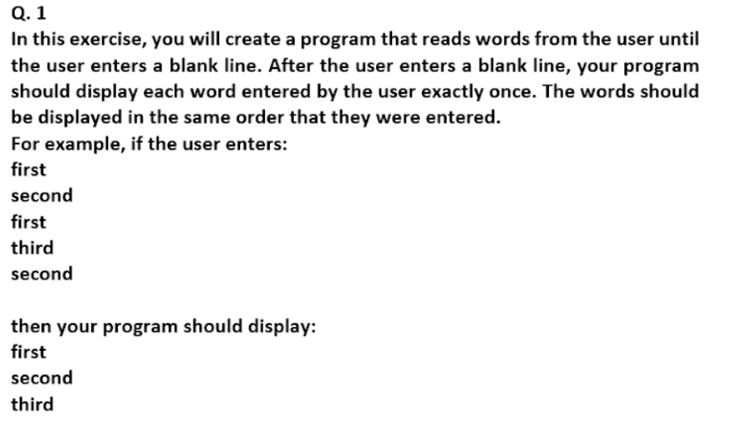

**SOLUTION:**

status=True

unique=list()

while(status):

word=input("Enter the word : ")

if word =='' :

status=False

else:

unique.append(word)

uniqueList=list()

for value in unique:

if value not in uniqueList:

uniqueList.append(value)

print("The words you entered are : ")

for value in uniqueList:

print(value)

print("-----------------------------")

print("PARTH PATEL\n19DCS098")

**OUTPUT:**

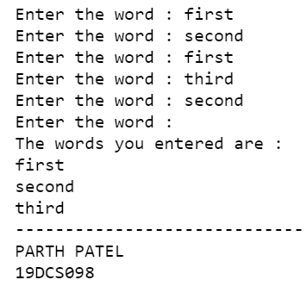

**DEFINITION:**

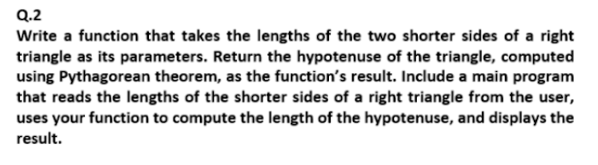

**SOLUTION:**

from math import sqrt

def Pythagorus(x,y):

return int(sqrt(((x**2)+(y**2))))

def main():

len1=int(input("Enter the length of first shorter side of right angled triangle : "))

len2=int(input("Enter the length of second shorter side of right angled triangle :"))

hypotenuse=Pythagorus(len1,len2)

print("Length of the hypotenuse from pythagorus theorem is : ",hypotenuse)

print("------------------------------------------------------------------")

print("PARTH PATEL\n19DCS098")

if __name__=="__main__":

main()

**OUTPUT:**

