**CHAROTAR UNIVERSITY OF SCIENCE AND TECHNOLOGY**

**DEVANG PATEL INSTITUTE OF ADVANCE TECHNOLOGY AND**

**RESEARCH (DEPSTAR)**

**Subject Code & Subject Name: CE259 Programming in Python**

**Practical Examination - I**

**Class 4 CSE -2 A/B BATCH**

1. W.A.P, keep track of when our friend’s birthdays are, and be able to find that

information based on their name. Create a dictionary (in your file) of names and

birthdays. When you run your program it should ask the person to enter a name,

and return the birthday of that person back to them. The interaction should look

something like this:

--- Welcome to the birthday dictionary. We know the birthdays of:

Rahul

Sohil

Sachin

---Who's birthday do you want to look up?

sohil

----sohils 's birthday is 05/11/1996.

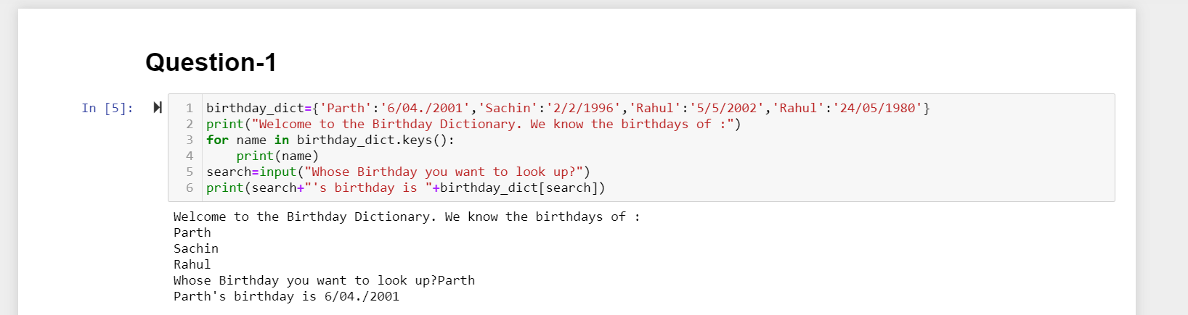

3. Write a function that takes an ordered list of numbers (a list where the elements

are in order from smallest to largest) and another number. The function decides

whether or not the given number is inside the list and returns (then prints) an

appropriate boolean.

