**A**

**Project Report**

**On**

**SUMMER INTERNSHIP-1**

**Prepared by**

Parth Niteshkumar Patel (19DCS098)

**Under the guidance of**

Prof. Chandrasekhar Pawar

A Report Submitted to

Charotar University of Science and Technology

For Partial Fulfillment of the Requirements for the

5th Semester Summer Internship-I (CE346)

**Submitted at**

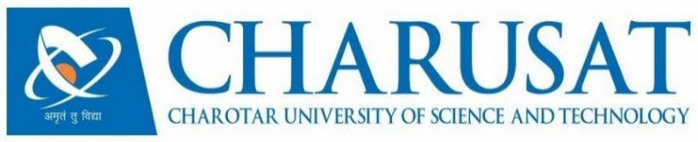

**Department of Computer Science & Engineering**

**Devang Patel Institute of Advance Technology and Research**

**At: Changa, Dist: Anand – 388421**

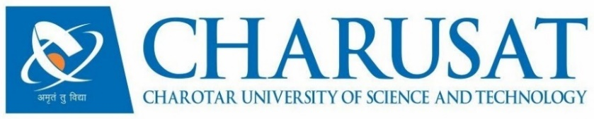

**CERTIFICATE**

This is to certify that the report entitled **Summer Internship-1** is a bonafide work carried out by **Mr. Parth Niteshkumar Patel (19DCS098)** under the guidance and supervision of **Prof. Chandrasekhar Pawar** for the subject **CS343 Summer Internship-I** of 5th Semester of Bachelor of Technology in **Department of Computer Science & Engineering,** **DEPSTAR** at Faculty of Technology & Engineering – CHARUSAT, Gujarat.

To the best of my knowledge and belief, this work embodies the work of candidate himself, has duly been completed, and fulfills the requirement of the ordinance relating to the B.Tech. Degree of the University and is up to the standard in respect of content, presentation and language for being referred to the examiner.

|  |  |
| --- | --- |
| Prof. Chandrasekhar Pawar  Internal Guide  Department of Computer Science & Engineering  DEPSTAR, CHARUSAT, Changa, Gujarat. |  |
| Prof. Parth Goel  I/C Head of Department  Department of Computer Science & Engineering  DEPSTAR, CHARUSAT, Changa, Gujarat | Dr. Amit Ganatra  Principal, DEPSTAR  Dean, FTE  CHARUSAT, Changa, Gujarat. |

**Devang Patel Institute of Advance Technology And Research At: Changa, Ta. Petlad, Dist. Anand, PIN: 388 421. Gujarat**



**CERTIFICATE**

We are glad to inform that **Mr. Parth Niteshkumar Patel** from **Charotar University of Science and Technology (CHARUSAT)** has successfully completed his internship at **AVM COMPUTERS/AMEE COMPUTER CLASSES** from **June 3 2021** to **July 10 2021**.

During his internship, he was exposed to fundamental concepts of web development through training and individual mini projects.

We found him extremely dynamic, enthusiast and hard working. He was very keen to learn the new concepts and was very active during the training session. As a result, we offered him a new internship offer as an android developer for our new venture Amee Computer Classes (Future E-learning platform).

His association with us is very fruitful and we hope that he will perform the current internship with the same enthusiasm, attitude and with proper approach.

**NOTE: Parth Patel’s internship has been extended and the team and domain has been changed. Also, Mr. Parth Niteshkumar Patel has accepted the new offer and the extended internship will start from 24 July 2021**

**Authorized Signatory**



**Owner, Lead Developer and Tutor**

**AVM COMPUTERS**

**ACC**

**ACKNOWLEDGEMENT**

* I, Parth Patel, intern at AVM Computers and ACC E-learning, with immense pleasure and commitment would like to present the internship report. This internship has given me wide opportunity to think, implement and interact with various aspects of management skills as well as the new emerging technologies.
* I hereby avail this opportunity to express my gratitude to all the people who extended and are extending their valuable time and knowledge to guide me and help me during the internship tenure.

I express deep sense of gratitude towards our Head of the CSE Department, Dr. Parth Goel and my internal coordinator Prof. Chandrasekhar Pawar for the support during the whole session of internship. It is because of them, that we were prompted to do hard work, adopting new technologies.

Thanks,

Parth Niteshkumar Patel

**ABSTRACT**

* The purpose of the internship was to explore the real world and to develop skills so that I can become job ready.
* I started internship as a web intern but almost after completing my half internship, I was given an excellent life-changing offer.
* For the first half of the internship, I learnt the basics concepts of Web development. I also learnt how to behave in professional environment and how to pass on the work.
* I did many small projects and just before starting the big project, I accepted their new offer and now again I am starting from scratch.
* I consider myself lucky enough to join this small start-up instead of big tech companies, as I will get to know many new and latest concepts of the trending technology which will help me to pick up the pace of the changing world.

FROM,

Parth Niteshkumar Patel

19DCS098

**TABLE OF CONTENTS**

1. COMPANY DESCRIPTION ………………………………………….
2. INTERNSHIP INFORMATION………………………………………
3. PROJECTS……………………………………………………………..
4. PROJECTS DESCRIPTION AND CONCLUSION………………….
5. CONCLUSION………………………………………………………..

**COMPANY DESCRIPTION:**

* AVM Computers is a small start-up which is operated by 6 experienced developers.
* All the developers are specialized in mobile, web and desktop development.
* The start-up also deals with hardware and software business and it also runs an educational institute to transfer their knowledge to young aspirants.
* They have recently came with the concept of starting an E-learning platform where all can study for free and that too with a guided path.
* The team named it “Amee Computer Classes”.
* Currently, there are 6 team members and 6 interns for their support.
* Mr. Ajay Shah is the owner and founder of both the start-up and ACC.
* He is an enthusiast of new technology.
* He is also a passionate tutor who loves to teach the various concepts of computer engineering.
* The start-up has a vision to develop a platform, which can provide a platform/ interface where all can learn the foundational knowledge of Computer engineering with a guided path.

1. **INTERNSHIP INFORMATION:**

* INTERNSHIP START DATE: June 3 2021
* INTERNSHIP END DATE: July 30 2021
* INTERNSHIP DOMAIN: Web development – June 2 2021 – July 1- 2021
* NEW INTERNSHIP DOMAIN: Android Development – July 24 – till end
* MINI PROJECTS UNDERTAKEN (WEB) : 7
* PRIMARY PROJECT: To contribute in development of new android application of ACC and also to contribute in other projects.
* STIPEND: N.A.
* NOC required: N.A.
* TIMINGS: 17:00 to 21:00 (including break)

1. **PROJECTS:**

**2.1 Project-1:**

**Project Title:** Make Your Portfolio Website using HTML

**NOTE: The screenshots are combined with the project-2**

**2.2 Project-2:**

**Project Title:** Enhance your previous portfolio website with the help of CSS

**SCREENSHOTS**

**Project:** Portfolio Website

## Technologies Used: HTML, CSS

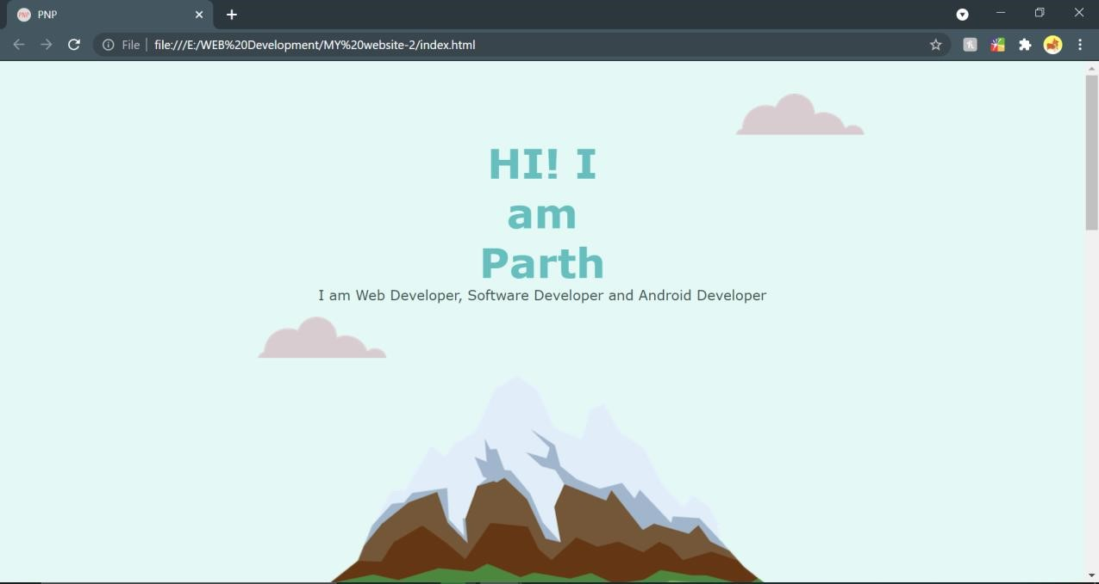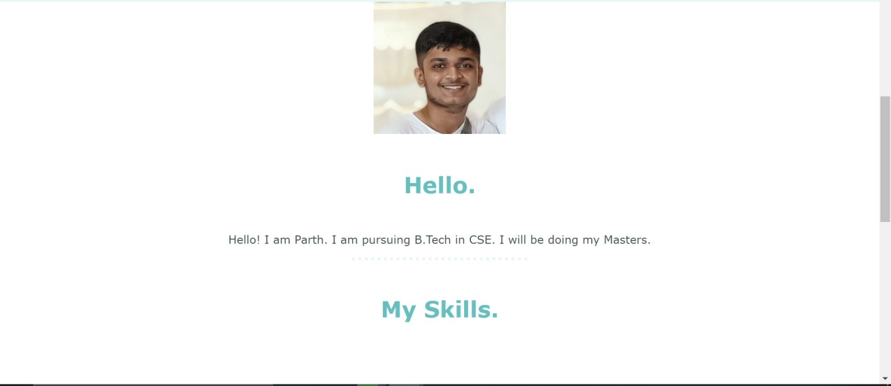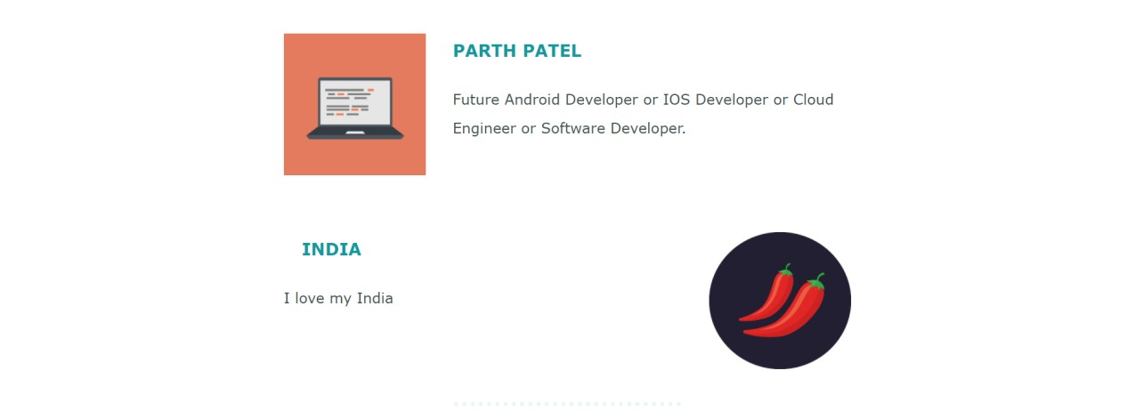



**2.3 Project-3:**

**Project Title:** Complete the Tin Dog Website provided in the course.

**SCREENSHOTS**

Project: Tin Dog Website

Technologies Used: HTML, CSS

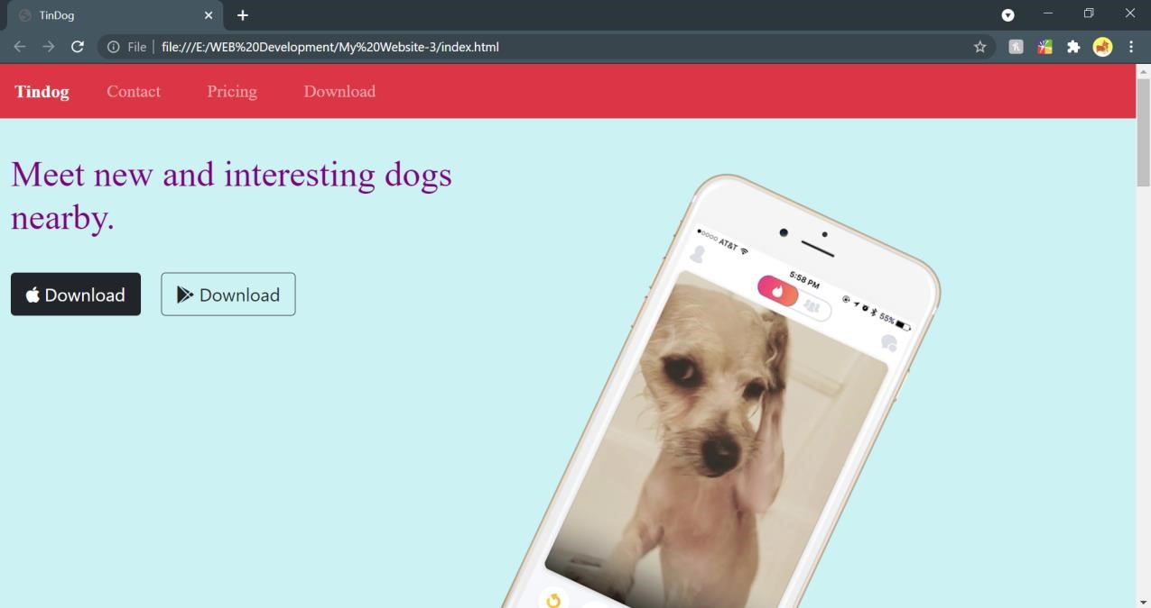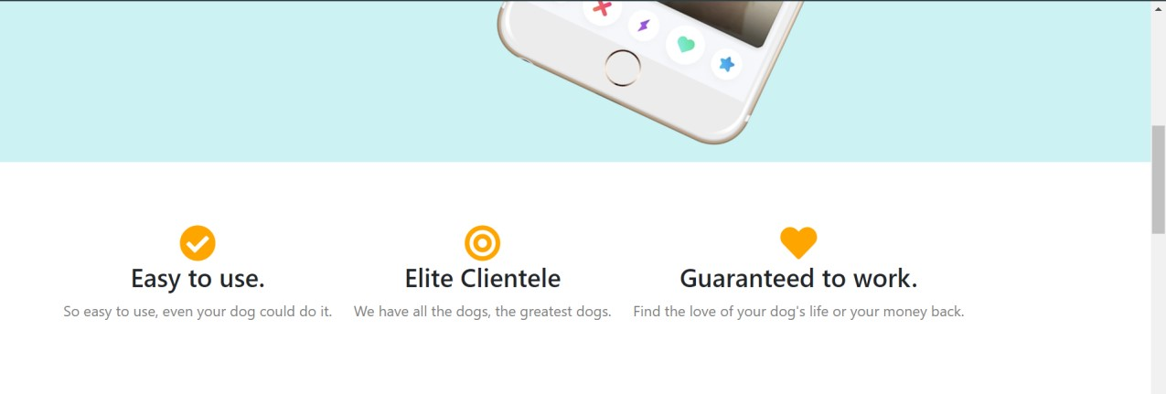

## Top Section



## Middle Section

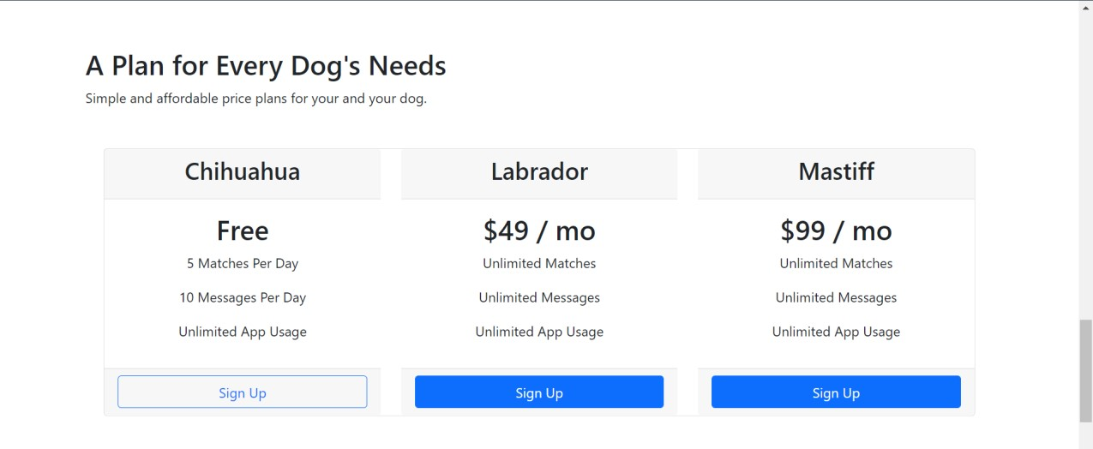

## Price Section



**Bottom Section**

**2.4 Project-4:**

**Project Title:** Make a simple gym website with form for becoming the member

**SCREENSHOTS**

**Project:** GYM Website

## Technologies Used: HTML, CSS

**Description:** It is a simple website that contains a form section where you can fill the necessary details

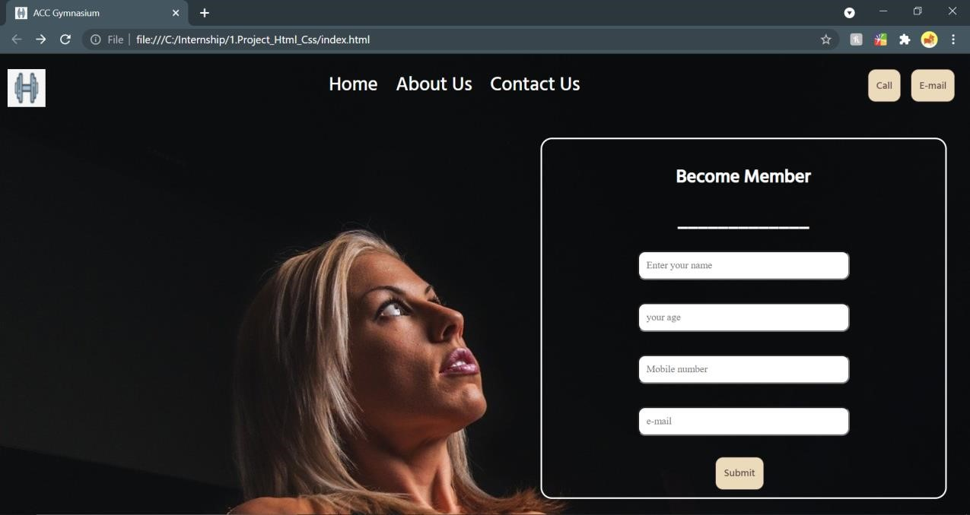

**2.5 Project-5:**

**Project Title:** Make a notetaking website with the help of HTML, CSS, and javaScript

**SCREENSHOT**

**Project:** Note Taking Website

**Technologies Used:** HTML, CSS and JavaScript

**Description:** It is a website where one can take notes and also can delete the notes. One can add title to the note also.

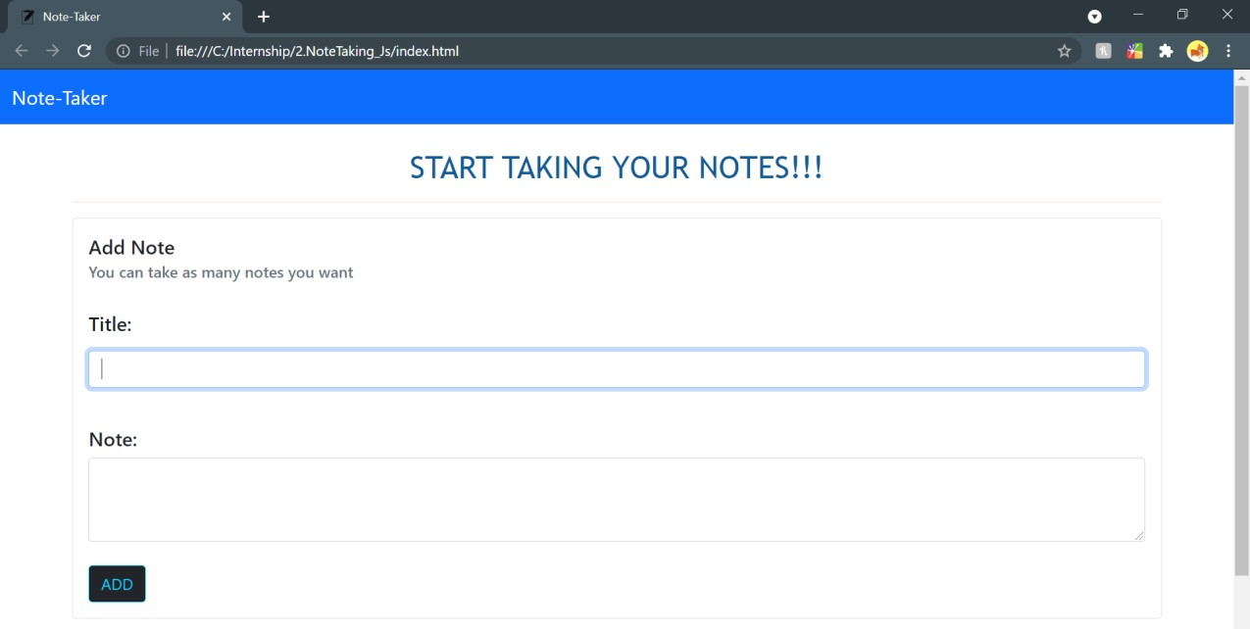

**Section to add Notes**

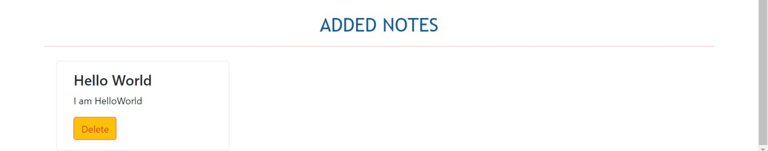

**Note Added**

**2.6 Project-6:**

**Project Title: Make a basic Calculator**

**SCREENSHOTS**

**Project:** Calculator

**Technologies Used:** HTML, CSS and JavaScript

**Description:** It is a simple website which do basic calculations.

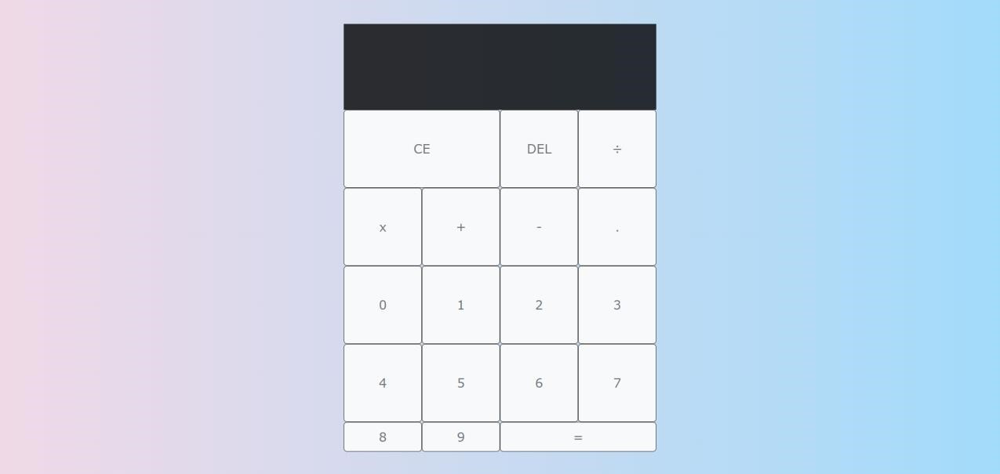

## BASIC INTERFACE

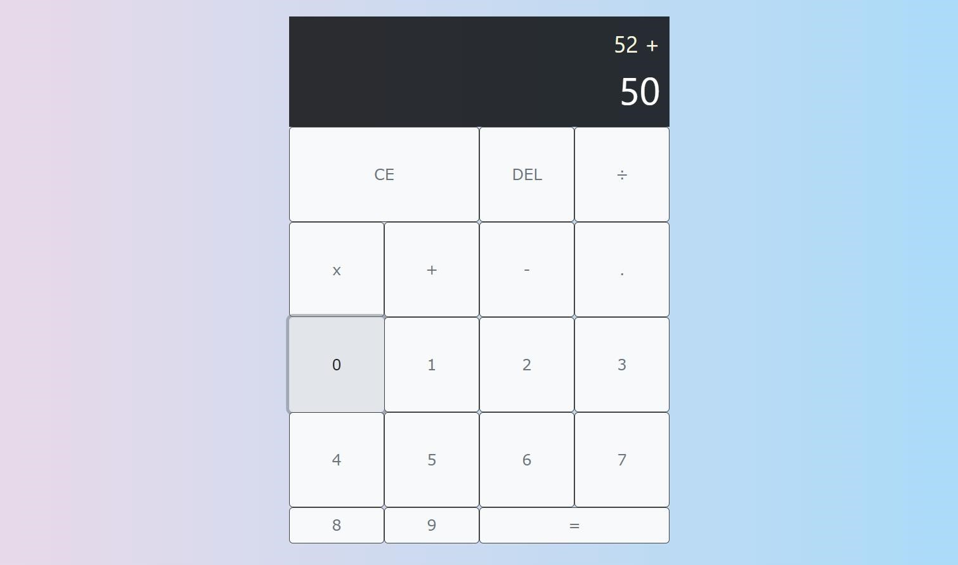

## ADDITION

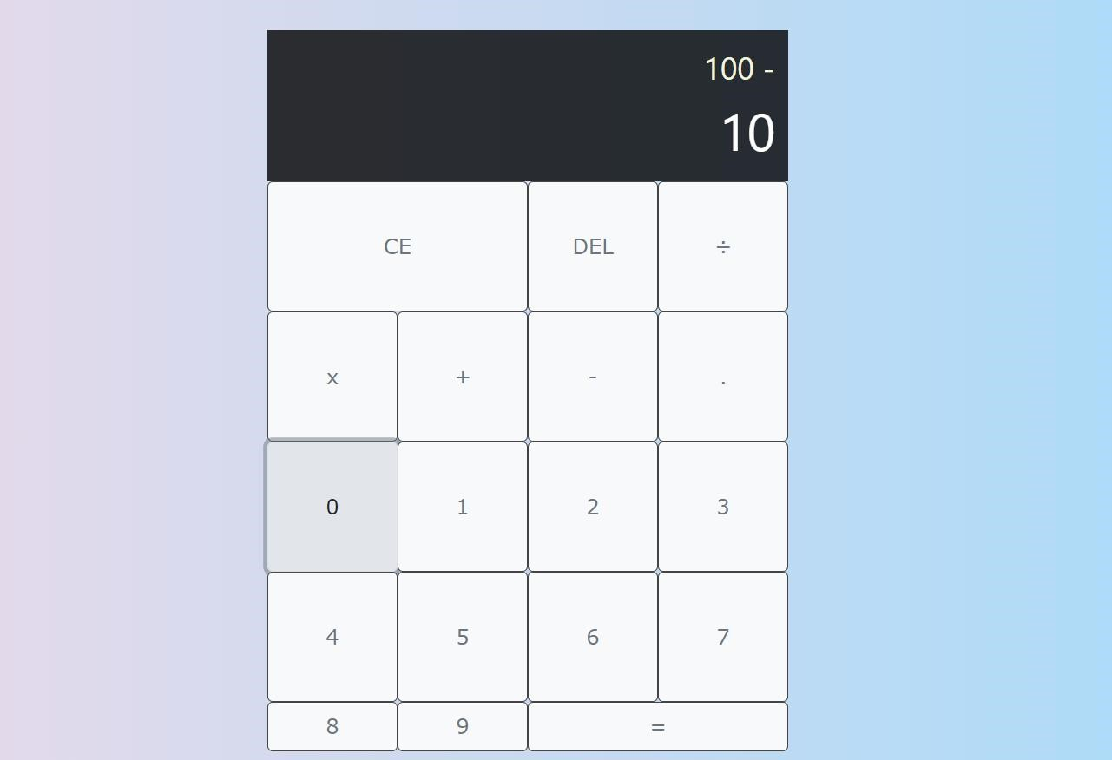

## SUBTRACTION

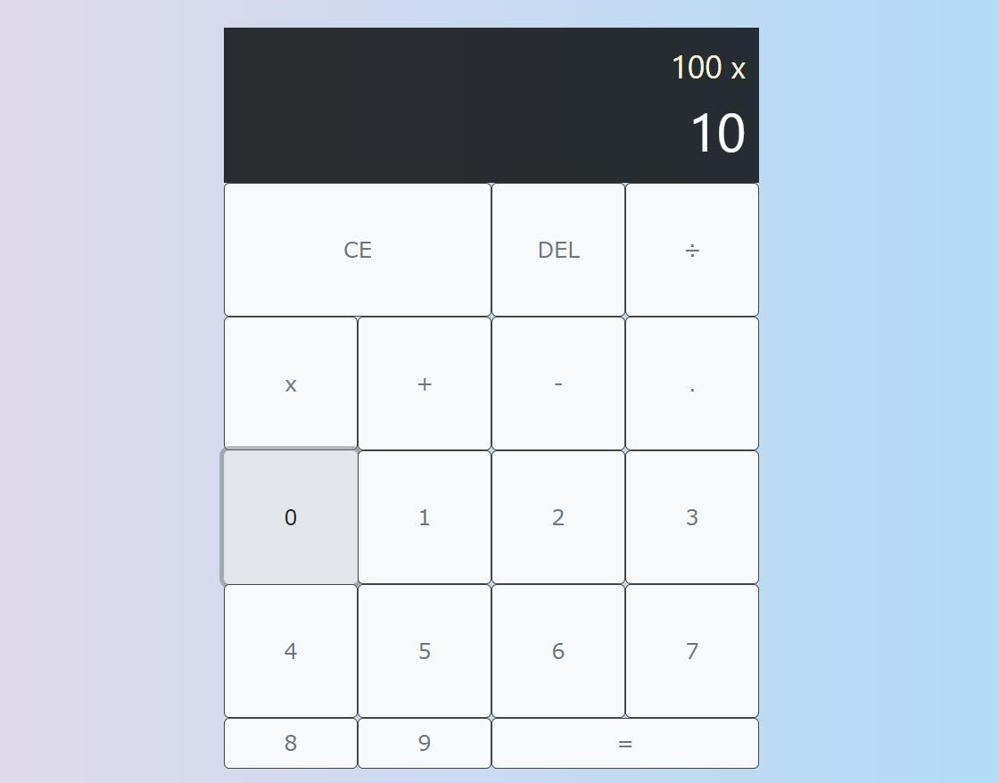

## MULTIPLICATION

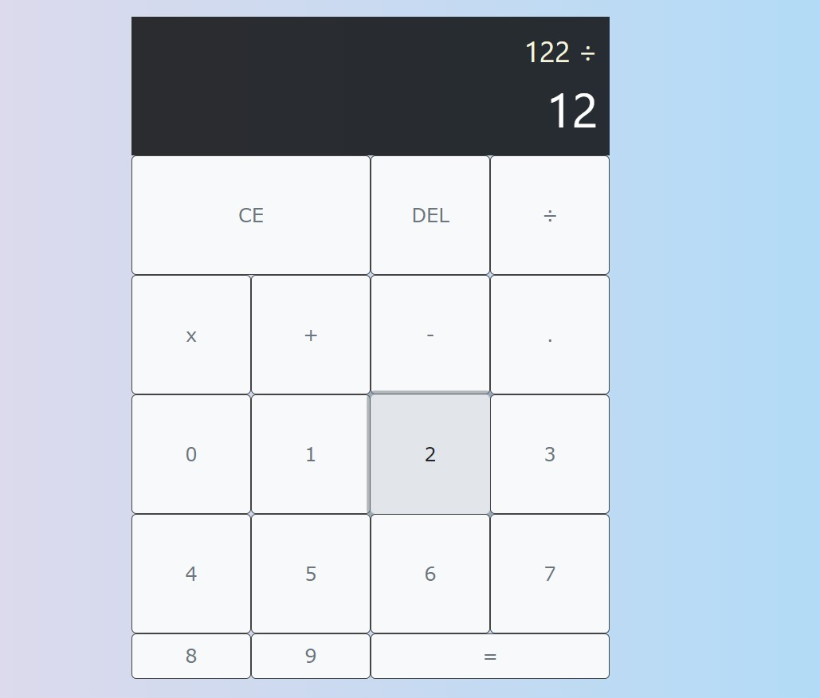

## DIVISION

**2.7 Project-7:**

**Project Title:** Make an instrumental website

**SCREENSHOTS**

**Project:** Instrumental Website

**Technologies Used:** HTML, CSS and JavaScript

**Description:** It is a website where one can play and interact to listen instrumental sounds and can relax their mood.

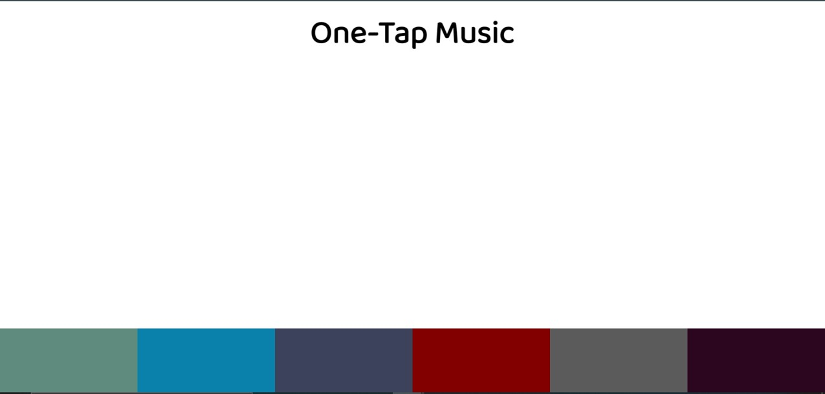

**BASIC INTERFACE**

**CONCLUSION**

* During the internship, I am learning plenty of new concepts that I would have not been able to do while just studying in university.
* The first month was all about Web development and then, surprisingly, I was offered an extension and to learn android development and then to join the mobile development team.
* Currently, I am learning android development and then I will be contributing in their projects.
* I am very exciting to start my new journey as Android Developer.
* I am very thankful to Prof. Jesal Desai, Prof. Rima Patel and Prof. Chandrashekhar Pawar for giving their valuable time and guidance to me.
* Following are the technologies that I am going to learn within a year:
  + - 1. Java
      2. Kotlin
      3. SQLite
      4. FireBase
      5. Software Development life Cycle
      6. Agile Development