**A**

**Project Report**

**On**

**"NOTE TAKER"**

**Prepared by**

**Parth Patel-19DCS098**

**Saumya Shah-19DCS133**

**Under the guidance of**

**Priyal Vaghela**

**Assistant Professor**

A Report Submitted to

Charotar University of Science and Technology

for Partial Fulfillment of the Requirements for the

5th Mobile Application Development(MAD) (CS377)

**Submitted at**



**CSE**

**DEPSTAR**



**CERTIFICATE**

This is to certify that the report entitled “**NOTE TAKER**” is a bonafied work carried out by **Parth Patel(19DCS098)** and **Saumya Shah(19DCS133)** under the guidance and supervision of **Assistant Prof. Priyal Vaghela** for the subject [CS 377] MOBILE APPLICATION DEVELOPMENT(CSE) of 5th Semester of Bachelor of Technology in **DEPSTAR** at Faculty of Technology & Engineering – CHARUSAT, Gujarat.

To the best of my knowledge and belief, this work embodies the work of candidate himself, has duly been completed, and fulfills the requirement of the ordinance relating to the B.Tech. Degree of the University and is up to the standard in respect of content, presentation and language for being referred to the examiner.

|  |  |
| --- | --- |
| Priyal Vaghela  Assistant Professor  Branch Name(CSE)  DEPSTAR, Changa, Gujarat. |  |
| Dr. Amit Ganatra  Principal, DEPSTAR  Dean, FTE  CHARUSAT, Changa, Gujarat. | |

**ABOUT THE PROJECT:**

* The project “NOTE TAKER” is an android application in which one can create, update, delete and store their notes.
* For security measures, we have added mandatory finger print authentication, so notes can be only accessed by registered users.
* Programming Language Used:
* Front-end: **XML**
* Back-end: **JAVA**
* Data Base Used: **SQLite**
* IDE Used: **ANDROID STUDIO.**

**DESIGN OF THE APPLICATION:**

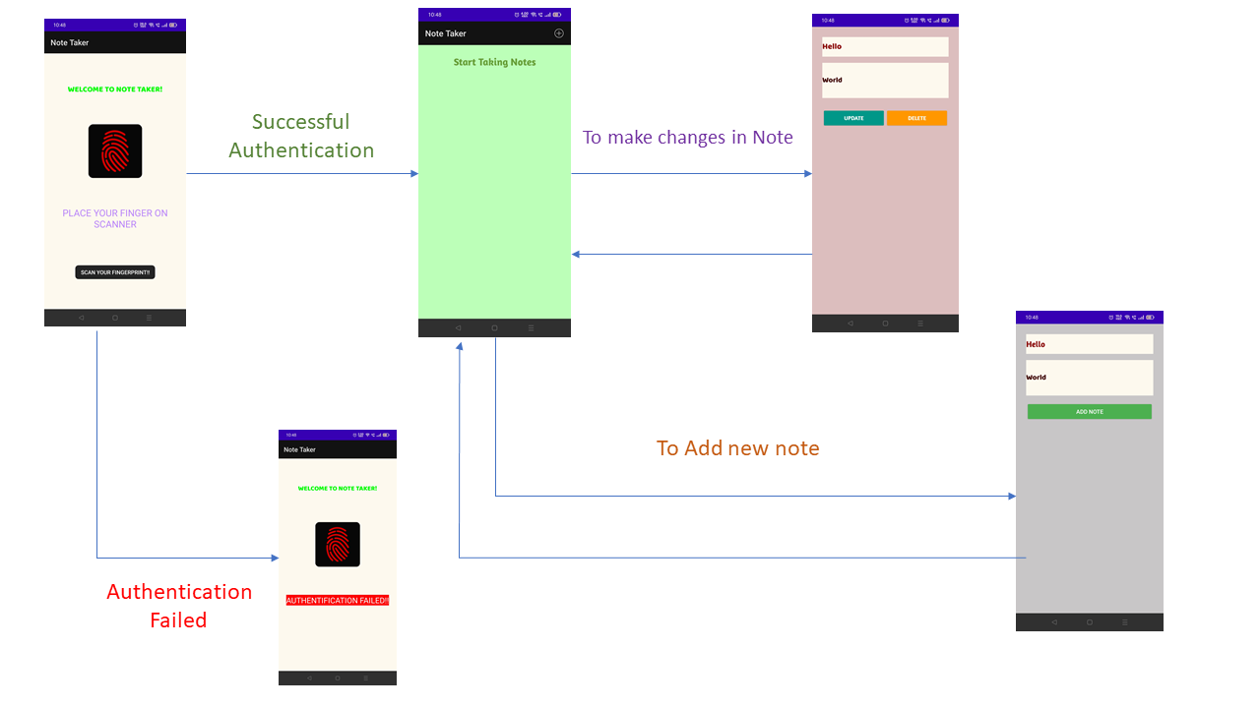

**PROGRAM CODE OF THE APPLICATION:**

**MANIFEST.XML:**

*<?*xml version="1.0" encoding="utf-8"*?>*<manifest xmlns:android="http://schemas.android.com/apk/res/android"  
 package="com.parthnpatel.notetaking">  
  
  
 <uses-permission android:name="android.permission.USE_FINGERPRINT"/>  
  
 <application  
 android:allowBackup="true"  
 android:icon="@mipmap/ic_launcher"  
 android:label="@string/app_name"  
 android:roundIcon="@mipmap/ic_launcher"  
 android:supportsRtl="true"  
 android:theme="@style/Theme.NoteTaking">  
 <activity  
 android:name=".MainActivity"  
 android:exported="true" />  
 <activity  
 android:name=".ModifyData"  
 android:exported="true" />  
 <activity  
 android:name=".AddNoteAcitivity"  
 android:exported="true" />  
 <activity  
 android:name=".Finger_Print"  
 android:exported="true">  
 <intent-filter>  
 <action android:name="android.intent.action.MAIN" />  
  
 <category android:name="android.intent.category.LAUNCHER" />  
 </intent-filter>  
 </activity>  
 </application>  
  
</manifest>

**COLORS.XML:**

*<?*xml version="1.0" encoding="utf-8"*?>*<resources>  
 <color name="purple_200">#FFBB86FC</color>  
 <color name="purple_500">#FF6200EE</color>  
 <color name="purple_700">#FF3700B3</color>  
 <color name="teal_200">#FF03DAC5</color>  
 <color name="teal_700">#FF018786</color>  
 <color name="black">#FF000000</color>  
 <color name="white">#FFFFFFFF</color>  
 <color name="title">#8E0505</color>  
 <color name="title_background">#FEF9EF</color>  
 <color name="description">#3D0000</color>  
 <color name="background">#DDBEBE</color>  
 <color name="green">#00FF00</color>  
 <color name="main_background">#BCFFB9</color>  
 <color name="add_background">#C8C6C6</color>  
 <color name="red">#FF0000</color>  
  
</resources>

**STRINGS.XML:**

<resources>  
 <string name="app_name">Note Taker</string>  
 <string name="notetaking_app">Start Taking Notes</string>  
 <string name="enter_the_title">Enter the title</string>  
 <string name="enter_the_description">Enter the Description</string>  
 <string name="update">UPDATE</string>  
 <string name="delete">DELETE</string>  
 <string name="add_note">ADD NOTE</string>  
 <string name="welcome">WELCOME TO NOTE TAKER!</string>  
 <string name="please_authenticate">PLEASE AUTHENTICATE</string>  
 <string name="fingerprintlogo">FINGER PRINT LOGO</string>  
  
</resources>

**FINGER_PRINT_BACKGROUND.XML:**

*<?*xml version="1.0" encoding="utf-8"*?>*<resources>  
 <color name="finger_print_background">#070707</color>  
</resources>

**ACTIVITY_MAIN.XML:**

*<?*xml version="1.0" encoding="utf-8"*?>*<androidx.constraintlayout.widget.ConstraintLayout xmlns:android="http://schemas.android.com/apk/res/android"  
 xmlns:app="http://schemas.android.com/apk/res-auto"  
 xmlns:tools="http://schemas.android.com/tools"  
 android:layout_width="match_parent"  
 android:layout_height="match_parent"  
 android:background="@color/main_background"  
 tools:context=".MainActivity">  
  
 <ListView  
 android:id="@+id/list"  
 android:layout_width="match_parent"  
 android:layout_height="wrap_content"  
 android:dividerHeight="1px"  
 android:minHeight="48dp"  
 android:padding="10dp"  
 app:layout_constraintBottom_toBottomOf="parent"  
 app:layout_constraintEnd_toEndOf="parent"  
 app:layout_constraintStart_toStartOf="parent"  
 app:layout_constraintTop_toTopOf="parent"  
 app:layout_constraintVertical_bias="0.120000005"  
 tools:ignore="TouchTargetSizeCheck" />

<TextView  
 android:id="@+id/text"  
 android:layout_width="249dp"  
 android:layout_height="49dp"  
 android:fontFamily="@font/amaranth_bold"  
 android:text="@string/notetaking_app"  
 android:textAlignment="center"  
 android:textColor="#689F38"  
 android:textSize="24sp"  
 app:layout_constraintBottom_toBottomOf="parent"  
 app:layout_constraintEnd_toEndOf="parent"  
 app:layout_constraintStart_toStartOf="parent"  
 app:layout_constraintTop_toTopOf="parent"  
 app:layout_constraintVertical_bias="0.041" />  
  
</androidx.constraintlayout.widget.ConstraintLayout>

**ACTIVITY_ADD_NOTE_ACTIVITY.XML:**

*<?*xml version="1.0" encoding="utf-8"*?>*<LinearLayout xmlns:android="http://schemas.android.com/apk/res/android"  
 xmlns:app="http://schemas.android.com/apk/res-auto"  
 xmlns:tools="http://schemas.android.com/tools"  
 android:layout_width="match_parent"  
 android:layout_height="match_parent"  
 android:background="@color/add_background"  
 android:orientation="vertical"  
 android:padding="25dp">  
  
  
 <EditText  
 android:id="@+id/title_editText"  
 android:layout_width="match_parent"  
 android:layout_height="wrap_content"  
 android:layout_marginBottom="15dp"  
 android:background="@color/title_background"  
 android:backgroundTint="@color/title_background"  
 android:ems="10"  
 android:fontFamily="@font/amaranth_bold"  
 android:hint="@string/enter_the_title"  
 android:importantForAutofill="no"  
 android:minHeight="48dp"  
 android:textColor="@color/title"  
 android:textSize="20sp"  
 tools:ignore="TextContrastCheck">  
  
 <requestFocus />  
  
 </EditText>  
  
 <EditText  
 android:id="@+id/description_editText"  
 android:layout_width="match_parent"  
 android:layout_height="wrap_content"  
 android:layout_marginBottom="15dp"  
 android:background="@color/title_background"  
 android:backgroundTint="@color/title_background"  
 android:ems="10"  
 android:fontFamily="@font/baloo_bhai"  
 android:hint="@string/enter_the_description"  
 android:importantForAutofill="no"  
 android:inputType="textMultiLine"  
 android:minLines="3"  
 android:textColor="@color/description"  
 tools:ignore="TextContrastCheck" />  
  
 <Button  
 android:id="@+id/addButton"  
 android:layout_width="match_parent"  
 android:layout_height="wrap_content"  
 android:layout_gravity="center"  
 android:backgroundTint="#4CAF50"  
 android:text="@string/add_note"  
 android:textColor="@color/white"  
 app:rippleColor="#FFEB3B"  
 tools:ignore="TextContrastCheck" />  
  
  
</LinearLayout>

**ACTIVITY_MODIFY_DATA.XML:**

*<?*xml version="1.0" encoding="utf-8"*?>*<LinearLayout xmlns:android="http://schemas.android.com/apk/res/android"  
 xmlns:app="http://schemas.android.com/apk/res-auto"  
 xmlns:tools="http://schemas.android.com/tools"  
 android:layout_width="match_parent"  
 android:layout_height="match_parent"  
 android:background="@color/background"  
 android:orientation="vertical"  
 android:padding="25dp">  
  
 <EditText  
 android:id="@+id/title_editText"  
 android:layout_width="match_parent"  
 android:layout_height="wrap_content"  
 android:layout_marginBottom="15dp"  
 android:background="@color/title_background"  
 android:backgroundTint="@color/title_background"  
 android:ems="10"  
 android:fontFamily="@font/baloo_bhai"  
  
 android:hint="@string/enter_the_title"  
 android:importantForAutofill="no"  
 android:minHeight="48dp"  
 android:textColor="@color/title"  
 android:textSize="20sp"  
 tools:ignore="TextContrastCheck" />  
  
 <EditText  
 android:id="@+id/description_editText"  
 android:layout_width="match_parent"  
 android:layout_height="wrap_content"  
 android:layout_marginBottom="25dp"  
 android:background="@color/title_background"  
 android:backgroundTint="@color/title_background"  
 android:ems="10"  
 android:fontFamily="@font/baloo_bhai"  
 android:hint="@string/enter_the_description"  
 android:importantForAutofill="no"  
 android:inputType="textMultiLine"  
 android:minLines="3"  
 android:textColor="@color/description"  
 tools:ignore="TextContrastCheck" />  
  
 <LinearLayout  
 android:layout_width="match_parent"  
 android:layout_height="wrap_content"  
 android:layout_gravity="center"  
 android:orientation="horizontal"  
 android:weightSum="2">  
 <Button  
 android:id="@+id/updateButton"  
 android:layout_width="wrap_content"  
 android:layout_height="wrap_content"  
 android:layout_weight="1"  
 android:backgroundTint="#009688"  
 android:fontFamily="@font/amaranth_bold"  
 android:text="@string/update"  
 android:textColor="@color/white"  
 app:rippleColor="#8BC34A" />  
 <Button  
 android:id="@+id/deleteButton"  
 android:layout_width="wrap_content"  
 android:layout_height="wrap_content"  
 android:layout_weight="1"  
 android:backgroundTint="#FF9800"  
 android:fontFamily="@font/amaranth_bold"  
 android:text="@string/delete"  
 android:textColor="@color/white"  
 app:rippleColor="#F44336" />  
  
 </LinearLayout>  
</LinearLayout>

**ACTIVITY_VIEW_DATA.XML:**

*<?*xml version="1.0" encoding="utf-8"*?>*<LinearLayout xmlns:android="http://schemas.android.com/apk/res/android"  
 android:layout_width="match_parent"  
 android:layout_height="wrap_content"  
  
 android:orientation="vertical"  
 android:padding="3dp">  
  
 <TextView  
 android:id="@+id/id"  
 android:layout_width="411dp"  
 android:layout_height="wrap_content"  
  
 android:background="@color/title_background"  
 android:backgroundTint="@color/title_background"  
 android:fontFamily="@font/amaranth_bold"  
 android:textAlignment="center"  
 android:textColor="@color/title"  
 android:textSize="16sp"  
 android:visibility="invisible" />  
  
 <TextView  
 android:id="@+id/title"  
 android:layout_width="match_parent"  
 android:layout_height="wrap_content"  
 android:background="@color/title_background"  
 android:backgroundTint="@color/title_background"  
 android:fontFamily="@font/amaranth_bold"  
 android:maxLines="1"  
 android:padding="3dp"  
 android:paddingBottom="10dp"  
 android:textAlignment="center"  
 android:textColor="@color/title"  
 android:textSize="20sp" />  
  
 <TextView  
 android:id="@+id/description"  
 android:layout_width="match_parent"  
 android:layout_height="wrap_content"  
 android:layout_marginBottom="10dp"  
 android:background="@color/title_background"  
 android:backgroundTint="@color/title_background"  
 android:ellipsize="end"  
  
 android:padding="3dp"  
 android:textAlignment="gravity"  
 android:textColor="@color/description"  
 android:textSize="18sp"  
 android:visibility="visible" />  
  
  
</LinearLayout>

**ACTIVITY_FINGER_PRINT.XML:**

*<?*xml version="1.0" encoding="utf-8"*?>*<androidx.constraintlayout.widget.ConstraintLayout xmlns:android="http://schemas.android.com/apk/res/android"  
 xmlns:app="http://schemas.android.com/apk/res-auto"  
 xmlns:tools="http://schemas.android.com/tools"  
 android:layout_width="match_parent"  
 android:layout_height="match_parent"  
 android:background="@color/title_background"  
 tools:context=".Finger_Print">  
  
 <TextView  
 android:id="@+id/displayView"  
 android:layout_width="wrap_content"  
 android:layout_height="wrap_content"  
 android:layout_marginTop="76dp"  
 android:fontFamily="@font/baloo_bhai"  
 android:text="@string/welcome"  
 android:textColor="@color/green"  
 android:textSize="20sp"  
 app:layout_constraintEnd_toEndOf="parent"  
 app:layout_constraintStart_toStartOf="parent"  
 app:layout_constraintTop_toTopOf="parent"  
 tools:ignore="TextContrastCheck" />  
  
 <TextView  
 android:id="@+id/resultDisplay"  
 android:layout_width="wrap_content"  
 android:layout_height="wrap_content"  
 android:layout_marginBottom="200dp"  
 android:text="@string/please_authenticate"  
 android:textAlignment="center"  
 android:textColor="@color/purple_200"  
 android:textSize="24sp"  
 app:layout_constraintBottom_toBottomOf="parent"  
 app:layout_constraintEnd_toEndOf="parent"  
 app:layout_constraintHorizontal_bias="0.498"  
 app:layout_constraintStart_toStartOf="parent"  
 tools:ignore="TextContrastCheck" />  
  
 <ImageView  
 android:id="@+id/displayImage"  
 android:layout_width="173dp"  
 android:layout_height="136dp"  
 android:contentDescription="@string/fingerprintlogo"  
 app:layout_constraintBottom_toTopOf="@+id/resultDisplay"  
 app:layout_constraintEnd_toEndOf="parent"  
 app:layout_constraintStart_toStartOf="parent"  
 app:layout_constraintTop_toBottomOf="@+id/displayView"  
 app:srcCompat="@mipmap/finger_print" />  
  
</androidx.constraintlayout.widget.ConstraintLayout>

**MAINACTIVITY.JAVA:**

package com.parthnpatel.notetaking;  
  
import androidx.annotation.NonNull;  
import androidx.appcompat.app.AppCompatActivity;  
  
import android.content.Intent;  
import android.database.Cursor;  
import android.os.Bundle;  
import android.view.Menu;  
import android.view.MenuItem;  
import android.view.View;  
import android.widget.AdapterView;  
import android.widget.ListView;  
import android.widget.SimpleCursorAdapter;  
import android.widget.TextView;  
  
public class MainActivity extends AppCompatActivity {  
  
 private SqlManager sqlManager;  
 private ListView listView;  
 private SimpleCursorAdapter simpleCursorAdapter;  
  
 final String[] from=new String[] { SqlHelper.*ID*,SqlHelper.*TITLE*,SqlHelper.*DESCRIPTION*};  
 final int[] to=new int[]{R.id.*id*,R.id.*title*,R.id.*description*};  
  
 @Override  
 protected void onCreate(Bundle savedInstanceState) {  
 super.onCreate(savedInstanceState);  
 setContentView(R.layout.*activity_main*);  
  
 sqlManager=new SqlManager(this);  
 sqlManager.openDataBase();  
 Cursor cursor=sqlManager.fetchData();  
 listView=findViewById(R.id.*list*);  
 listView.setEmptyView(findViewById(R.id.*text*));  
  
 simpleCursorAdapter=new SimpleCursorAdapter(this,R.layout.*activity_view_data*,cursor,from,to,0);  
 simpleCursorAdapter.notifyDataSetChanged();  
  
 listView.setAdapter(simpleCursorAdapter);  
  
 listView.setOnItemClickListener(new AdapterView.OnItemClickListener() {  
 @Override  
 public void onItemClick(AdapterView<?> parent, View view, int position, long viewid) {  
 TextView text_id=view.findViewById(R.id.*id*);  
 TextView text_title=view.findViewById(R.id.*title*);  
 TextView text_description=view.findViewById(R.id.*description*);  
  
 String id=text_id.getText().toString();  
 String title=text_title.getText().toString();  
 String description=text_description.getText().toString();  
  
 Intent modify_intent= new Intent(getApplicationContext(),ModifyData.class);  
  
 modify_intent.putExtra("id",id);  
 modify_intent.putExtra("title",title);  
 modify_intent.putExtra("description",description);  
  
 startActivity(modify_intent);  
  
 }  
 });  
  
 }  
  
 @Override  
 public boolean onCreateOptionsMenu(Menu menu) {  
 getMenuInflater().inflate(R.menu.*menu*,menu);  
 return true;  
 }  
  
 @Override  
 public boolean onOptionsItemSelected(@NonNull MenuItem item) {  
  
 int id=item.getItemId();  
  
 if(id==R.id.*add_note*){  
  
 Intent add_note=new Intent(this,AddNoteAcitivity.class);  
  
 startActivity(add_note);  
 }  
  
 return super.onOptionsItemSelected(item);  
 }  
}

**SQLHELPER.JAVA:**

package com.parthnpatel.notetaking;  
  
import android.content.Context;  
import android.database.sqlite.SQLiteDatabase;  
import android.database.sqlite.SQLiteOpenHelper;

import java.security.PublicKey;

public class SqlHelper extends SQLiteOpenHelper {  
  
 public static final String *TABLE_NAME*="NOTETAKER";  
 public static final String *ID*="_id";  
 public static final String *TITLE*="title";  
 public static final String *DESCRIPTION*="description";  
 public static final String *DB_NAME*="NOTETAKER_APPLICATION.DB";  
  
 private static final String *CREATE_TABLE*="create table "+*TABLE_NAME*+ "("+*ID*+" INTEGER PRIMARY KEY AUTOINCREMENT, "+  
 *TITLE*+ " TEXT NOT NULL, "+*DESCRIPTION*+" TEXT NOT NULL);";  
  
  
 public SqlHelper(Context context){  
  
 super(context,*DB_NAME*,null,1);  
 }  
  
  
 @Override  
 public void onCreate(SQLiteDatabase sqLiteDatabase) {  
  
 sqLiteDatabase.execSQL(*CREATE_TABLE*);  
  
 }  
  
 @Override  
 public void onUpgrade(SQLiteDatabase sqLiteDatabase, int i, int i1) {  
  
 sqLiteDatabase.execSQL("DROP TABLE IF EXISTS "+*TABLE_NAME*);  
 onCreate(sqLiteDatabase);  
 }  
}

**SQLMANAGER.JAVA:**

package com.parthnpatel.notetaking;  
  
import android.content.ContentValues;  
import android.content.Context;  
import android.database.Cursor;  
import android.database.SQLException;  
import android.database.sqlite.SQLiteDatabase;  
  
public class SqlManager {  
  
 private SqlHelper sqlHelper;  
 private Context context;  
 private SQLiteDatabase database;  
  
 public SqlManager(Context context){  
  
 this.context=context;  
  
 }  
  
 public SqlManager openDataBase() throws SQLException{  
  
 sqlHelper=new SqlHelper(context);  
  
 database=sqlHelper.getWritableDatabase();  
  
 return this;  
 }  
  
 public void closeDataBase() {  
 sqlHelper.close();  
 }  
  
 public void insert(String title,String description){  
 ContentValues contentValues=new ContentValues();  
  
  
 contentValues.put(sqlHelper.*TITLE*,title);  
 contentValues.put(sqlHelper.*DESCRIPTION*,description);  
 database.insert(sqlHelper.*TABLE_NAME*,null,contentValues);  
  
 }  
  
 public Cursor fetchData(){  
  
 String columnNames[]=new String[]{sqlHelper.*ID*,sqlHelper.*TITLE*,sqlHelper.*DESCRIPTION*};  
 Cursor cursor= database.query(sqlHelper.*TABLE_NAME*,  
 columnNames,  
 null,  
 null,  
 null,  
 null,  
 null);  
  
 if(cursor!=null){  
  
 cursor.moveToFirst();  
 }  
  
 return cursor;  
 }  
  
 public int update(long id,String title,String description){  
  
 ContentValues contentValues=new ContentValues();  
  
 contentValues.put(sqlHelper.*TITLE*,title);  
 contentValues.put(sqlHelper.*DESCRIPTION*,description);  
  
 int status=database.update(sqlHelper.*TABLE_NAME*,contentValues,sqlHelper.*ID*+"="+id,null);  
  
 return status;  
 }  
  
 public void delete(long id){  
  
 database.delete(sqlHelper.*TABLE_NAME*,sqlHelper.*ID*+"="+id,null);  
 }  
}

**ADDNOTEACTIVITY.JAVA:**

package com.parthnpatel.notetaking;  
  
  
import android.app.Activity;  
import android.content.Intent;  
import android.os.Bundle;  
import android.view.View;  
import android.widget.Button;  
import android.widget.EditText;  
  
public class AddNoteAcitivity extends Activity implements View.OnClickListener {  
  
 private Button add;  
 private EditText title,description;  
 private SqlManager sqlManager;  
  
 @Override  
 protected void onCreate(Bundle savedInstanceState) {  
 super.onCreate(savedInstanceState);  
  
 setTitle("Add Note!");  
  
 setContentView(R.layout.*activity_add_note_acitivity*);  
  
 add=findViewById(R.id.*addButton*);  
 title=findViewById(R.id.*title_editText*);  
 description=findViewById(R.id.*description_editText*);  
  
 sqlManager=new SqlManager(this);  
  
 sqlManager.openDataBase();  
  
 add.setOnClickListener(this);  
  
 }  
  
  
 @Override  
 public void onClick(View view) {  
  
 switch (view.getId()){  
 default:  
 final String titleText=title.getText().toString();  
 final String descriptionText=description.getText().toString();  
  
 sqlManager.insert(titleText,descriptionText);  
  
 Intent main =new Intent(AddNoteAcitivity.this,MainActivity.class).setFlags(Intent.*FLAG_ACTIVITY_CLEAR_TOP*);  
  
 startActivity(main);  
  
 break;  
  
 }  
 }  
}

**MODIFYDATA.JAVA:**

package com.parthnpatel.notetaking;  
  
import android.app.Activity;  
import android.content.Intent;  
import android.os.Bundle;  
import android.view.View;  
import android.widget.Button;  
import android.widget.EditText;  
  
public class ModifyData extends Activity implements View.OnClickListener {  
  
 private EditText title,description;  
 private Button update_button,delete_button;  
  
 private long _id;  
 private SqlManager sqlManager;  
  
  
 @Override  
 protected void onCreate(Bundle savedInstanceState) {  
 super.onCreate(savedInstanceState);  
  
 setTitle("MODIFY NOTES");  
 setContentView(R.layout.*activity_modify_data*);  
  
 sqlManager=new SqlManager(this);  
 sqlManager.openDataBase();  
 title=findViewById(R.id.*title_editText*);  
 description=findViewById(R.id.*description_editText*);  
 update_button=findViewById(R.id.*updateButton*);  
 delete_button=findViewById(R.id.*deleteButton*);  
  
 Intent intent=getIntent();  
 String id=intent.getStringExtra("id");  
 String titleString=intent.getStringExtra("title");  
 String descriptionString=intent.getStringExtra("description");  
  
 _id=Long.*parseLong*(id);  
  
 title.setText(titleString);  
 description.setText(descriptionString);  
  
 update_button.setOnClickListener(this);  
 delete_button.setOnClickListener(this);  
 }  
 @Override  
 public void onClick(View view) {  
  
 switch (view.getId()){  
  
 case R.id.*updateButton*:  
 String titleSet= title.getText().toString();  
 String descriptionSet=description.getText().toString();  
  
 sqlManager.update(_id,titleSet,descriptionSet);  
  
 this.returnHome();  
 break;  
  
 case R.id.*deleteButton*:  
 sqlManager.delete(_id);  
 this.returnHome();  
 break;  
 }  
 }  
 private void returnHome() {  
 Intent home=new Intent(getApplicationContext(),MainActivity.class).setFlags(Intent.*FLAG_ACTIVITY_CLEAR_TOP*);  
 startActivity(home);  
 }  
}

**FINGERPRINT.JAVA:**

package com.parthnpatel.notetaking;  
  
import androidx.appcompat.app.AppCompatActivity;  
import androidx.core.content.ContextCompat;  
  
  
import android.Manifest;  
import android.content.pm.PackageManager;  
import android.hardware.fingerprint.FingerprintManager;  
import android.os.Bundle;  
import android.widget.ImageView;  
import android.widget.TextView;  
import android.widget.Toast;  
import android.os.Bundle;  
public class Finger_Print extends AppCompatActivity {  
  
 private TextView result;  
 private ImageView image;  
 private FingerprintManager fingerprintManager;  
  
 @Override  
 protected void onCreate(Bundle savedInstanceState) {  
 super.onCreate(savedInstanceState);  
 setContentView(R.layout.*activity_finger_print*);  
  
 result=findViewById(R.id.*resultDisplay*);  
 image=findViewById(R.id.*displayImage*);  
  
 fingerprintManager=(FingerprintManager) getSystemService(*FINGERPRINT_SERVICE*);  
  
 if(!fingerprintManager.isHardwareDetected()){  
 result.setText("FingerPrint Scanner is not detected!!");  
  
 Toast.*makeText*(getApplicationContext(), "YOU CANNOT USE THIS APP!!", Toast.*LENGTH_SHORT*).show();  
 }  
  
 else if(ContextCompat.*checkSelfPermission*(this, Manifest.permission.*USE_FINGERPRINT*)!= PackageManager.*PERMISSION_GRANTED*){  
  
 result.setText("Permission Not Granted!!");  
  
 Toast.*makeText*(getApplicationContext(), "PLEASE GRANT THE PERMISSION TO USE FINGERPRINT", Toast.*LENGTH_SHORT*).show();  
 }  
  
 else if( !fingerprintManager.hasEnrolledFingerprints()){  
  
 result.setText("No FingerPrints Enrolled!!");  
  
 Toast.*makeText*(getApplicationContext(), "PLEASE REGISTER FINGERPRINT IN YOUR DEVICE!!", Toast.*LENGTH_SHORT*).show();  
 }  
  
 else{  
  
 result.setText("PLACE YOUR FINGER ON SCANNER");  
  
 Toast.*makeText*(getApplicationContext(), "SCAN YOUR FINGERPRINT!!", Toast.*LENGTH_SHORT*).show();  
 FingerPrintAuthentication check=new FingerPrintAuthentication(this);  
  
 check.authentification(fingerprintManager,null);  
  
  
  
 }  
 }  
}

**FINGERPRINTAUTHENTICATION.JAVA:**

package com.parthnpatel.notetaking;  
  
import android.app.Activity;  
import android.content.Context;  
import android.content.Intent;  
import android.hardware.fingerprint.FingerprintManager;  
import android.os.Build;  
import android.os.CancellationSignal;  
import android.widget.TextView;  
  
import androidx.core.content.ContextCompat;  
  
  
public class FingerPrintAuthentication extends FingerprintManager.AuthenticationCallback {  
  
 private Context context;  
  
 public FingerPrintAuthentication(Context context){  
  
 this.context=context;  
 }  
  
 public void authentification(FingerprintManager fingerprintManager,FingerprintManager.CryptoObject cryptoObject){  
  
 CancellationSignal cancellationSignal=new CancellationSignal();  
 fingerprintManager.authenticate(cryptoObject,cancellationSignal,0,this,null);  
  
  
 }  
  
 private void update(String str, boolean status){  
  
 TextView textView=(TextView) ((Activity)context).findViewById(R.id.*resultDisplay*);  
  
 textView.setText(str);  
  
 if(status==false){  
  
 textView.setBackgroundColor(ContextCompat.*getColor*(context,R.color.*red*));  
 textView.setTextColor(ContextCompat.*getColor*(context,R.color.*white*));  
  
 }  
  
 else{  
 textView.setBackgroundColor(ContextCompat.*getColor*(context,R.color.*green*));  
 textView.setTextColor(ContextCompat.*getColor*(context,R.color.*white*));  
 }  
 }  
  
 @Override  
 public void onAuthenticationError(int errorCode, CharSequence errString) {  
  
 this.update("OOPS! SOME ERROR OCCURED : "+errString,false);  
 }  
  
 @Override  
 public void onAuthenticationFailed() {  
  
 this.update("AUTHENTIFICATION FAILED!!",false);  
 }  
  
 @Override  
 public void onAuthenticationHelp(int helpCode, CharSequence helpString) {  
  
 this.update(helpString.toString()+" : ",false);  
 }  
  
 @Override  
 public void onAuthenticationSucceeded(FingerprintManager.AuthenticationResult result) {  
  
 *//this.update("AUTHENTIFICATION SUCCESSFUL!!",true);* Intent pass=new Intent(context.getApplicationContext(),MainActivity.class);  
 context.startActivity(pass);  
  
  
  
 }  
}

**OUTPUT SCREENSHOTS:**

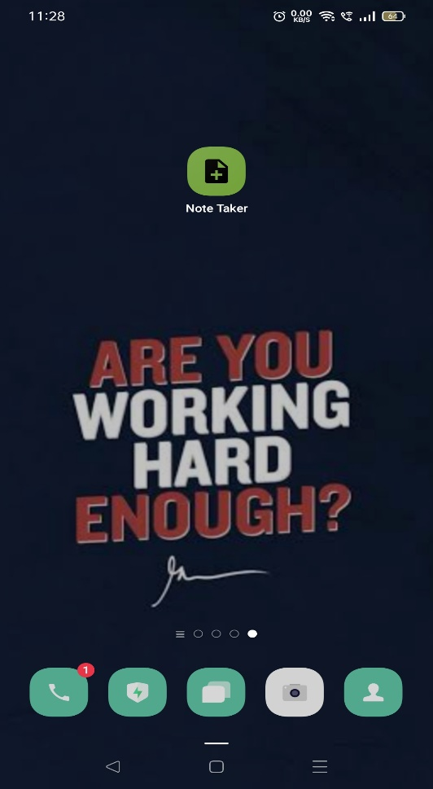

**ICON OF NOTE TAKER APP**

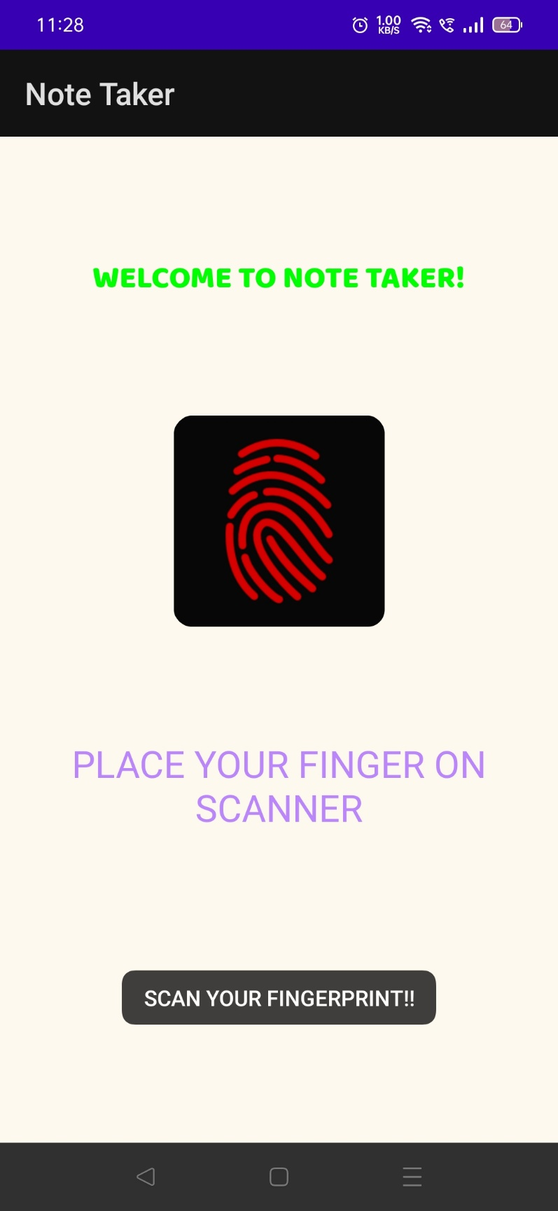

**ON OPENING THE APP, YOU WILL BE ASKED TO SCAN YOUR FINGERPRINT FOR SECURITY.**

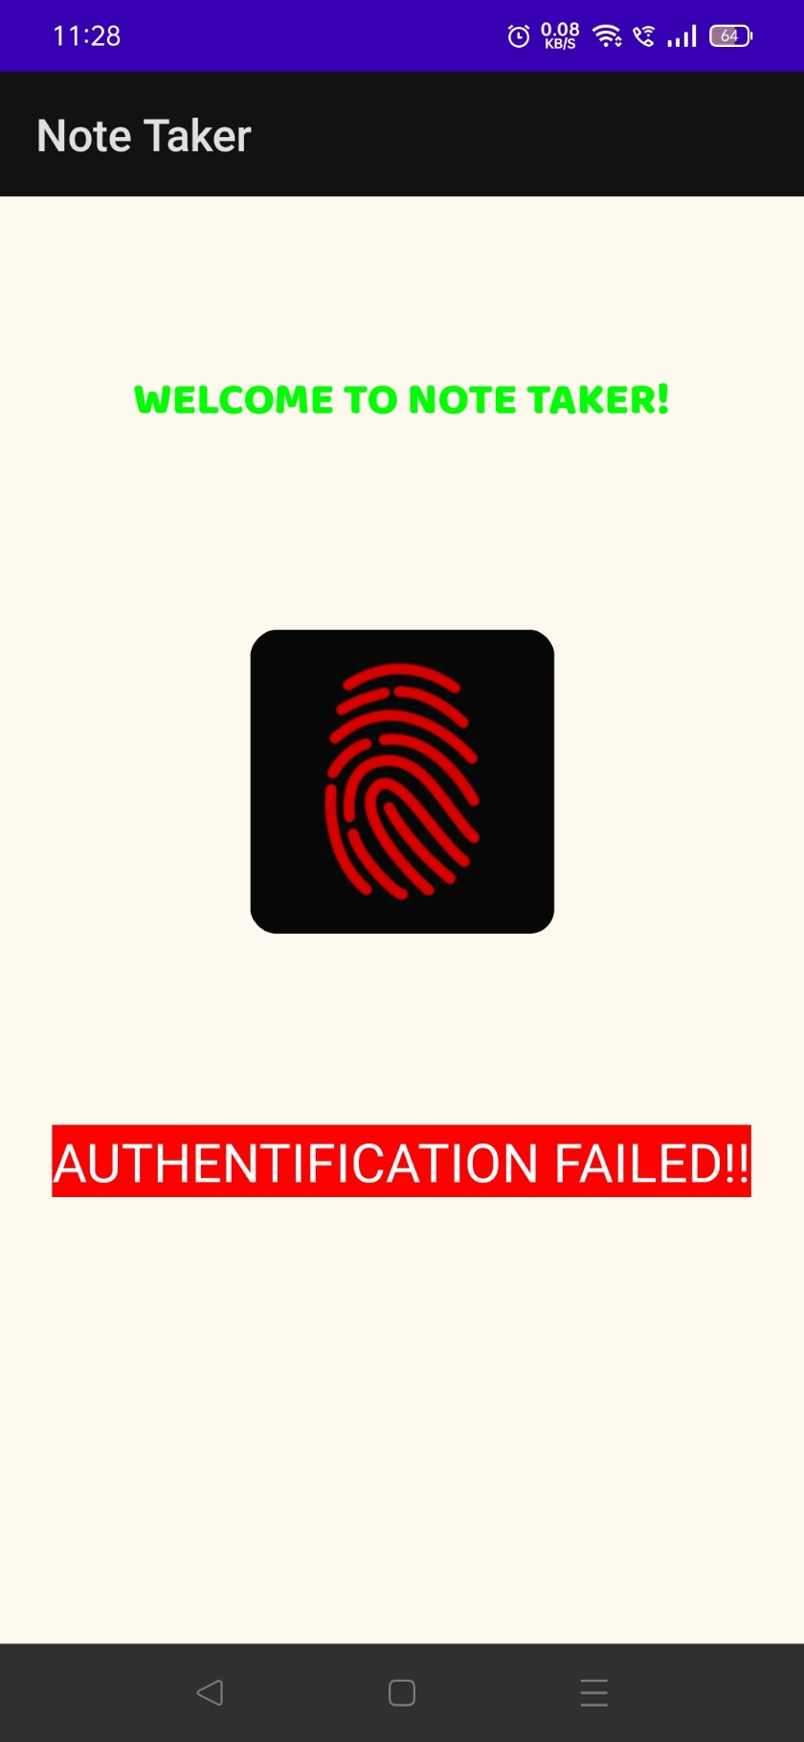

**AUTHENTIFICATION FAILED**

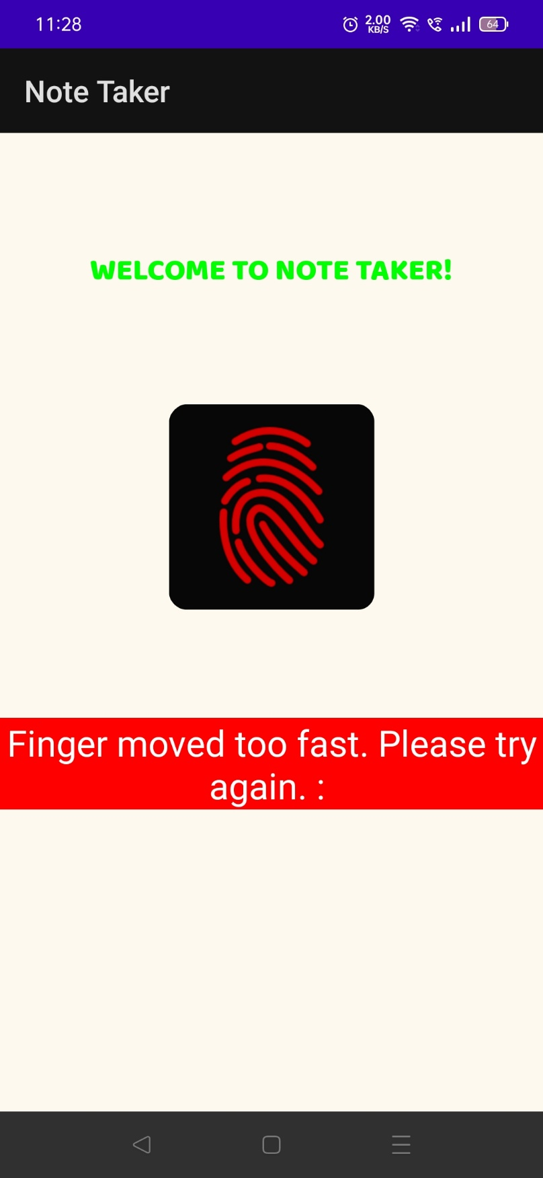

**APP CAN DETECT IF AUTHENTICATION FAILED BECAUSE OF OTHER REASONS**

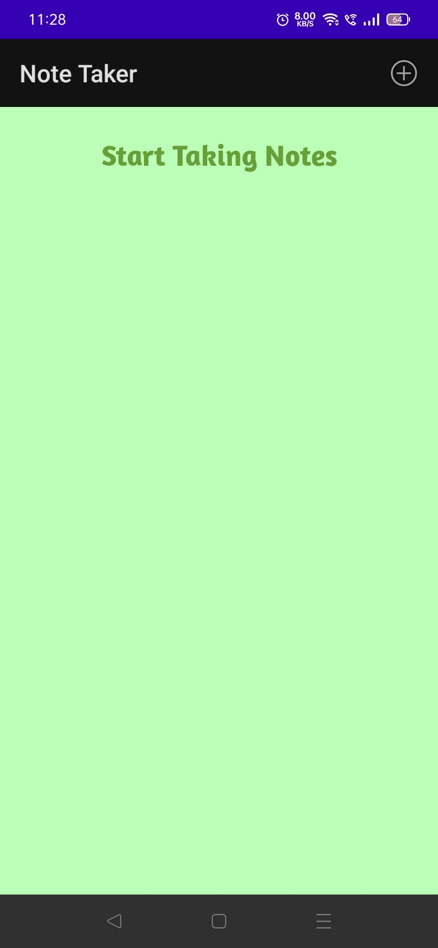

**UPON SUCCESSFUL AUTHENTICATION, THIS ACTIVITY WILL OPEN.**

**(IF SOME NOTES ARE ALREADY MADE, THEY WILL BE DISPLAYED)**

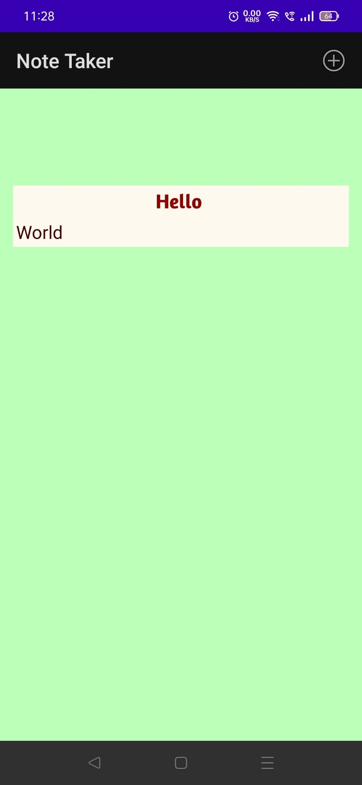

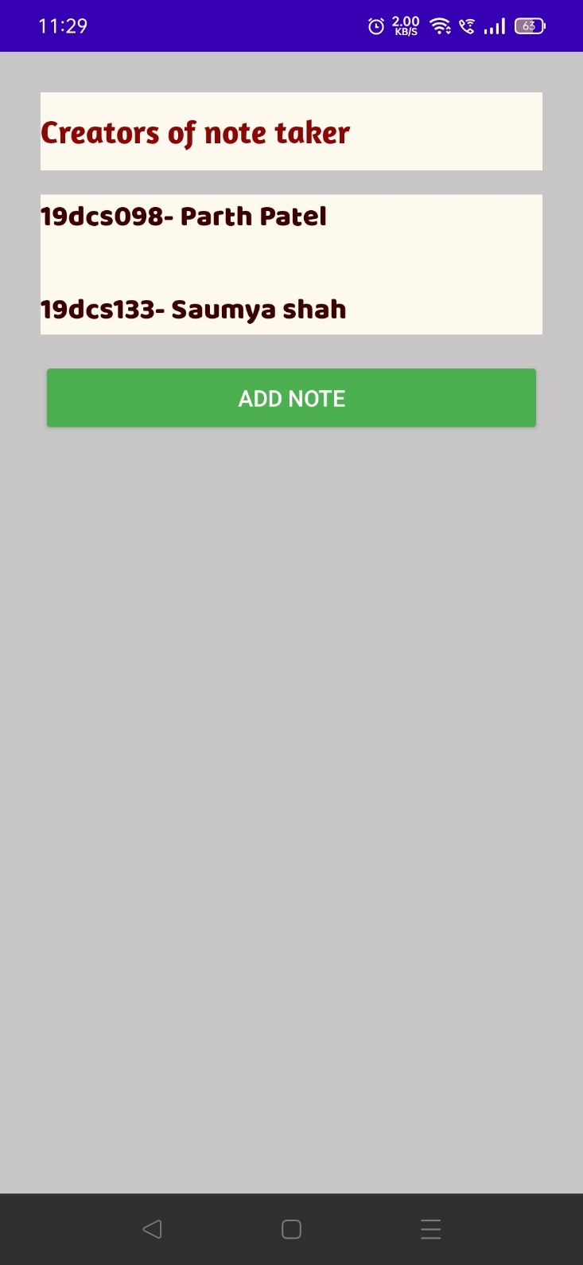

**ON CLICKING + ICON, THE ABOVE SCREEN WILL BE DISPLAYED WHERE YOU CAN CREATE NEW NOTE.**

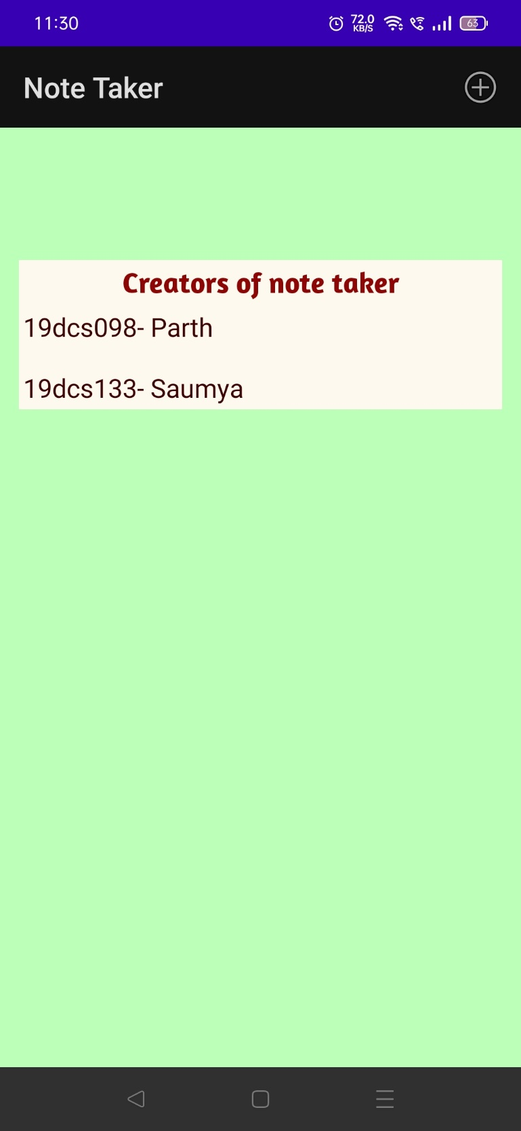

**ON CLICKING ADD BUTTON, NOTES WILL BE ADDED.**

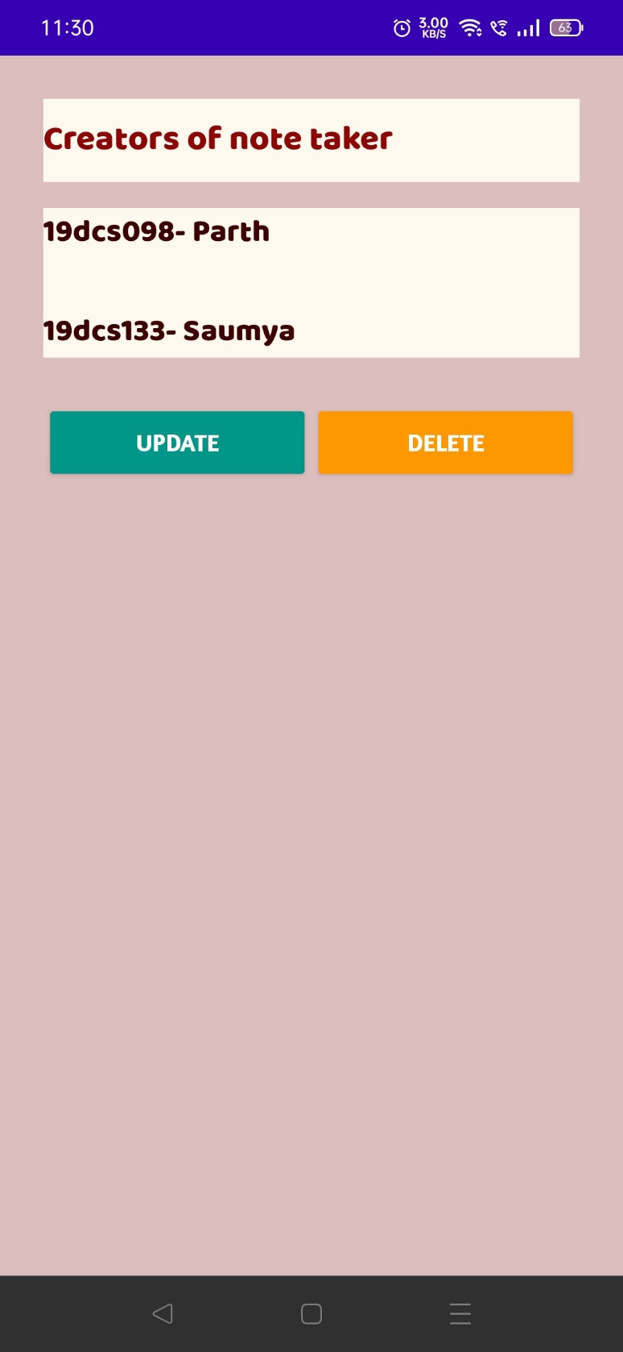

**YOU CAN UPDATE AND DELETE YOUR NOTES.**