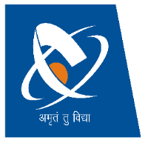 

**Charotar University of Science and Technology**

**Faculty of Technology and Engineering**

**Devang Patel Institute of Advance Technology and Research**

**Department of Computer Science & Engineering**

|  |  |
| --- | --- |
| **Academic Year: 2021-2022** | **Semester: 5** |
| **Subject Coordinator: Ms. Chintal Upendra Raval** |  |

**Subject: CS341 Artificial Intelligence**

* **Theory:**

**Pedagogy**

|  |  |  |
| --- | --- | --- |
| **Internal Exam** | | **University Exam** |
| **30 Marks** | | **70 Marks** |
| **15 Marks (60/4)** | **15 Marks** |  |
| **Sessional 1 (30)** | **Assignment (5)** |  |
| **Sessional 2 (30)** | **Presentation on Advance Topic (10)** |  |

* **Practical:**

|  |  |  |
| --- | --- | --- |
| **Internal Exam** | **External Exam** | |
| **25 Marks** | **25 Marks** | |
| **Lab Manual (10)** | **15 Marks** | **10 Marks** |
| **Project (15)** | **Viva** | **Practical Exam** |