NAME: PARTH NITESHKUMAR PATEL

ID: 19DCS098

**DEFINITION NUMBER :3**

**AIM:**

Write a program to demonstrate cut and fail in prolog.

**PROGRAM CODE:**

animal(cobra).

animal(python).

animal(blackMamba).

snake(cobra).

snake(python).

snake(blackMamba).

likes(raj,X):- snake(X),!,fail.

likes(raj,X):- animal(X).

**OUTPUT:**

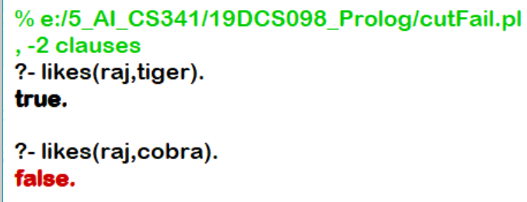

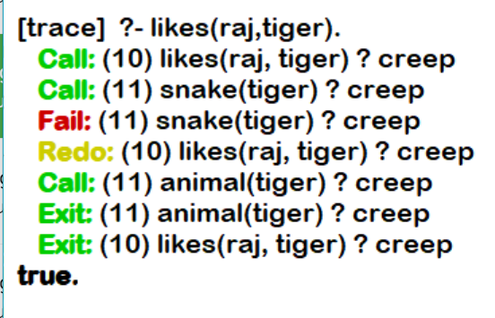

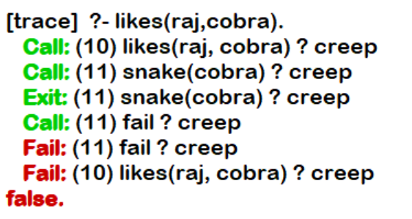

**CONCLUSION:**

By performing the above practical, we learned about cut and fail.

**CUT:**

* Represented by !.
* It always succeeds, but cannot be backtracked. It is best used to prevent unwanted backtracking,

**fail** is a special symbol that will immediately fail when Prolog encounters it as a goal