Assignment – 1

**Python Programming**

1. Ask the user for a number. Depending on whether the number is even or odd, print out an appropriate message to the user.
2. Take a list, say for example this one:

a = [1, 1, 2, 3, 5, 8, 13, 21, 34, 55, 89], and write a program that prints out all the elements of the list that are less than 5.

1. Take two lists

a = [1, 1, 2, 3, 5, 8, 13, 21, 34, 55, 89]

b = [1, 2, 3, 4, 5, 6, 7, 8, 9, 10, 11, 12, 13] and write a program that returns a list that contains only the elements that are common between the lists (without duplicates). Make sure your program works on two lists of different sizes.

1. Ask the user for a string and print out whether this string is a palindrome or not.
2. Ask the user for a number and determine whether the number is prime or not.
3. Write a program that asks the user how many Fibonacci numbers to generate using recursion.
4. Write a Python class named Circle constructed by a radius and two methods which will

compute the area and the perimeter of a circle.

1. Develop programs for data structure algorithms using python – sorting (Bubble sort and

Insertion sort)

1. Write a program that accepts a sentence and calculate the number of letters and digits.
2. Given a square chessboard of N x N size, the position of Knight and position of a target is given. We need to find out minimum steps a Knight will take to reach the target position.

For example:

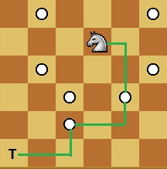

In above diagram Knight takes 3 step to reach from (4, 5) to (1, 1) (4, 5) -> (5, 3) -> (3, 2) -> (1, 1) as shown in diagram.