**A**

**Project Report**

**On**

**"HELPER"**

**Prepared by**

**Parth Patel-19DCS098**

**Shruti Patel-19DCS102**

**Saumya Shah-19DCS133**

**Under the guidance of**

**Priyal Vaghela**

**Assistant Professor**

A Report Submitted to

Charotar University of Science and Technology

for Partial Fulfillment of the Requirements for the

5th Semester Software Group Project-III

**Submitted at**



**CSE**

**DEPSTAR**



**CERTIFICATE**

This is to certify that the report entitled “**HELPER**” is a bonafied work carried out by **Parth Patel(19DCS098), Shruti Patel(19DCS102)** and **Saumya Shah(19DCS133)** under the guidance and supervision of **Assistant Prof. Priyal Vaghela** for the subject **Software Group Project-III** (CSE) of 5th Semester of Bachelor of Technology in **DEPSTAR** at Faculty of Technology & Engineering – CHARUSAT, Gujarat.

To the best of my knowledge and belief, this work embodies the work of candidate himself, has duly been completed, and fulfills the requirement of the ordinance relating to the B.Tech. Degree of the University and is up to the standard in respect of content, presentation and language for being referred to the examiner.

|  |  |
| --- | --- |
| Priyal Vaghela  Assistant Professor  Branch Name(CSE)  DEPSTAR, Changa, Gujarat. |  |
| Dr. Amit Ganatra  Principal, DEPSTAR  Dean, FTE  CHARUSAT, Changa, Gujarat. | |

**ACKNOWLEDGEMENT**

* We, the developers of “HELPER”, with immense pleasure and commitment would like to present the project assignment.
* The development of this project has given us wide opportunity to think, implement and interact with various aspects of management skills as well as the new emerging technologies.
* We hereby avail this opportunity to express our gratitude to number of people who extended their valuable time, full support and cooperation in developing the project.
* We express deep sense of gratitude towards our Head of the CSE Department, Dr. Parth Goel and project guide Prof. Priyal Vaghela for the support during the whole session of study and development. It is because of them, that we were prompted to do hard work, adopting new technologies.

Thanks,

Parth Patel(19DCS098)

Shruti Patel(19DCS102)

Saumya Shah(19DCS133)

**ABSTRACT**

* HELPER is an android application, designed to showcase the new emerging technology of natural language Processing
* Fundamentally, HELPER provides an ease in using the mobile device.
* Because of present scenario, many people are becoming lethargic and want to complete all the tasks with minimum effort. The same is the case with the usage of mobile phone.
* Also, it is a great to have your mobile performing the functionalities using your voice, instead of typing or moving your finger.
* We are here with the solution for above problem.
* Now you can make your android phone act like a butler and can perform various jobs on your voice commands.

**Table of Contents**

1. Title Page……………………………………………………………….1
2. Certificate………………………………………………………………2
3. Acknowledgement……………………………………………………...3
4. Abstract…………………………………………………………………4
5. Project Definition………………………………………………………6
6. Description……………………………………………………………..7
7. Software and Hardware Requirements…………………………………8
8. Major Functionalities…………………………………………………..9
9. Flow Chart…………………………………………………………….10
10. Screen Shots……………………………………………………………11
11. Limitations……………………………………………………………..20
12. Expected Outcomes…………………………………………………….21
13. Future Enhancements…………………………………………………..22
14. Tools and Technologies ………………………………………………..23
15. References……………………………………………………………..24

**PROJECT DEFINITION**

* HELPER- here comes your assistant is an android application.
* The application idea was developed by Saumya Shah and the application is developed by Parth Patel, Shruti Patel, and Saumya Shah.
* Our Main Aim is to facilitate customer to use their phone without any hassle of using fingers.
* The project will help in making using the mobile phone more convenient.
* The project simply connects the people with the new technologies facilitating the automation, which is the future.

**DESCRIPTION**

* HELPER as the name suggest is here to help you.
* Fundamentally, we have tried to develop an virtual mobile assistant with all our knowledge domain.
* We can say that our main aim was to clone the google assistant.
* But there comes the specialty of the application. Our helper application can run without the help of internet.
* One might have noticed that all the assistants available in the market require constant internet connectivity in order to function, but that is not the case with our application.
* Also, we have tried to keep the USER INTERFACE as simple as possible, so that it can contribute to more user friendliness.
* We have included a mandatory fingerprint authentication step before using the assistant.

**Software and Hardware Requirements**

**HARDWARE REQUIREMENTS:**

* Smart Phone
* Built-in/External Microphone
* Built in Camera
* Bluetooth driver
* Minimum 1 GB of RAM

**SOFTWARE REQUIREMENTS**:

* ANDROID OS
* Access to Bluetooth
* Access to Camera
* Access to all system functionalities

**MAJOR FUNCTIONALITY AND FEATURES**

* HELPER is very Easy To Use
* The users do not have to spend extra money
* No need to create any account
* 24/7 Availability
* No need to login
* Added security
* Mandatory Finger Print authentication step
* To access the website, just press a single button
* No personal details required
* Note Taker app available in it.

**SYSTEM FLOW CHART**

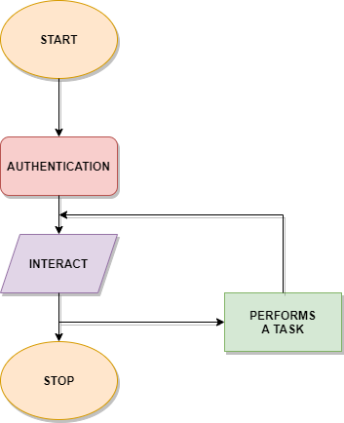

**SCREENSHOTS**

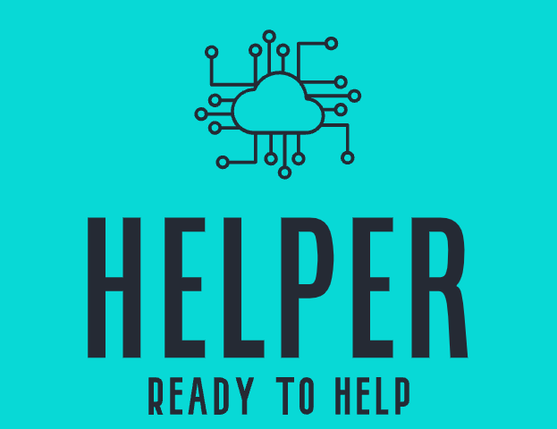

**LOGO OF THE APPLICATION**

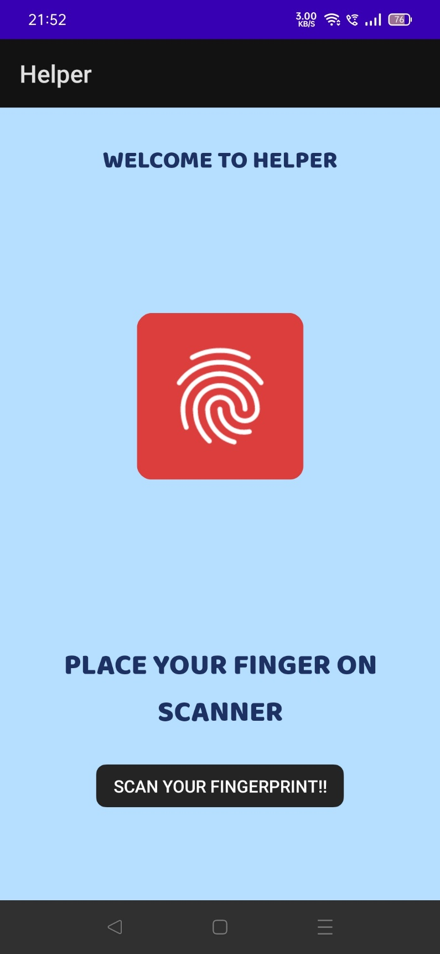

**WELCOME SCREEN AND FINGER PRINT AUTHENTIFICATION**

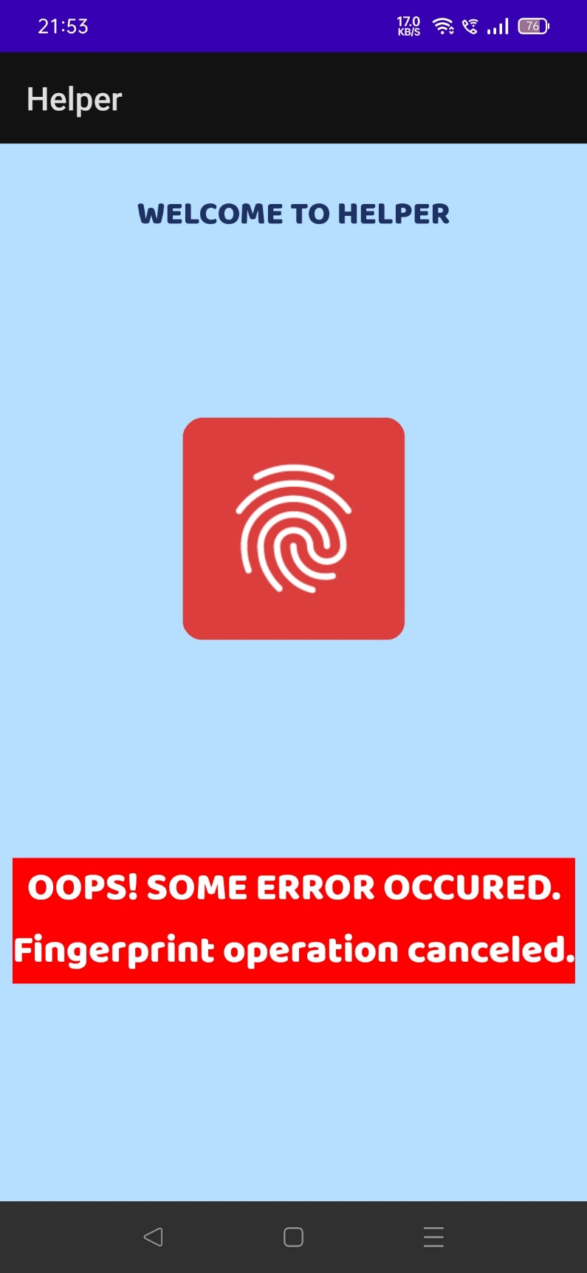

**AUTHENTIFICATION INTERRUPTED BECAUSE OF MISCELLINEOUS REASON**

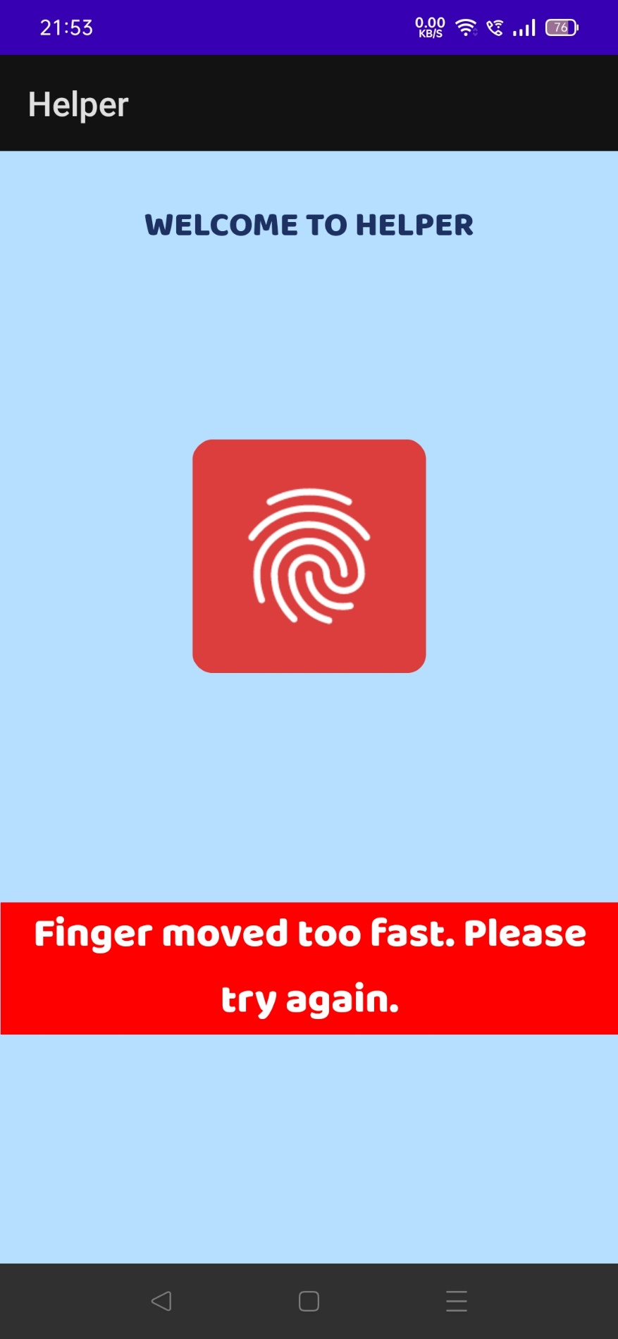

**AUTHENTIFICATION FAILED DUE TO FINGER MOVED TOO FAST**

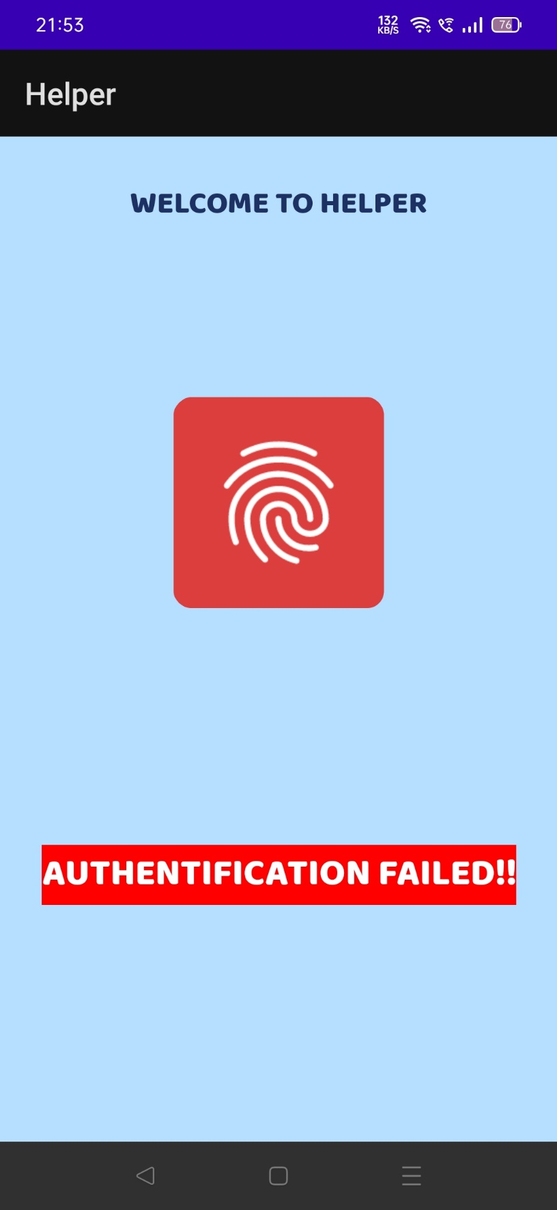

**AUTHENTIFICATION FAILED**

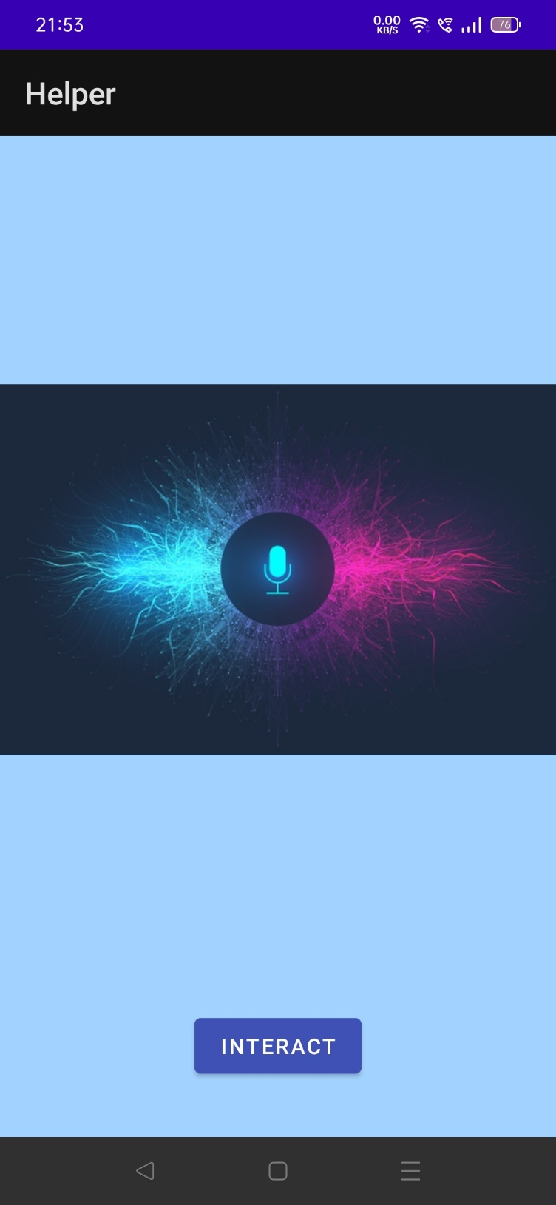

**INTERACTION SCREEN**

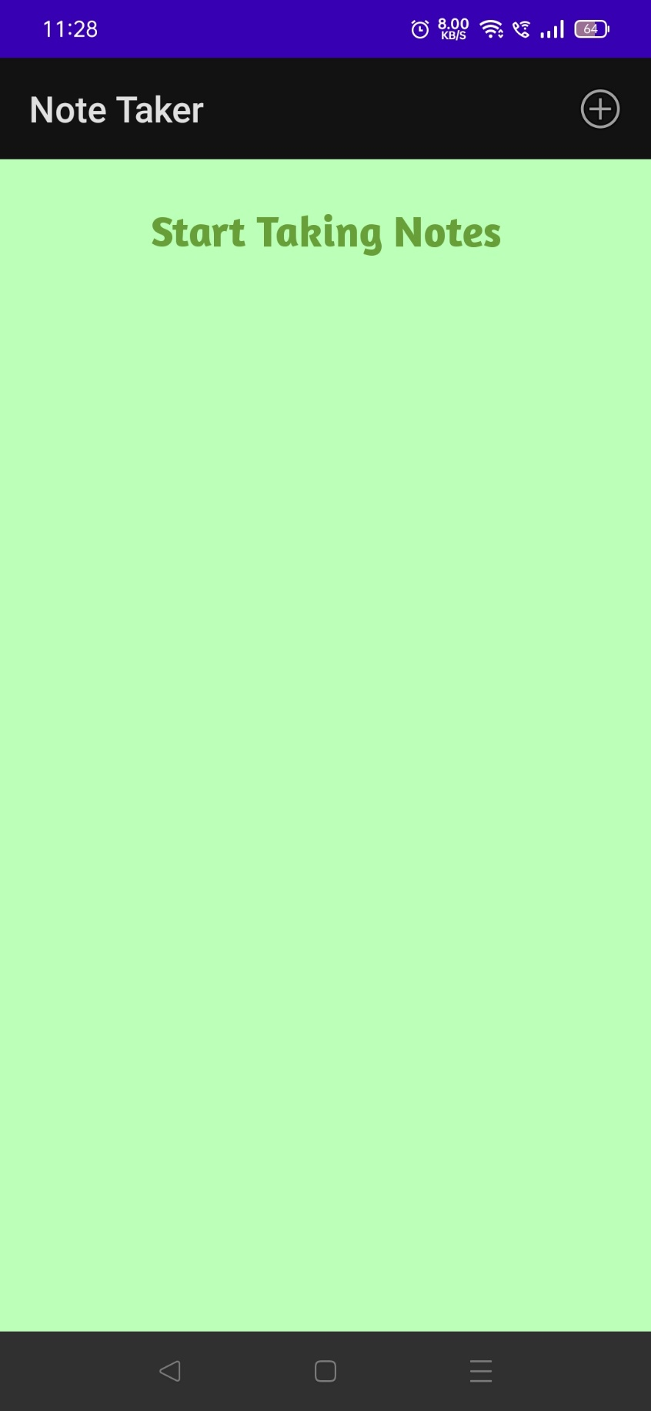

**NOTE TAKING APP’S WELCOME SCREEN**

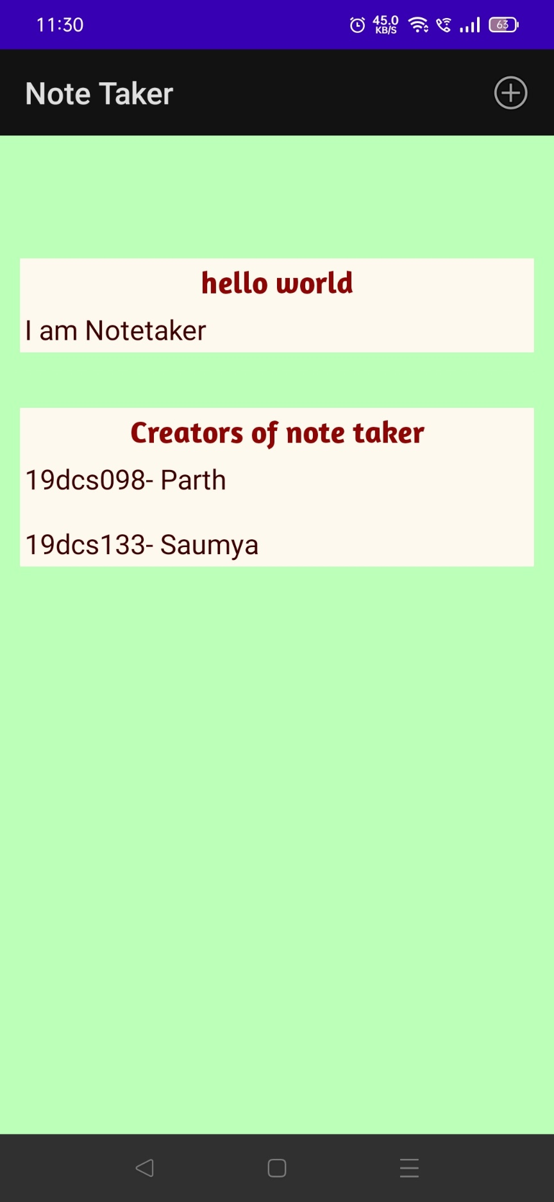

**NOTES STORED IN THE DATABASE**

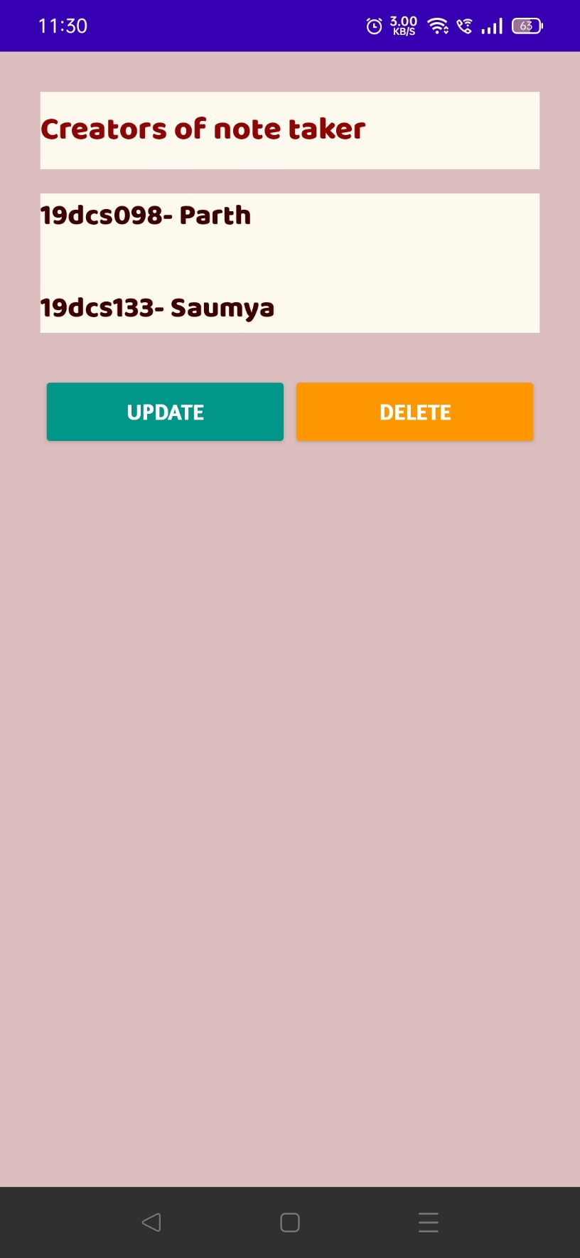

**EDIT SECTION**

**LIMITATIONS**

* The application has accuracy issues as it is still under development phase
* Sometimes, application tends to get stuck at one point.
* Application may get crashed if ram is not sufficient
* Application may not be accurate in catching the correct the words.
* To interact with the application, you need to press button, which can be cumbersome.
* Application is still just a basic clone of google assistant.
* It can only perform limited functions and is not as dynamic as google assistant.

**EXCEPTED OUTCOMES**

* HELPER will provide an ease to use the mobile phone to users.
* HELPER will work even if device is not connected with the internet
* HELPER also aims at reducing the time taken to perform conventional functions
* HELPER provide an in-built secret note taking section which can be handy for the students.

**FUTURE ENHANCEMENT**

* The team will try hard to make it more efficient than the existing Assistants.
* More functionalities will be added to the applications.
* UI will be made more user attractive
* UI will be made more user friendly
* AI CHATBOT will be added for more usability.

**TOOLS AND TECHNOLOGIES USED**

* Java Standard Edition
* XML
* SQLite
* Android Studio
* Test Mobile
* Android Emulator
* Natural Language Processing

**REFERENCES:**

**SIMILAR Projects:**

* GOOGLE ASSISTANT
* APPLE’S SIRI
* SAMSUNG’S BIXBY
* AMAZON’S ALEXA

**WORK CITED/BIBLIOGRAPHY:**

* [**https://developer.android.com/courses**](https://developer.android.com/courses)
* [**https://www.jetbrains.com/academy/**](https://www.jetbrains.com/academy/)
* [**https://www.javatpoint.com/android-tutorial**](https://www.javatpoint.com/android-tutorial)
* [**https://romannurik.github.io/AndroidAssetStudio/icons-launcher.html**](https://romannurik.github.io/AndroidAssetStudio/icons-launcher.html)
* [**https://developer.android.com/docs**](https://developer.android.com/docs)
* [**https://colorhunt.co/**](https://colorhunt.co/)
* [**https://coderedirect.com/questions/397079/speechrecognizer-not-available-when-targeting-android-11**](https://coderedirect.com/questions/397079/speechrecognizer-not-available-when-targeting-android-11)
* [**https://github.com/Karumi/Dexter**](https://github.com/Karumi/Dexter)
* [**https://stackoverflow.com/**](https://stackoverflow.com/)
* [**https://www.geeksforgeeks.org/**](https://www.geeksforgeeks.org/)