**PRACTICAL-1**

**AIM:**

**Implement the cipher in any programming language of your choice. Perform encryption, decryption.**

**Discuss and try some possible attacks on traditional Caesar cipher.**

**THEORY:**

* Caesar Cipher Technique is the simple and easy method of encryption technique.
* It is simple type of substitution cipher.
* Each letter of plain text is replaced by a letter with some fixed number of positions down with alphabet.
* The plain text character is traversed one at a time.
* For each character in the given plain text, transform the given character as per the rule depending on the procedure of encryption and decryption of text.
* After the steps is followed, a new string is generated which is referred as cipher text.

**BRUTE FORCE:**

* The cipher text can be hacked with various possibilities.
* One of such possibility is **Brute Force Technique,** which involves trying every possible decryption key.
* This technique does not demand much effort and is relatively simple for a hacker.

**PROGRAM CODE:**

#PYTHON CODE FOR CAESER CIPHER

def encrypt(text,key):

encrpytedString = ""

#SEPERATING THE ALPHABETS FROM THE STRING

for i in range(len(text)):

char = text[i]

#ENCRYPTING THE ALPHABETS WITH THE HELP OF KEY

encrpytedString += chr((ord(char) + key-65) % 26 + 65)

return encrpytedString

#check the above function

text = input("ENTER THE TEXT TO BE ENCRYPTED: ")

key = input("ENTER THE KEY : ")

print("PLAIN TEXT : " + text)

print("KEY: " + key)

encrpytedMessage=""

encryptedMessage=encrypt(text,int(key))

print("CIPHER TEXT: " +encryptedMessage)

print("\n\nTHE CAESER CIPHER ALGORITHM CAN BE BREACHED BY BRUTE FORCE TECHNIQUE\n\n")

message =encrypt(text,int(key)) #encrypted message

LETTERS = 'ABCDEFGHIJKLMNOPQRSTUVWXYZ'

for key in range(len(LETTERS)):

translated = ''

for symbol in message:

if symbol in LETTERS:

num = LETTERS.find(symbol)

num = num - key

if num < 0:

num = num + len(LETTERS)

translated = translated + LETTERS[num]

else:

translated = translated + symbol

print('Hacking key #%s: %s' % (key, translated))

print("\nPARTH PATEL\n19DCS098")

**OUTPUT:**

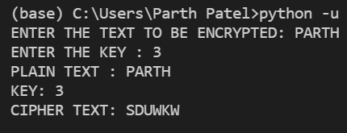

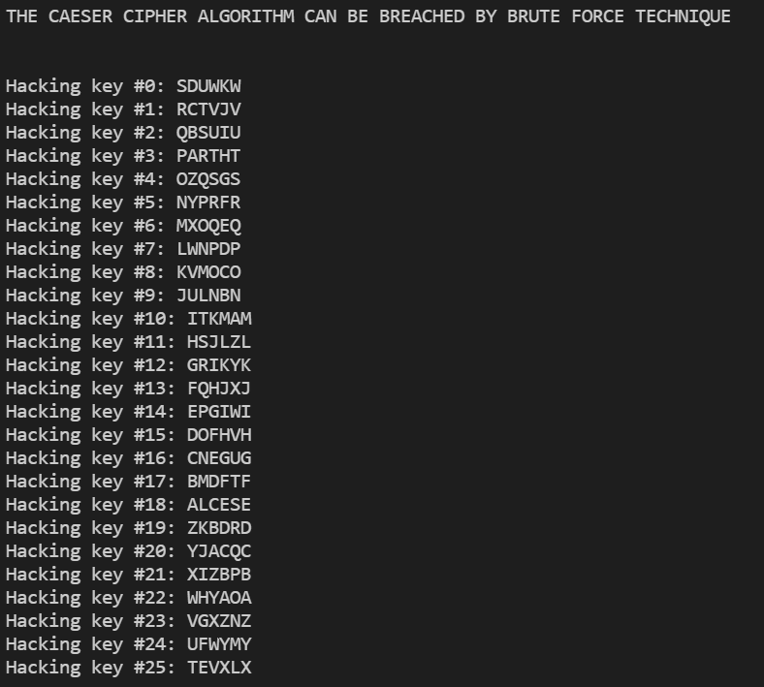

**CONCLUSION:**

* By performing the above practical, I learned the basic concept of Caesar Cipher Algorithm and how