**PRACTICAL-6**

**AIM:**

Implement GPG for windows.

**THEORY:**

* Gpg4win is an email and file encryption package for most versions of Microsoft Windows and Microsoft Outlook, which utilises the GnuPG framework for symmetric and public-key cryptography, such as data encryption, digital signatures, hash calculations etc.
* Gpg4win enables users to securely transport emails and files with the help of encryption and digital signatures. Encryption protects the contents against an unwanted party reading it. Digital signatures make sure that it was not modified and comes from a specific sender.
* GPG is an excellent method to ensure secure communication between two parties. It allows sensitive information to be easily shared across an insecure network.

**HOW IT WORKS**

* It allows you to send or publish your public key out in the open on an insecure network.
* The party looking to send you a secure message uses your public key to encrypt a message using that key.
* The message is then sent to you where you then use your private key to decrypt it. You can then reply using the sender’s public key which allows you to securely encrypt messages to them. They then use their private key to decrypt messages encrypted by you.

**IMPLEMENTATION:**

* Firstly, you need to install the software from the setup file.
* Upon successful installation, the following two icons will be visible on desktop

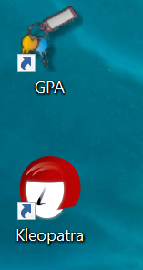

* Click on GPA and “Generate Key” and Enter the name
* For this, go to keys tab and click New Key

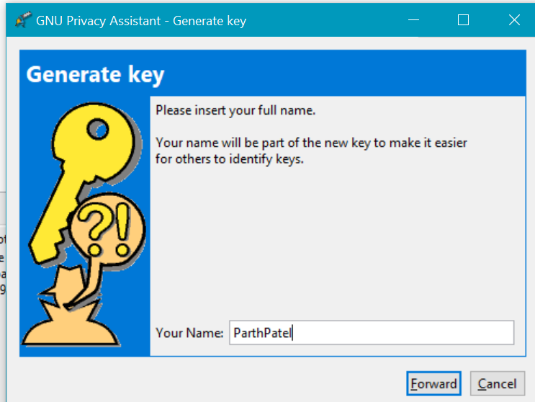

* Now, Enter the E-mail

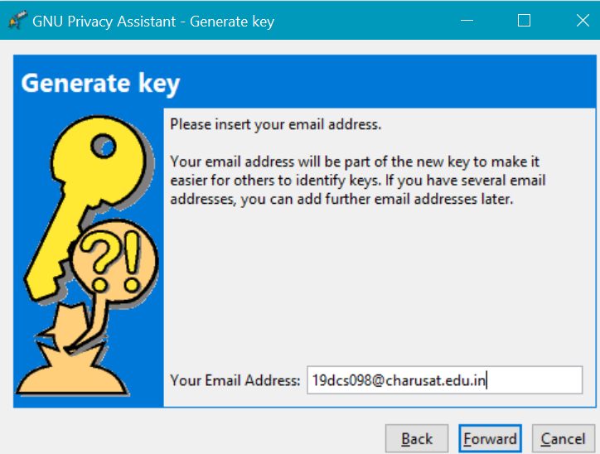

* Enter the password

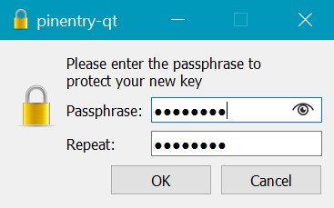

* Save the back-up file

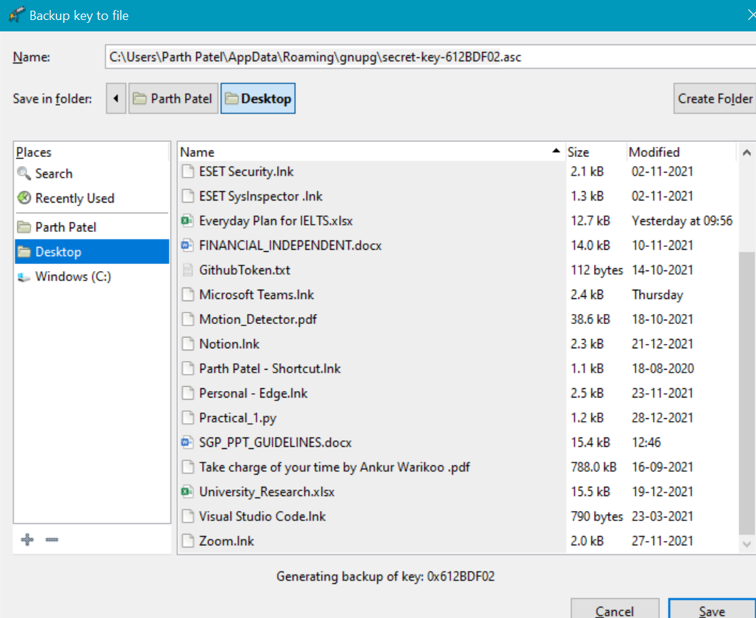

* Enter the password again to confirm

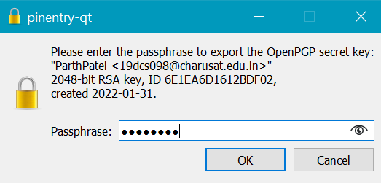

* Process Successful

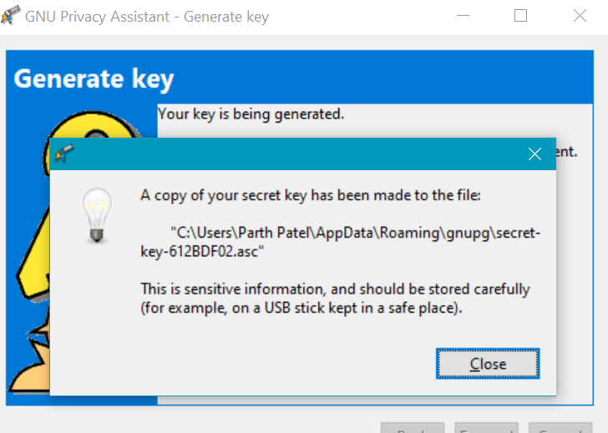

**ENCRPYTION**

* Write the message in the clipboard

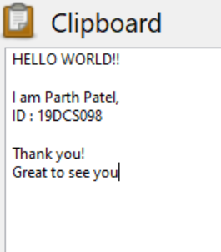

* Click on Encrypt button and following screen will prompt

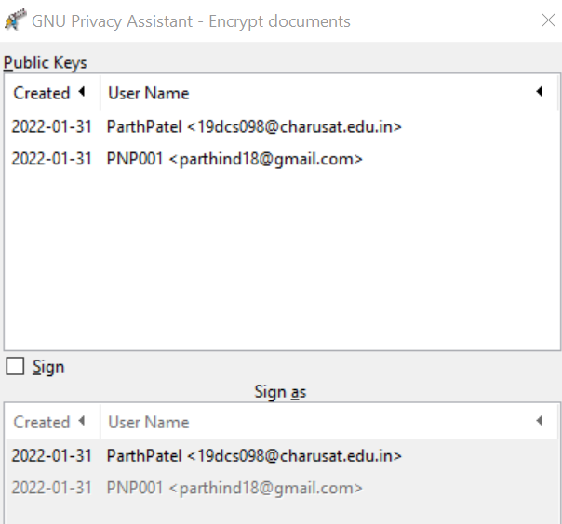

* Select the user through which encryption will take place.
* The Encrypted message displayed as below

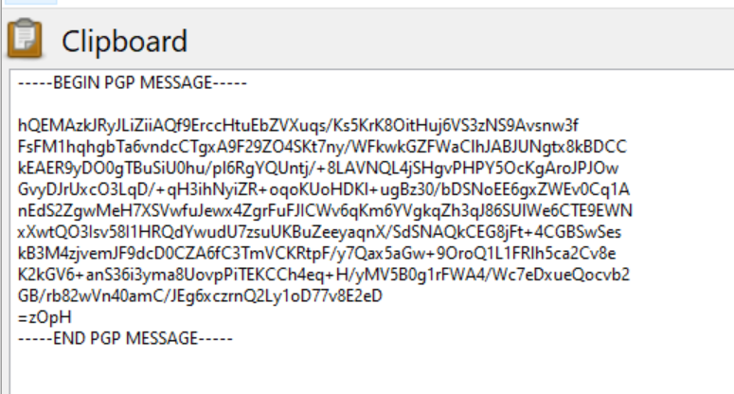

* On clicking Decrypt button, original message will appear

**CONCLUSION:**

By performing the practical, I learnt the basic concepts of GFG.