**PRACTICAL-8**

**AIM:**

1. Perform Port Scanning, File Transfer, Client-server chat and Basic Webserver implementation using netcat.
2. Find the service running on the particular port using netcat.

**THEORY:**

**NetCat**:

* netcat (often abbreviated to nc) is a computer networking utility for reading from and writing to network connections using TCP or UDP.
* The command is designed to be a dependable back-end that can be used directly or easily driven by other programs and scripts.
* At the same time, it is a feature-rich network debugging and investigation tool, since it can produce almost any kind of connection its user could need and has a number of built-in capabilities.
* Its list of features includes port scanning, transferring files, and port listening, and it can be used as a backdoor.
* The original netcat's features include:
  + 1. Outbound or inbound connections, TCP or UDP, to or from any ports
    2. Full DNS forward/reverse checking, with appropriate warnings
    3. Ability to use any local source port
    4. Ability to use any locally configured network source address
    5. Built-in port-scanning capabilities, with randomization
    6. Built-in loose source-routing capability
    7. Can read command line arguments from standard input
    8. Slow-send mode, one line every N seconds
    9. Hex dump of transmitted and received data
    10. Optional ability to let another program service establish connections
    11. Optional telnet-options responder

**Port Scanning:**

* This may useful to know which ports are open and running services on a target machine.
* Try the nc / netcat command as follow.
* The -z flag can be used to tell nc to report open ports, rather than initiate a connection.
* You need to specify hostname / ip along with the port range to limit and speedup operation:
* Command: nc -z -v hostname port-range
* Ex: nc -z -v localhost 80

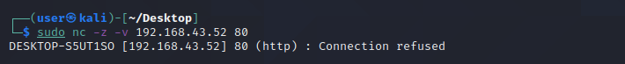

**File Transfer:**

* The nc ( netcat ) command can be used to transfer arbitrary data over the network.
* It represents a quick way for Linux administrators to transfer data without the need for an additional data transfer services such as FTP, HTTP, SCP etc.
* This config will show you an example on how to transfer data between to network hosts.
* We will be transferring data myfile.txt file from a localhost to a destination host with an IP address 10.1.1.2.
* Command (Transmitter): nc -v -l -p port < filename
* Command (Reciever): nc -v hostname port > filename
* Ex (Transmitter): nc -v -l -p 36180 < hello.txt
* Ex (Receiver): nc -v localhost 36180 > hello.txt

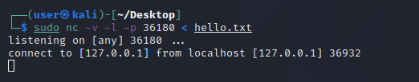

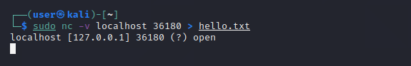

**Client-Server Chat:**

* To create a simple chat we need two instances of netcat, one to listen for incoming connections (the server) and another one to start the connection.
  + Command (Server): nc -l -p port
  + Command (Client): nc hostname port
  + Ex (Server): nc -l -p 36180
  + Ex (Client) : nc localhost 36180

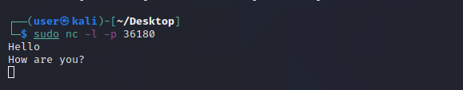

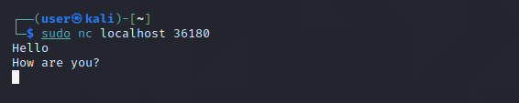

**Basic Webserver Implementation:**

* The netcat tool nc can operate as a TCP client. Because HTTP works over TCP, nc can be used as an HTTP server!
* Because nc is a UNIX tool, we can use it to make custom web servers: servers which return any HTTP headers you want, servers which return the response very slowly, servers which return invalid HTTP, etc.
* You can also use nc as a quick-and-dirty static file server.
  + Command: nc -l -p 8000
  + Ex: nc -l -p 8000

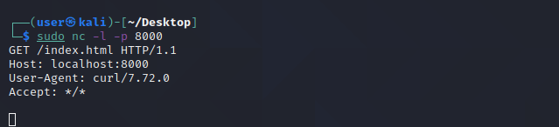

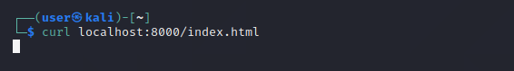

* After we start listening on port 8000, we can use command “curl localhost:8000/index.html” to send request on port 8000 on localserver.
* We can confirm that by looking at response in server side where GET request will be reflected.

**CONCLUSION:**

In this practical, we learned about NetCat which has many functionality and it is easy to use tool. We first transferred a file using nc and then implemented a chat server. We also implemented basic web server with single command.