**PRACTICAL:2**

**AIM:**

For given Dataset (you may continue to use the same processed dataset from experiment 1 only for this experiment), perform the following using Python Pandas and scikit-learn library or by writing your own user-defined function:

1. Perform Data Standardization and Normalization
2. Select the 10 best features of the data using different statistical scoring methods. (Hint: Chi-Squared Statistical Test is a good scoring method)
3. Split the data into training and testing sets in a ratio of 80:20.

**CODE:**

import pandas as pd

df=pd.read_csv('fullspecs.csv')

df=df.dropna()

df

df.drop(4,inplace=True)

df.replace(to_replace='Yes',value='1',inplace=True)

df.replace(to_replace='No',value='0',inplace=True)

df.rename(columns={'2019 Acura RDX Specs: FWD w/Technology Pkg':'column_1','2019 Acura RDX Specs: FWD w/Advance Pkg':'column_2','2019 Acura RDX Specs: FWD w/A-Spec Pkg':'column_3'},inplace=True)

df

df=df.astype({'column_1':float,'column_2':float,'column_3':float})

df.dtypes

df.describe()

df.isnull().sum()

y=df['column_1']

y

x=df[['column_1','column_2','column_3']]

x

x1=df.iloc[0:2,1:3]

x1

print(x.shape)

print(y.shape)

x.head()

y.head()

from sklearn.model_selection import train_test_split

x_train,x_test,y_train,y_test=train_test_split(x,y,test_size=0.2,random_state=15)

x_train

x_test

y_train

y_test

print(x_train.shape)

print(y_train.shape)

print(y_test.shape)

from sklearn.preprocessing import StandardScaler

scaler=StandardScaler()

print(scaler.fit(x_train))

scaler=StandardScaler().fit(x_train)

std_x=scaler.transform(x_train)

std_x

from sklearn.preprocessing import Normalizer

transformer=Normalizer().fit(x_test)

transformer

transformer=Normalizer().fit(x_test)

transformer=scaler.transform(x_test)

transformer

df.head(1)

from sklearn.feature_selection import SelectKBest

from sklearn.feature_selection import chi2

bestfeaters=SelectKBest(score_func=chi2,k=3)

fit=bestfeaters.fit(x,y)

dfscores=pd.DataFrame(fit.scores_)

dfcolumns=pd.DataFrame(x.columns)

featureScores=pd.concat([dfcolumns,dfscores],axis=1)

featureScores

featureScores.columns=['Spec','Scores']

featureScores.nlargest(3,'Scores')

**OUTPUT:**

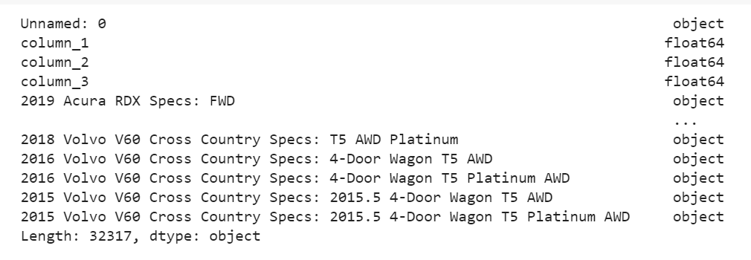

*Details of df*

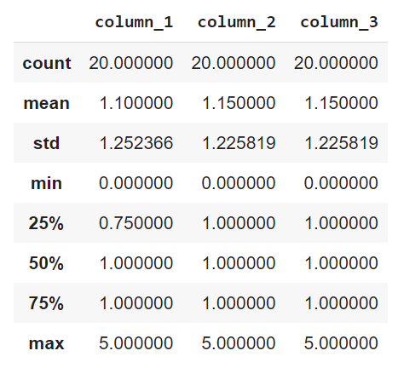

*Output of describe()*

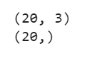

*Dimensions of x and y*

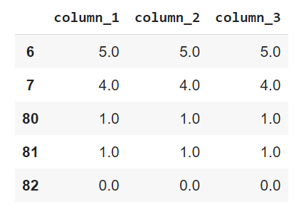

*x.head()*

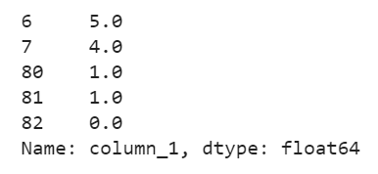

*y.head()*

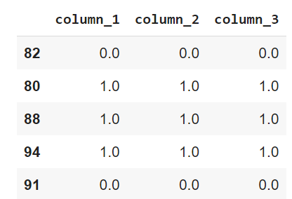

*Glimpses of x_train*

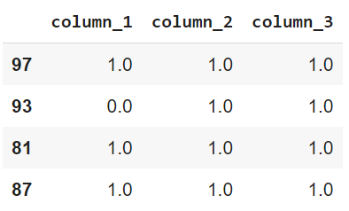

*X_test*

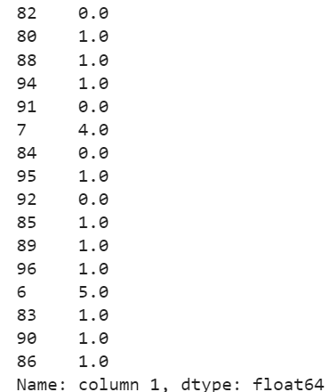

*Y_train*

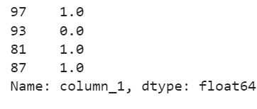

*Y_test*

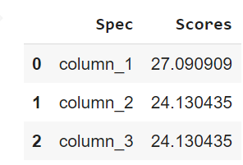

*Feature Scores*