**PRACTICAL:6**

**AIM:**

Implement K-Nearest Neighbours, Support Vector Machine (SVM) and Naïve Bayes Classifier with python’s Scikit-Learn on different datasets. Compare the classifiers based on their evaluation measures.

**CODE:**

import pandas as pd

from sklearn.neighbors import KNeighborsClassifier

from sklearn.svm import LinearSVC

from sklearn.naive_bayes import GaussianNB

from sklearn.metrics import classification_report

df = pd.read_csv("covtype.data")

df.describe()

df.isna().sum()

Y = df["1"].copy()

X = df[["51","510","221"]]

print(X.shape)

print(Y.shape)

neigh = KNeighborsClassifier(n_neighbors=5)

neigh.fit(X,Y)

y_knn = neigh.predict(X)

print(y_knn.shape)

nb_class = GaussianNB()

nb_class.fit(X,Y)

y_nb = nb_class.predict(X)

print(y_nb.shape)

svm_class = LinearSVC()

svm_class.fit(X,Y)

y_svm = svm_class.predict(X)

print(y_svm.shape)

print(classification_report(y_knn, Y))

print(classification_report(y_nb, Y))

print(classification_report(y_svm, Y))

**OUTPUT:**

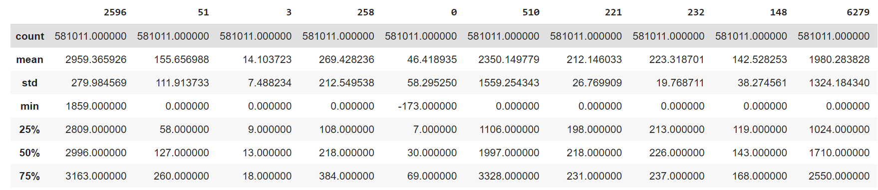

*Glimpses of describe()*

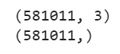

*Value of X,shape and Y.shape*



*Value of y_knn_shape*



*Value of y_nb_shape*

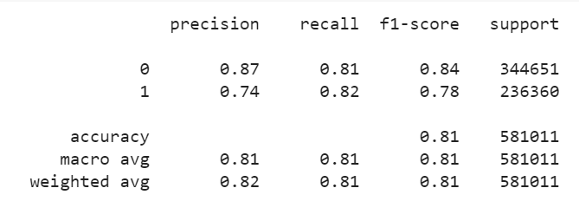

*Classification report of (y_knn,Y)*

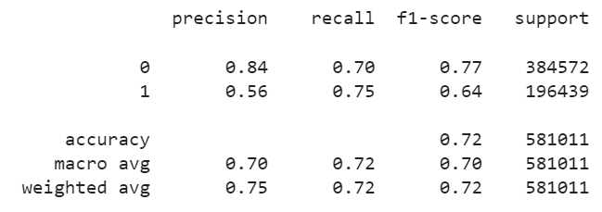

*Classification report of (y_nb,Y)*

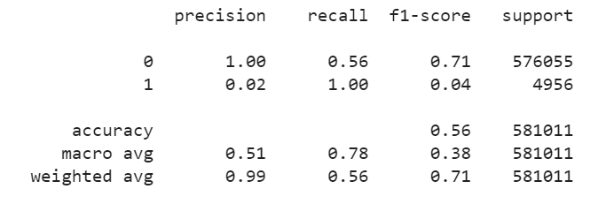

*Classification report of (y_svm,Ya)*