PRACTICAL:7

AIM:

Use K-Means Clustering and Hierarchical Clustering algorithm for following datasets.

CODE:

import numpy as np

import pandas as pd

from sklearn.cluster import KMeans

from sklearn.cluster import AgglomerativeClustering

import matplotlib.pyplot as plt

df = pd.read_csv("train.csv")

df

df = df.iloc[:5000, :50]

df = df.iloc[:5000, :50]

df.describe()

k_means_score = []

for i in range(1,11):

  kmeans=KMeans(n_clusters=i)

  kmeans.fit(df)

  k_means_score.append(kmeans.inertia_)

plt.plot(range(1,11), k_means_score)

plt.show()

kmeans = KMeans(n_clusters=2)

y_kmeans = kmeans.fit_predict(df)

df = np.array(df)

plt.scatter(df[y_kmeans==0, 0], df[y_kmeans==0, 1], c="red")

plt.scatter(df[y_kmeans==1, 0], df[y_kmeans==1, 1], c="blue")

plt.scatter(kmeans.cluster_centers_[:,0], kmeans.cluster_centers_[:,1],c="yellow")

plt.show()

cluster = AgglomerativeClustering(n_clusters=2)

cluster.fit_predict(df)

plt.scatter(df[:,0], df[:,1], c=cluster.labels_, cmap="rainbow")

plt.show()

OUTPUT:

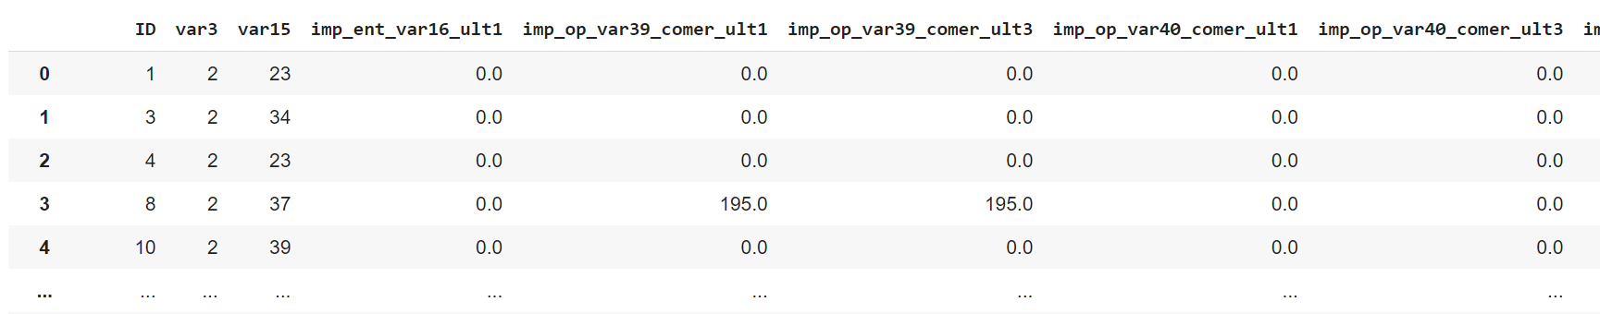

Glimpses of dataset

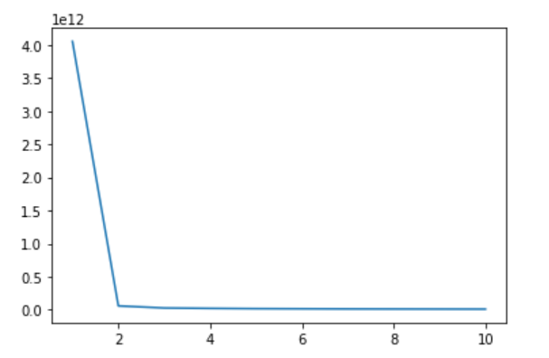

Plot of k_means_score

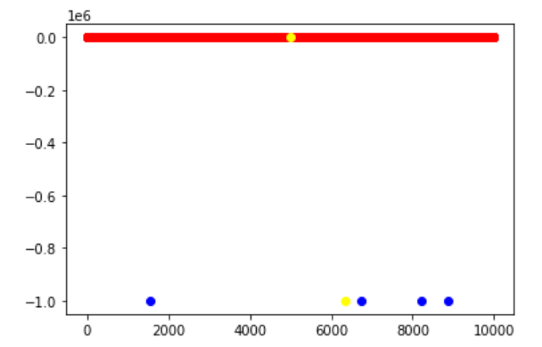

Scatter graph of k-means cluster

