**PRACTICAL-10**

**AIM:**

Prepare the detailed case study on Design Thinking Methodology in the area of Azure.

**THEORY:**

**CASE STUDY ON DESIGN THINKING METHODOLOGY**

**What is Design Thinking?**

* Design thinking is a method used by designers in ideation as well as mobile app development.
* It is very useful when complex problem is given by client. It also helps in tackling problems which are unknown. Design Thinking is not only limited to IT field it also helpful in Engineering, medicine, business, architecture, sports, research, etc.

**Design Thinking Process:**

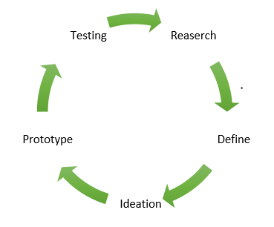

**Research**: Research the requirements of the users or target users.

**Define**: Define and understand the problems using research data.

**Ideation**: Find the solution for defined problems and ideas.

**Prototype**: Develop a prototype for solution.

**Testing**: Test the prototype to check that whether it is developed as per the requirements or not.

These 5 stages are not always sequential; they can occur simultaneously as well as repetitively.

**Importance of Design Thinking:**

* As Design Thinking has a human-centred approach, it focuses on the end-users and how to make the user experience better and more fulfilling.
* Since it involves multidisciplinary teams, the collective advantage of wisdom, expertise and experience is available while creating solutions.
* It also involves finding solutions in an unconventional way. So, while solving real problems this creates & delivers value to the end-users.
* Going to the market with a MVP (minimum viable product) is totally perfect for design driven firms. In such cases, they learn from the feedback of users, incorporate the same in their build and release an upgraded version of the product. Eg., Facebook, Instagram, Whatsapp and the likes.
* It helps create successful brands and generate ROI from these brands.

**Benefits of using design thinking in mobile app development:**

* **Increase in sales**: If the UX for end-user is seamless, the end-user will repeatedly use your application. This repeated use suggests brand loyalty which can further result in increase in sales.
* **Current and future marketing trend**: Mobile app is the need of the hour and is also the future of various applications and businesses. Hence, it becomes vital for businesses to develop mobile applications.
* **Marketing on the go**: Marketers can now focus on promoting their business via web and mobile platforms.
* **Ease of connecting to customers**: Customers can provide feedback effortlessly and so companies can learn and improve on their setbacks directly from the customers’ feedback.

**IMPLEMENTATION:**



**Getting the files to local machine**



**Hovering to the destination**



**Checking the git status**



**Git Remote**

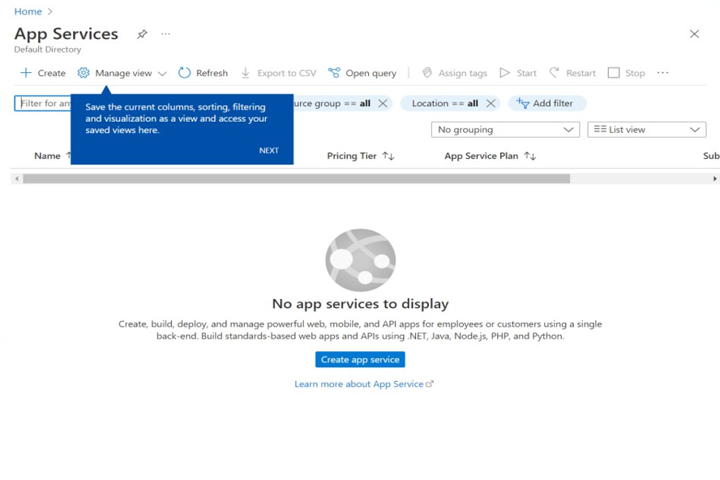

**Checking out the app services**

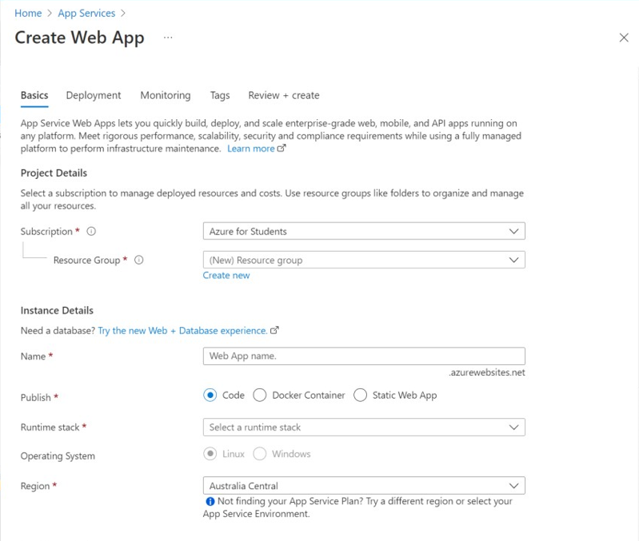

**Creating the web app**



**Giving name to the webapp**

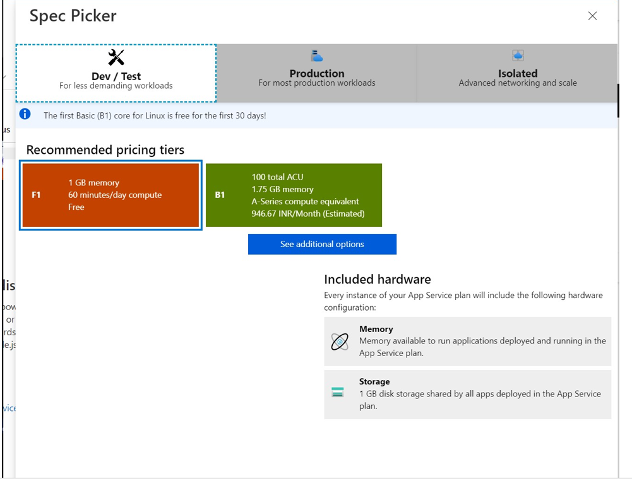

**Selecting the web app memory**

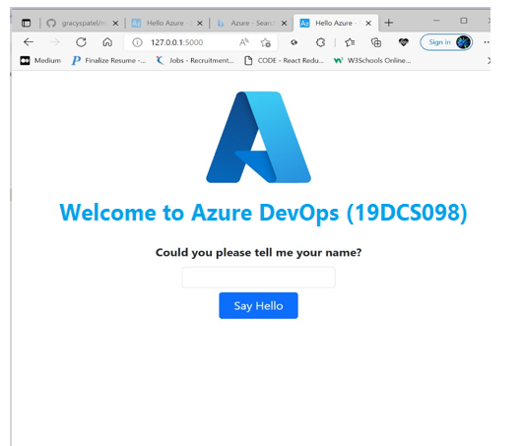

**Setup Completed**

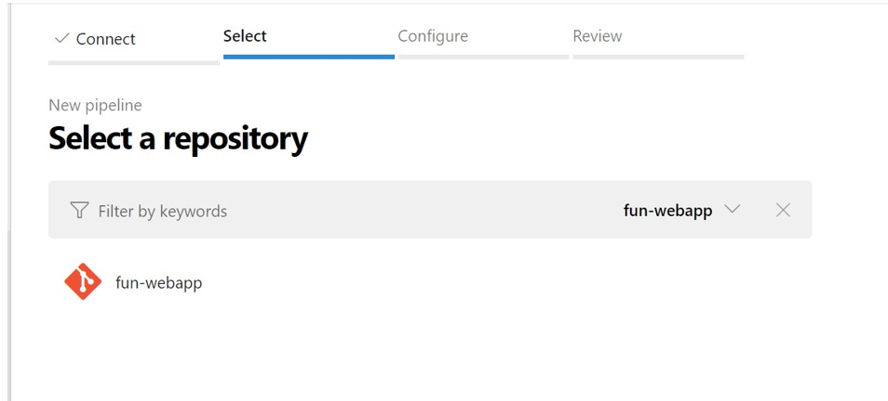

**Attaching local host project**

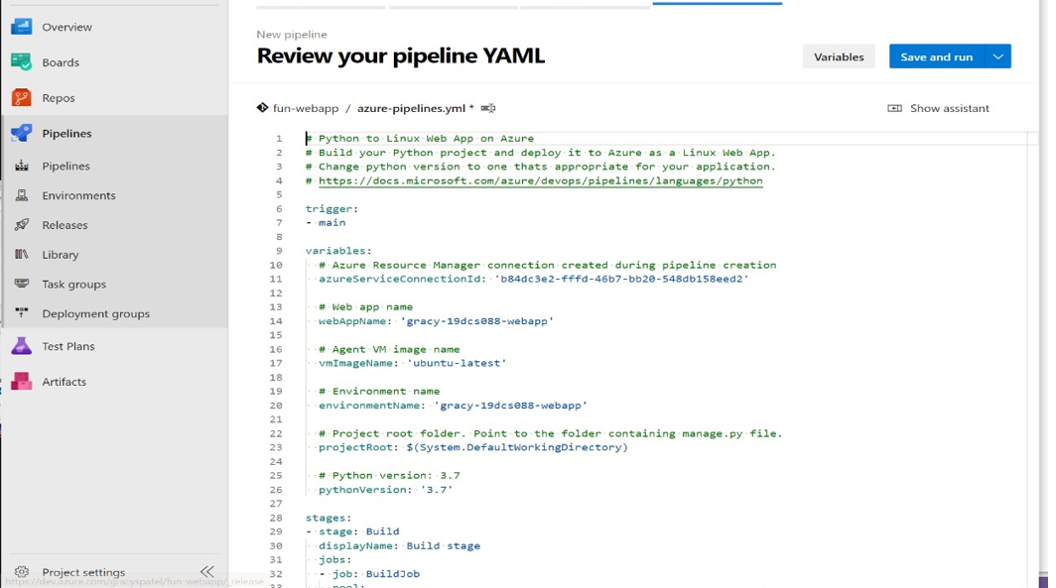

**Reviewing the application**

**CONCLUSION:**

In this practical, I learned about Design Thinking Methodology.