**PRACTICAL-2**

**AIM:**

List at least 10 Agile Development tools for desktop and mobile application development in IT industry and prepare the detailed case study on “JIRA Tool” for Agile Development.

**SOLUTION:**

The 10 **AGILE DEVELOPMENT TOOLS** are mentioned below:

1. Jira Software
2. Infinity
3. GitScrum
4. Proggio
5. ClickUp
6. Blossom
7. Assembla
8. Planbox
9. Zoho Sprints
10. Monday.com

**Case Study on JIRA TOOL:**

In order to deliver a project successfully, the most important points a team needs are time and cost management and a proper co-ordination between the team members. The industry around the world is seeing a massive paradigm shift in the way teams work and co-ordinate. Initially, only cost was a major factor considered for a project but in this digital era, time and cost both are an essential components in determining the success of any project.

So, the team leaders and project managers needed a tool through which they can track, monitor, assign the tasks and also, can see the progress of each team member, and that too on a single platform. So, the answer to all the questions is JIRA.

Basically, JIRA is a software tool extensively used for project management, issue tracking.

In other words, **JIRA is an issue management platform that allows teams to easily manage their issues throughout their lifecycle.**

**JIRA is mostly used by the teams that follow agile methodology for the project.**

Agile teams use an iterative approach to break down complex projects. In the past, software development teams often failed to meet deadlines because of the sheer complexity of their work. The agile methodology for project management was developed to address the many inefficiencies present in traditional software development projects.

Since working software is the primary measure of progress for agile teams, the trajectory of the project is bound to change as feedback from clients, customers, and team members are integrated with each new release

So, we can say that agile managers embrace the changes.

Now, we start exploring the JIRA Tool.

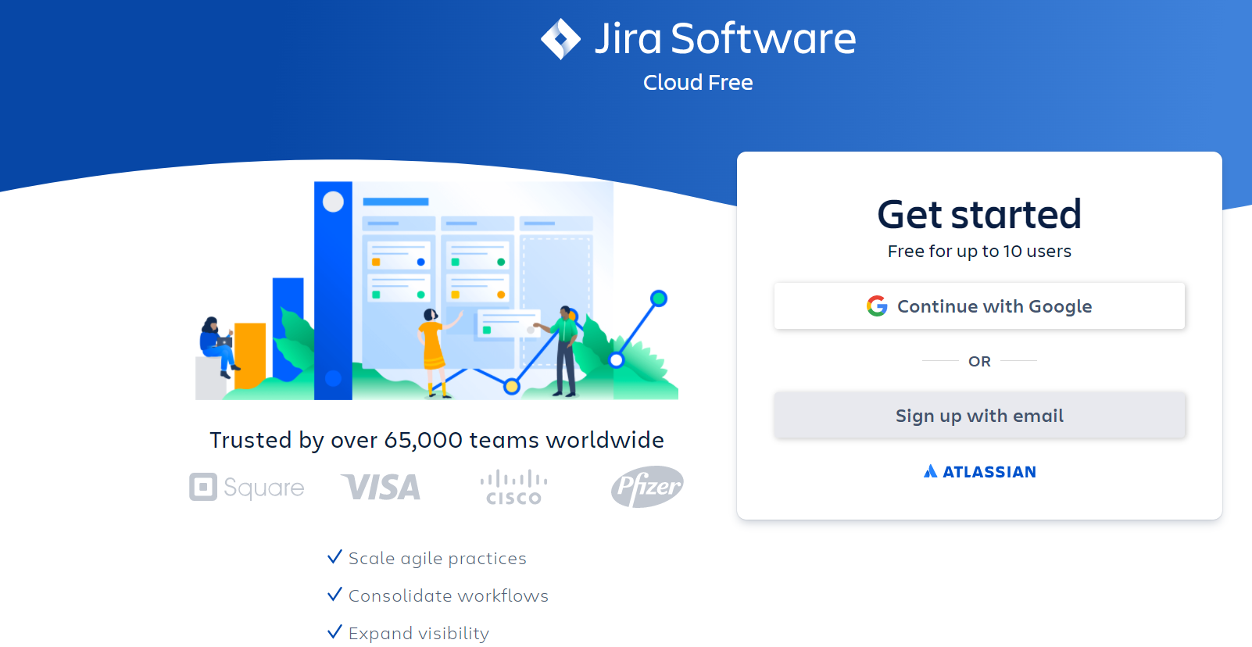

**Figure-1:** This is the account creation page. You can create the account via Google or via Email.It will activate your free version.

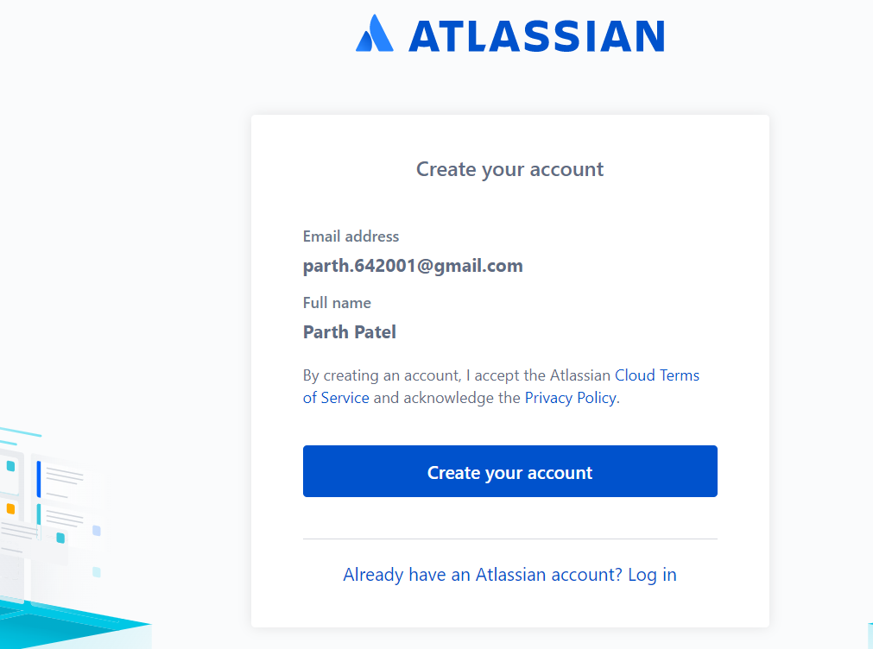

**Figure-2:** This is the screen where you will get prompt to create your account

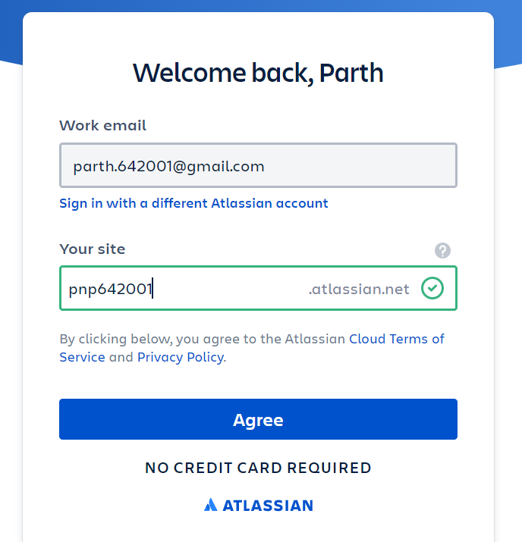

**Figure-3:** In order to uniquely identify you, it will ask to enter an unique user name.

Upon green tick, you need to click on Agree button.

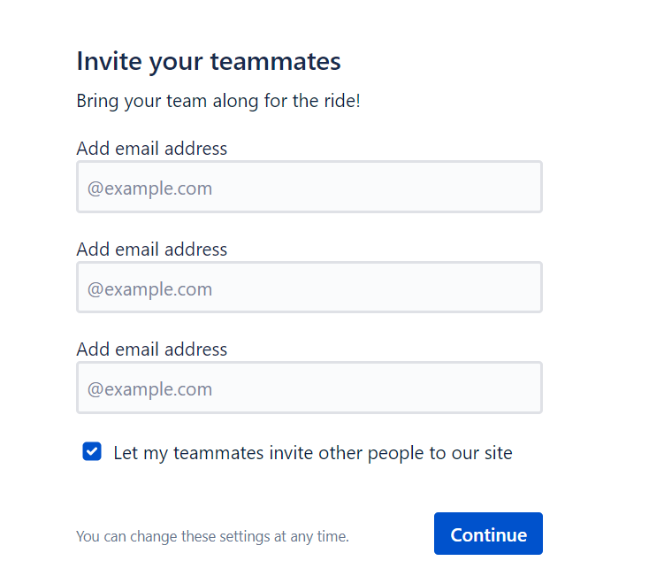

**Figure-4:** Once, your account is activated, you will come across the above window, where you can add your team member in your project.

**NOTE: you can also add team member after creating the project.**

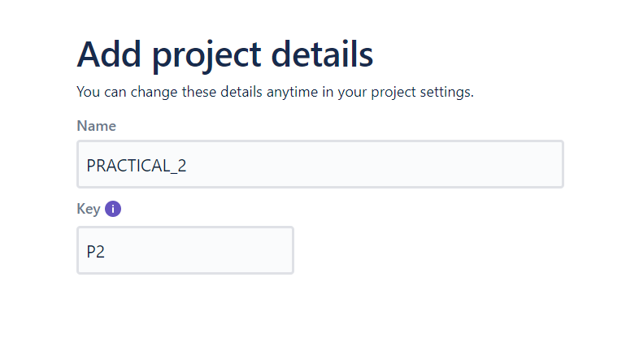

**Figure-5:** Then, you will be asked to create your first project.

**NOTE: Key is mandatory. It is useful in identifying the project.**

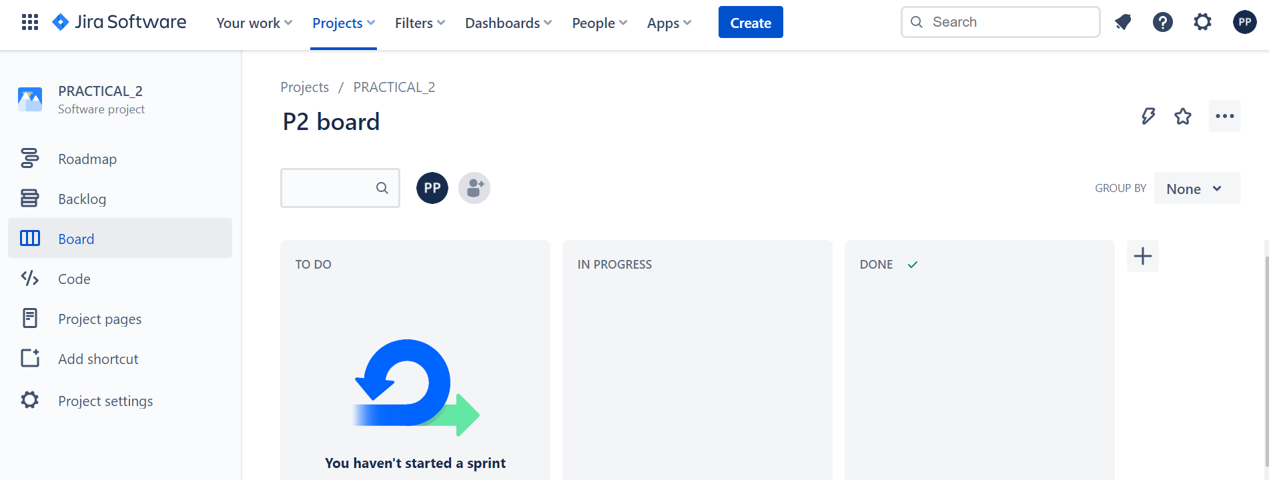

**Figure-6:** This is the main window that you will see once, a project is created or you are included in the project.

Now, we will explore the functionalities, one by one.

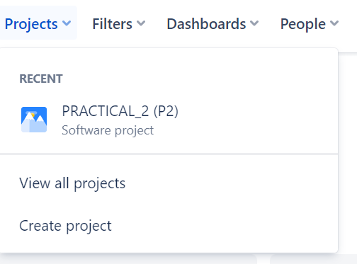

**Figure-7:** You can create Project and also, you can view all the projects.

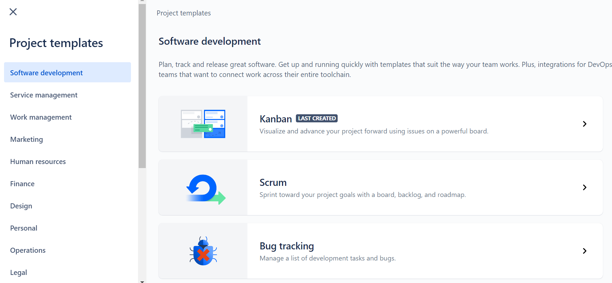

**Figure-8:** On clicking the create project, above window will appear, where different types of templates are available. We will select the SCRUM option.

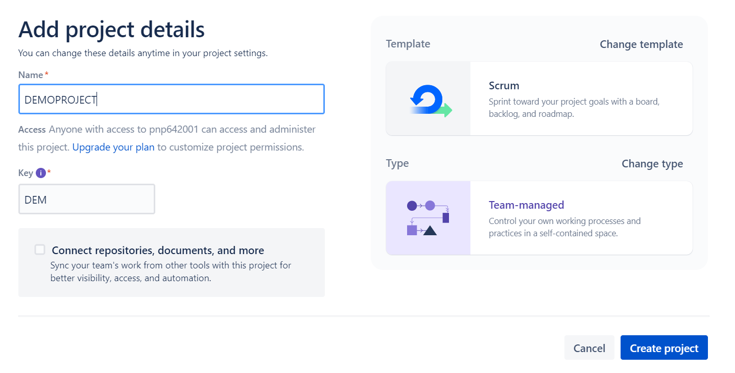

**Figure-9:** We will give name and key to the project and also, we will select Team Managed Project.



**Figure-9:** To add a team member, you can click the right most button shown in the image.

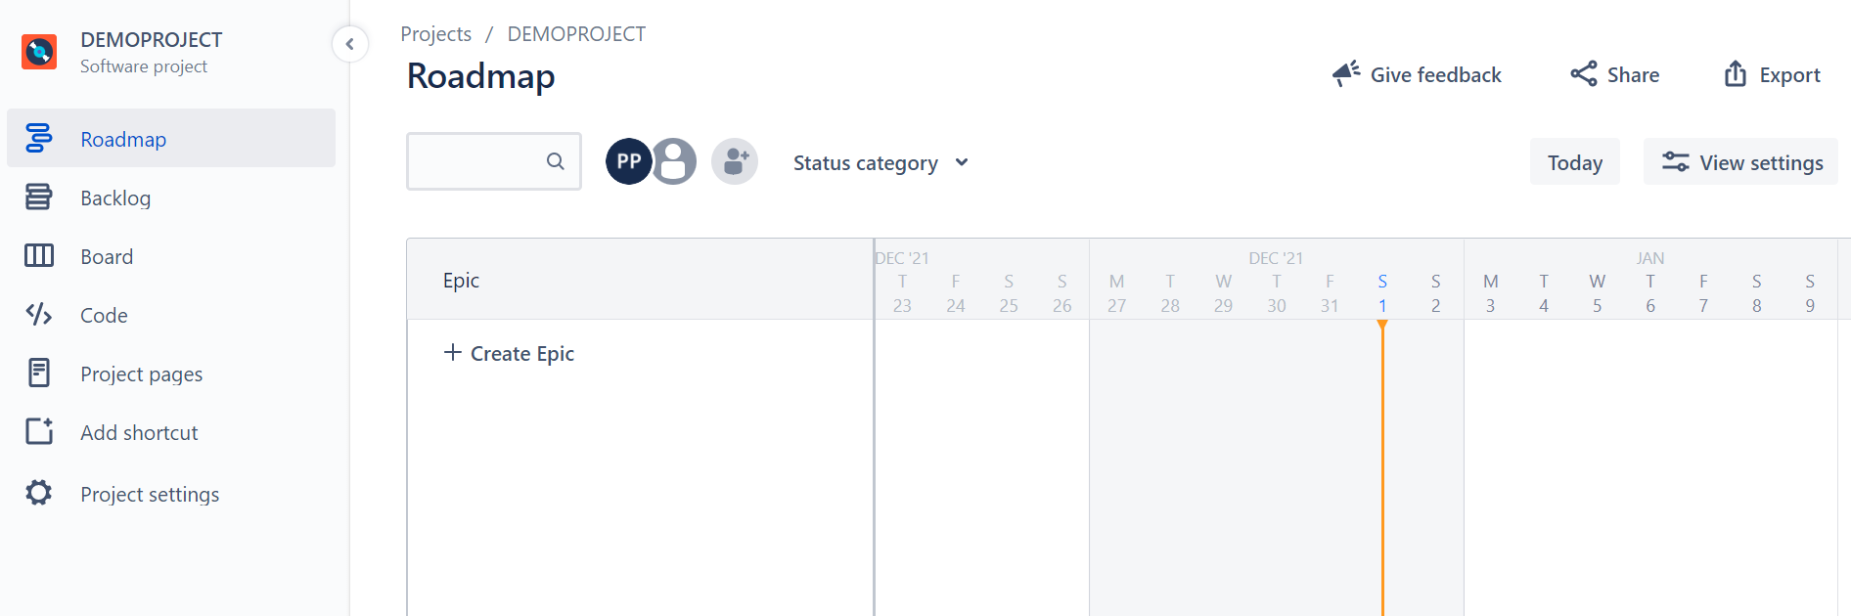

**Figure-10:** On clicking the roadmap option, you will see the above window, where you can create epics.

**EPIC:** epic is a large user story which is broken into smaller tasks (user stories) based on the customer or end-user needs

Basically, when team is discussing with the customer, then we use epics to mention the key points and features that customer wants in the project.

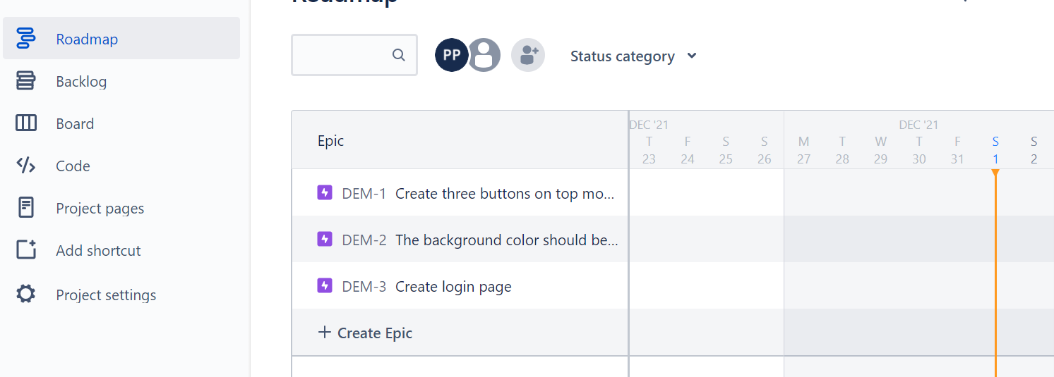

**Figure-11:** As you can see, we have added three epics.

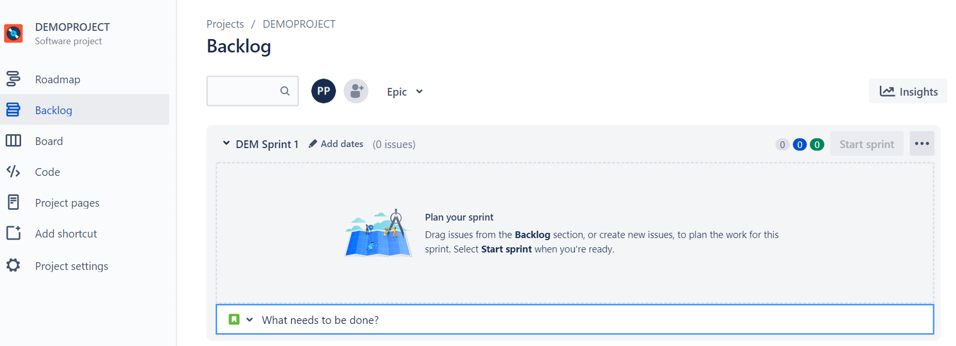

**Figure-12:** On clicking the backlog option, you see the above window.

**BACKLOG:** backlog is a list of tasks that represents outstanding work in a project

**SPRINT:** A sprint is a fixed time period in a continuous development cycle where teams complete work from their product backlog

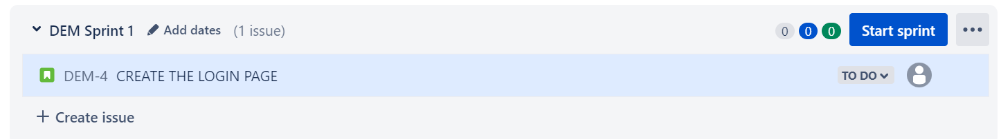

**Figure-13:** We have created a sprint.

Now, we will add the date and will assign to our newly added team member.

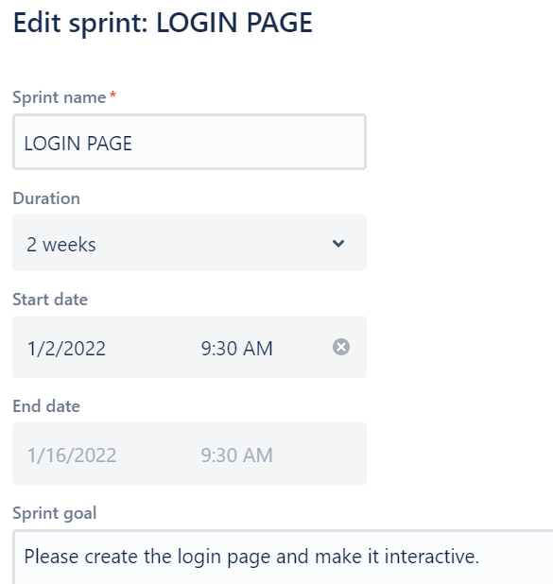

**Figure-14:** As you see, we have assign the deadline to the sprint along with the necessary goal.

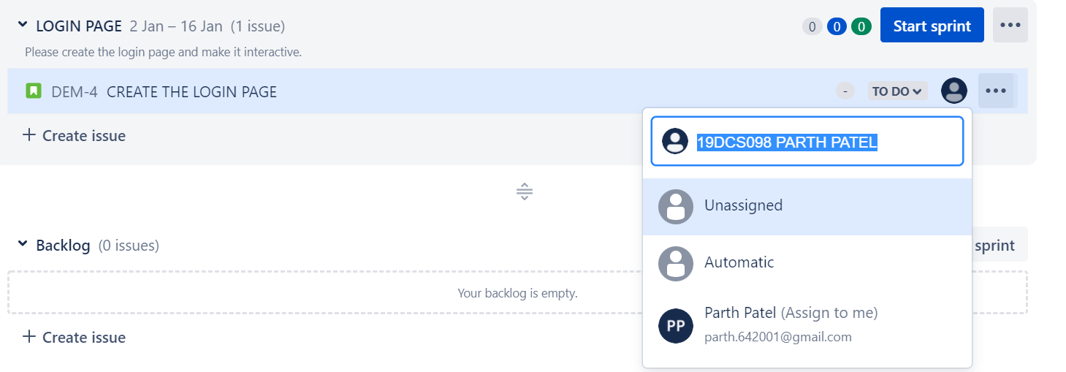

**Figure-15:** We have assigned the sprint to our team member.

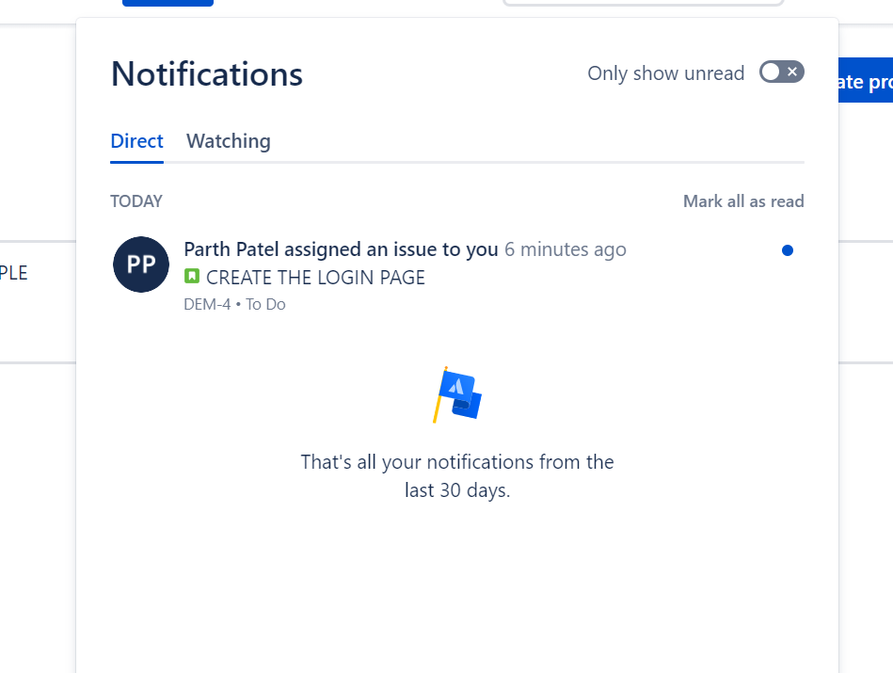

**FIGURE-16:** Notification arrived in the team mate’s account.

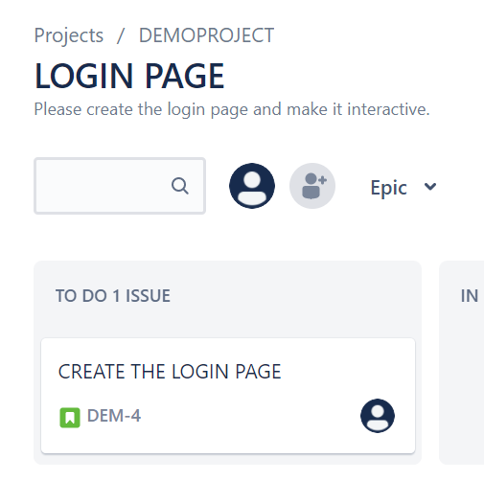

**Figure-17:** Once the team mate starts the sprint, it is displayed in the to-do list

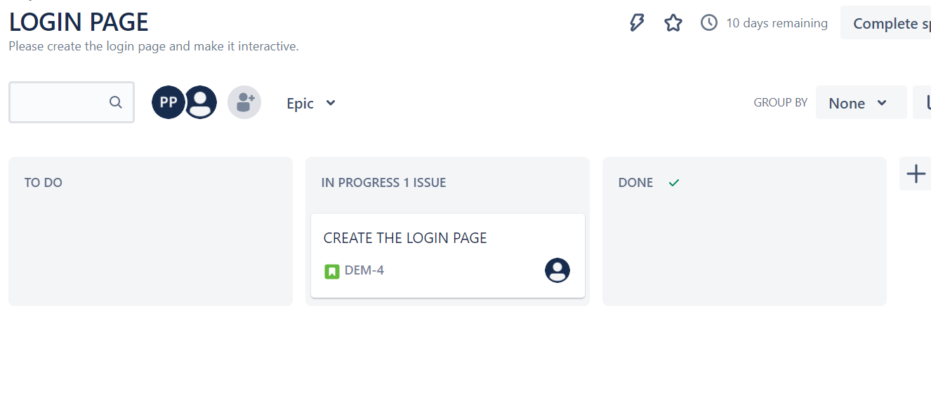

**Figure-18:** Once the work on sprint starts, it leader will see it in IN PROGRESS panel.

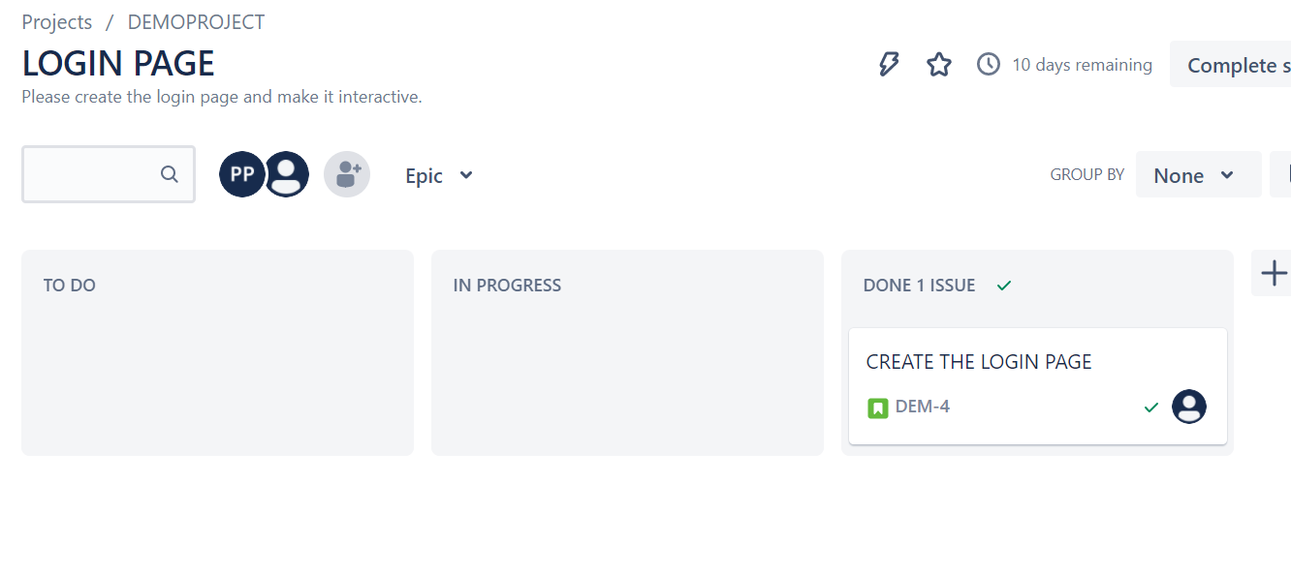

**Figure-19:** Once, the sprint is completed, it is displayed in the DONE PANEL.

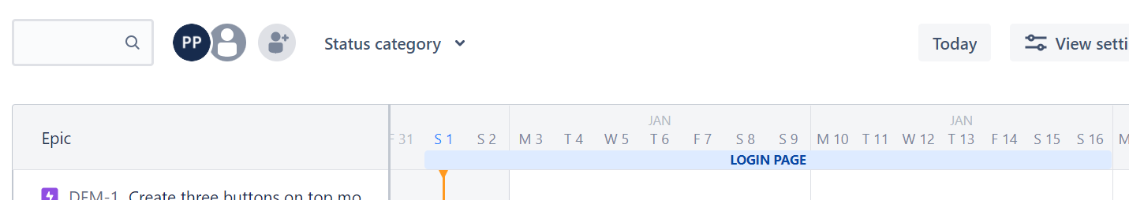

**FIGURE-20:** Progress updated in the roadmap

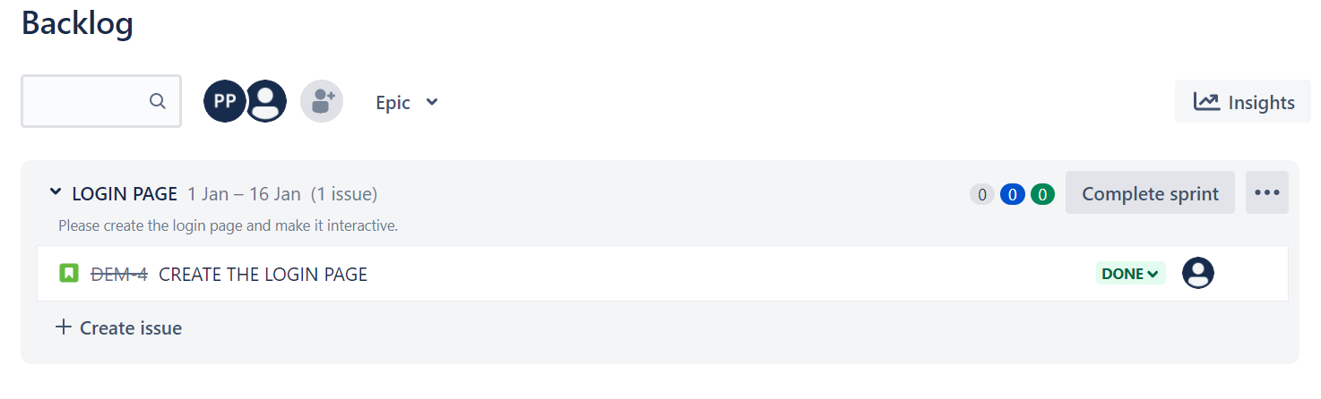

**Figure-21:** Progress updated in the backlog section.

**NOTE: The leader can change the status of the backlog.**

There are also lots of other features, which can be explored in the paid version like reports, then also certain features can be activated from the feature settings.

Some note worthy terms with their meanings to mention are as follows:

**DAILY SCRUM**: The **Daily Scrum** is a 15-minute time-boxed event for the Development Team to synchronize activities and create a plan for the next 24 hours.

**SCRUM MASTER**: A **scrum master** is a professional who leads a team through a project using agile project management techniques

**CONCLUSION:**

By performing the above practical, I learned about the JIRA TOOL which is used for agile project management and also various features of the tool that will help to manage the project in an efficient way which will help us to save both COST and TIME of the Company.