**PRACTICAL-3**

**AIM:**

List at least 5 software development planning tools and prepare the detailed case study of Risk Analysis & Management (i.e. Risk Identification, Risk Projection, Risk Refinement, Risk Mitigation.) on “VLC Media Player” mobile application

**SOLUTION:**

Most programming items are customized to accommodate customer's necessities. The most significant is that the underlying technology changes and advances so generally and rapidly that experience of one element may not be connected to the other one.

All such business and ecological imperatives bring risk in software development; hence, it is fundamental to manage software projects efficiently

1. **TRELLO**

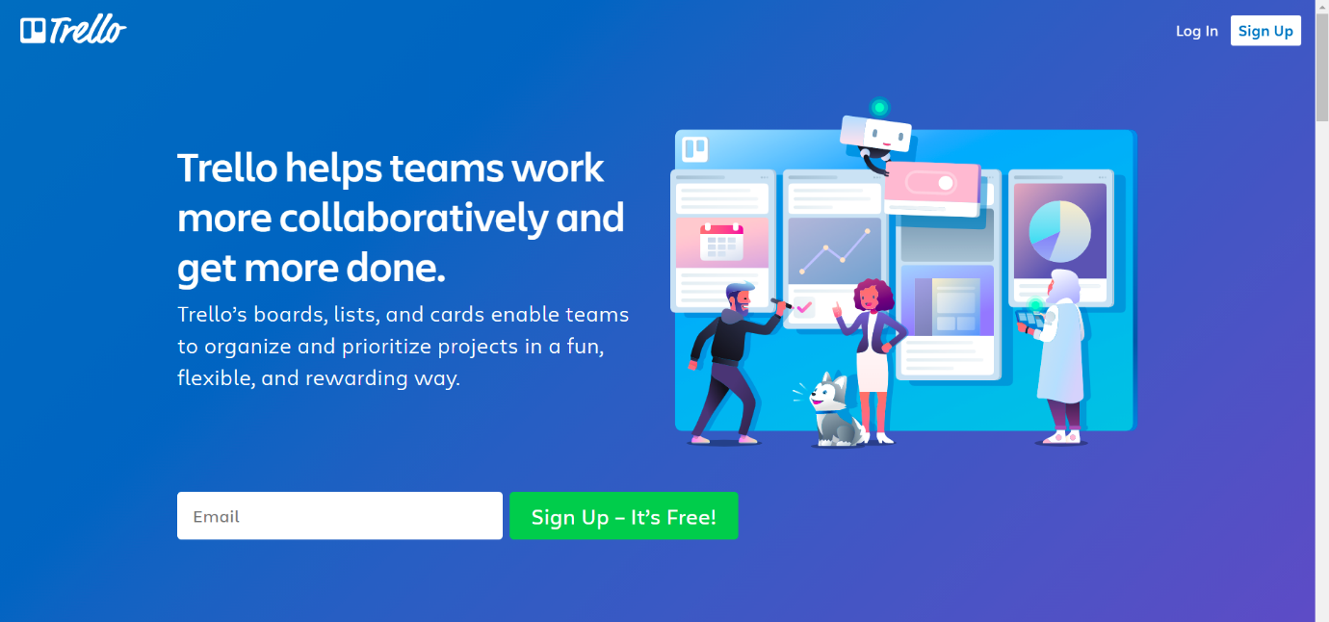

Trello allows you to create boards and fill them with different lists. I went for a simple Kanban-based board and created lists that correspond with statuses (in progress, to do etc.) Trello is a tool that would allow me to create more granular tasks but I’ve decided to use checklists that are built inside the cards to track smaller tasks. You can also add attachments to cards, making it easier to communicate new iterations or getting feedback. Adding due dates to particular cards is also handy when you want to plan a project.

1. **ASANA**



Asana is a popular tool for managing projects of various sizes, and while the free version comes with limited features, it seems to be perfectly suitable for smaller projects. The plan of your project can be displayed as a list, a board or a calendar (see below). The latter view is especially useful when planning milestones and deadlines. You can see how much time there actually is between different due dates. Keep in mind, however, that setting start dates for tasks is not available in the free plan.

1. **NIFTY**

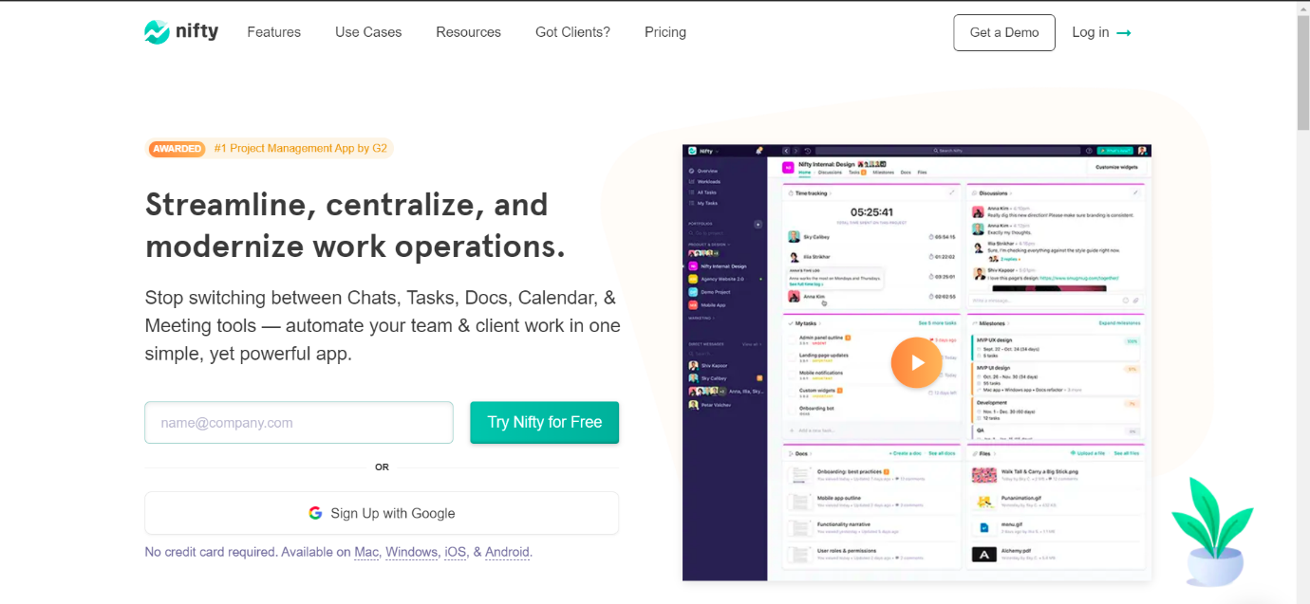

The creators of Nifty pride themselves on building an app that covers project management and team collaboration. The collaboration aspect is supported by the fact that a team chat is a part of this app. What about the project management part? You can plan your project starting with a list of tasks, or map your milestones on a Gantt chart.

1. **TEAMGANTT**

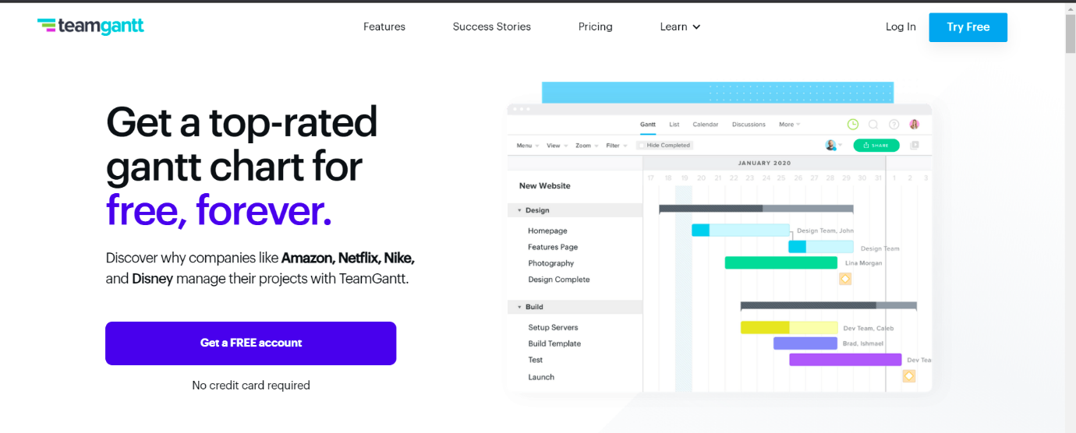

Out of the box you’ll notice that TeamGantt will not leave you hanging. The onboarding experience will help you tremendously, especially if you’re new to project planning or gantt charts in general. As the name of this software would suggest, creating Gantt charts is the core functionality here. The process of building and editing charts is very straightforward, you can also assign people to particular tasks

1. **NTASK**

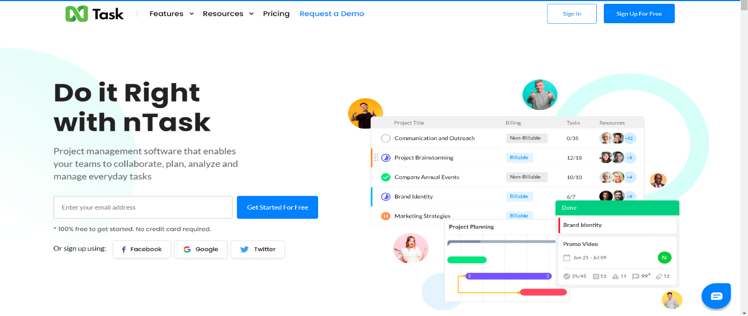

If you’re looking for a tool for planning and managing a series of projects, nTask could just be right for you. Of course, it will also be suitable for single project purposes. It’s just that nTask is really good at providing you with the big picture of all your ongoing projects. When it comes to planning a single project, you can create a list of tasks or a simple Gantt chart. The assignments can also be viewed as a grid.

**CASE STUDY ON “RISK ANALYSIS & MANAGEMENT IN EDA APPLICATION”**

**OVERVIEW:**

* **EXPLORATORY DATA ANALYSIS** application aka **EDA app** is an application which gives an generalized overview of an data set by following the EDA principles.
* This application aims at saving the precious time of data analysts by automating their basic tasks that they need to perform in order to determine whether the data set is relevant or not.
* The application will be available as a web application
* We know that development of such large application is time consuming process and also the project may involve high risk factors that can be fatal for the project. As a result, the risk analysis and proper management of the project is necessary.

**Risk management is concerned with identifying risks and drawing up plans to minimise their effect on a project**.

A risk is a probability that some adverse circumstance will occur.

• Project risks affect schedule or resources

• Product risks affect the quality or performance of the software being developed

• Business risks affect the organisation developing or procuring the software

A risk management process contains 4 major steps.

* **Risk identification** - Identify project, product and business risks
* **Risk analysis** - Assess the likelihood and consequences of these risks
* **Risk planning** - Draw up plans to avoid or minimise the effects of the risk
* **Risk monitoring** - Monitor the risks throughout the project.

RISK INFORMATION:

|  |  |
| --- | --- |
| **Project** | EDA Application for CHARUSAT |
| **Risk Type** | Operational Risk |
| **Priority** | 3 |
| **Risk Factor** | Further Project Execution will depend on the functioning of the application.  The application may not work for certain datasets |
| **Probability** | 30% |
| **Impact** | Project completion will be delayed if certain datasets that needs to be processed will cause the stoppage error. |
| **Monitoring Approach** | To check the population set of the data sets to be used in the project in the testing phase in order to find and rectify the problem. |
| **Contingency Plan** | Modification in the testing strategy and to change the deadlines of the project in order to get sufficient time for the damage control |
| **Estimated Resources** | 2 additional data analysts to be added by next week for further guidance in both development and testing. |

**RISK IDENTIFICATION:**

According to my point of view, in the risk identification process, certain risk that our application has are as follows:

* **Technical Disadvantage:**

The technology that is being used/provided by the application may become obsolete before launching it or in a short time after the launch.

* **Development Environment:**

There is high probability that, change in development flow or method due to some miscellaneous reasons can affect the application.

For example, if a developer leaves the project and back up is not ready then, the development of the application might get delayed.

The situation may get worse if lead developer leaves the project.

* **Business Impact:**

The market already have the similar applications which can give tremendous competition and impact the brand value.

* **Application not meeting the expectation**

This is the most common risk that every project possesses, that whether their application will satisfy the needs of the end user or will it fail once launched.

**Risk Projection**

|  |  |  |  |
| --- | --- | --- | --- |
| RISK | CATEGORY | PROBABILITY | IMPACT |
| Technical Disadvantage | TR | 30% | 4 |
| Development Environment | PR | 40% | 8 |
| Business Impact | BR | 30% | 5 |
| Application not meeting the expectation | BR | 35% | 9 |

TR- Technical Risk

PR- Project Risk

BR- Business Risk

**Risk Planning:**

* An effective strategy for dealing with risk must consider three issues
* Risk mitigation (i.e., avoidance)
* Risk monitoring
* Risk management and contingency planning

Risk mitigation (avoidance) is the primary strategy and is achieved through a plan

As we have identified the risks, so, we will be planning to either avoid, monitor, or will try to eliminate the risk. Here, we can divide the risk into multiple sub lists. For example, for the risk of technical disadvantage, we can further more go into details and can try to avoid the risk by segregating the technologies that can cause the risk.

For Development risk, we can have a back up plan so risk can be managed and the impact can be reduced.

Similarly, for the business impact, we can avoid the risk by adding some unique features in our application which the rivals are not offering.

**Risk monitoring**

We can monitor the development risk by following a specific SDLC model like agile.

For the technical disadvantage, we can hire some versatile developers who can adapt very quickly to the changing tech and can help in reducing the risk.

**ANOTHER SAMPLE EXAMPLE:**

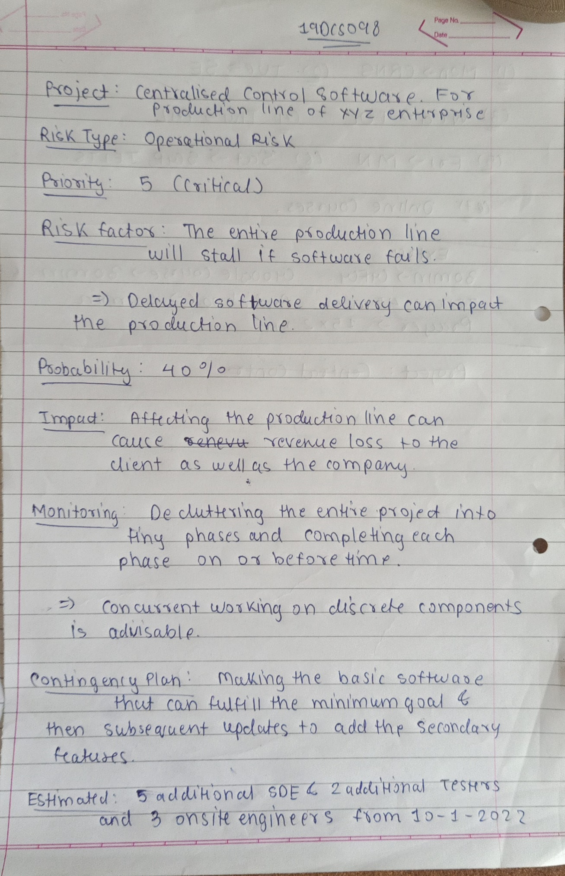

**CONCLUSION:**

By performing the above practical, which included the case study for the risk analysis and management, I learned how to estimate and identify the risks involved in the projects, how to measure their impact and how to avoid, monitor and rectify the risks.