**PRACTICAL-8**

**AIM:**

List at least 5 online or offline Software Maintenance tools & prepare the detail case study on “VLC Media Player” Maintenance document as a VLC Media Player Developer

**IMPLEMENTATION:**

Software maintenance is a part of Software Development Life Cycle. Its main purpose is to modify and update software application after delivery to correct faults and to improve performance. Software is a model of the real world. When the real-world changes, the software requires alteration wherever possible.

The list of maintenance tools is given below.

**Bugzilla:**

* This program is used by thousands of software companies as a "defect tracking system."
* The program keeps track of bugs that crop up in a software product and allows individuals or groups of developers to communicate and solve the problems.
* Bugzilla allows software engineers to manage quality assurance, track bugs and submit bug-fixing patches to review.
* The program is technically free, though they charge for extensive support issues.
* Bugzilla is a secure program that has the ability to scan and correct database inconsistencies.

**HP Quality Center:**

* This Web-based application helps software engineers put their programs through the ringer by testing them for various bugs and errors.
* HP Quality Center has the ability to plan and schedule tests, analyze results and manage issues and defects.
* There are three versions of the program, the most extensive of which has the ability to deal with hundreds of applications at the same time with management teams distributed throughout the world.
* The starter edition is available with a free download from the HP website.

**IBM Rational Quality Manager:**

* The IBM Rational Quality Manager is similar to the HP Quality Center in that it conducts tests using an Internet-based application.
* The program lets users customize the way the information is presented through custom-designed dashboards, and it lets them schedule their software tests with the various members of their team.
* These tests can be automated or done manually if there is a particular area of the software the engineers wish to get a closer look at.
* The program description states that it will accelerate project schedules and ensure that applications meet the objectives of the company.
* The express edition is available for download at the IBM site.Smoke Testing

**Micro Focus SilkPerformer:**

* Micro Focus SilkPerformer is a program that can be used by large enterprise-class companies to develop software applications through extensive testing.
* The Micro Focus site states that the program can accelerate the resolution of problems by finding them early in development cycles.
* SilkPerformer has full support for all Web 2.0 applications and efficient test cycles and test creation.
* The program performs load tests that can be viewed across many environments in an effort to quickly determine if there are conditions that cause it to crash.
* A trial version of the program is available from the Micro Focus site.

**Sage 300:**

* Provide companies with an overview of their business by assuring a single repository and compliance with procedures
* Equip the technical services with a maintenance solution tailored to their business, easy to use and quick to deploy
* Optimize spare parts, stocks and supplier’s management
* Avoid the risk of errors between Sage 300 business management and CMMS
* Apply the rules of business management to CMMS at every step of inventory and purchasing management process (e.g. replenishment threshold, control units, main supplier, …)

**Bugzilla:**

* This program is used by thousands of software companies as a “defect tracking system.”
* The program keeps track of bugs that crop up in a software product and allows individuals or groups of developers to communicate and solve the problems.
* Bugzilla allows software engineers to manage quality assurance, track bugs and submit bug-fixing patches to review. The program is technically free, though they charge for extensive support issues.

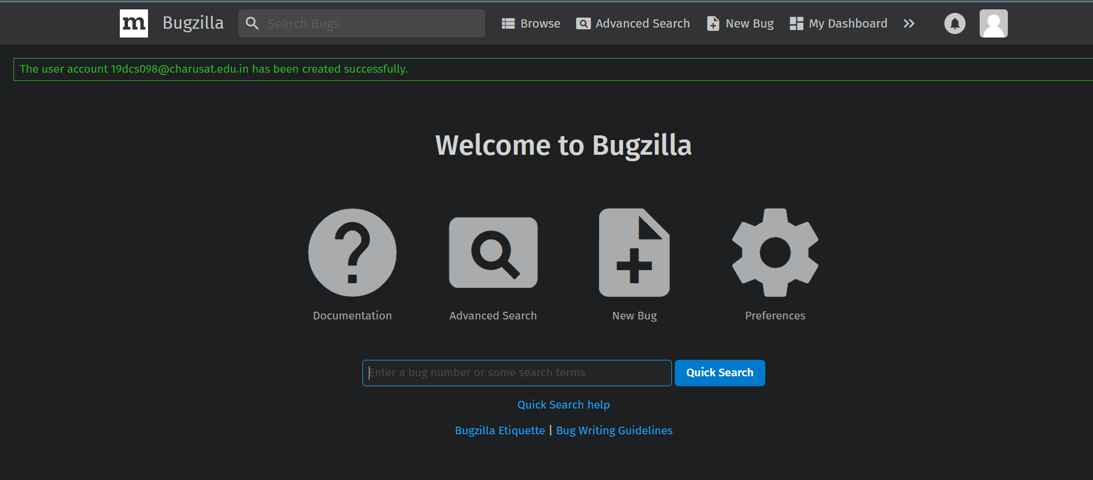

**Home Page of Bugzilla**

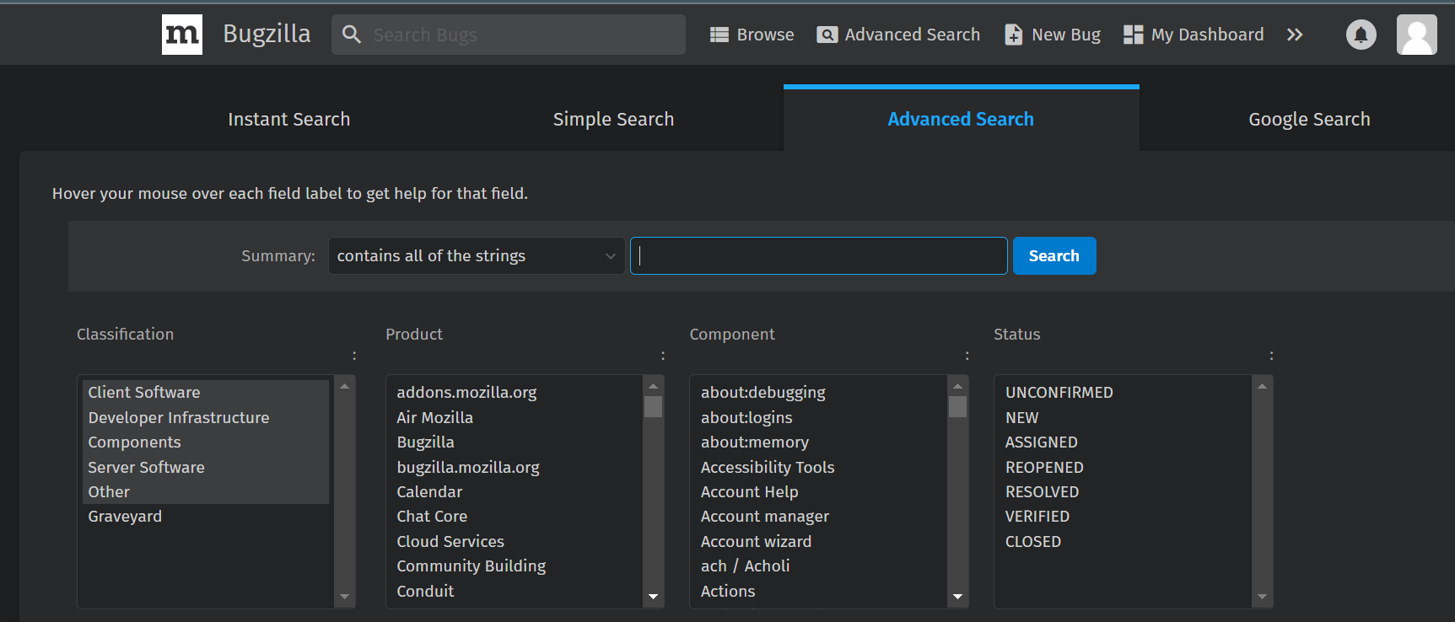

**Glimpse of advanced Search Panel**

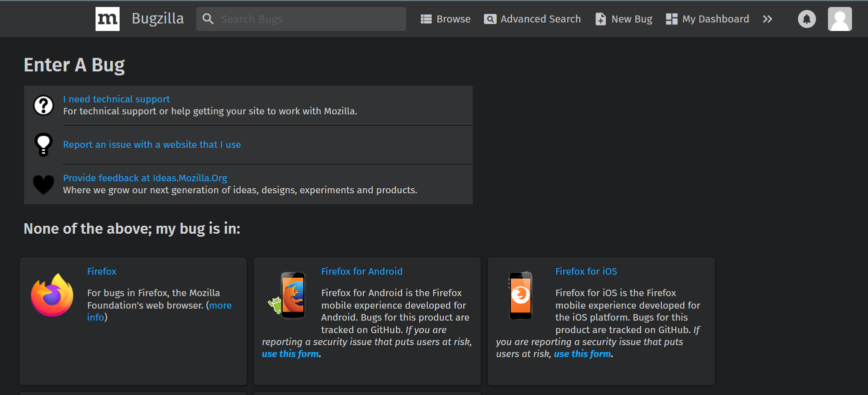

**Glimpse of New Bug Panel**

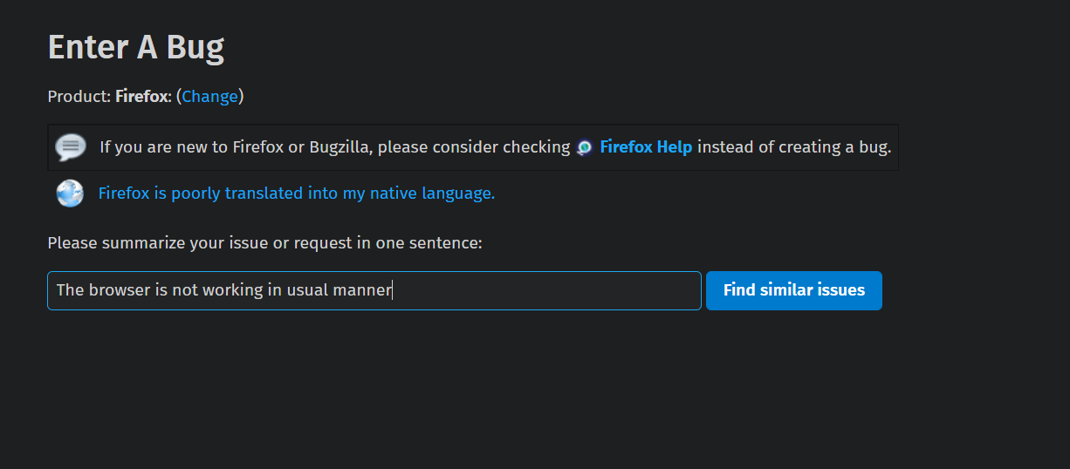

**Searching for the bug**

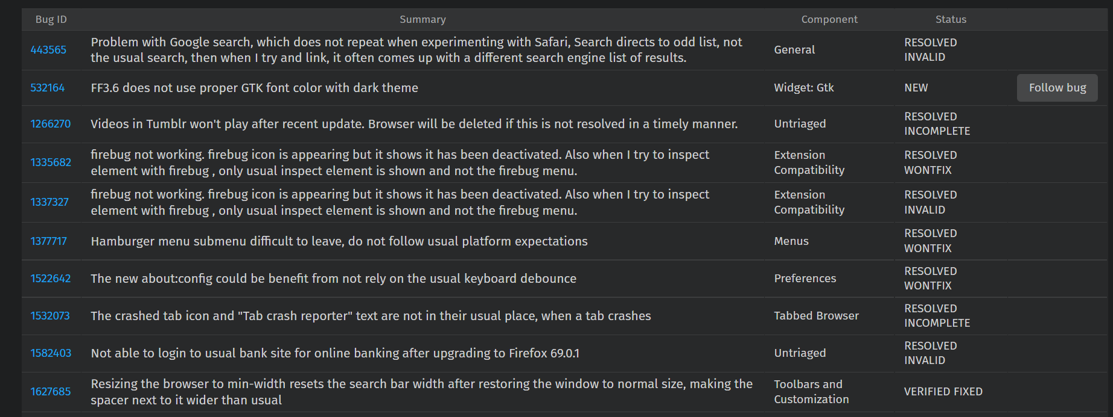

**Search Result of similar bug list**

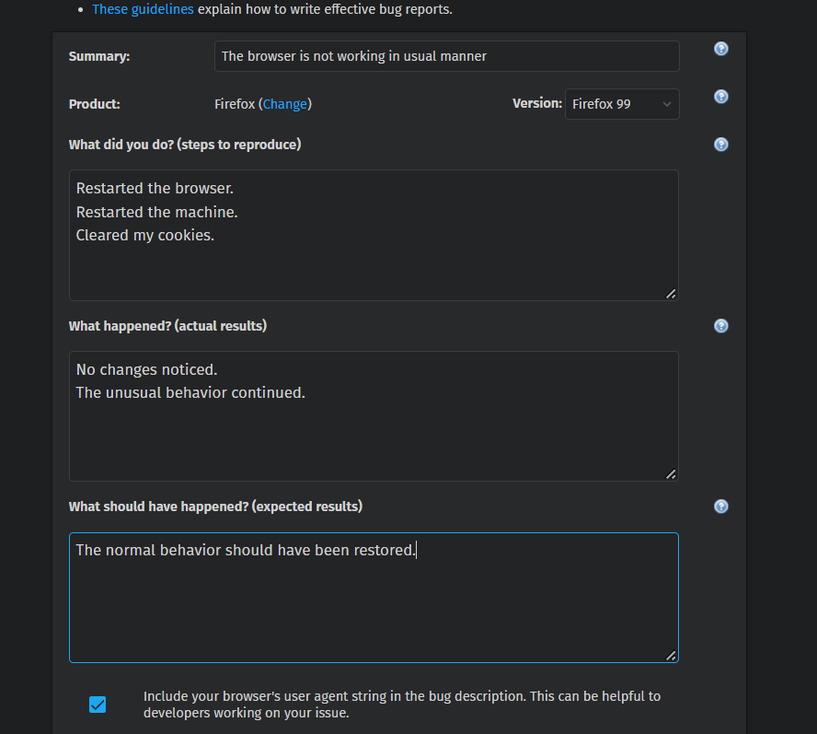

**Making a summarized Bug Report**

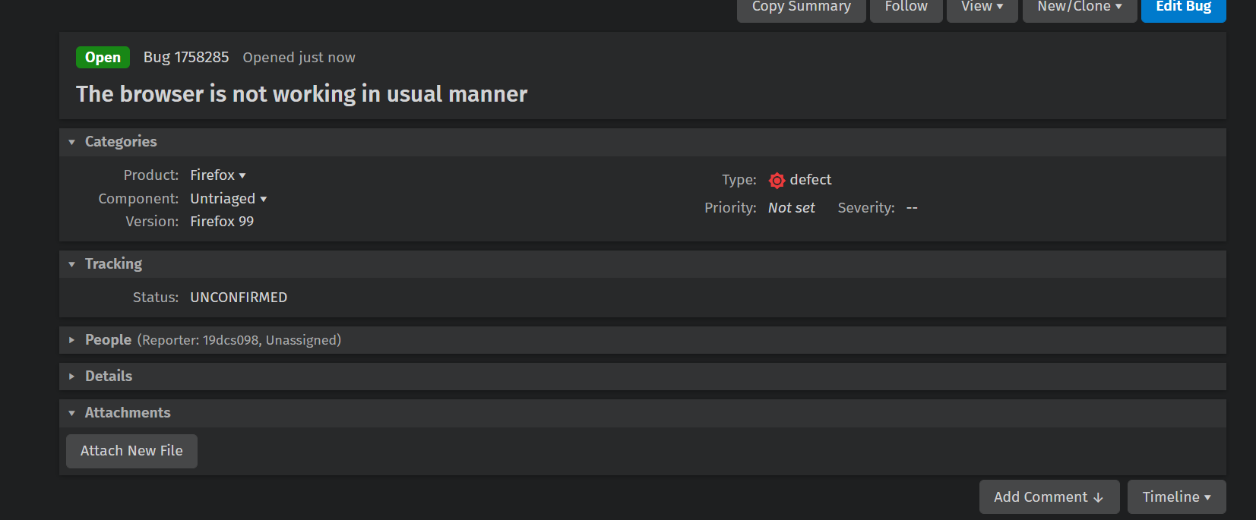

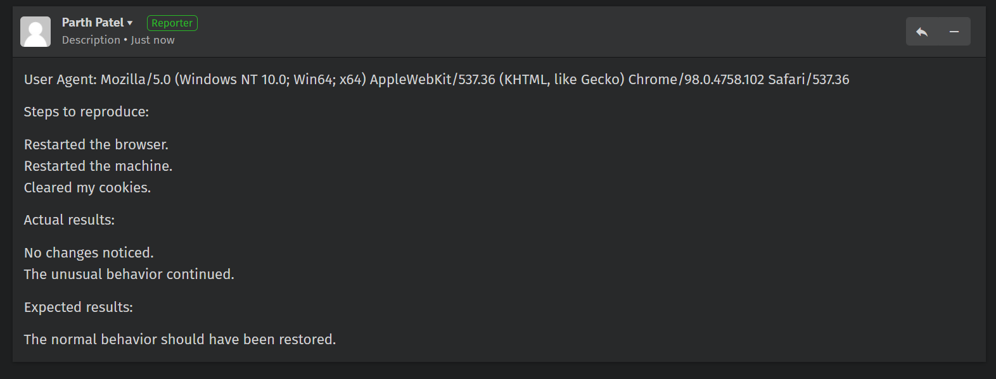

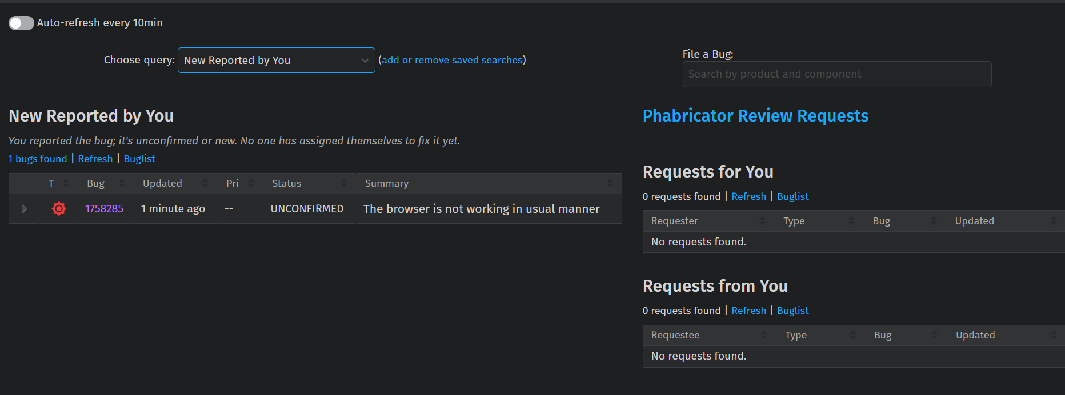

**Glimpse of Dashboard**

**CASE STUDY: VLC Media Player Maintenance Document**

**Abstract:**

Maintenance has always been a pricey task, and the expense fluctuates based on the scale and complexity of the intended software. As a result, this article demonstrates how VLC Media Player's software maintenance functions.

**Introduction:**

According to a poll, developers spend 57 percent of their time resolving bugs and 35 percent developing system changes when working on a project. As a result, project maintenance is always a high concern. Depending on the size and complexity of the target software, maintenance operations can be costly.

In maintenance efforts, the majority of the programmer's time is spent acquiring information and understanding what an existing system accomplishes. This is because the developer who fixes or improves software may not be the same person who created it.

A concern can be any conceptual unit a developer can think about. A concern, for example, could be the code that implements a certain feature of an application. Dispersed code that implements non-functional requirements such as performance concerns, security, and so on can also be a source of concern. A single or numerous concerns can be impacted by a simple software modification. It's difficult to grasp how a modification to one feature or issue affects other features or worries, on top of the problem of identifying and locating the code of interest for a maintenance operation.

These issues necessitate the development of tools to aid in programme comprehension, hence reducing maintenance time and increasing software maintenance productivity. Also, a facility to document the knowledge of software’s actual developer is needed to reduce the maintenance time.

**VLC Media player:**

VLC Media player was released in 2009 and since that date the developers and VLC Media player team has encountered many problems and they have devoted their time on making the software maintenance rather than developing the software. The following are the things developers need to maintain to make the software more efficient. VLC supports many audio and video compression methods and file formats including DVD

**Software maintenance process of VLC Media player:**

Starting with the project, the identification and tracing of the project are the initial steps in the process. This procedure identifies which parts of the software require modification and upkeep. Depending on the situation, this can be user-generated or detected by developers. VLC Media Players require audio and video format maintenance, and it should support all available formats and work in any format.

The second stage focuses on determining the type of maintenance. Understanding the potential implications of the suggested modification is part of the analysis process. This step usually involves a cost analysis to determine whether or not the modification is financially viable. Support for all types of formats in VLC Media Player is required and will not cause any issues; rather, it will enrich the project. There will be no significant price increases.

The design is included in the third stage. Using requirement specifications to design new modifications. This includes adding to the document's pre-defined specification sheet.

The Fifth stage includes the System testing and before launching the maintenance specified above each module is sent for testing and the whole system once.

The Last and the final stage is the delivery of the changes made. VLC media player support for all types of Video and Audio format will be done and there will be new installation of the software. Here, now the changes are given to the customer.

**Maintenance cost:**

The expense of software upkeep might be rather substantial. This isn't to say that software maintenance isn't important. Software maintenance can cost up to two-thirds of the entire software process cycle, or more than half of the SDLC processes, in some situations. VLC Media Player software maintenance expenses are determined by a variety of factors and vary based on the situation. Because technology (and coding languages) develop over time, the older the software is, the more upkeep it will cost. In some cases, updating an old piece of software to fit today's technology can be an extremely costly procedure.

**CONCLUSION:**

By performing the above practical, I learnt the basic concepts of software maintenance tools and usage of Bugzilla.