**PRACTICAL-1**

**AIM:**

Installation and introduction of Mininet tool. Explore various features of Mininet tool.

**THEORY:**

* Mininet is a virtual testbed used for testing network tools and protocols.
* We will see how to use mininet from CLI (Command Line Interface) and also about the Miniedit, which is GUI version.
* Mininet can create a realistic virtual network on any type of machine
* Mininet offers the following features:

• Fast prototyping for new networking protocols.

• Simplified testing for complex topologies without the need of buying expensive hardware.

• Realistic execution as it runs real code on the Unix and Linux kernels.

• Open source environment backed by a large community contributing extensive documentation.

* Mininet was originally designed to experiment with OpenFlow2 and Software-Defined Networking (SDN)

**INSTALLATION STEPS:**

* To install the mininet, follow the below steps

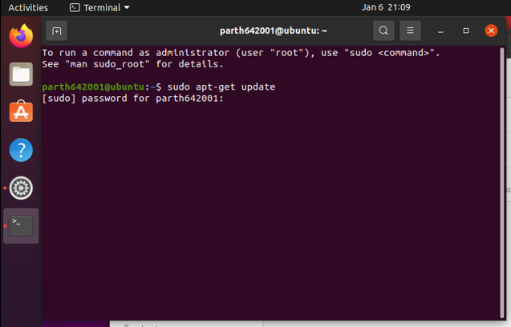

* Then follow the second step

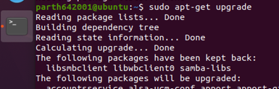

* Then install GIT

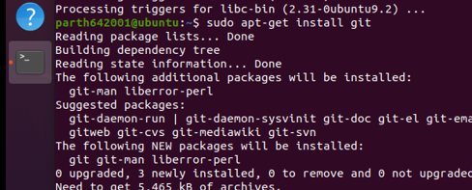

* Then enter the following command



* Then traverse to the mininet folder and enter the below command



* Then select and the version of the mininet and enter the below commands



* Enter the following command to start the mininet in the terminal

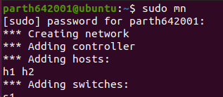

* To display the list of Mininet CLI commands and examples on their usage, type the following command

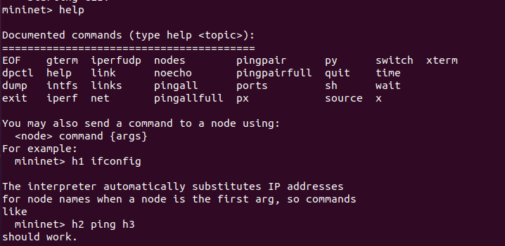

* To display the available nodes, type the following command



* Stop the emulation by typing the following command

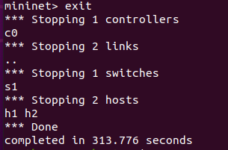

**CONCLUSION:**

By performing the above practical, I learnt how to install mininet in the Ubuntu Linux OS and its basic functionalities and commands.