**PRACTICAL-2**

**AIM:**

Create a network topology which connects 3 switches directly, with a host of each switch in mininet environment.

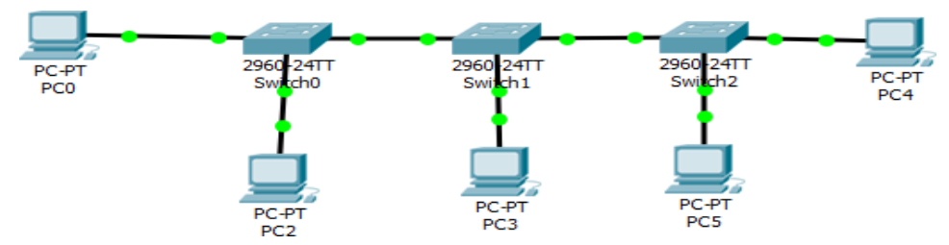

**THEORY:**

* To create this topology, we will use miniedit.
* MiniEdit is a simple GUI (Graphical User Interface) editor for Mininet.
* MiniEdit is an experimental tool created to demonstrate how Mininet can be extended.

The icons represent the following tools:

Mininet-select

The Select tool is used to move nodes around on the canvas. Click and drag any existing node.

Mininet-host

The Host tool creates nodes on the canvas that will perform the function of host computers. Click on the tool, then click anywhere on the canvas you wish to place a node.

Mininet-switch

The Switch tool creates OpenFlow-enabled switches on the canvas. These switches are expected to be connected to a controller.

Mininet-legacy-switch

The Legacy Switch tool creates a learning Ethernet switch with default settings. The switch will operate independently, without a controller.

Mininet-legacy-router

The Legacy Router tool creates a basic router that will operate independently, without a controller. It is basically just a host with IP Forwarding enabled

Mininet-netlink

The NetLink tool creates links between nodes on the canvas. Create links by selecting the NetLink tool, then clicking on one node and dragging the link to the target node.

Mininet-controller

The Controller tool creates a controller. Multiple controllers can be added. By default, the MiniEdit creates a mininet openFlow referencecontroller, which implements the behavior of a learning switch. Other controller types can be configured.

Mininet-run-stop

The Run starts Mininet simulation scenario currently displayed in the MiniEdit canvas. The Stop button stops it. When MininEdit simulation is in the “Run” state, right-clicking on network elements reveals operational functiosn such as opening a terminal window, viewing switch configuration, or setting the status of a link to “up” or “down”.

**TOPOLOGY:**

* To start the miniedit, Enter the following command



* The following window will be prompted

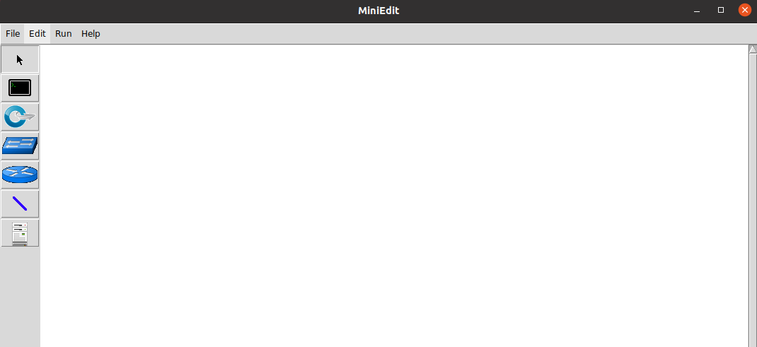

* Create the following topology with the help of miniedit components

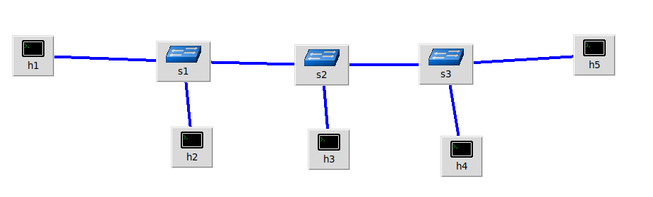

* Now, right click on h1, then click on properties option
* The following option will open

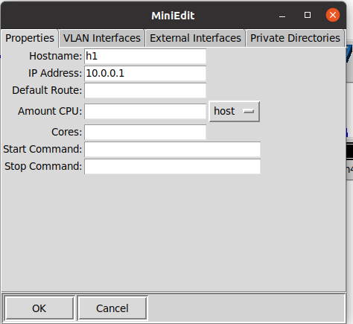

* Follow the same procedure for all the hosts.
* Click on Run button
* Right click on h1 and select Terminal option.
* Then perform the ping operation.

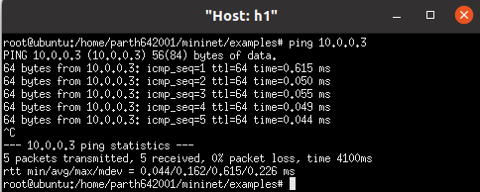

* Thus, the connection is established.

**CONCLUSION:**

By performing the above practical, I learnt the basics of MiniEdit and how to create a simple topology in it and how to test the topology.