**PRACTICAL-3**

**AIM:**

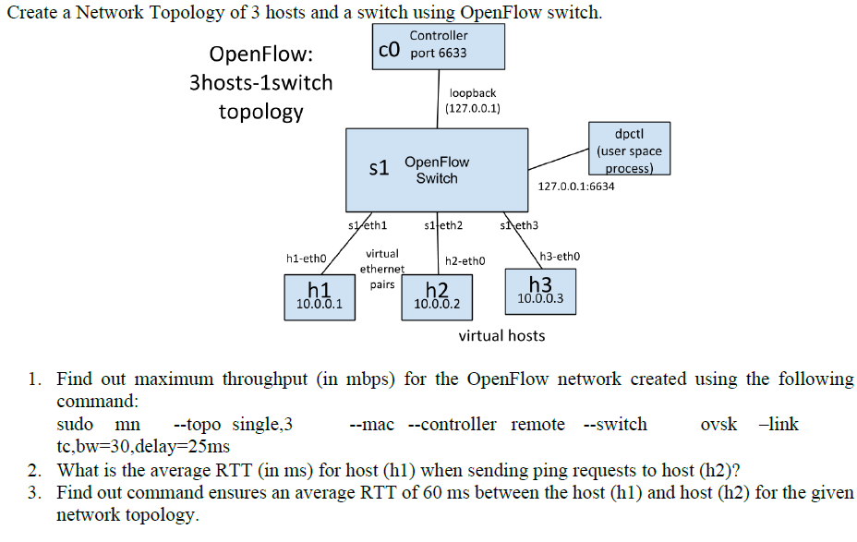

**THEORY:**

**OPENFLOW:**

* OpenFlow is a communications protocol that gives access to the forwarding plane of a network switch or router over the network.

**OVS CONTROLLER:**

* A simple OpenFlow controller that manages any number of switches over the OpenFlow protocol

**RTT:**

* Round-trip delay or round-trip time is the amount of time it takes for a signal to be sent plus the amount of time it takes for acknowledgement of that signal having been received

**OPENFLOW SWITCH:**

* An OpenFlow switch is a network switch based on the OpenFlow protocol that employs software-defined network (SDN) techniques to forward packets in a network

**DPTCL:**

* The dpctl program is a command line tool for monitoring and administering OpenFlow datapaths

**TOPOLOGY IMPLEMENTATION:**

* Open terminal, and write the command mentioned in the question.
* If no mistake occurs, then following will be displayed

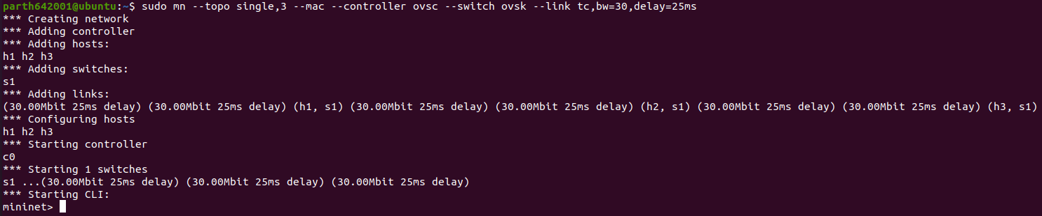

* The only change is instead of remote controller, we are taking ovs controller.
* To check the throughput, we will use the following command

Command: iperf <host1> <host2>

Result:



* To find RTT, we will use ping command**.**

Command: <host1> ping <host2>

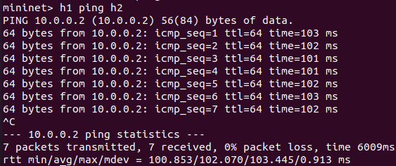

* AVERAGE RTT : 102.070 ms
* Now, we will see the usage of dpctl commands.

Command: dpctl show

* Prints to the console information on datapath switch including information on its flow tables and ports.

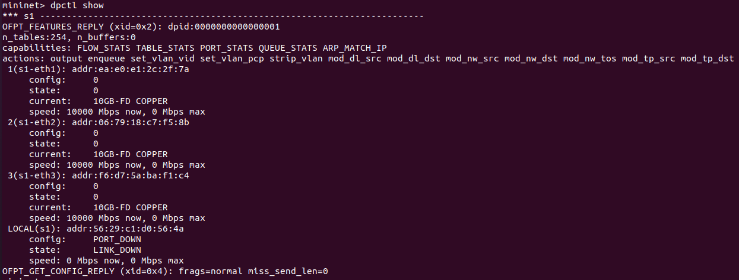

Command: dpctl dump-desc

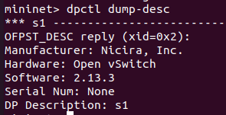

Command: dpctl dump-ports

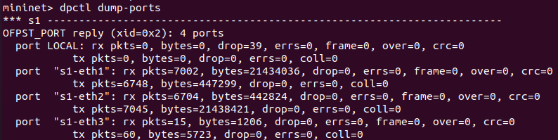

Command: dpctl dump-ports-desc

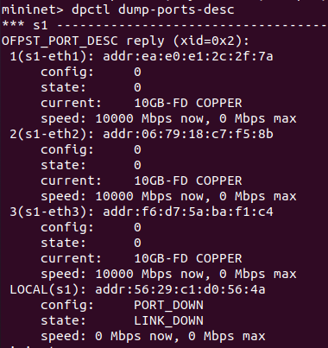

Command: dpctl dump-flows



**CONCLUSION:**

By performing the above practical, I learnt the basics about openflow, how to create topology in terminal in mininet and basics of dpctl and it’s commands.