**PRACTICAL-5**

**AIM:**

Implement the basic hub example using Pox controller and verify Hub behaviour with tcpdump. Also, Create the learning switch.

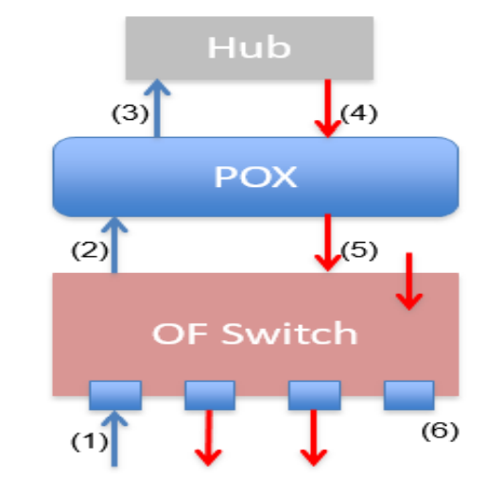

**THEORY:**

**POX CONTROLLER:**

* POX is an open source development platform for Python-based software-defined networking (SDN) control applications.
* It creates a realistic virtual network, running real kernel, switch and application code on a single machine.
* It adds a listener that listen to openflow switches for connection.

**TCP DUMP:**

* TCP Dump is a widely used command line packet analyzer tool.
* It is used to capture and filter tcp/ip packets that are received or transfer over a network on a Specific interface.

**IMPLEMENTATION:**

* First, we will open the terminal and navigate to pox folder.

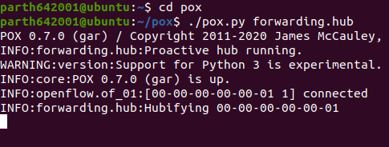

Starting the POX controller

* Now, open another terminal and create the topology

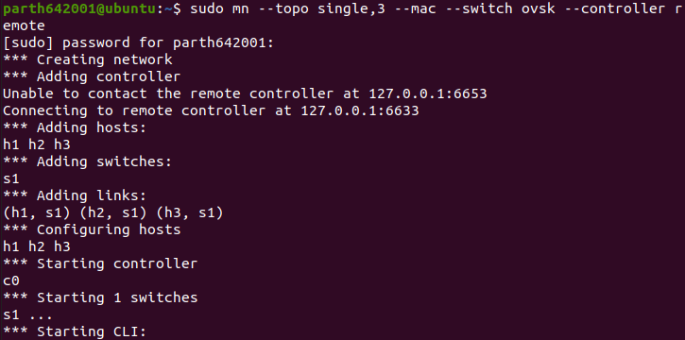

Topology created

* Once the topology is created, controller will detect and will connect to the hub.



POX controller connected to hub

* Now, we will check the connection

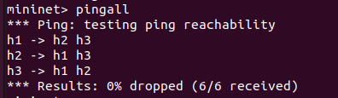

Performing pingall

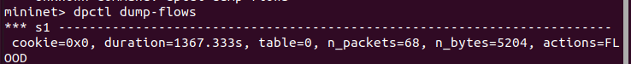

Flow table entry

* Now, we will verify the hub’s behaviour with tcpdump
* We will give the command to open console of individual mode.

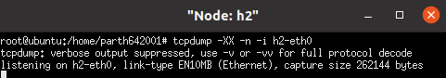

We will set up h2 to receive packets

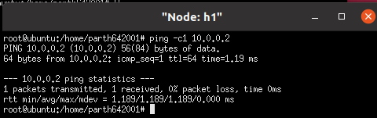

Sending packets from h1 to h2

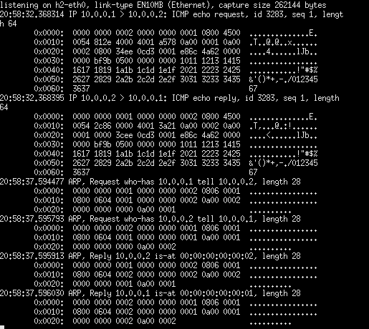

H2 receiving the packets

* We will test certain commands
* Command: tcpdump -D
* It displays the available interfaces

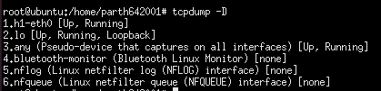

* Command: tcpdump -n -i eth0
* It captures the ip packets

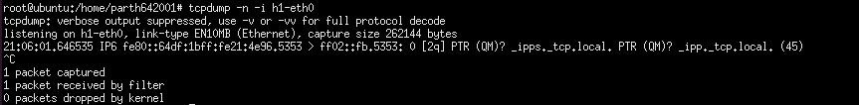

* Now, we will create a learning switch.
* We will open the terminal and we will navigate to pox folder to start the controller learning switch.

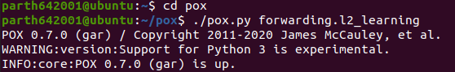

* Now, we will open another terminal to create topology

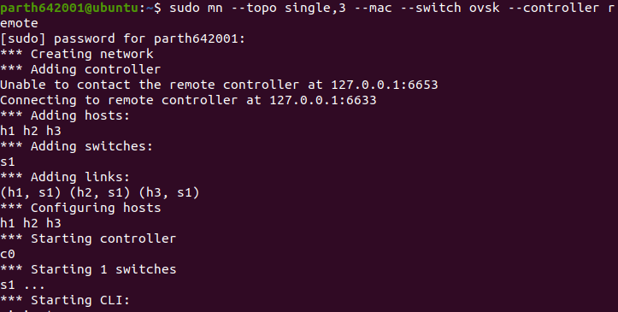

Topology created

* Also, controller has connected to the switch



**CONCLUSION:**

* In this practical, I learnt the basics of POX controller and the working of tcp-dump