**PRACTICAL-1**

**AIM**

Installation and configuration of Instant Contiki OS with Cooja.

**THEORY**

* Contiki is an operating system for networked, memory-constrained systems with a focus on low-power wireless Internet of Things devices.
* Extant uses for Contiki include systems for street lighting, sound monitoring for smart cities, radiation monitoring, and alarms. It is open-source software released under a BSD license.
* Contiki was created by Adam Dunkels in 2002 and has been further developed by a worldwide team of developers from Texas Instruments, Atmel, Cisco, ENEA, ETH Zurich, Redwire, RWTH Aachen University, Oxford University, SAP, Sensinode, Swedish Institute of Computer Science, ST Microelectronics, Zolertia, and many others.
* Contiki provides multitasking and a built-in Internet Protocol Suite (TCP/IP stack), yet needs only about 10 kilobytes of random-access memory (RAM) and 30 kilobytes of read-only memory (ROM).
* A full system, including a graphical user interface, needs about 30 kilobytes of RAM

**Hardware**

* Contiki is designed to run on types of hardware devices that are severely constrained in memory, power, processing power, and communication bandwidth.
* A typical Contiki system has memory on the order of kilobytes, a power budget on the order of milliwatts, processing speed measured in megaHertz, and communication bandwidth on the order of hundreds of kilobits/second.
* Such systems include many types of embedded systems, and old 8-bit computers.

**Networking**

* Contiki provides three network mechanisms: the uIP TCP/IP stack, which provides IPv4 networking, the uIPv6 stack, which provides IPv6 networking, and the Rime stack, which is a set of custom lightweight networking protocols designed for low-power wireless networks.
* The IPv6 stack was contributed by Cisco and was, when released, the smallest IPv6 stack to receive the IPv6 Ready certification.
* The IPv6 stack also contains the Routing Protocol for Low power and Lossy Networks (RPL) routing protocol for low-power lossy IPv6 networks and the 6LoWPAN header compression and adaptation layer for IEEE 802.15.4 links.

**Low-power operation**

* Many Contiki systems are severely power-constrained. Battery operated wireless sensors may need to provide years of unattended operation and with little means to recharge or replace batteries.
* Contiki provides a set of mechanisms to reduce the power consumption of systems on which it runs. The default mechanism for attaining low-power operation of the radio is called ContikiMAC. With ContikiMAC, nodes can be running in low-power mode and still be able to receive and relay radio messages.

**Simulation**

* The Contiki system includes a sensor simulator called Cooja, which simulates of Contiki nodes. The nodes belong to one of the three following classes: a) emulated Cooja nodes, b) Contiki code compiled and executed on the simulation host, or c) Java nodes, where the behavior of the node must be reimplemented as a Java class.
* One Cooja simulation may contain a mix of sensor nodes from any of the three classes. Emulated nodes can also be used to include non-Contiki nodes in a simulated network.

**Features**

* Contiki supports per-process optional preemptive multithreading, inter-process communication using message passing through events, as well as an optional graphical user interface (GUI) subsystem with either direct graphic support for locally connected terminals or networked virtual display with Virtual Network Computing (VNC) or over Telnet.

A full installation of Contiki includes the following features:

* + Multitasking kernel
  + Optional per-application preemptive multithreading
  + Protothreads
  + Internet Protocol Suite (TCP/IP) networking, including IPv6
  + Windowing system and GUI
  + Networked remote display using Virtual Network Computing
  + A web browser (claimed to be the world's smallest)
  + Personal web server
  + Simple telnet client
  + Screensaver
* Contiki is supported by popular SSL/TLS libraries such as wolfSSL, which includes a port in its 3.15.5 release.

**Ports**

The Contiki operating system is ported to the following systems:

**Microcontrollers**

* Atmel – ARM, AVR
* NXP Semiconductors – LPC1768, LPC2103, MC13224
* Microchip – dsPIC, PIC32 (PIC32MX795F512L)
* Texas Instruments – MSP430, CC2430, CC2538, CC2630, CC2650, CC2538: RE-Mote[permanent dead link], Firefly, Zoul (comprises the CC2538 and CC1200 in a single module format)
* STMicroelectronics – STM32 W

**PRACTICAL IMPLEMENTATION**

The following steps show how to install Contiki OS in VMware.

* Download the required files of Contiki OS from <https://sourceforge.net/projects/contiki/>
* Extract all the files that you downloaded.

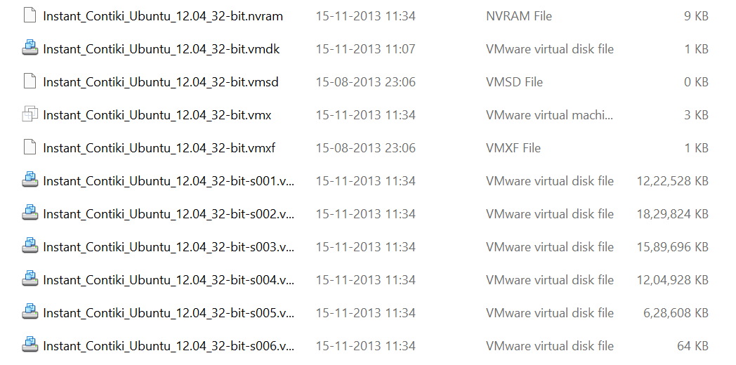

* Download and install VMWare.

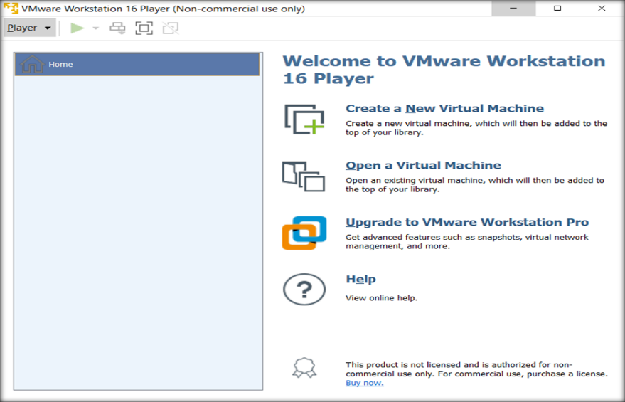

* Choose Open a Virtual Machine and explore to the folder where instant Contiki files are situated.

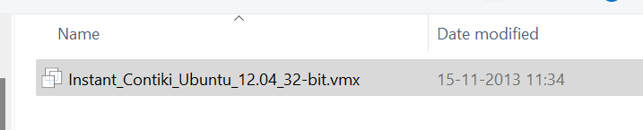

* On opening that file, new virtual machine will be created containing the given Contiki OS.

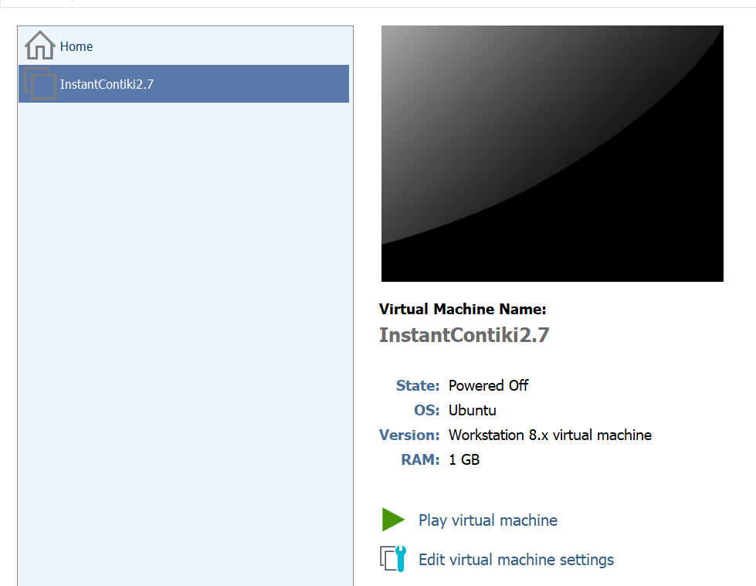

* To start Contiki OS, click on “Play virtual machine”

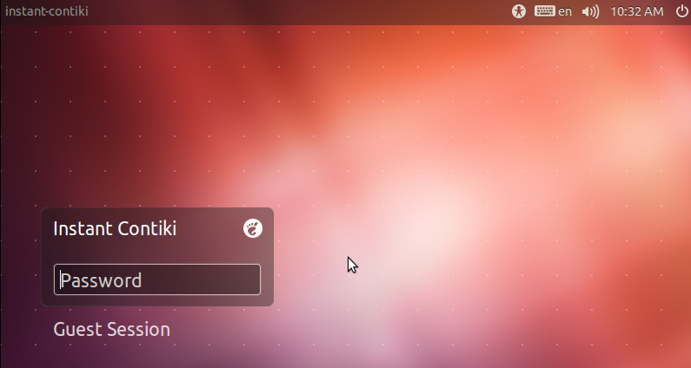

* The default password is “user” and Desktop will be seen.

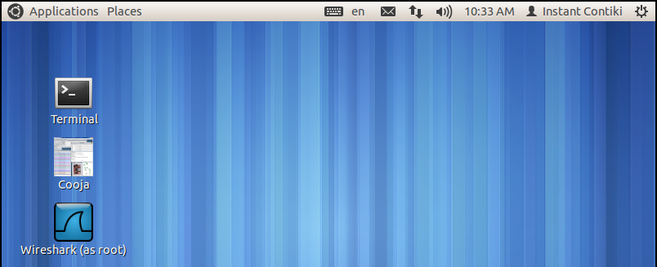

**CONCLUSION**

In this practical, I learned how to install Contiki OS in VMware.