**PRACTICAL-3**

**AIM**

Simulate Hello World program using Cooja

**THEORY**

* Hello World is the most basic and introductory program which is performed as a convention by newbie whenever, we start learning any new language or software.
* We will do the same in Cooja.
* For simplicity, we will perform using the pre-built example of hello world which is already available in the examples folder.

**PRACTICAL IMPLEMENTATION**

* Open Cooja simulator.
* Go to file > create new simulation

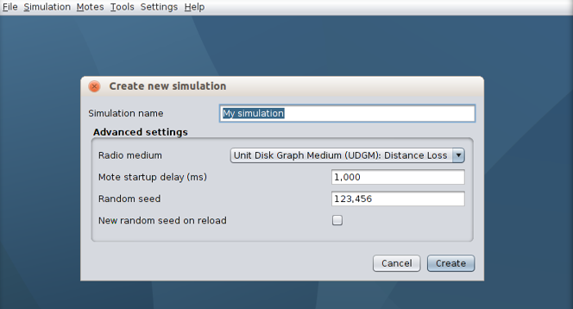

* Give it any name you like and keep the rest of settings as default.

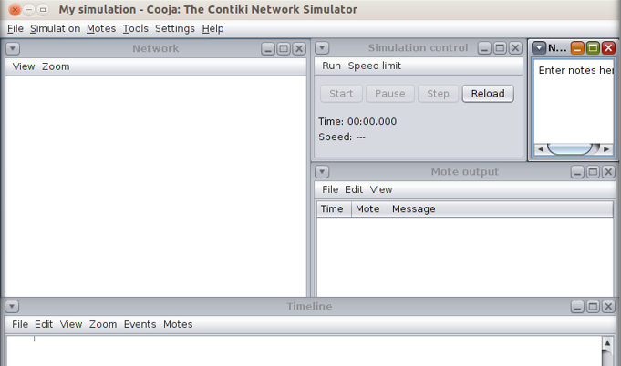

* We will add 3 cooja motes.
* In Contiki process/firmware, browse to hello-world folder in examples.

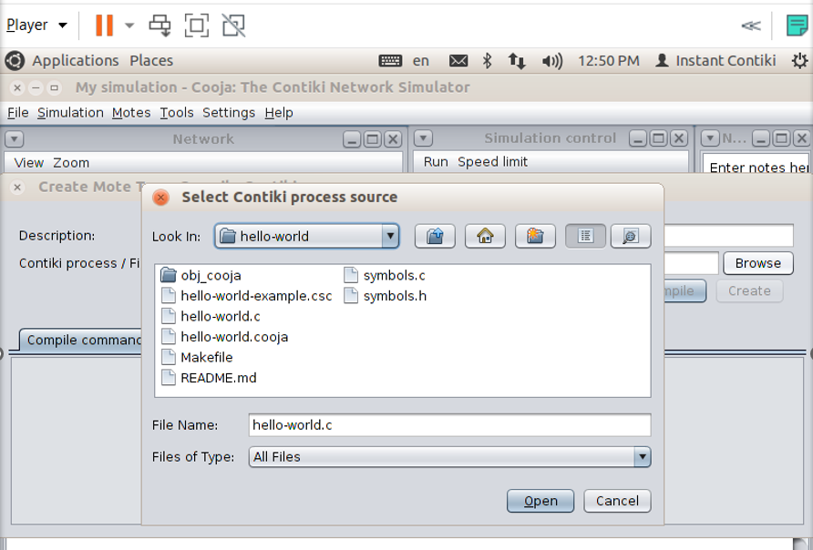

* For that, go to Motes > Add motes > Create new mote type > Cooja mote.

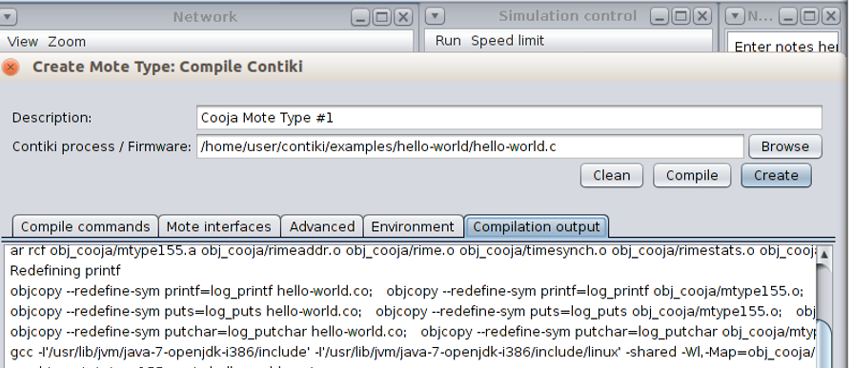

* It will compile the program and show compilation output.
* Click on “create”

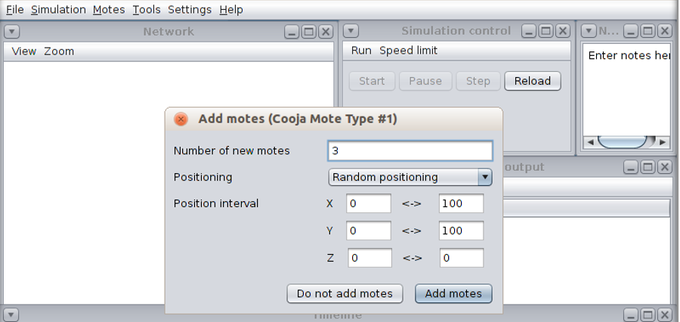

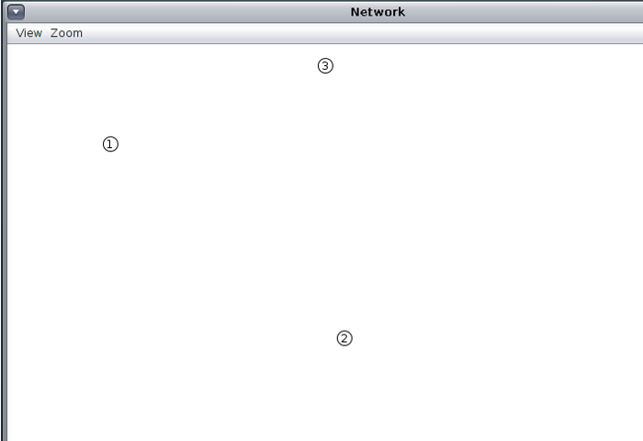

* 3 motes will be added at random positions now.

* To run the simulation, click on start.

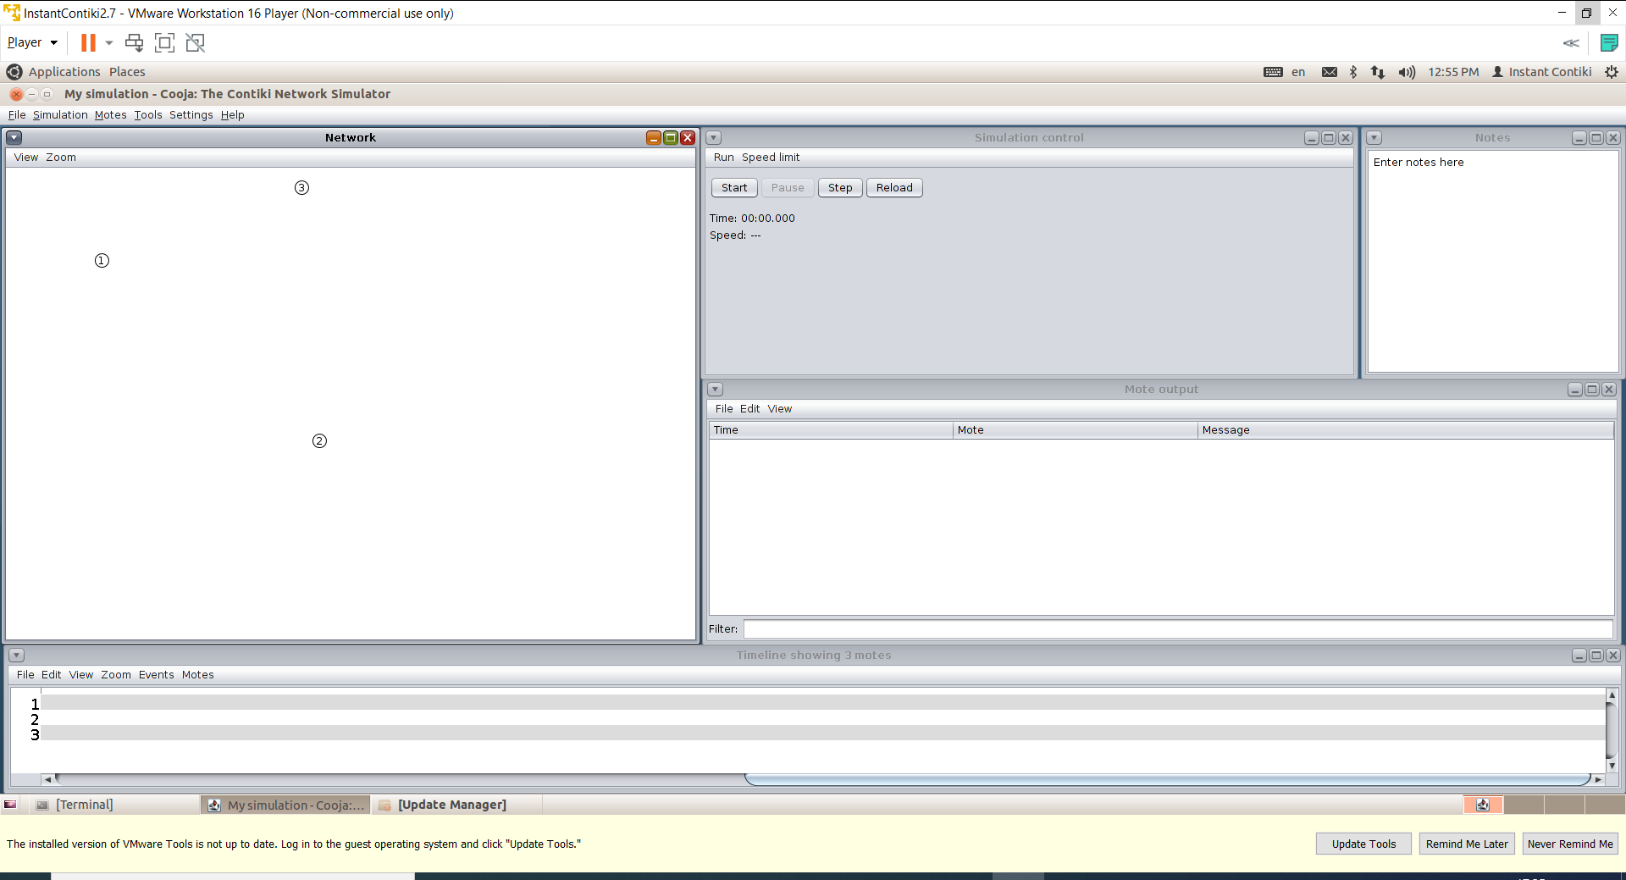

* Go to view > Log output: printf()’s

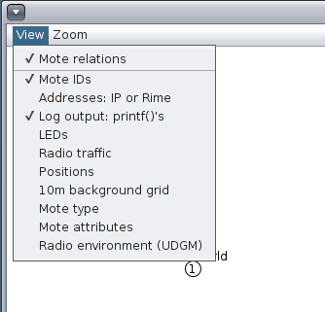

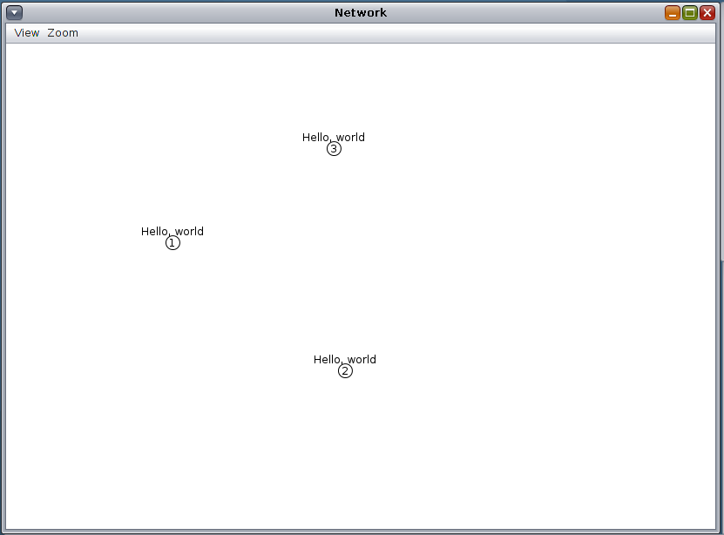

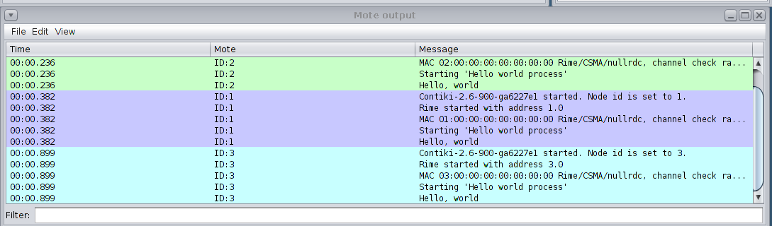

**CONCLUSION**

In this practical, I learnt regarding how to simulate hello world program in Cooja.