**PRACTICAL-5**

**AIM**

Simulate client server architecture using UDP on contiki-os.

**THEORY**

* In computer networking, the User Datagram Protocol (UDP) is one of the core members of the Internet protocol suite. With UDP, computer applications can send messages, in this case referred to as datagrams, to other hosts on an Internet Protocol (IP) network.
* Prior communications are not required in order to set up communication channels or data paths.
* UDP uses a simple connectionless communication model with a minimum of protocol mechanisms.
* UDP provides checksums for data integrity, and port numbers for addressing different functions at the source and destination of the datagram.
* It has no handshaking dialogues, and thus exposes the user's program to any unreliability of the underlying network; there is no guarantee of delivery, ordering, or duplicate protection.
* If error-correction facilities are needed at the network interface level, an application may use Transmission Control Protocol (TCP) or Stream Control Transmission Protocol (SCTP) which are designed for this purpose.
* UDP is suitable for purposes where error checking and correction are either not necessary or are performed in the application; UDP avoids the overhead of such processing in the protocol stack. Time-sensitive applications often use UDP because dropping packets is preferable to waiting for packets delayed due to retransmission, which may not be an option in a real-time system.
* The protocol was designed by David P. Reed in 1980 and formally defined in RFC 768.

**PRACTICAL IMPLEMENTATION**

* For this task, we will add a Z1 mote as router and other motes to receive signals and we will observe the UDP traffic between them.
* First of all, we will open Cooja simulator and create new simulator.

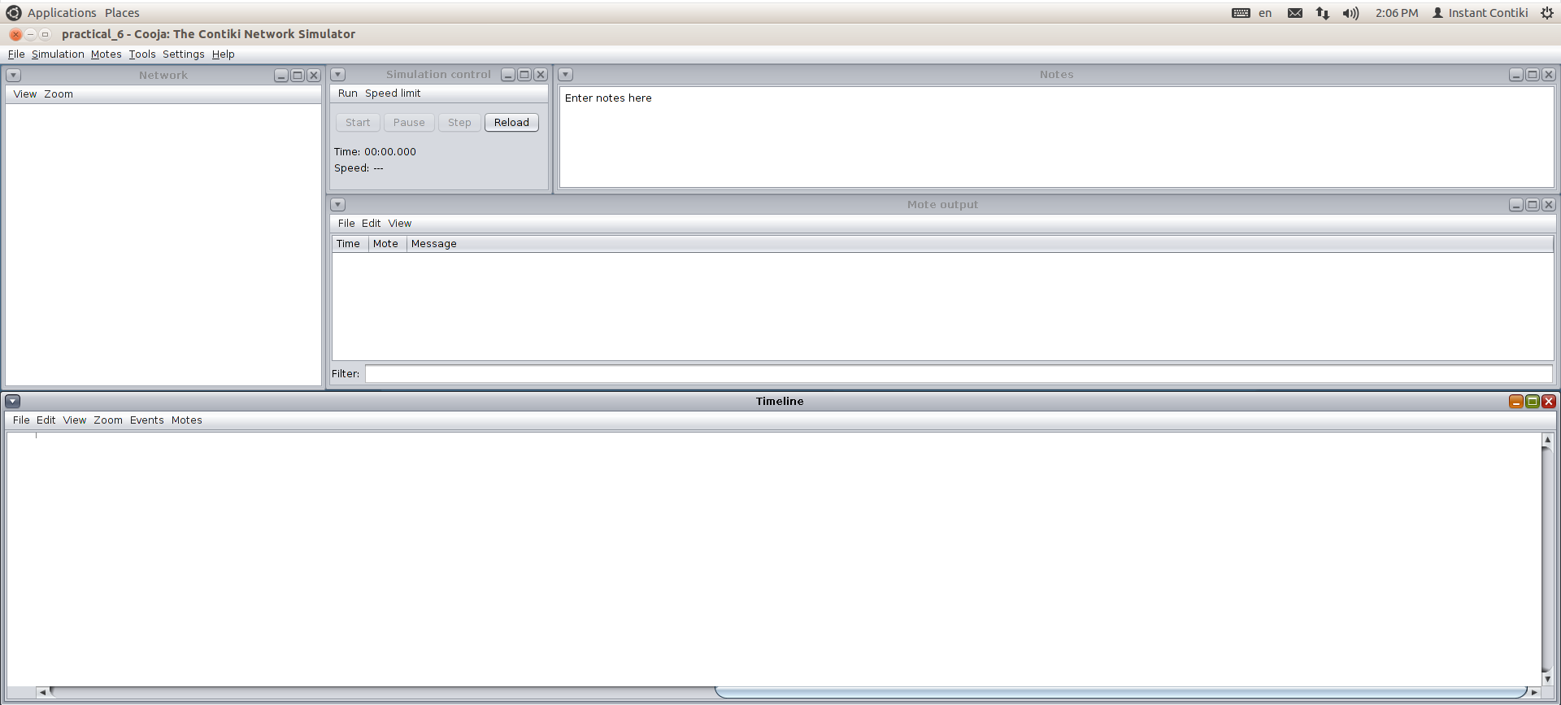

* Then, we will first add the router mote, so we will go to Motes > Create new mote type > Z1 mote.

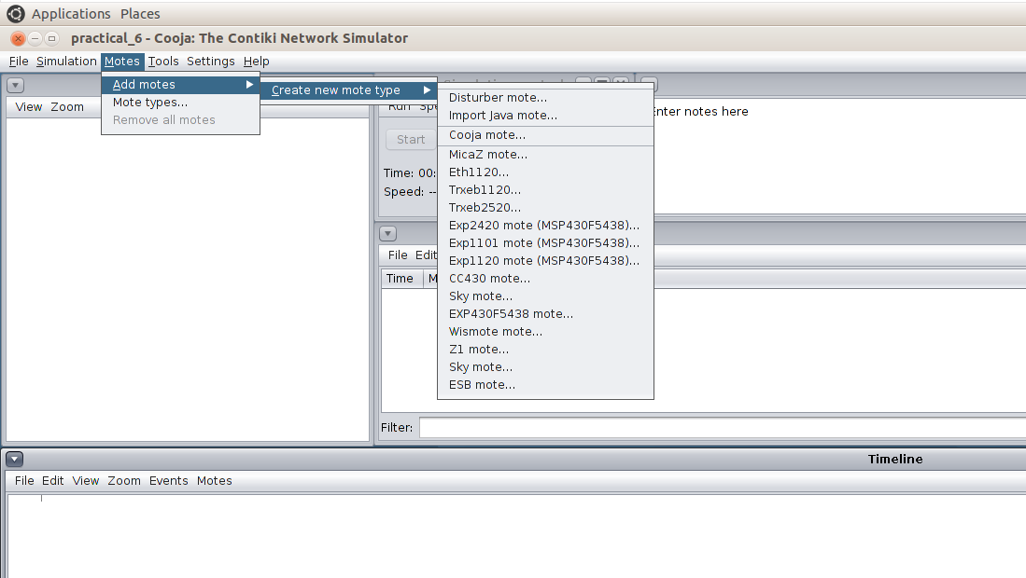

* We will browse through example folder to find udp-ipv6 > udp-server.c.
* We will compile it and press create.

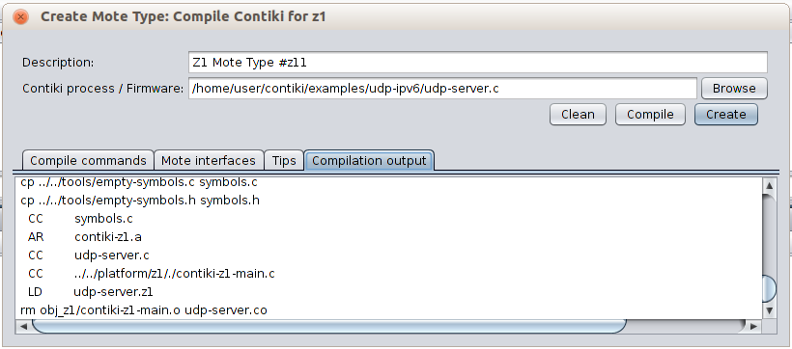

* We will need only 1 router so number of new motes will be 1 only.

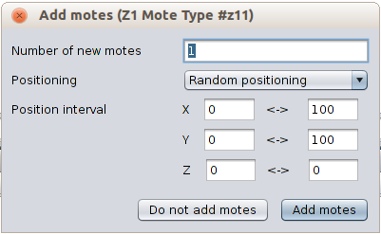

* To create receiving motes, we will follow the same process to add Z1 motes.
* This time, we will browse to udp-ipv6 > udp-client.c.

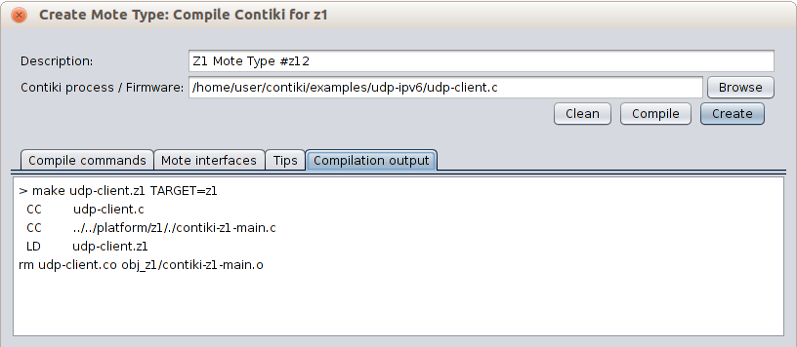

* We will need more receivers for better visualization so we will add 4 motes.

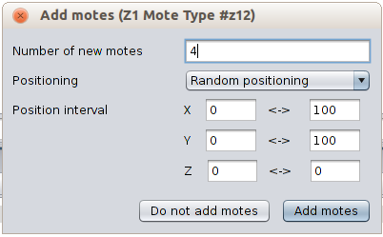

* When we will add motes, we will be able to see a screen like this.
* By clicking on the mote, you will be able to see its range.
* We can change some view options as our convenience.

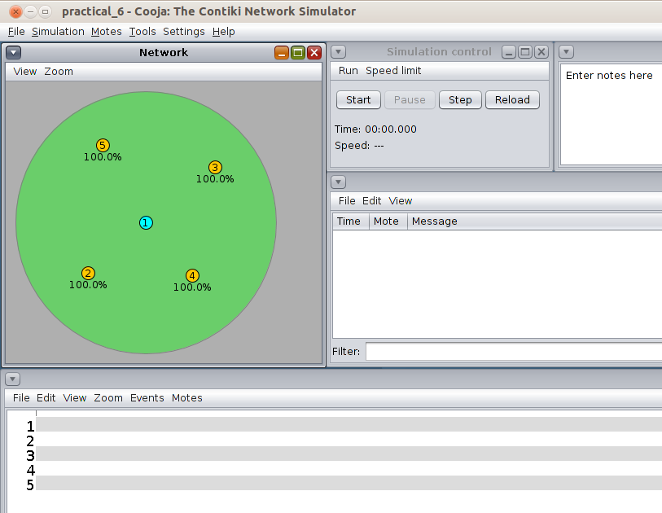

* Then, we will finally start the simulator to see the UDP traffic.

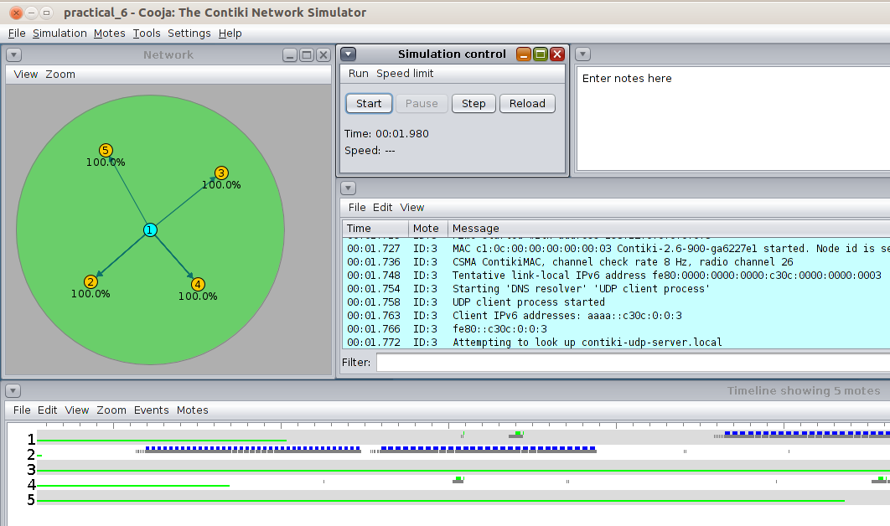

**CONCLUSION**

In this practical, I learnt regarding how to implement UDP protocol in Cooja.