**PRACTICAL-7**

**AIM**

Demonstrate message publish & subscribe mechanism of MQTT protocol using node red.

**THEORY**

**Node Red:**

* + Node-RED is a programming tool for wiring together hardware devices, APIs and online services in new and interesting ways.
  + It provides a browser-based editor that makes it easy to wire together flows using the wide range of nodes in the palette that can be deployed to its runtime in a single-click.
  + Node-RED provides a browser-based flow editor that makes it easy to wire together flows using the wide range of nodes in the palette. Flows can be then deployed to the runtime in a single-click.
  + JavaScript functions can be created within the editor using a rich text editor.
  + A built-in library allows you to save useful functions, templates or flows for re-use.
  + The light-weight runtime is built on Node.js, taking full advantage of its event-driven, non-blocking model. This makes it ideal to run at the edge of the network on low-cost hardware such as the Raspberry Pi as well as in the cloud.
  + With over 225,000 modules in Node's package repository, it is easy to extend the range of palette nodes to add new capabilities.
  + The flows created in Node-RED are stored using JSON which can be easily imported and exported for sharing with others.
  + An online flow library allows you to share your best flows with the world.

**MQTT**:

* + MQTT is an OASIS standard messaging protocol for the Internet of Things (IoT).
  + It is designed as an extremely lightweight publish/subscribe messaging transport that is ideal for connecting remote devices with a small code footprint and minimal network bandwidth.
  + MQTT today is used in a wide variety of industries, such as automotive, manufacturing, telecommunications, oil and gas, etc.
  + Features of MQTT:
    - Lightweight and Efficient
    - MQTT clients are very small, require minimal resources so can be used on small microcontrollers. MQTT message headers are small to optimize network bandwidth.
    - Bi-directional Communications
    - MQTT allows for messaging between device to cloud and cloud to device. This makes for easy broadcasting messages to groups of things.
    - Scale to Millions of Things
    - MQTT can scale to connect with millions of IoT devices.

**PRACTICAL**

* We can install node red on windows by following command.
* npm install -g --unsafe-perm node-red
* Then we can run “node-red” command in cmd to start the node-red.

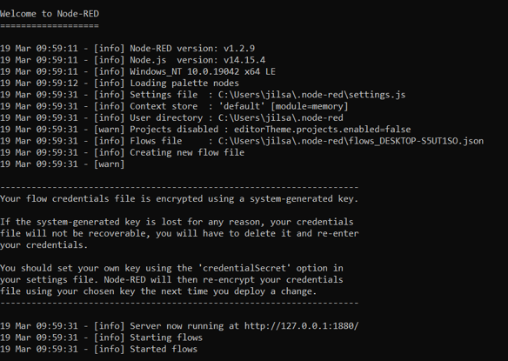

* It will give us an IP address to use web-based node-red.

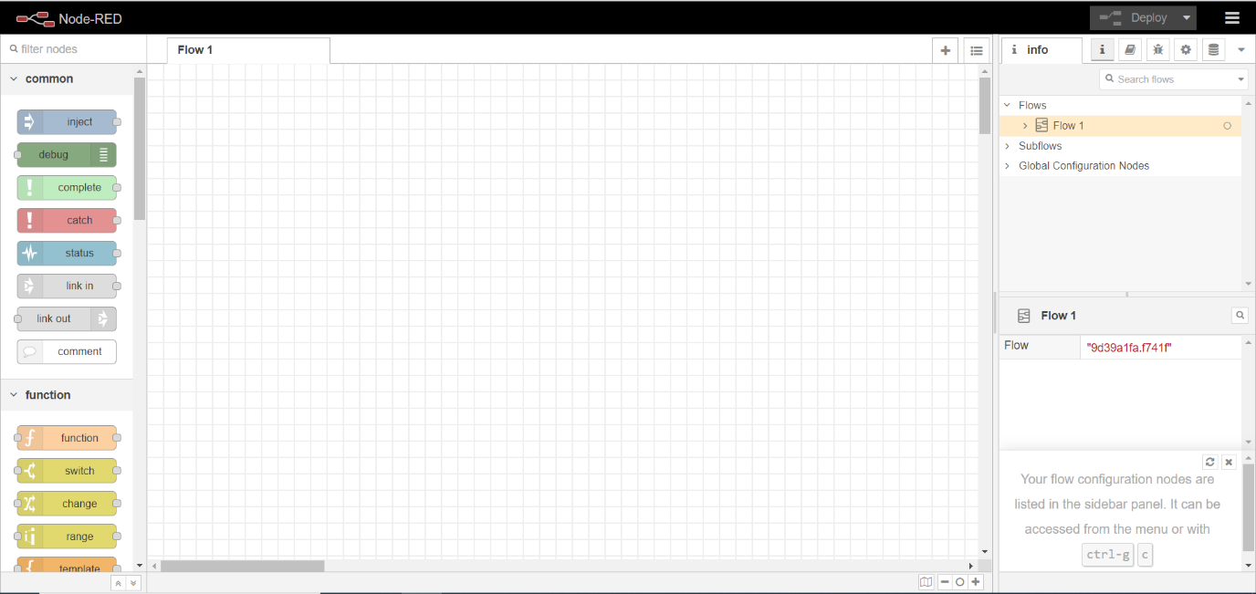

* First, we will install broker for MQTT protocol.
* For that, we will go to menu situated at top right corner.
* We will see Manage Palette option there.

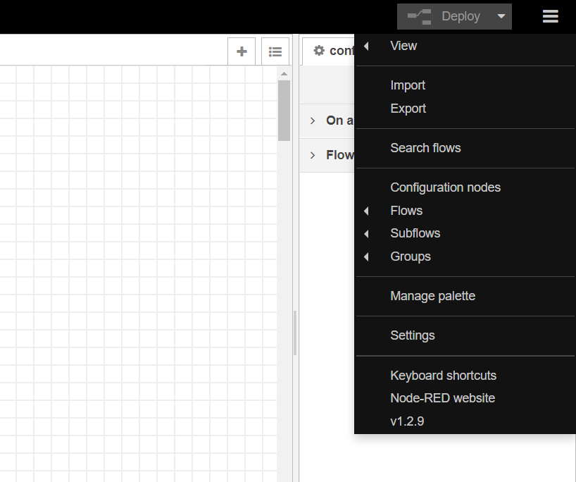

* By clicking on it, User settings will be opened.

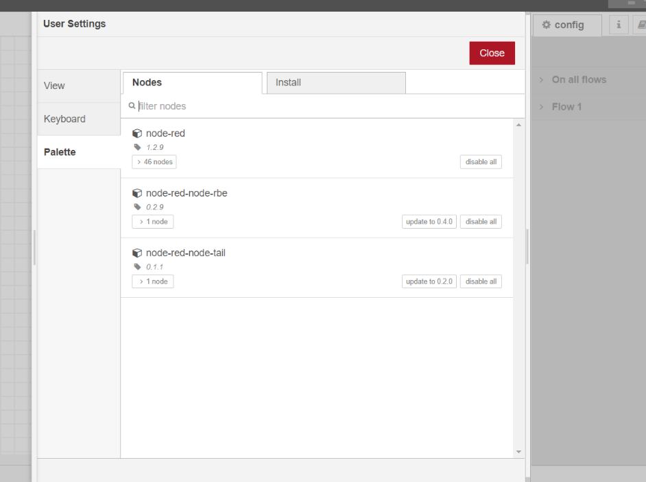

* We go to Install tab and search MQTT.

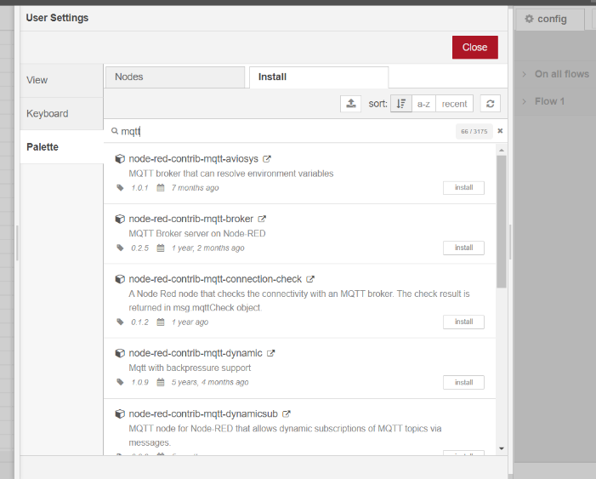

* We will install “node-red-contrib-mqtt-broker” or “node-red-contrib-aedes”

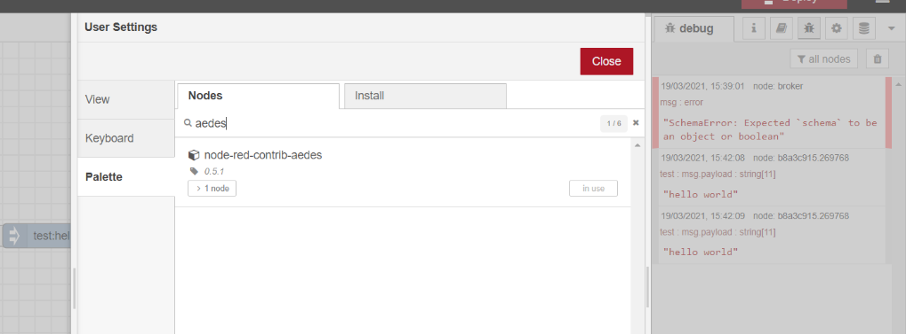

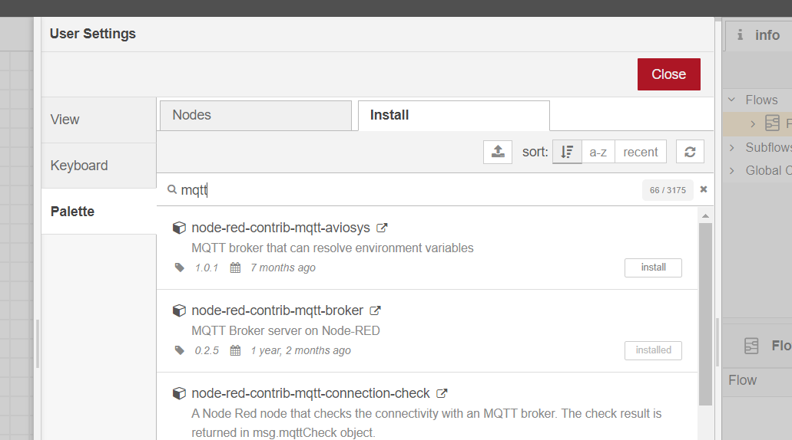

* Then we will add 4 nodes.

1. Inject node, which will be renamed as Timestamp.
2. Debug node, which will be renamed as msg.payload.
3. MQTT in
4. MQTT out

* We will connect timestamp node to MQTT out and debug node to MQTT in.

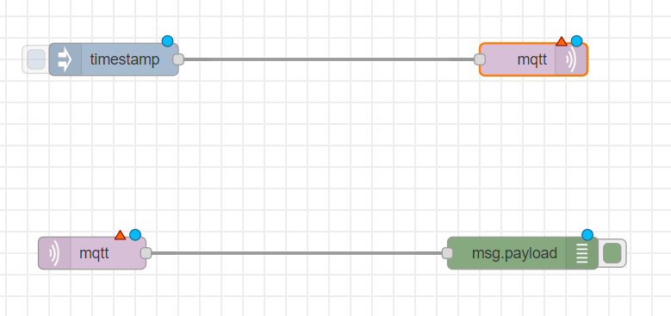

* Then we will add MOSCA MQTT broker or AEDES MQTT broker.

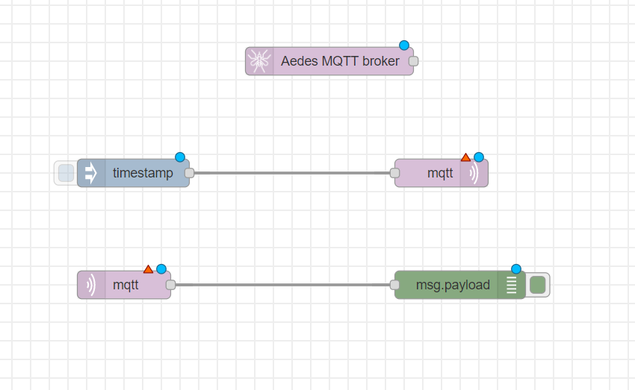

* We can double click on node to see and change their propertied.

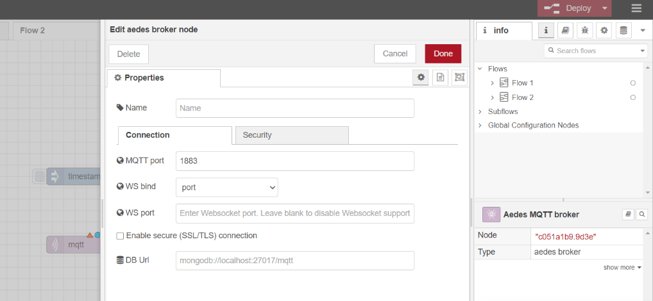

* We will first configure MQTT out node.

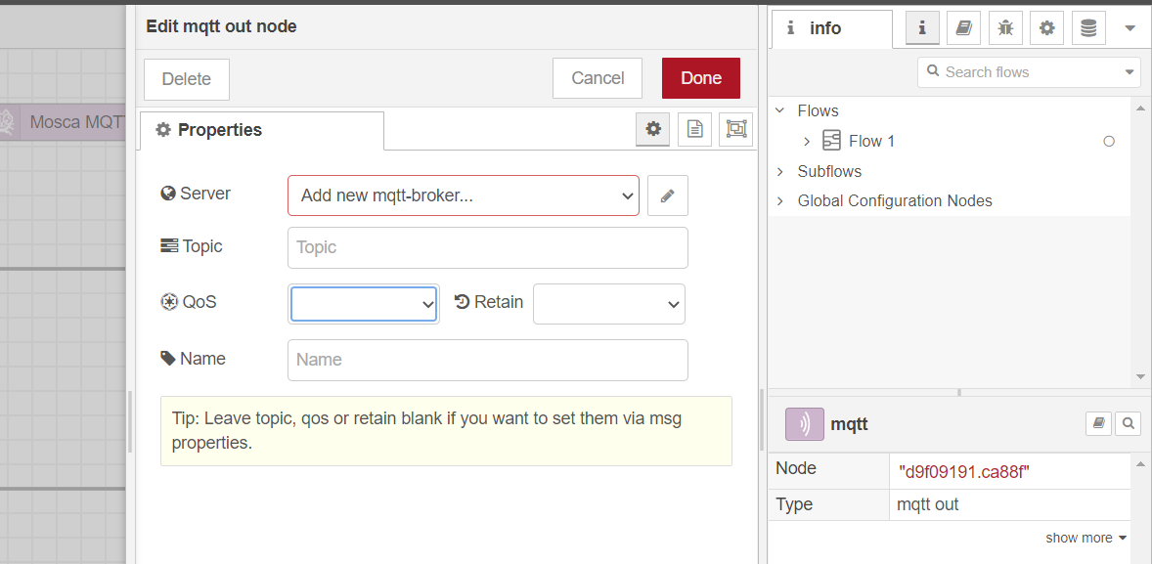

* We will add new mttt-broker. So we click on the button beside it.
* We will add name and server IP address.
* We can add additional settings like security too if we want.

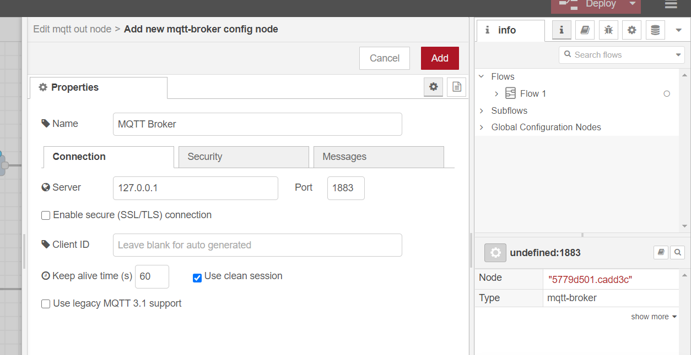

* When we click add, the server will be created and we will fill a couple of fields there like topic and QoS.

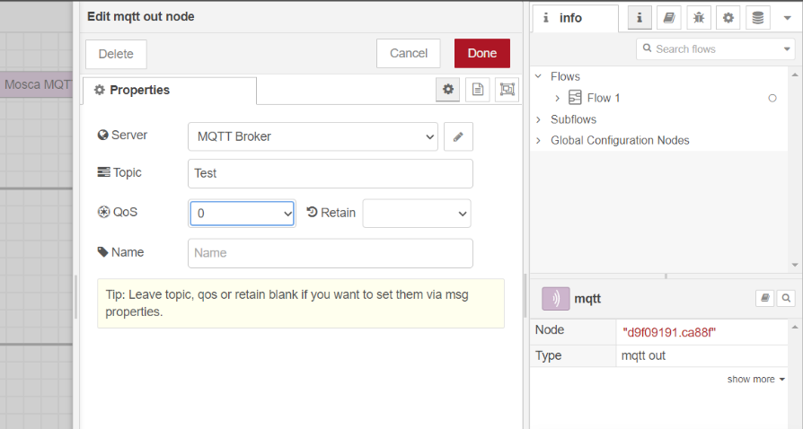

* We will provide same configuration for MQTT in node but we don’t need to create MQTT Broker again.

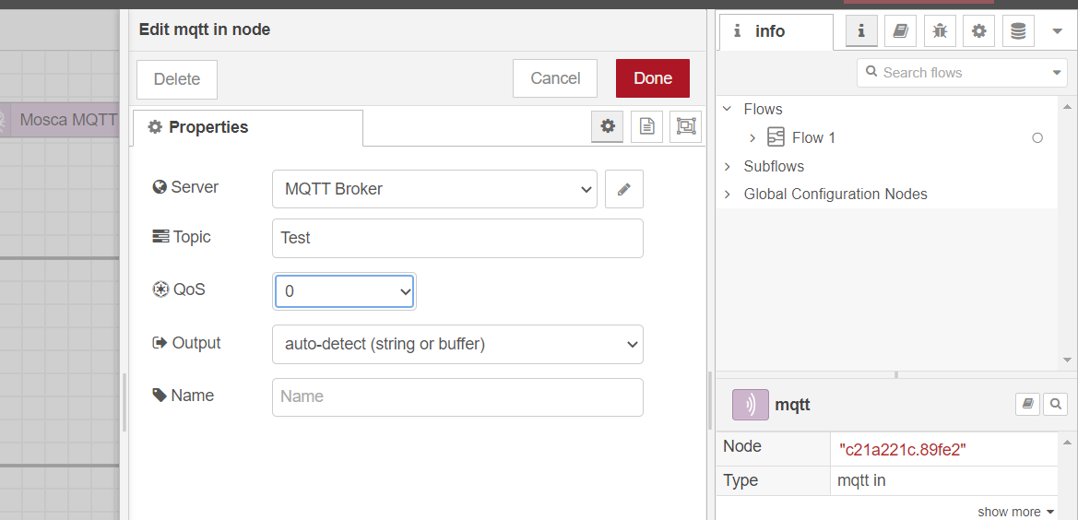

* We will give input string in timestamp node. We change the timestamp to string of “Hello world” and give it the topic name same as MQTT nodes.

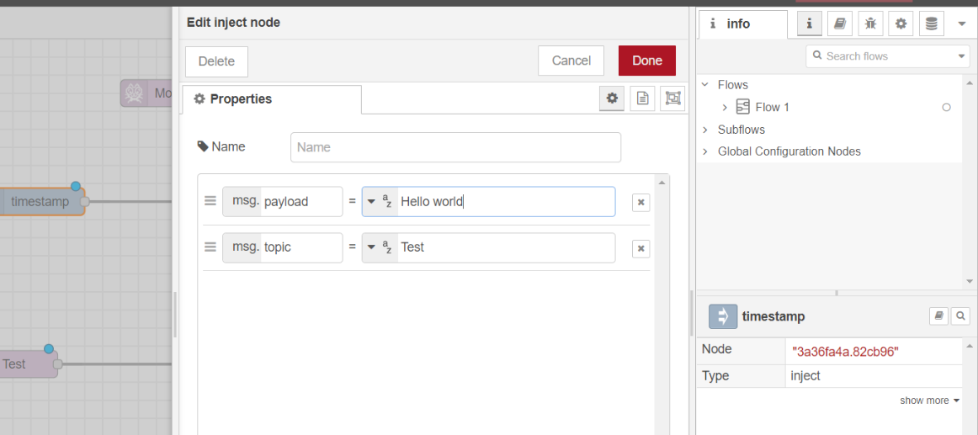

* Now we can deploy our model by “Deploy” button on top right corner.

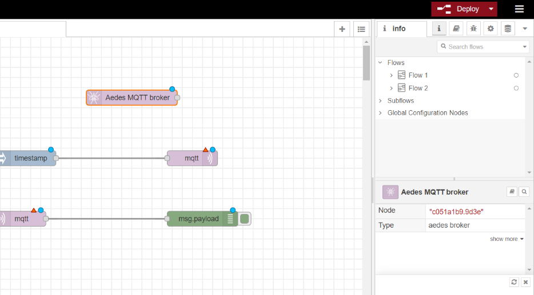

* We can see “Successfully deployed” message.

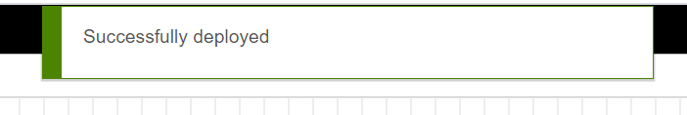

* And in a moment, we will be able to see connected status if there is no error.

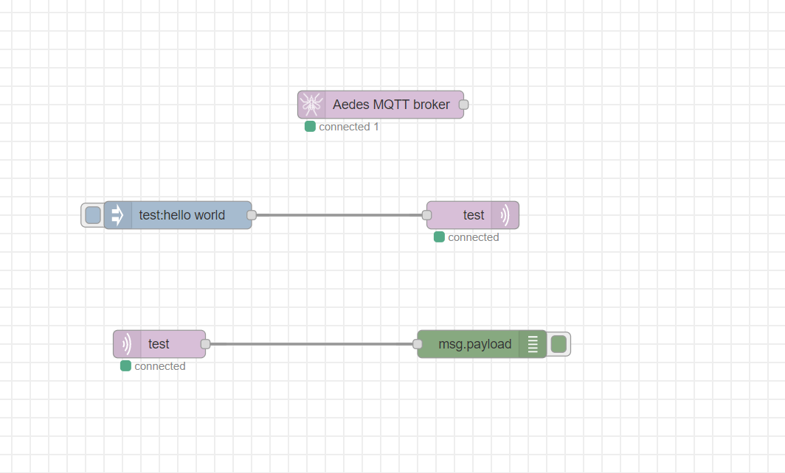

* In debug console, which can be opened from right panel, we can see the output received by debug node after clicking inject node to send the text.

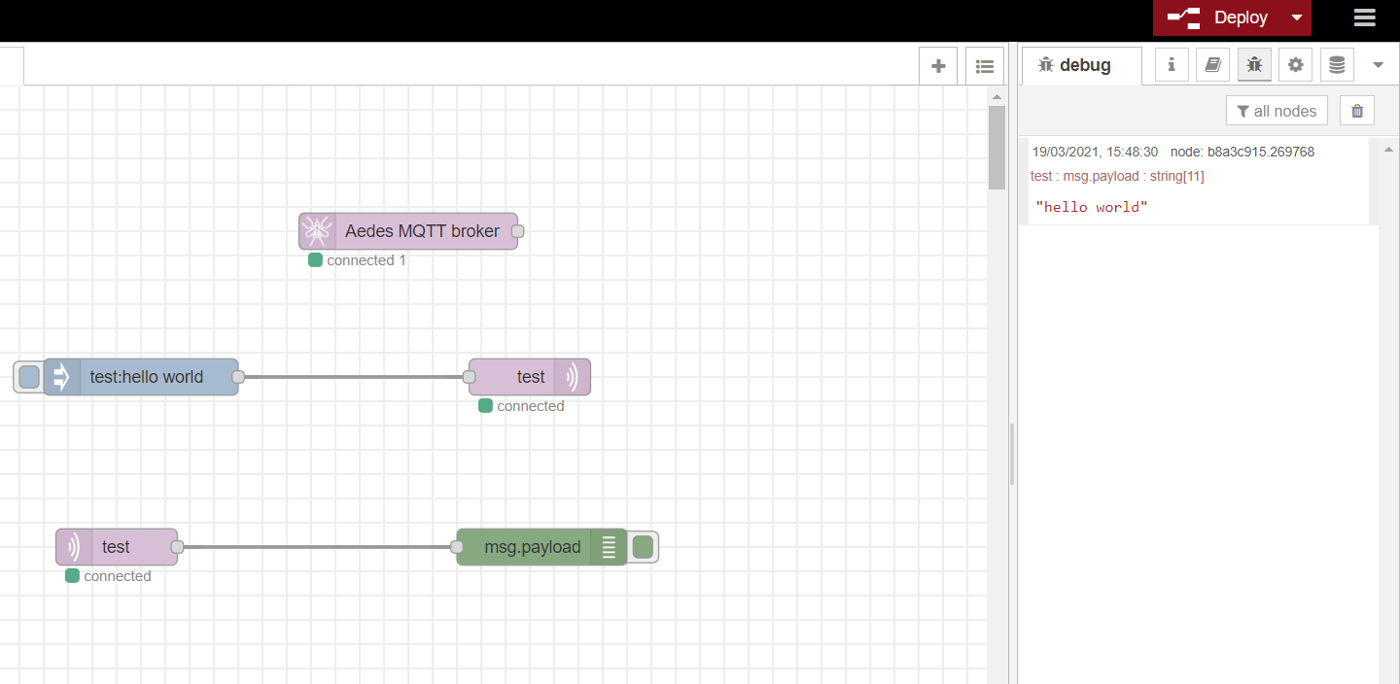

* We can see the status on top too.

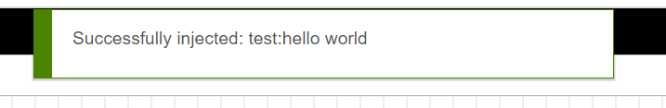

**CONCLUSION**

In this practical, we learned about Node red and MQTT. We implemented the MQTT connection using Node red.