**PRACTICAL-8**

**AIM**

Proteus Simulation for Home automation and smart city.

**THEORY**

**Proteus:**

* The Proteus Design Suite is a proprietary software tool suite used primarily for electronic design automation.
* The software is used mainly by electronic design engineers and technicians to create schematics and electronic prints for manufacturing printed circuit boards.
* The Proteus Design Suite is a Windows application for schematic capture, simulation, and PCB (Printed Circuit Board) layout design.
* It can be purchased in many configurations, depending on the size of designs being produced and the requirements for microcontroller simulation.
* All PCB Design products include an autorouter and basic mixed mode SPICE simulation capabilities.
* The micro-controller simulation in Proteus works by applying either a hex file or a debug file to the microcontroller part on the schematic.
* It is then co-simulated along with any analog and digital electronics connected to it.
* This enables its use in a broad spectrum of project prototyping in areas such as motor control, temperature control and user interface design.
* It also finds use in the general hobbyist community and, since no hardware is required, is convenient to use as a training or teaching tool.

**PRACTICAL**

* Proteus has easy to use interface where we can drag and drop the components.
* We will make the following topology.

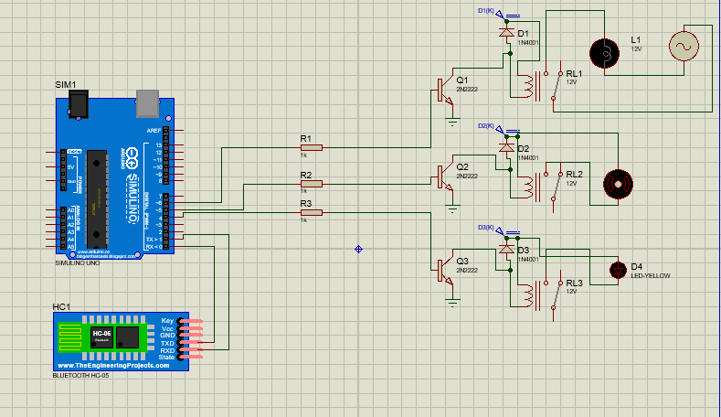

* Now we need to upload the code in Arduino.
* We will make the Hex file of the following code and upload it into Arduino.

String voice;

void setup() {

Serial.begin(9600);

pinMode(6, OUTPUT);

pinMode(5, OUTPUT);

pinMode(4, OUTPUT);

}

void loop() {

while(Serial.available()){

delay(3);

char c = Serial.read();

voice+=c;}

if(voice.length() >0){

Serial.println(voice);

if(voice == "light on")

{digitalWrite(6, HIGH);}

else if(voice == "light off")

{digitalWrite(6, LOW);}

else if(voice == "fan on")

{digitalWrite(5, HIGH);}

else if(voice == "fan off")

{digitalWrite(5, LOW);}

else if(voice == "night lamp on")

{digitalWrite(4, HIGH);}

else if(voice == "night lamp off")

{digitalWrite(4, LOW);}

else if(voice == "all on")

{digitalWrite(4, HIGH);

digitalWrite(5, HIGH);

digitalWrite(6, HIGH);}

else if(voice == "all off")

{digitalWrite(4, LOW);

digitalWrite(5, LOW);

digitalWrite(6, LOW);}

voice = "";}

}

* We will also make a simple mobile app to control the components attached with Arduino.
* We can also make the street light system for smart city by using following topology and code.

#include<LiquidCrystal.h>

LiquidCrystal lcd(7, 6, 5, 4, 3, 2);

void setup() {

pinMode(8,OUTPUT);

pinMode(9,OUTPUT);

pinMode(10,OUTPUT);

lcd.begin(16,2);

lcd.print("Ldr out = ");

lcd.setCursor(0,1);

}

void loop()

{

int a=analogRead(A0);

lcd.setCursor(12,0);

lcd.print(a);

if(a<1)

{

lcd.setCursor(1,0);

lcd.println("LIGHT'S OFF");

digitalWrite(8,LOW);

delay(500);

digitalWrite(9,LOW);

delay(500);

digitalWrite(10,LOW);

}

if(a>1)

{

lcd.setCursor(1,0);

lcd.println("LIGHT'S ON");

digitalWrite(8,HIGH);

delay(500);

digitalWrite(9,HIGH);

delay(500);

digitalWrite(10,HIGH);

}

}

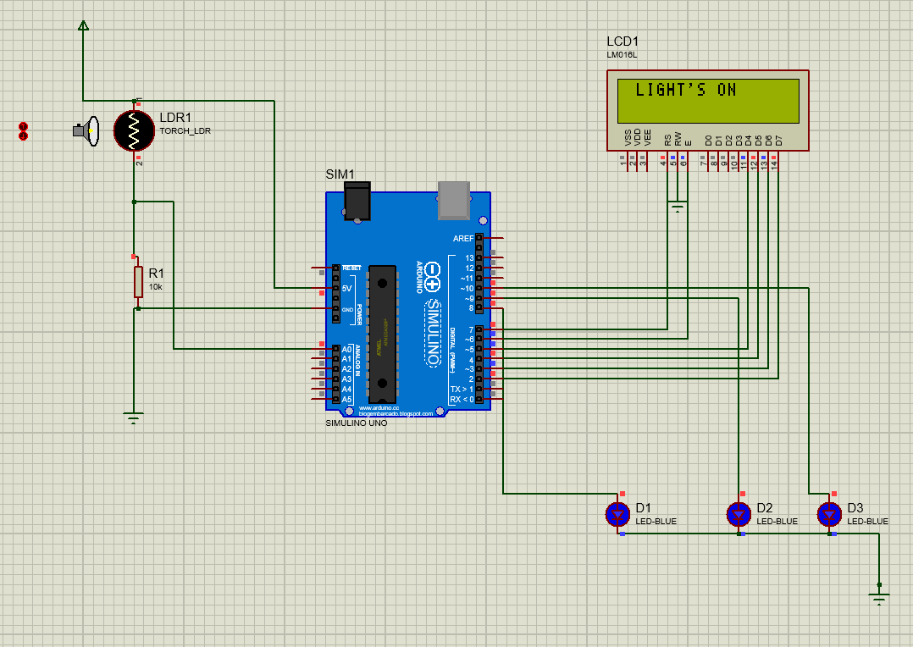

**CONCLUSION**

In this practical, we learned about Proteus Design Suit and also implement Proteus Simulation for Home automation.