**PRACTICAL-1**

**AIM:**

To install Hadoop framework, configure it and setup a single node cluster. Use web based tools to monitor your Hadoop setup

**IMPLEMENTATION:**

The Hadoop framework is written in Java, and its services require a compatible Java Runtime Environment (JRE) and Java Development Kit (JDK).

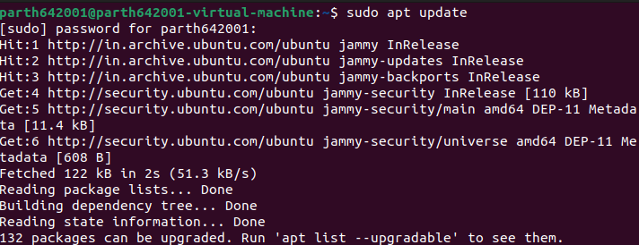

Apache Hadoop 3.x fully supports Java 8. The OpenJDK 8 package in Ubuntu contains both the runtime environment and development kit.

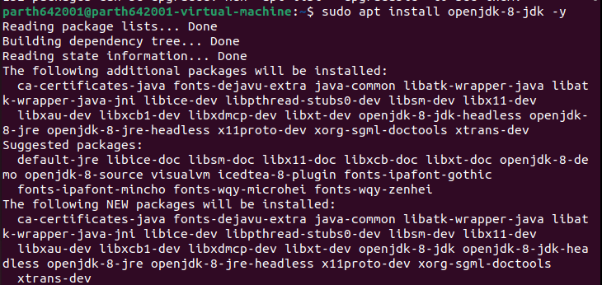

The OpenJDK or Oracle Java version can affect how elements of a Hadoop ecosystem interact. Hence, we need to be specific.

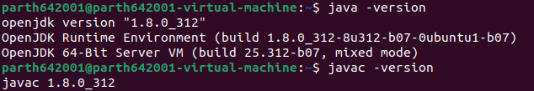

Install the OpenSSH server and client.

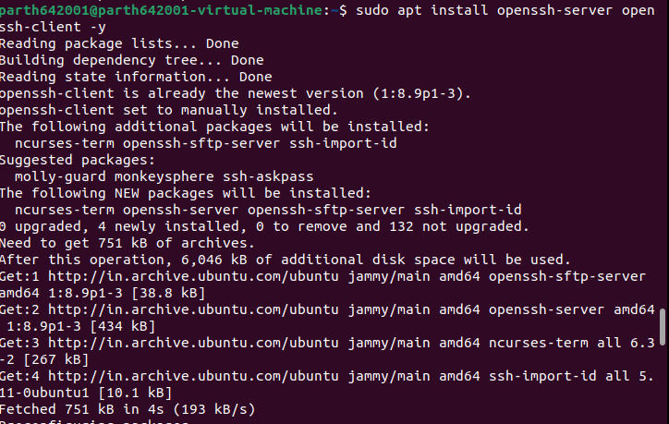

Utilize the adduser command to create a new Hadoop user. The username, in this example, is **hdoop**. You are free the use any username and password you see fit. Switch to the newly created user and enter the corresponding password.

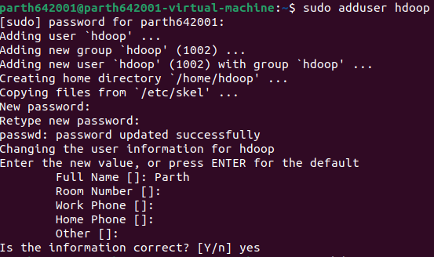

The user now needs to be able to SSH to the localhost without being prompted for a password.

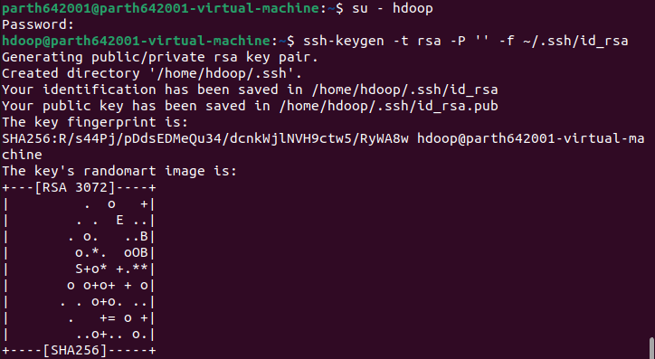

Use the cat command to store the public key as **authorized_keys**in the *ssh* directory

Set the permissions for your user with the chmod command

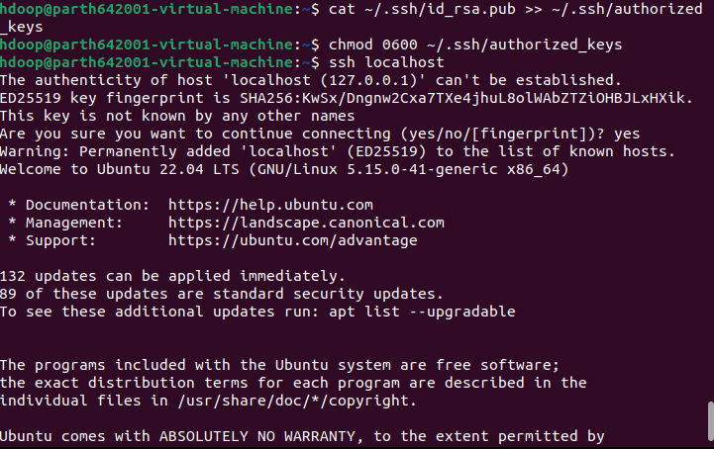

Download and extract the Hadoop setup.

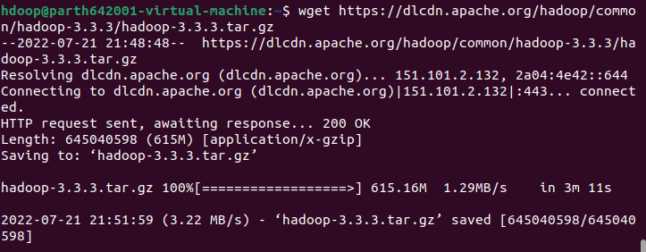

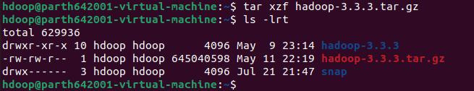

Hadoop excels when deployed in a fully distributed mode on a large cluster of networked servers. However, if you are new to Hadoop and want to explore basic commands or test applications, you can configure Hadoop on a single node.

This setup, also called pseudo-distributed mode, allows each Hadoop daemon to run as a single Java process. A Hadoop environment is configured by editing a set of configuration files:

* bashrc
* hadoop-env.sh
* core-site.xml
* hdfs-site.xml
* mapred-site-xml
* yarn-site.xml



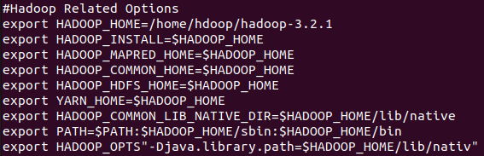



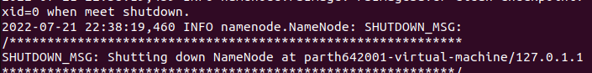

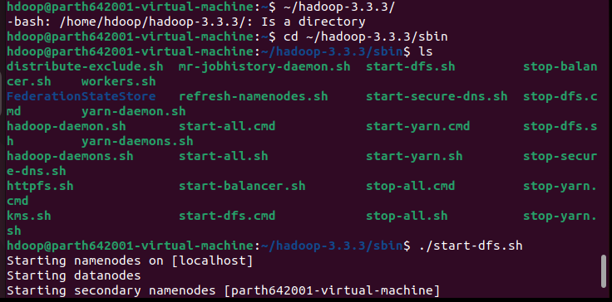

Navigate to the *hadoop-3.2.1/sbin* directory and execute the following commands to start the NameNode and DataNode.

Once the namenode, datanodes, and secondary namenode are up and running, start the YARN resource and nodemanagers

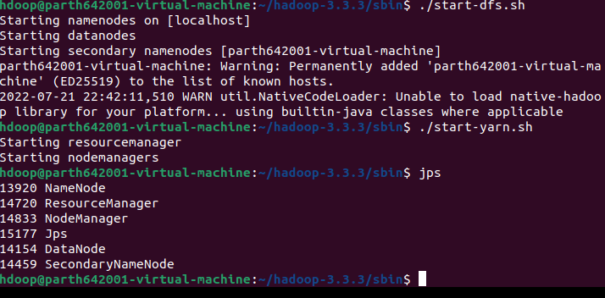

One can also use localhost to access the Hadoop overview.

<http://localhost:9870>

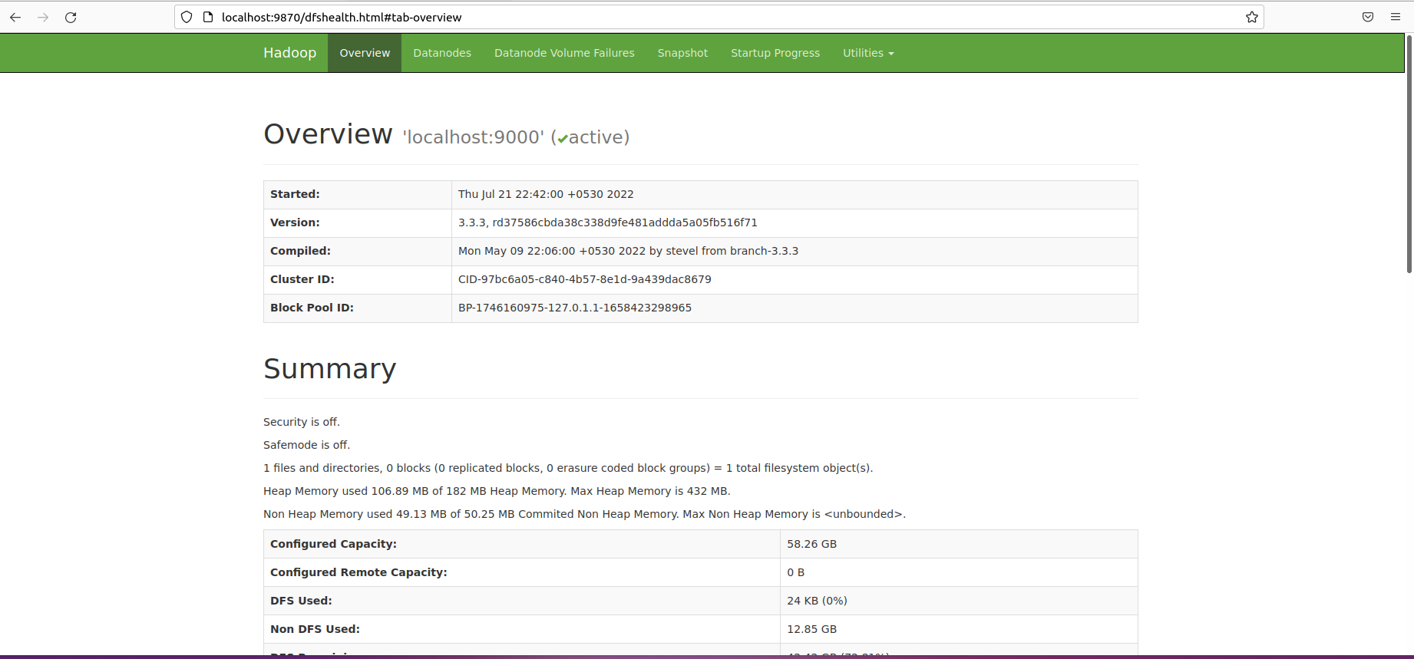

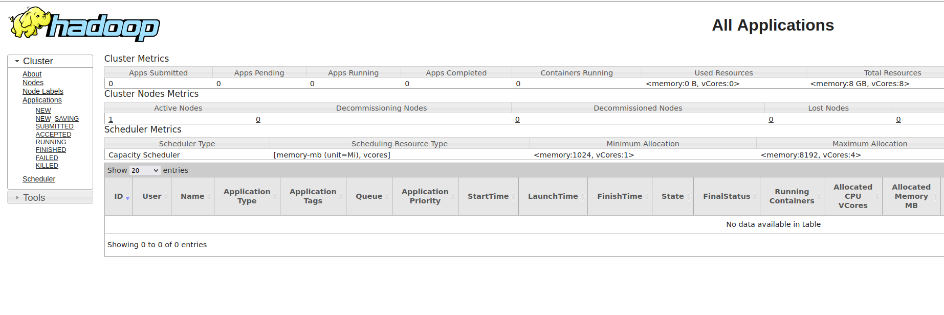

**CONCLUSION:**

By performing this practical, I learnt how to install and configure Hadoop.