**PRACTICAL-10**

**AIM:**

To install, deploy & configure Apache Spark Cluster. To Select the fields from the dataset using Spark SQL. To explore Spark shell and read from HDFS.

**THEORY:**

• Apache Spark is an open-source unified analytics engine for large-scale data processing. Spark provides an interface for programming entire clusters with implicit data parallelism and fault tolerance. Originally developed at the University of California, Berkeley's AMPLab, the Spark codebase was later donated to the Apache Software Foundation, which has maintained it since.

• Apache Spark has its architectural foundation in the resilient distributed dataset (RDD), a read-only multiset of data items distributed over a cluster of machines, that is maintained in a fault-tolerant way.

• The Dataframe API was released as an abstraction on top of the RDD, followed by the Dataset API. In Spark 1.x, the RDD was the primary application programming interface (API), but as of Spark 2.x use of the Dataset API is encouraged even though the RDD API is not deprecated. The RDD technology still underlies the Dataset API.

• Spark and its RDDs were developed in 2012 in response to limitations in the MapReduce cluster computing paradigm, which forces a particular linear dataflow structure on distributed programs: MapReduce programs read input data from disk, map a function across the data, reduce the results of the map, and store reduction results on disk.

• Spark's RDDs function as a working set for distributed programs that offers a (deliberately) restricted form of distributed shared memory.

• Inside Apache Spark the workflow is managed as a directed acyclic graph (DAG). Nodes represent RDDs while edges represent the operations on the RDDs.

• Spark facilitates the implementation of both iterative algorithms, which visit their data set multiple times in a loop, and interactive/exploratory data analysis, i.e., the repeated database-style querying of data.

• The latency of such applications may be reduced by several orders of magnitude compared to Apache Hadoop MapReduce implementation. Among the class of iterative algorithms are the training algorithms for machine learning systems, which formed the initial impetus for developing Apache Spark.

• Apache Spark requires a cluster manager and a distributed storage system. For cluster management, Spark supports standalone (native Spark cluster, where you can launch a cluster either manually or use the launch scripts provided by the install package. It isalso possible to run these daemons on a single machine for testing), Hadoop YARN, Apache Mesos or Kubernetes.

• For distributed storage, Spark can interface with a wide variety, including Alluxio, Hadoop Distributed File System (HDFS), MapR File System (MapR-FS), Cassandra, OpenStack Swift, Amazon S3, Kudu, Lustre file system, or a custom solution can be implemented.

• Spark also supports a pseudo-distributed local mode, usually used only for development or testing purposes, where distributed storage is not required and the local file system can be used instead; in such a scenario, Spark is run on a single machine with one executor per CPU core.

**CODE:**

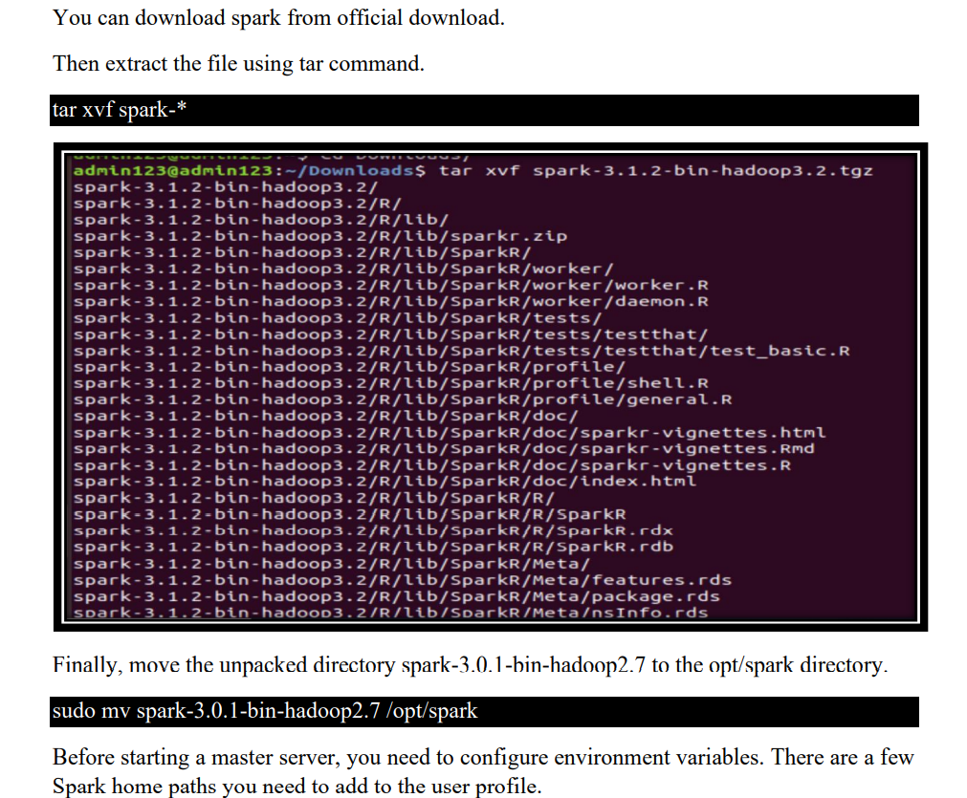

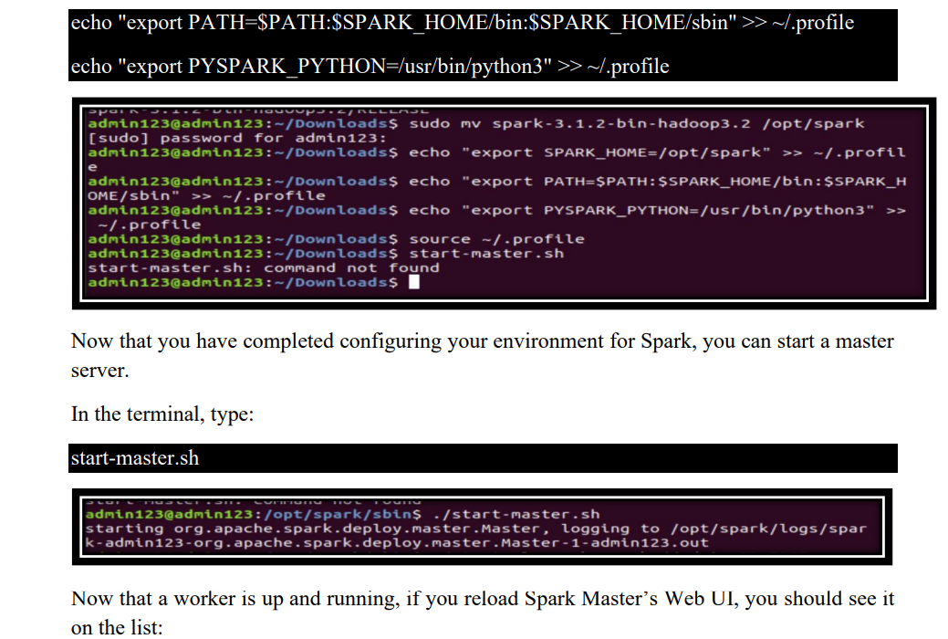

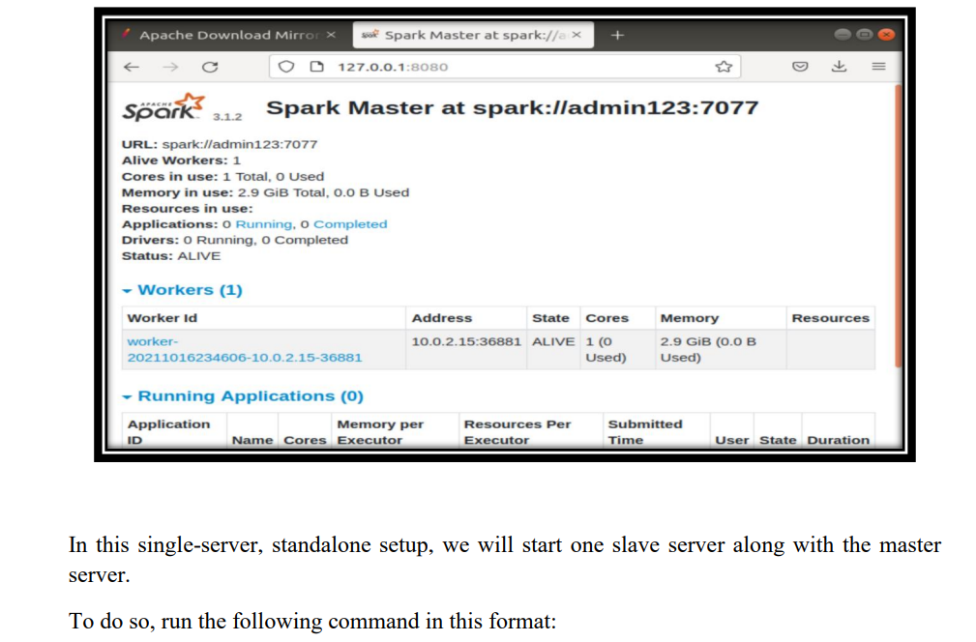

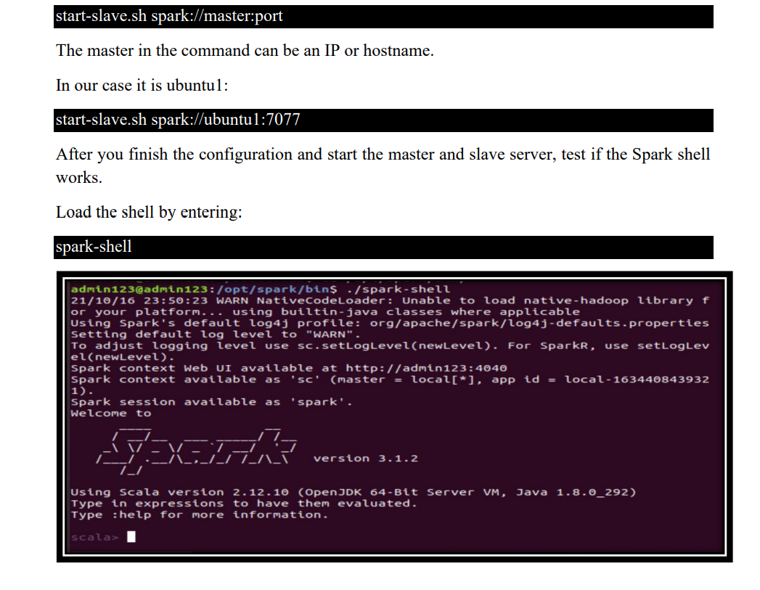

#### **CONCLUSION:**

In this practical, we learnt about spark and installed it and configured it. We explored the spark shell as well.